CHAPTER FOUR
4.0 PROJECT LOCATION
4.1 BRIEF HISTORICAL BACKGROUND OF KWARA STATE
Kwara (Yoruba: Ìpínlẹ̀ Kwárà) is a state in Western Nigeria, bordered to the east by Kogi State, to the north by Niger State, and to the south by Ekiti, Osun, and Oyo states, while its western border makes up part of the international border with Benin. Its capital is the city of Ilorin and the state has 16 local government areas.
Of the 36 states of Nigeria, Kwara is the ninth largest in area but the sixth least populous with an estimated population of about 3.2 million as of 2016.Geographically, Kwara is split between the West Sudanian savanna in the east and the Guinean forest–savanna mosaic ecoregion in the rest of the state. Important geographic features include rivers with the Niger flowing along the northern border into Lake Jeba before continuing as the border while the Awun, Asa, Aluko, and Oyun rivers flow through the interior. In the far northwest of the state is the Borgu section of the Kainji National Park, a large national park that contains populations of grey heron, kob, hippopotamus, African bush elephant, olive baboon, and roan antelope, along with some of the last remaining West African lions on earth. In the far southwest, a small part of the Old Oyo National Park contains crowned eagle, martial eagle, African buffalo, oribi, and patas monkey populations.
4.1.2 ECONOMY OF KWARA STATE
Agriculture is the main source of the state's economy and the principal cash crops are: cotton, cocoa, coffee, kola nut, tobacco, sesame and palm produce. Kwara state is home to Shonga Farms, a product of the Back-to-Farm project of one of the past administrators of the state, Dr. Abubakar Bukola Saraki. Shonga Farms is made up of 13 commercial farmers. Mineral resources in the state are Petroleum, Gold, limestone, marble, feldspar, clay, kaolin, quartz and granite rocks, and laterite found majorly in omuaran.
4.1.3 ORGANIZATION STRUCTRE
An organizational structure is a system that outline shows certain activities that are direct in order to achieve the goals of an organization. These activities can includes rules, roles and responsibilities. The organizational structure also determine show information flows between levels within the Resturant.
4.2 LOCATION AND SETTING OF KWARA STATE
Kwara State was created on 27 May 1967, when the Federal Military Government of General Yakubu Gowon broke the four regions that then constituted the Federation of Nigeria into 12 states. At its creation, the state was made up of the former Ilorin and Kabba provinces of the then Northern Region and was initially named the West Central State but later changed to "Kwara", a local name for the River Niger, in the Hausa language.
Kwara state has since 1976 reduced considerably in size due to further state creation exercises in Nigeria. On 13 February 1976, the Idah/Dekina part of the state was carved out and merged with a part of the then Benue/Plateau state, to form Benue state.
On 27 August 1991, five Local Government areas, namely Oyi, Yagba, Okene, Okehi and Kogi were also excised to form part of the new Kogi state, while a sixth, Borgu Local Government Area, was merged with Niger state. The major populated local governments are Ilorin and Offa.
Kwara state has numerous mineral resources such as tourmaline, tantalite, and many mineral deposits in the northern part. Cocoa and Kolanut in the Southern parts Oke - Ero, Ekiti and Isin LGA.
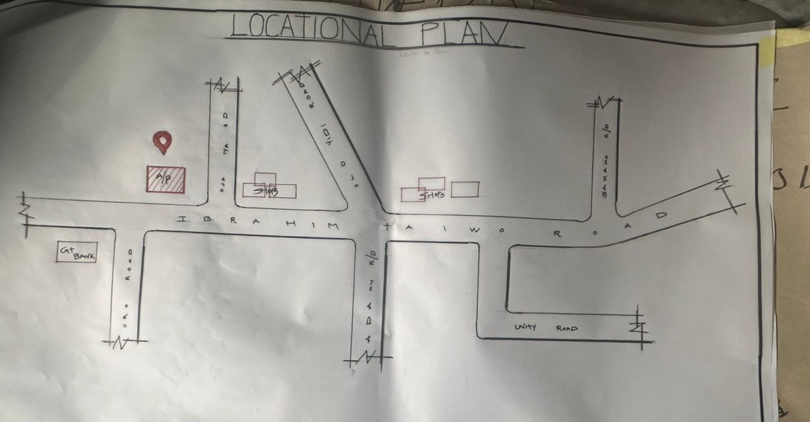
FIG 4.1; SHOWING LOCATION OF THE PROPOSE SITE
4.3 POPULATION
The population development of kwara state as well as related information and services.
The current metro area population of Ilorin in 2025 is 1,100,000, a 3.38% increase from 2024.
The metro area population of Ilorin in 2024 was 1,064,000, a 3.3% increase from 2023.
The metro area population of Ilorin in 2023 was 1,030,000, a 3% increase from 2022.
The metro area population of Ilorin in 2022 was 1,000,000, a 2.67% increase from 2021.
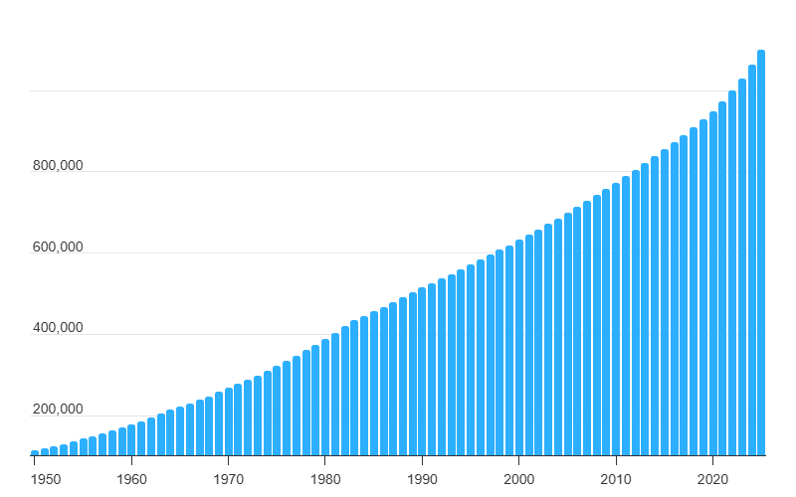
TABLE4.1; SHOWING GENDER GROUP
4.4 SITE INVENTORY
In the proposed site, some shrubs will be retained on site. It used to reduce sky glare and also serve as soft landscape and wind breaker.
Presence of road network which would serve as a means of accessibility to the site. Presence of electricity pole which serve as source of electricity to the site. Some trees would be retained while some will be removed if they disrupt the construction of building.
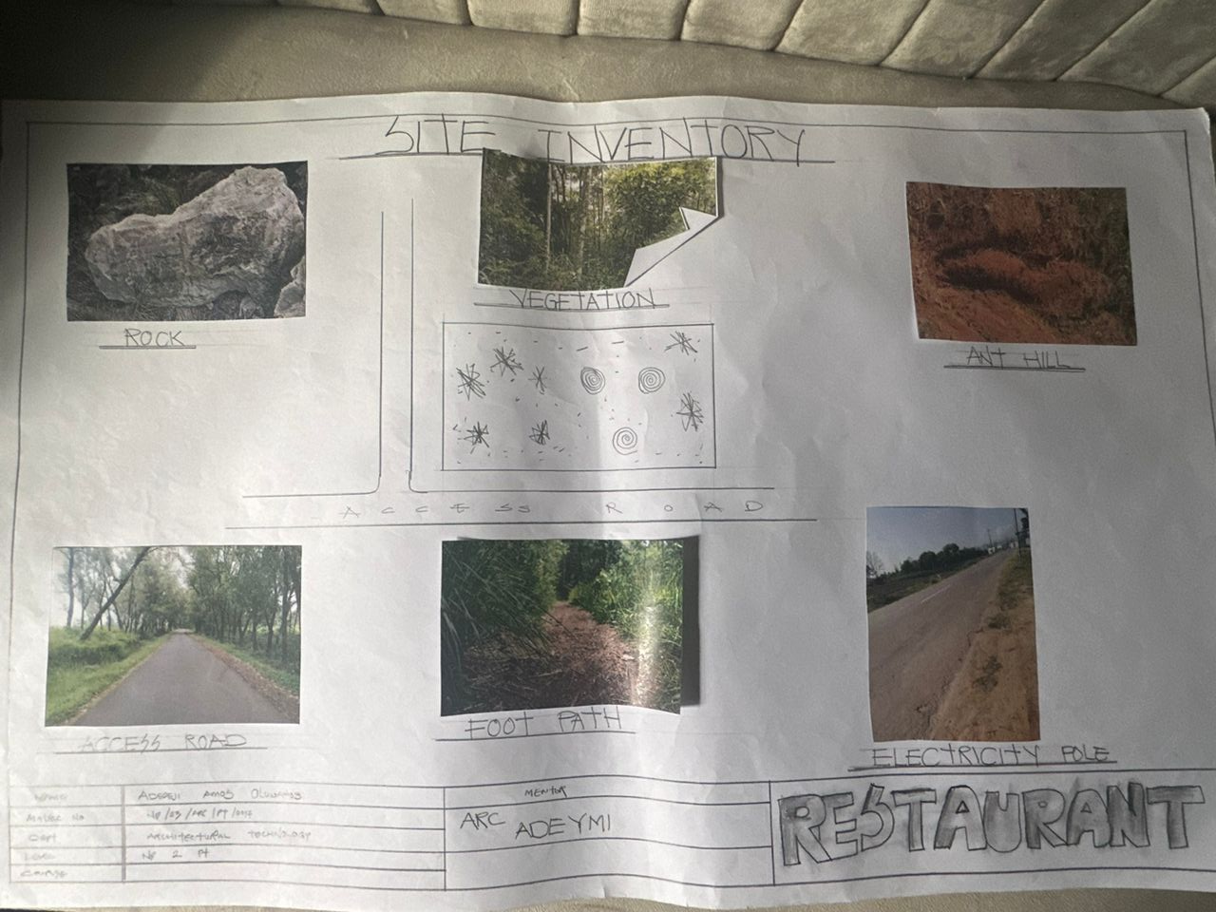
FIG4.2; SHOWING SITE INVENTORY OF THE PROPOSED SITE

4.5 SITE ANALYSIS
The site is benefitted with loamy soil which is a very good soil for grass and shrubs. It has a gentle slope towards the south east. Some of the grasses, shrubs and trees on the site are to be retained to enhance landscape patter of the site while some are to be removed and replanted where necessary. The two noticeable winds are to be directed into the building using landscape pattern to improve ventilation. Noise generated from vehicle traffic is controlled through proper planning, good landscaping and proper orientation of building. Generally, all the feature on the site are best put into different uses to aid control through proper planning, landscape and orientation.
Certainly, steps are considered to obtain vital information of the site, this information is the analysed in details. For design purpose, the information include soil condition, geology, topography, vegetation etc. It also involves carrying out a preliminary survey.
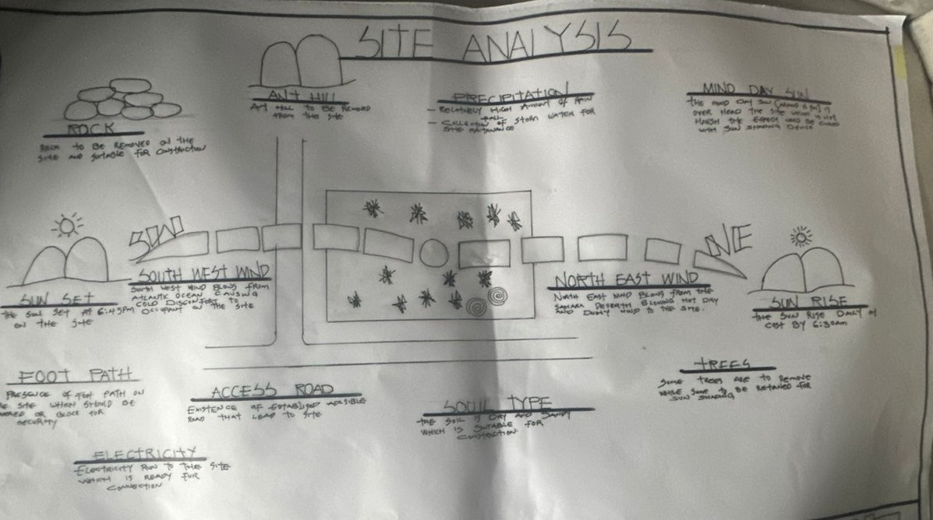
FIG4.3; SHOWING SITE ANALYSIS OF THE PROPOSED SITE
4.5.1 SITE SELECTION/JUSTIFICATION
In the site selection provision is made for interesting facilities that worth emulating since the overall success and efficiency of any project depend not on the functionality of the design but also on a careful choice of site. The site of this project has been carefully selected which is located in the premises of Taiwo Road, Ilorin local government kwara state. The proposed site is located at Ilorin, Kwara state.

4.5.2 LOCATION
The site is located
Taiwo Road 240241 Ilorin, Kwara state Nigeria.
Taiwo Road is one of the most prominent commercial corridors in Ilorin. The road is characterized by High vehicular and pedestrian traffic, a mix of commercial establishments such as eateries, banks, retail stores, and offices.
4.5.3 ACCESSIBILITY
Easy accessibility from different parts of the city, making it a strategic location for commercial developments such as eateries, restaurants, and retail outlets.
4.5.4 INFRASTRUCTURAL FACILITIES
Facilities such as water electricity, telephone network and road network are all in Ilorin, hence it can easily be tapped to the proposed site.
4.5.5 TOPOGRAPHY
The topography of the land is gentle slope which can be filled and levelled up to balance round all the site levels.
4.5.6 SOIL STRUCTURE
It is made up of clayish laterite soil, which is good for building construction.
4.6 GENERAL CLIMATIC CONDITION
Kwara State generally experiences a tropical savanna climate (Aw) with distinct wet and dry seasons. The temperature is warm throughout the year, with an average around 29.54°C (85.17°F). Rainfall varies, with an annual average of about 101.45 millimeters (3.99 inches), and the state has around 148.38 rainy days annually.
4.6.1 RELATIVE HUMIDITY
Relative humidity is higher during the rainy season, ranging from 75% to 88%, and lower during the dry season, ranging from 35% to 80%.
4.6.2 WIND
The prevailing winds are the south-west monsoon wind and the north-east continental wind.
4.6.3 TEMPERATURE
Kwara State is characterized by warm temperatures year-round, with January being the coolest month and April being the hottest. Temperatures can range from a minimum of 14°C (58°F) in January to an average of 27°C (81°F) throughout the year, with April experiencing intense heat that can reach 43°C (109°F).
4.6.4 VEGETATION
The proposed site is covered with grasses few trees and shrubs. Some will be removed before the construction while some will be retain for ornamentation.
4.7 SOCIAL SERVICES
4.7.1 ROAD
There are only two access to the site
The southern access which serve as the main entrance and also main access road
4.7.2 WATER AND ELECTRICITY
There are pipe born water networks and borehole water which serves the habitant of Ibadan. There is electricity supply from NEPA that serve the Kwara state in general
4.8 DESIGN CRITERIA
There are three (3) methods of designing of any project which are: Function before form method
Form before function method Combination of Shapes
Designing projects, the function, before form method used in line with this method, the following are the design criteria for this project:
Functional: in term of functional requirement, the following design criteria must be considered.
Sustainability, Site and Location, Flexibility, Circulation, Accessibility, Organization, Maintenance, Environment and Services
4.9 DESIGN BRIEF
After research and planning, the next step in the series of the project programed is design itself. To achieve functional and well established design there must be a brief to work on. This brief depends generally on the scope of individual design. The brief of this project is therefore based on the various activities that take place in the hospital. To have enough brief for the proposed Restaurant, case studies were carried out on the existing restaurant. The studies also give me the opportunity to know the nature of the various unit in building and how they are related to each other.
4.10 DESIGN ANALYSIS
This is the process of itemizing units within the component of the entire design with a view to establishing a solid understanding and appreciation of the space relationships.
GROUND FLOOR PLAN; Entrance, Eating area, VIP eating area, Snacks, Servers, Chef office, Kitchen, Changing room, Delivery bay, Dry store, Cold store, MD office, Rest room, Account office, W/C, Exist.
S/N | NAME | AREA[m2]
1 | ENTRANCE | 27.8m2
2 | EATING HALL | 47.5m2
3 | VIP EATING HALL | 32.2m2
4 | SNACKS | 19.0m2
5 | SERVERS | 17.5m2
6 | CHEF OFFICE | 17.9m2
7 | KITCHEN | 28.6m2
8 | CHANGING ROOM | 19.5m2
9 | DELIVERY BAY | 42.9m2
10 | DRY STORE | 8.9m2
11 | MD OFFICE | 21.8m2
12 | REST ROOM | 18.5m2
13 | COLD STORE | 16.2m2
14 | ACCOUNT OFFICE | 28.0m2
15 | EXIST | 18.9m2
16 | W/C | 11.2m2
TABLE4.2; SHOWING SPACIAL ALLOCATION OF FLOOR PLAN
Necessary units in the building. A borehole system of water supply is to be adopted alongside the government supplied services and a storage facility is to be provided for effective management of water supply.
4.12 PLANNING PRINCIPLE
The planning principle is one of the most important aspects of any design. The planning of various units taking into consideration the activities performed in each unit, how they are related to one another and the users of the various units in the design. In respect to the above factors.

