CHAPTER THREE
3.1 CASE STUDY
This is are search or an exercise that is carried out on existing building which is similar to the one researcher is writing on. The objective of a case study is to take a critical appraisal of existing related project with a view to identify the positive and negative aspect of such projects. It is only with time that a project can be adjusted so that it can be successful. The information obtained from the appraisal will guide the designer of new and similar project, the positive aspect of it shall be incorporated in the view proposal while attempts will be made to solve the problem of negative aspects. It is only through this that a designer can better enhance the quality and efficiency of building in the society. For a comprehensive analysis their case studies have been conducted.
3.2 SELETED CASE STUDIES
Case studies are of paramount important. It is an experimental research or analysis carried out on existing building or group of building functionally similar to the one which there search is working.
For any technical design to be meaningful there is always the need for preliminary research effort to be made on this proposal as a very necessary ground work.
The following are case studies of some restaurant.
- KILIMANJARO RESTAURANT
Location: 8 ASA DAM ROAD, ILORIN KWARA STATE
- LATITUDE CAFÉ AND LOUNGE
Location: V2/V3 VENTURA MALL, SANGO - OJOO ROAD IBADAN OYO STATE
- YAKOYO AFRIKANA
Location: SHOP 001, OJAJA MORE, IBADAN-IFE ROAD 220101, OSUN STATE
3.3 CASE SYUDY ONE
KILIMANJARO RESTAURANT
LOCATION:8 ASA DAM ROAD, ILORIN KWARA STATE.
OBSEVERATION
MERITS
- Adequate of staff
- There is enough toilet
- There is enough space for eating area.
DEMERITS
- Inadequate space for packing
- No enough spaces in the building
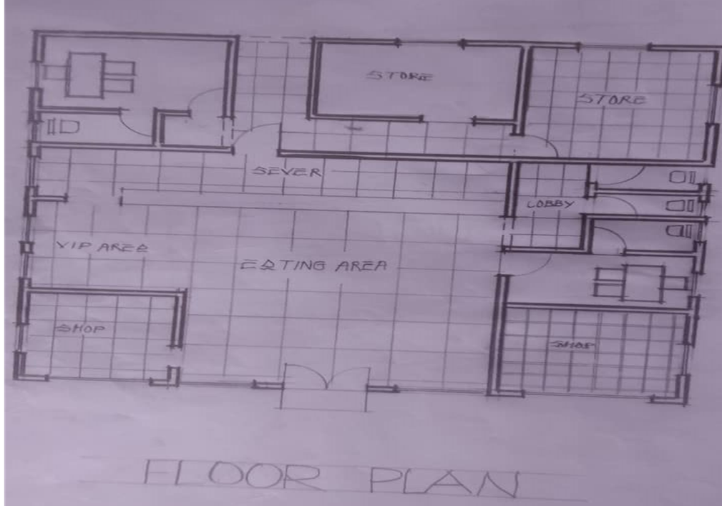
- It not well oriented.
FLOOR PLAN OF CASE STUDY ONE
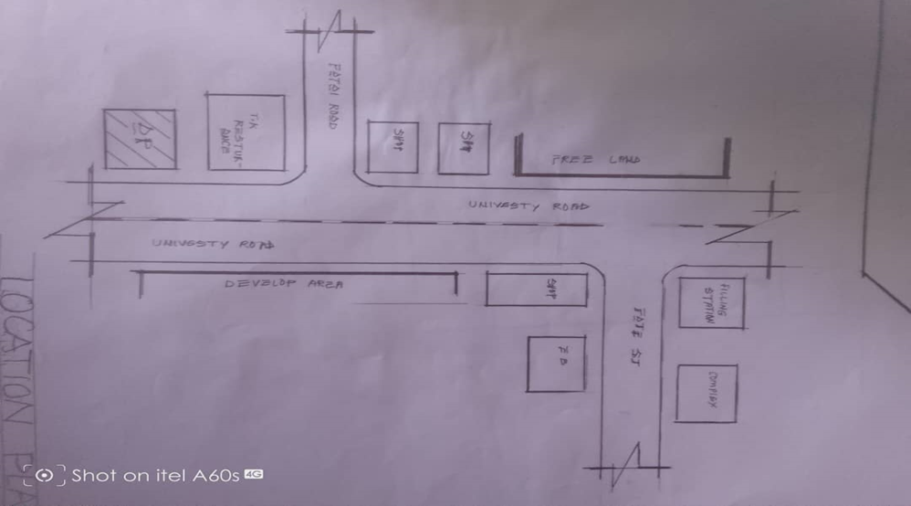
LOCATIONAL PLAN OF CASE STUDY ONE
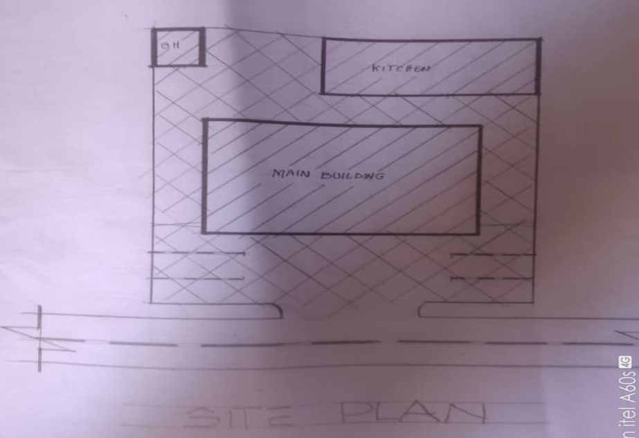
SITE PLAN OF CASE STUDY ONE

3.4 CASE STUDY TWO
LATITUDE CAFÉ AND LOUNGE
Location: V2/V3 VENTURA MALL, SANGO-OJOO ROAD IBADAN OYO STATE
OBSEVERATION
MERIT
- The eating area is spacious.
- Adequate of parking space.
- Very accessible to the access road.
- The building is well oriented.
DEMERIT
- No access from main office to the kitchen.
- Changing room is not enough for the staff.
- Inadequate space for the delivery bay.

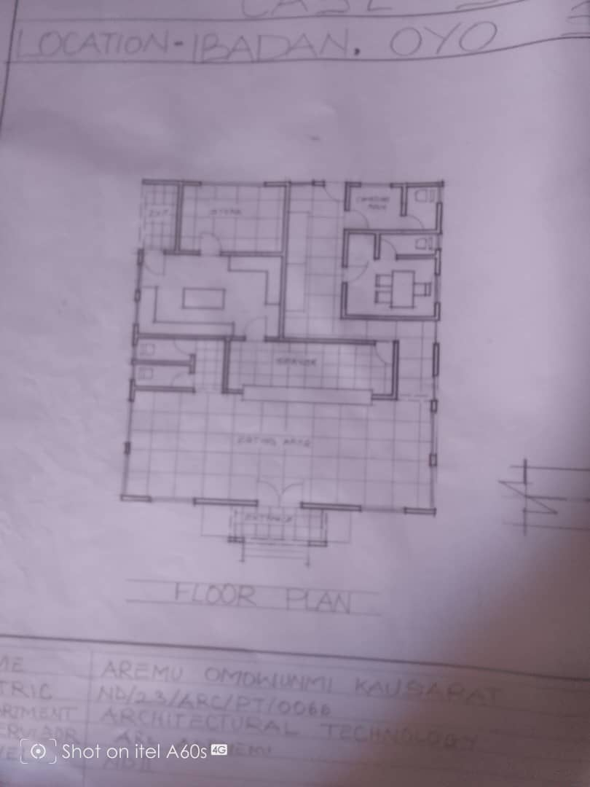
FLOOR PLAN OF CASE STUDY TWO
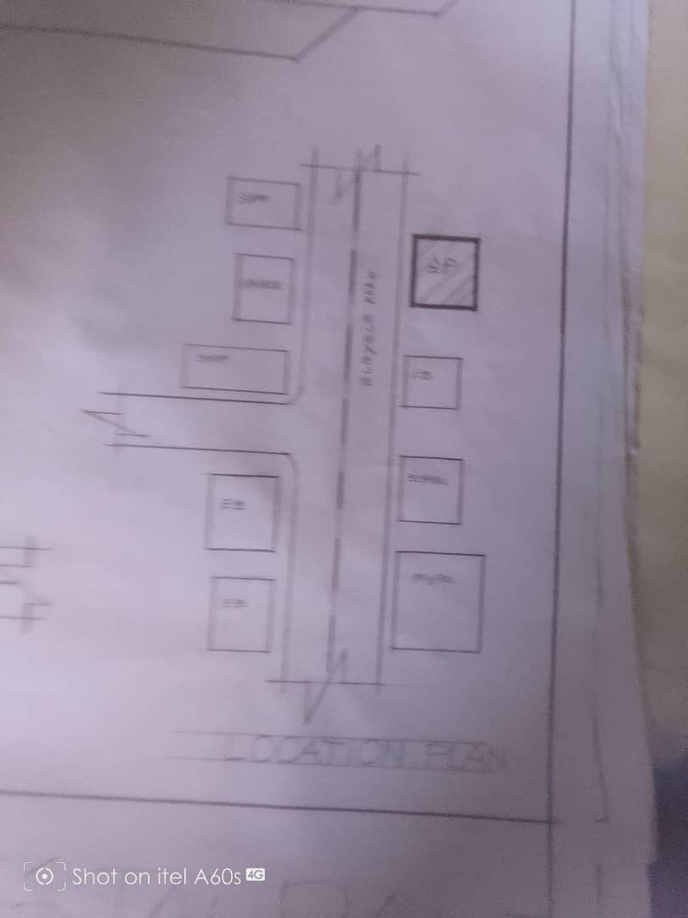
LOCATIONAL PLAN OF CASE STUDY TWO
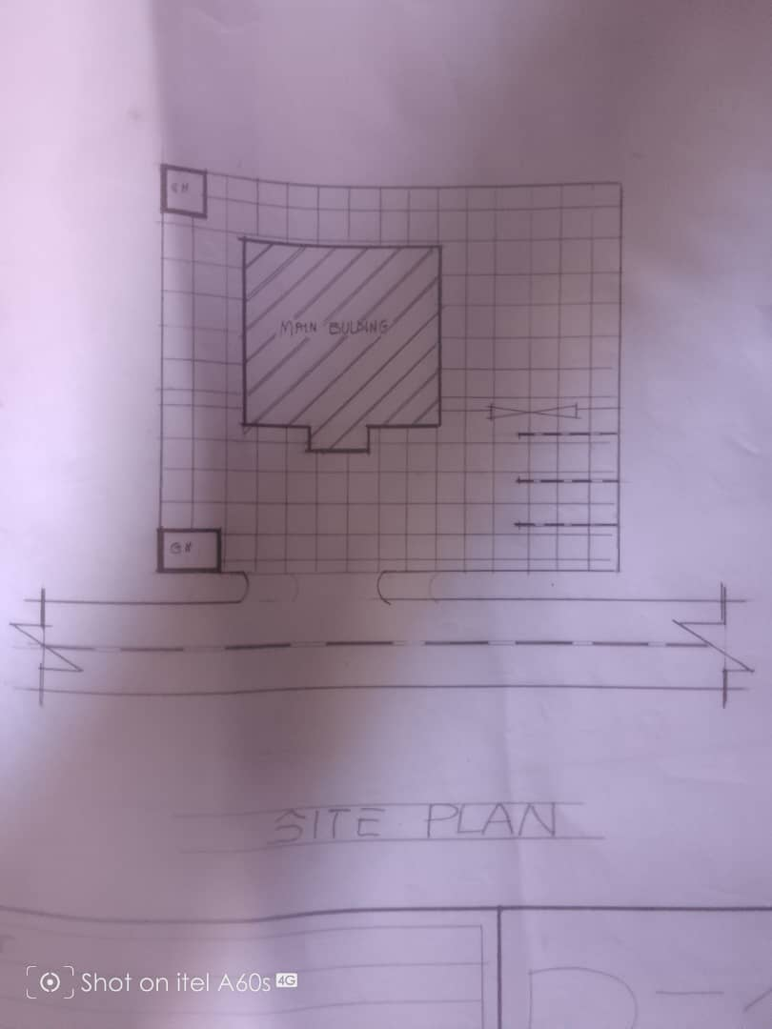
SITE PLAN OF CASE STUDY TWO

3.5 CASE STUDY THREE
YAKOYO AFRIKANA
LOCATION: SHOP 001, OJAJAMORE, IBANDAN-IFE ROAD 220101, OSUN STATE.
OBSEVERATION
MERIT
- It has enough space for eating
- The flooring material used is well friendly
DEMERIT
- Inadequate space for packing
- The unit in the building is not complete
- Not well oriented
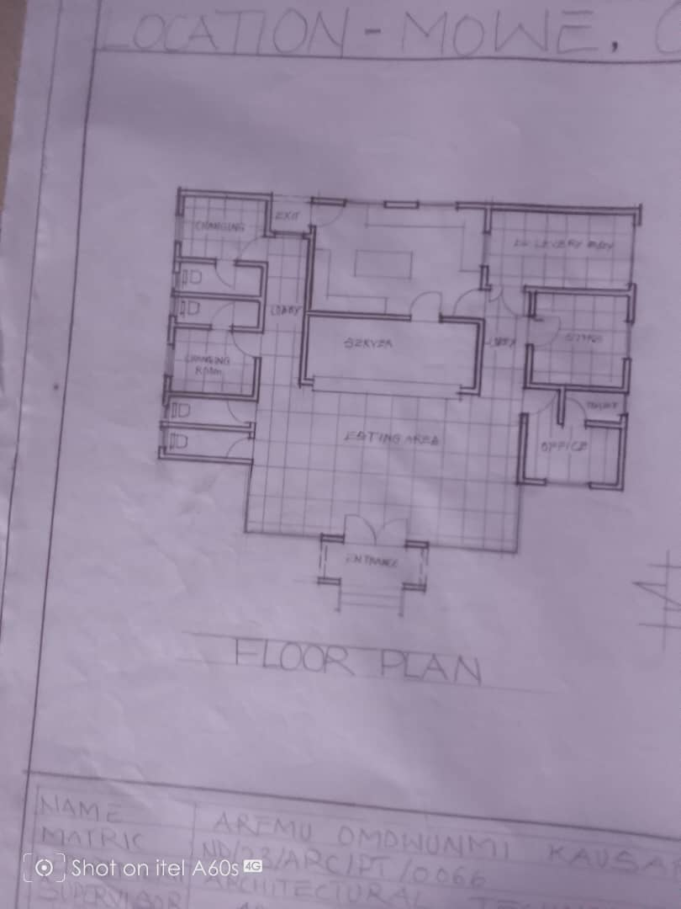
FLOOR PLAN OF CASE STUDY THREE
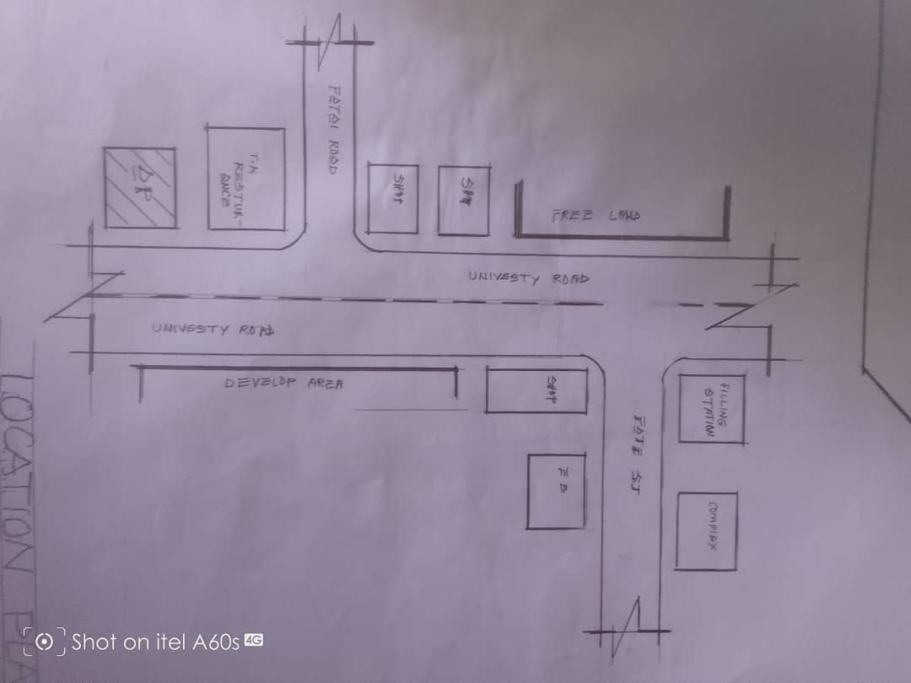
LOCATIONAL PLAN OF CASE STUDY THREE
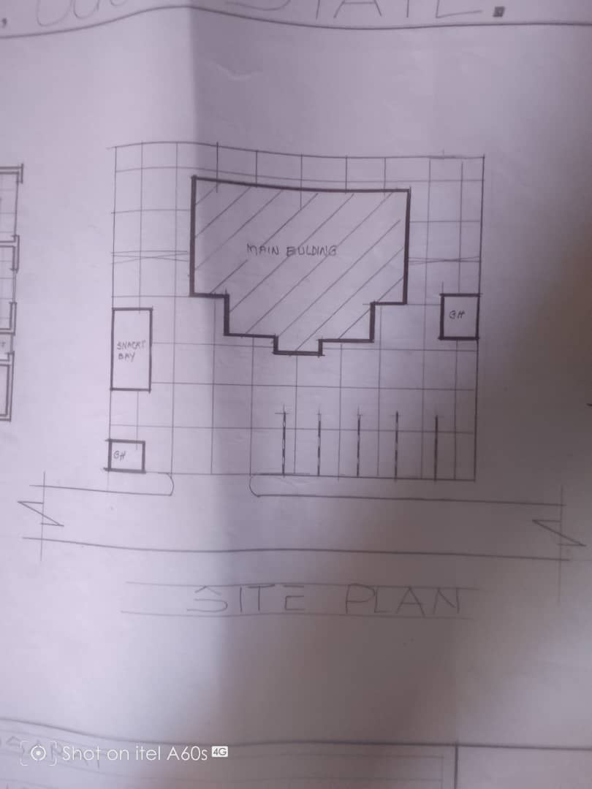
SITE PLAN OF CASE STUDY THREE
3.6 ONLINE CASE STUDY
ONLINE CASE STUDY ONE
PROJECT NAME: RESTAURANTS & BARS
LOCATION: KECAMATAN TINGKIR, INDONESIA
ARCHITECT: SAHABAT SELOJENE
LEAD ARCHITECT: ARY INDRA
YEAR: 2024
AREA: 1100m2

ONLINE CASE STUDY TWO
PROJECT NAME: CAPICHE RESTAURANT
LOCATION: SURAT INDIA
ARCHITECT: NEOGENESIS+STUDIO261
YEAR: 2024
AREA: 185m2
DEDUCTION FROM CASE STUDIES
During my visit to the restaurant. I was opportunities to see what was obtain in the restaurant, I made a proper studies of their related function and analysis were made to their present situation with the aim of incorporation with their merit in my own final proposal.
The following were deduce from my case study
- Proper zoning of dining, kitchen, storage, and service areas improves functionality and customer experience.
- Well-planned entrances, seating arrangements, and pathways enhance movement for both customers and staff.
- Natural ventilation, shading, and energy-efficient materials help adapt to the local climate and reduce costs.
- Architectural elements reflecting local traditions and culture create a unique identity for the restaurant.
Smart lighting, automated ventilation, and digital ordering systems enhance efficiency and modernize operations.

