CHAPTER FOUR
4.0PROJECT LOCATION
4.1 BRIEF HISTORICAL BACKGROUND OF EDO STATE
Edo state, southern Nigeria. It is bounded by the states of kogi to the northeast andAnambra to the east, Delta to the southeast and south and Ondo to the west and northwest, the Niger River flows along the state’s eastern boundary. Benin City is the capital and largest urban centre.
Edo state was formed in 1991 from the northern portion of Bendel state, the southern portion of Delta state. Priort to this in 1963, the citizens of the territory had voted to separate from what was then the western region and the mid-West region was created. This became Mid-Western state following the federal re-organization in 1967,from a second re-organization in 1967 until it division in 1991,it was named Bendel State.
Edo state lies a televisions between 500feet(150m)in the south and more than 1800feet(550m)in the north.Tropical rain forest covers most of the area. The state is in habited largely by the Edo(Bini)people, who are linked to the historic kingdom of Benin.
4.1.2 GEOGRAPHY OF BENIN CITY
Benin City is situated on a branch of the Benin River and lies along the main highways from Lagos to the eastern states. The city is also linked by roads to Sapele, Siluko, Okene and Ubiajaan disserved by air and the Niger river delta parts of koko and sapele.
4.1.3 ECONOMY OF BENIN CITY
Agriculture is the main stay of the economy. Yams, cassava(manioc),oil palm produce, rice and corn(maize) are the major subsistence crops, while rubber, timber and palm oil and kernel are cash crop. The Nigeria institute of palm research , the rubber research institute of Nigeria and the university of benin (founded in 1970) are located at benin city, while the state university (founded in 1981) is at Ekpoma pop(2006) 3,218,332.
4.1.4 ORGANIZATION STRUCTRE
An organizational structure is a system that outline shows certain activities that are direct in order to achieve the goals of an organization. These activities can includes rules, roles and responsibilities. The organizational structure also determine show information flows between levels within the clinic.
4.2 LOCATION AND SETTING OF BENIN CITY
Benin city also called Edo capital and the largest city of Edo state, southern Nigeria. Benin city is situated on a branch of the Benin River and lies along the main highways from Lagos to the eastern states. The city is also linked by road to Sapele, Siluko, Okene and Ubiaja and disserved by air and the Niger River delta port of Koko and Sapele.
Benin City was the principal city of the Edo(Bini) Kingdom of Benin (flourished 13th-19th century). It was destroy in 1987 by the British, who attacked after the Edo assaulted an earlier British expedition, which has been told not to enter the city during religious festival but none the less attempt to do so. Traces of the old wall and moat remain, but the new city is a close-packed pattern of the house and streets converging on the palace and compound of the Oba (sacred king) and the government offices. In the main square is a statue of Emotan, a woman hounoured for assisting a 15th century prince attempting to regain power and later became Oba Eware. The present Oba retains traditional and advisory roles in government.
Benin City has long been famous for its “Bronzes” actually brass work, some of which is said to date from the 13th century and for it sivory and wood carvings. Its museum (1960) has a notable collection of the some of the kingdom’s early pieces. The city’s present artisan still practice the ancient method of cireper due (lost-wax) casting and its wood-carvers are organized into a cooperative craft society.
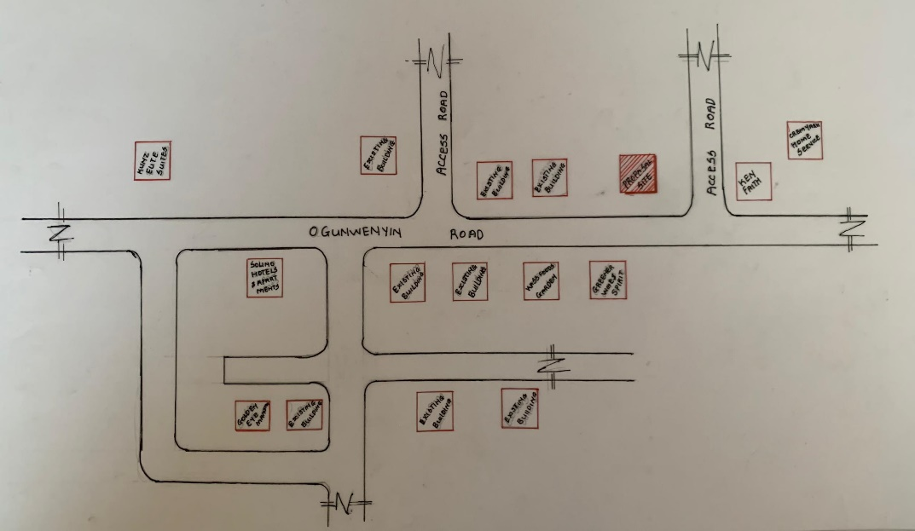
FIG 4.1; SHOWING LOCATION OF THE PROPOSE SITE
4.3 POPULATION
The population development of Benin city as well as related information and services.
The current metro area population of Benin City in 2025 is 2,045,000, a 3.65% increase from 2024
The metro area population of Benin City in 2024 is 1,973,000, a 3.57% increase from 2023
The metro area population of Benin City in 2023 is 1,905,000, a 3.48% increase from 2022.
The metro area population of Benin City in 2022 is 1,841,000, a 3.31% increase from 2021.
The metro area population of Benin City in 2021 is 1,782,000, a 3.18% increase from 2020.
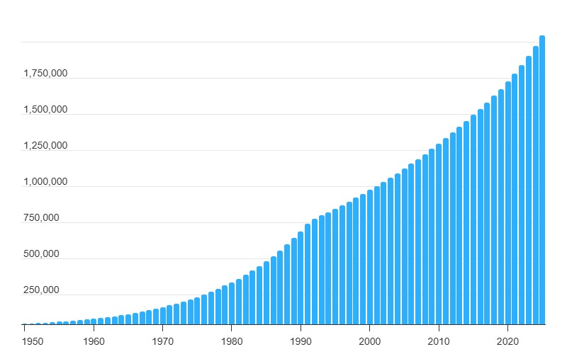
TABLE3.1; SHOWING GENDER GROUP
4.4 SITE INVENTORY
In the proposed site, some shrubs will be retained on site. It used to reduce sky glare and also serve as soft landscape and wind breaker.
Presence of road network which would serve as a means of accessibility to the site. Presence of electricity pole which serve as source of electricity to the site. Some trees would be retained while some will be removed if they disrupt the construction of building.
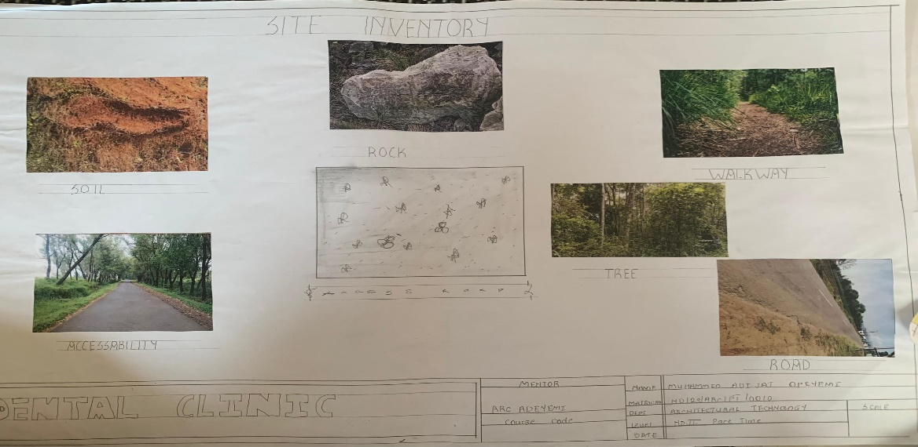
FIG 4.2; SHOWING SITE INVENTORY OF THE PROPOSED SITE
4.5 SITE ANALYSIS
The site is benefitted with loamy soil which is a very good soil for grass and shrubs. It has a gentle slope towards the south east. Some of the grasses, shrubs and trees on the site are to be retained to enhance landscape patter of the site while some are to be removed and replanted where necessary. The two noticeable winds are to be directed into the building using landscape pattern to improve ventilation. Noise generated from vehicle traffic is controlled through proper planning, good landscaping and proper orientation of building. Generally, all the feature on the site are best put into different uses to aid control through proper planning, landscape and orientation.
Certainly, steps are considered to obtain vital information of the site, this information is the analysed in details. For design purpose, the information include soil condition, geology, topography, vegetation etc. It also involves carrying out a preliminary survey of the site.
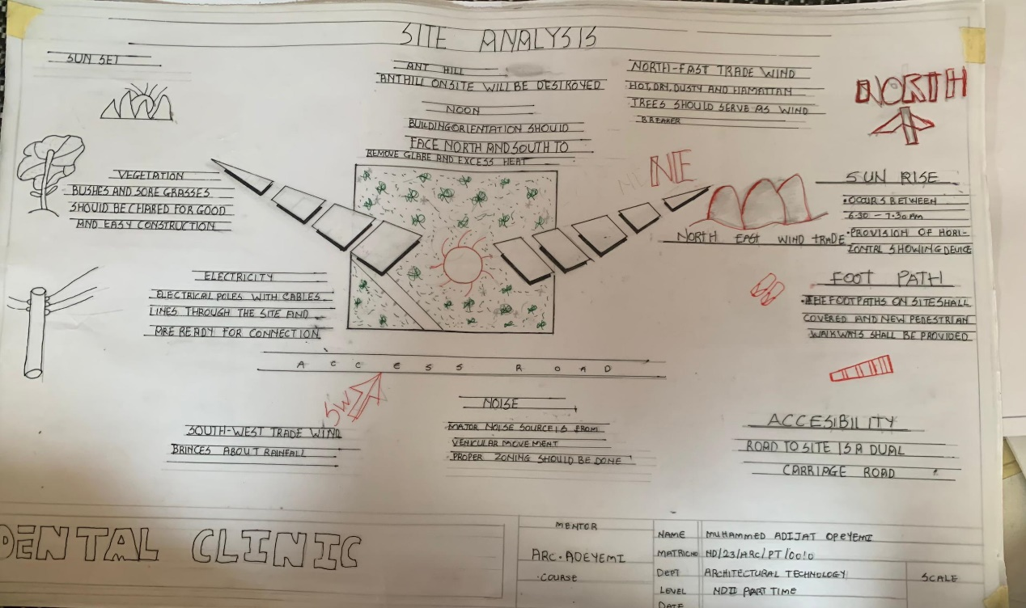
FIG 4.3; SHOWING SITE ANALYSIS OF THE PROPOSED SITE
4.5.1 SITE SELECTION/JUSTIFICATION
In the site selection provision is made for interesting facilities that worth emulating since the overall success and efficiency of any project depend not on the functionality of the design but also on a careful choice of site. The site of this project has been carefully selected which is located in the premises of Benin city, local government Edo state. The proposed site is located at Ogunwenyin road at benin city, Edo state.
4.5.2 LOCATION
The site is located at Ogunwenyin Road oka 300102 Benin city, Edo Nigeria:
Benin City is situated on a branch of the Benin River and lies along the main highways from Lagos to the eastern states. The city is also linked by roads to Sapele, Siluko, Okene, and Ubiaja and is served by air and the Niger River delta ports of Koko and Sapele.
4.5.3 ACCESSIBILITY
The site is easily accessible from the access road off from the main road that goes to sapele. The site can also be reached through the access road that lead to siluka.
4.5.4 INFRASTRUCTURAL FACILITIES
Facilities such as water electricity, telephone network and road network are all in Benin, hence it can easily be tapped to the proposed site.
4.5.5 TOPOGRAPHY
The topography of the land is gentle slope which can be filled and levelled up to balance round all the site levels.
4.5.6 SOIL STRUCTURE
It is made up of clayish laterite soil, which is good for building construction.
4.6 GENERAL CLIMATIC CONDITION
Benin has a tropical or equatorial climate, and is hot and humid year-round, with temperatures and humidity particularly high along the coast. In Cotonou, the average maximum temperature is 87F (31C) and the average minimum temperature is 75F (24C). Rainfall varies in Benin. There are two rainy seasons in the south, from April to mid-July, and from mid-September to late October; and a rainy season in the north from June to early October. During the rainy season smaller roads in Benin often become impassable and national parks tend to close during the wet season for this reason. The Harmattan wind blows in from the Sahara Desert between December and March, during the dry season, bringing heat and dust; but the hottest time of year is between February and April. The best time to visit Benin is between November and February, when travellers may have to contend with the hot Harmattan winds, but miss the rain and the worst of the heat
4.6.1 RELATIVE HUMIDITY
The town is under the influence of high humidity throughout the year with a monthly relative humidity remaining above 60%. This is even higher between May and September with a relative humidity figure of about 80% average.
4.6.2 WIND
There are two prevailing winds namely: The rain bearing south-west monsoon wind which blows across the Atlantic Ocean between the month of May and October. This is called wet season. The dusty north-east trade wind which laden with dust blows through the Sahara desert during the month of November to April with very title rainfall toward April. This is called the dry season and it brings along Harmattan during its driest period
4.6.3 TEMPERATURE
The monthly average temperature is quite uniform having February and March as the hottest months recording a higher average of about 48°C (about 85"F). July and August are the coolest (lowest monthly average of 76'F).
4.6.4 VEGETATION
The proposed site is covered with grasses few trees and shrubs. Some will be removed before the construction while some will be retain for ornamentation.
4.7 SOCIAL SERVICES
4.7.1 ROAD
There are only two access to the site
The southern access which serve as the main entrance and also main access road
4.7.2 WATER AND ELECTRICITY
There are pipe born water networks and borehole water which serves the habitant of Benin City. There is electricity supply from NEPA that serve the Benin City in general
4.8 DESIGN CRITERIA
There are three (3) methods of designing of any project which are: Function before form method
Form before function method Combination of Shapes
Designing projects, the function, before form method used in line with this method, the following are the design criteria for this project:
Functional: in term of functional requirement, the following design criteria must be considered.
Sustainability, Site and Location, Flexibility, Circulation, Accessibility, Organization, Maintenance, Environment and Services
4.9 DESIGN BRIEF
After research and planning, the next step in the series of the project programed is design itself. To achieve functional and well established design there must be a brief to work on. This brief depends generally on the scope of individual design. The brief of this project is therefore based on the various activities that take place in the hospital. To have enough brief for the proposed dental hospital, case studies were carried out on the existing dental hospital. The studies also give me the opportunity to know the nature of the various dental treatment and how they are related to each other.
4.10 DESIGN ANALYSIS
This is the process of itemizing units within the component of the entire design with a view to establishing a solid understanding and appreciation of the space relationships.
GROUND FLOOR PLAN; Entrance, Reception, Security Room, Cosmetic Room, Waiting Room, Consultation Room, Isolation Room, Dentistry Office, Account Room, Pharmacy, Surgery Room, Maxillofacial Surgery Room, X – Ray Room, Card Room, Store, Male Ward, Female Ward, Operational Room, Toilet, Changing Room, Conference Room, Control Room, Nurse Office, Laboratory, Exit.
4.11 SPACE REQUIREMENT
UNITS | AREA[M2]
ENTRANCE | 24.6m2
RECPETION
SECURITY ROOM | 20.8m2
COSMETIC ROOM | 15.9m2
CONSULTATION ROOM | 18.5
DENTISTRY OFFICE | 15.2
ACCOUNT ROOM | 18.5
PHARMACY | 16.5
SURGERY ROOM | 21.5
MAXILOFACIAL SURGERY ROOM | 22.6
X-RAY ROOM | 31.5
STORE | 31.5
MALE WARD | 48.1
FEMALE WARD | 48.3
OPERATIONAL ROOM | 15.9
TOILET | 22.2
CHANGING ROOM | 12.1
CONFERENCE ROOM | 38.9
CONTROL ROOM | 31.2
NURSE OFFICE | 21.9m2
LABORATORY | 21.5
TABLE3. 2; SHOWING SPACIAL ALLOCATION OF FLOOR PLAN
Necessary units in the building. A borehole system of water supply is to be adopted alongside the government supplied services and a storage facility is to be provided for effective management of water supply.
4.12 PLANNING PRINCIPLE
The planning principle is one of the most important aspects of any design. The planning of various units taking into consideration the activities performed in each unit, how they are related to one another and the users of the various units in the design. In respect to the above factors.

