CHAPTER THREE
3.1 CASE STUDIES
Thisisaresearchoranexercisethatiscarriedoutonexistingbuildingwhichissimilartotheoneresearcheriswritingon.Theobjectiveofacasestudyistotakeacriticalappraisalofexistingrelated project withaviewtoidentifythepositiveandnegativeaspectofsuchprojects.Itisonlywithtimethata project canbeadjustedsothatitcanbesuccessful.Theinformationobtainedfromtheappraisalwillguidethedesignerofnewandsimilarproject,thepositiveaspectofitshallbeincorporatedintheviewproposalwhileattemptswillbemadetosolvetheproblemofnegativeaspects. Itisonlythroughthisthatadesignercanbetterenhancethequalityandefficiencyofbuildinginthesociety.Foracomprehensiveanalysistheircasestudieshavebeenconducted.
3.2 SELETED CASE STUDIES
Casestudiesareofparamountimportant.Itisanexperimentalresearchoranalysiscarriedoutonexistingbuildingorgroupofbuildingfunctionallysimilartotheonewhichtheresearchisworking.
Foranytechnicaldesigntobemeaningfulthereisalwaystheneedforpreliminaryresearchefforttobemadeonthisproposalasaverynecessarygroundwork.
Thefollowingarecasestudiesofsomedentalclinic.
    - BozidDentalClinicatoluyoleIbadan,Oyostate.
    - IreAyoDentalClinicatawolowobodijaIbadan,OyoState.
    - EmpiredentalclinicAsadamIlorin, kwarastate.

3.3 CASE STUDY ONE
Location: Bozid Dental Clinic at Oluyole Ibadan, Oyo state

OBSEVERATION
MERITS
- Adequateparkingspace
- Itiswelllandscape
- Easilyaccessiblefromthegate
- Provisionofdrainage facilities
- Goodsecurityarrangement

DEMERIT
- Nospaceforfutureexpansion
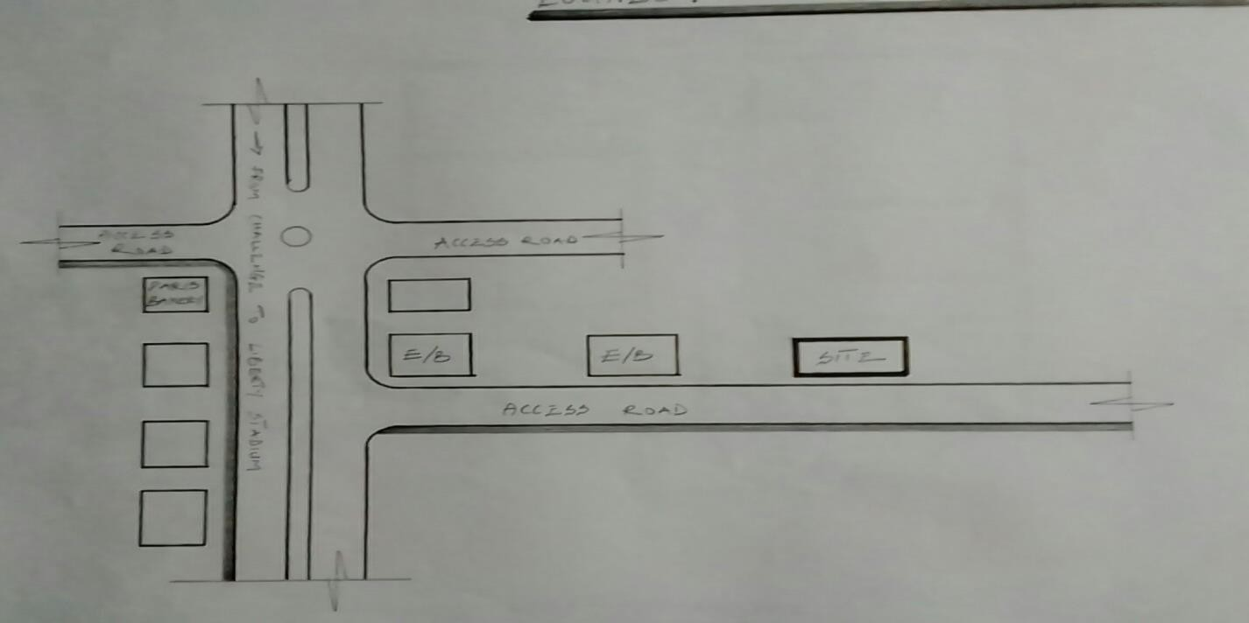

FIG3.1;SHOWINGLOCATIONPLANOFCASESTUDYONE
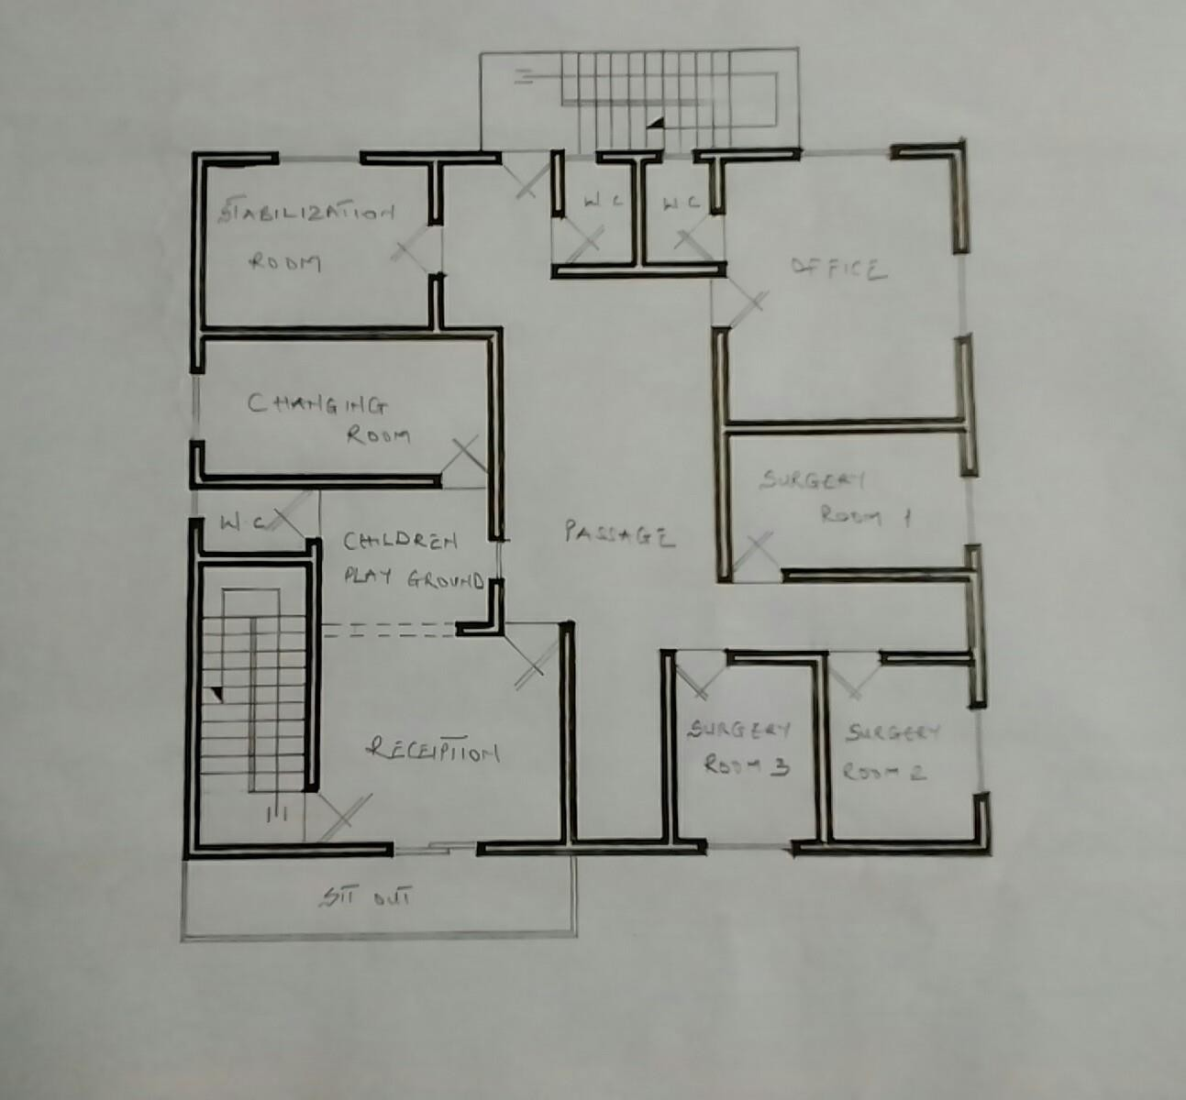

FIG3.2;SHOWINGFLOORPLANOFCASESTUDYONE

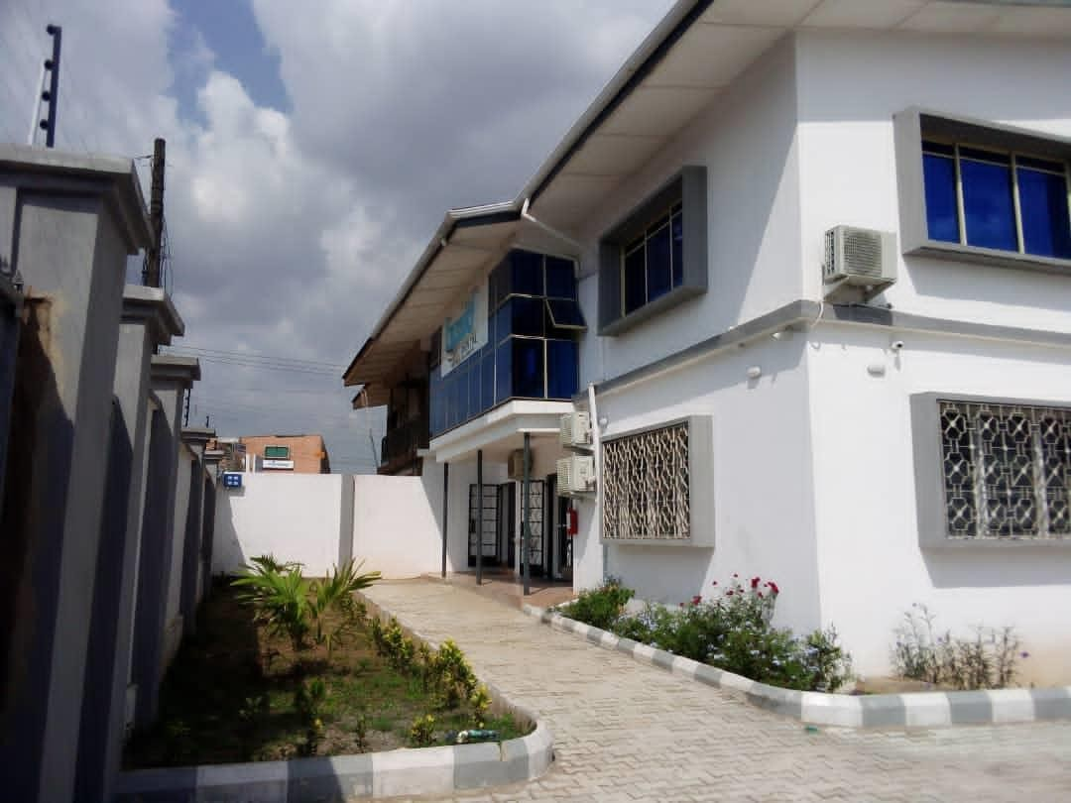

PLATE3.1;SHOWINGFRONTVIEWOFCASESTUDYONE

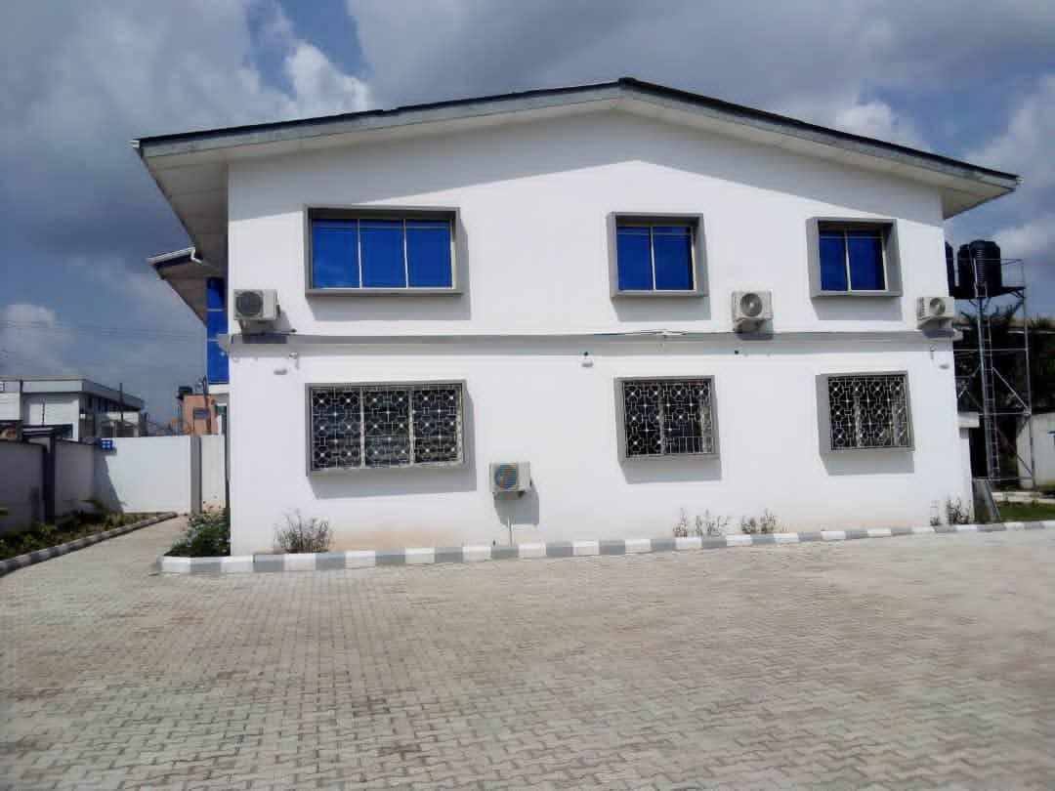

PLATE3.2;SHOWINGRIGHTVIEWOFCASESTUDYONE
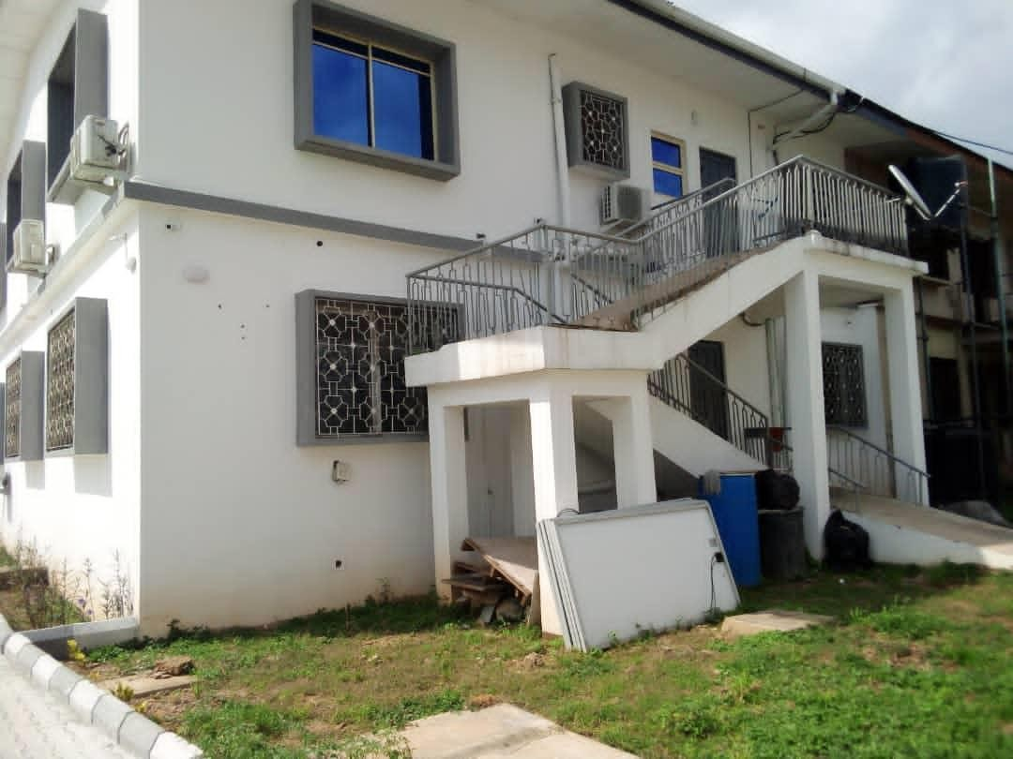

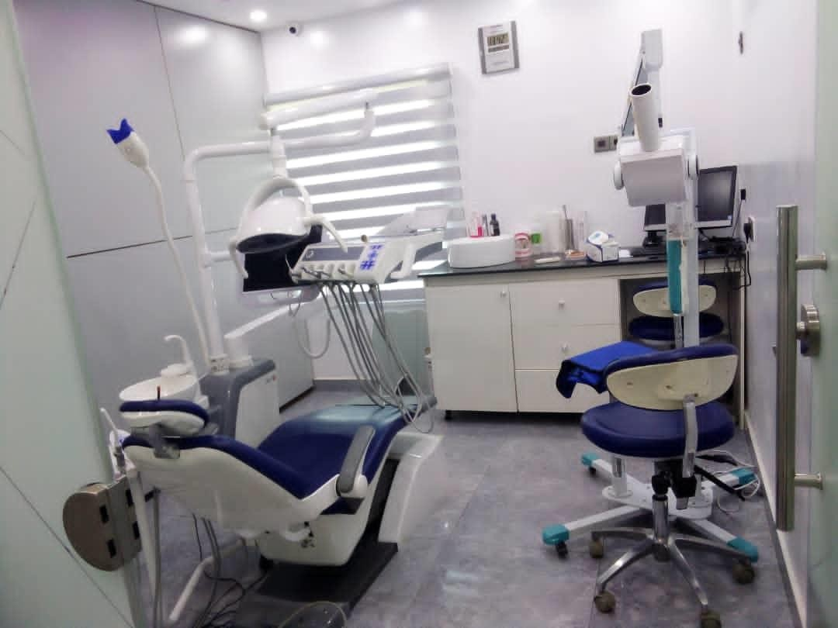
PLATE3.3;SHOWINGBACKVIEWOFCASESTUDYONE

PLATE3.4;SHOWINGSURGERYROOMOFCASESTUDYONE
3.4 CASE STUDY TWO (2)
LOCATION: IRE AYO DENTAL CLINIC AT AWOLOWO BODIJA,IBADAN,OYO STATE

MERITS
- Adequateparkingspace
- Provisionofdrainagefacilities

DEMERITS
- Noteasytoaccess
- Itisnotwelllandscape
- Notinaconduciveenvironment

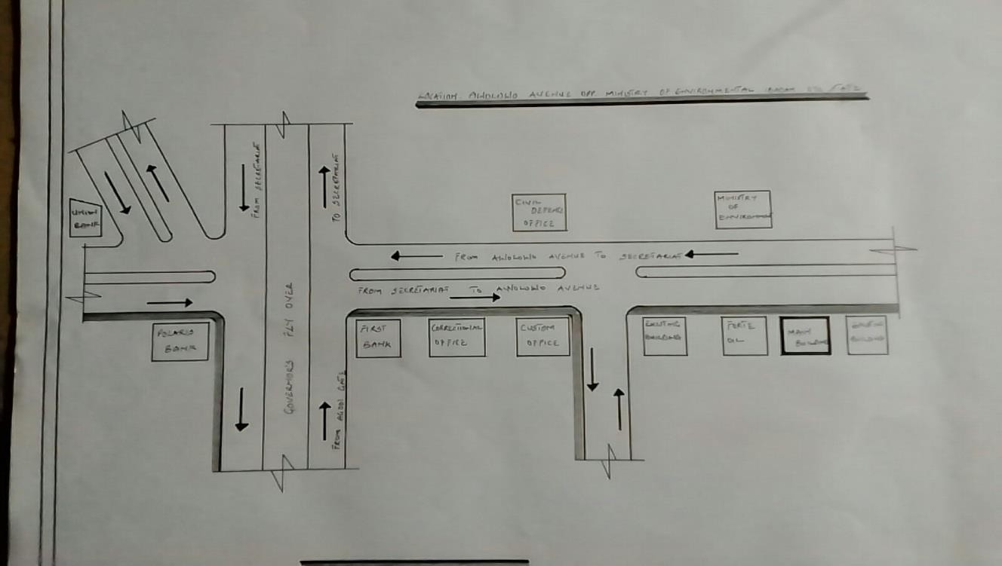

FIG3.3;SHOWINGLOCATIONPLANOFCASESTUDY TWO
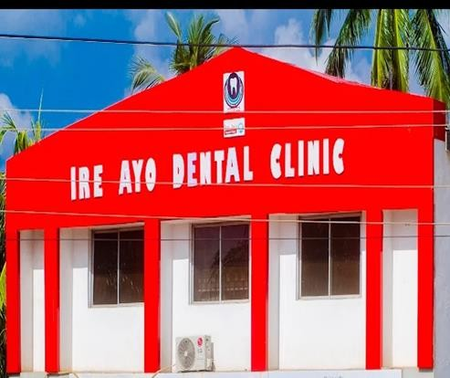
PLATE 3.5; SHOWING FRONT VIEW OF CASE STUDY TWO
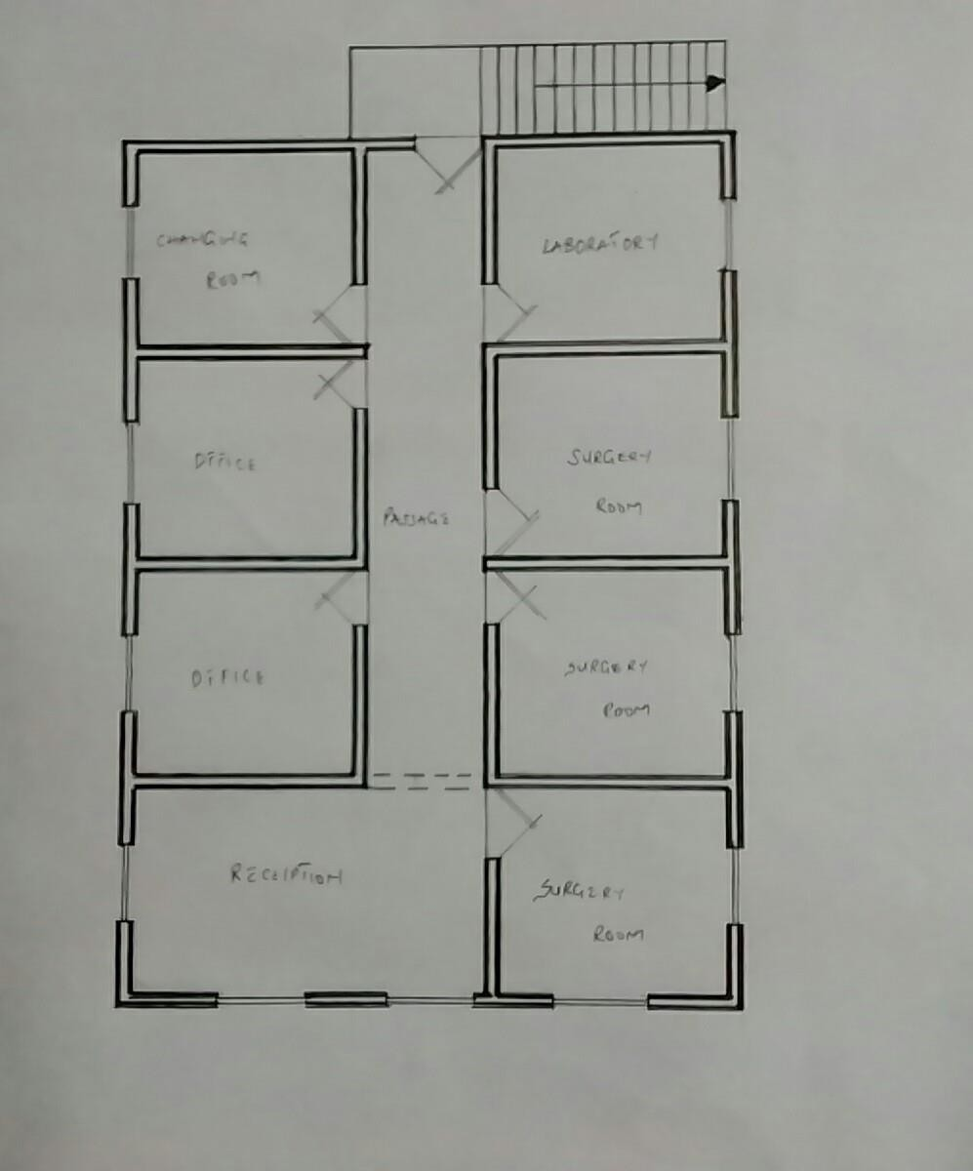

FIG3.5; SHOWING THE FLOOR PLAN OF CASE STUDY TWO

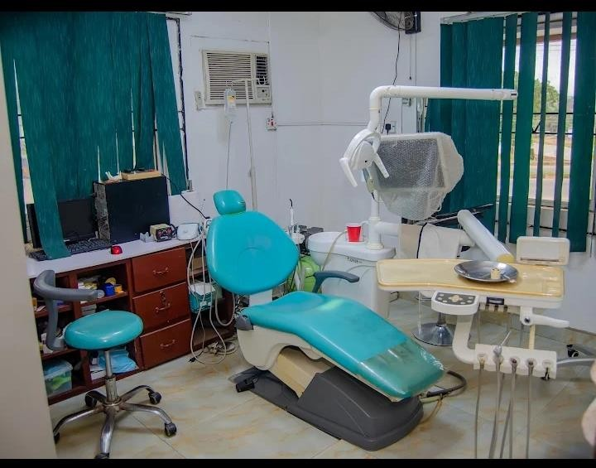

PLATE3.6;SHOWINGSURGERYROOMOFCASESTUDY

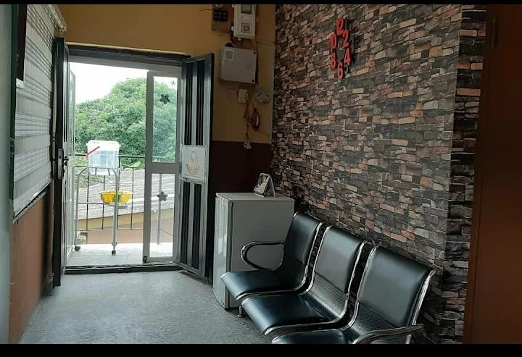
PLATE 3.7;SHOWINGWAITINGAREAOFCASESTUDYTWO

3.5 CASE STUDY THREE (3)
LOCATION: EMIPIRE DENTAL CLINIC AT ASADAM ILORIN, KWARA STATE

MERITS
- Easy to locate
- Good security
- Well landscaping

DEMERIT
- Inadequateparking space

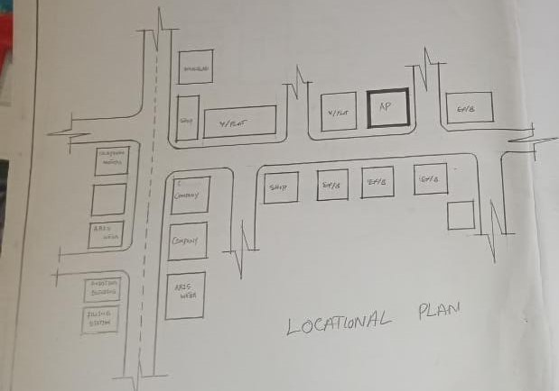

FIG3.6;SHOWINGLOCATIONPLANOFCASESTUDY THREE

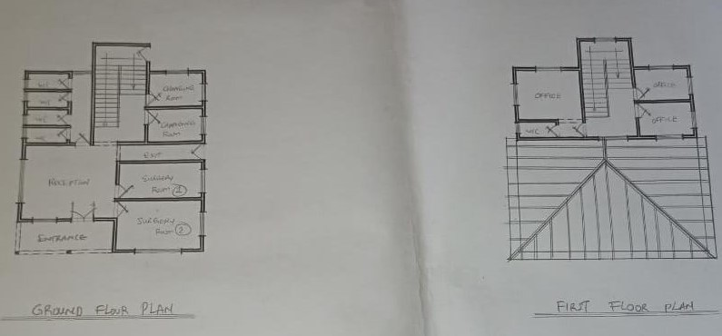
FIG3.7; SHOWING FLOOR PLAN OF CASE STUDY THREE

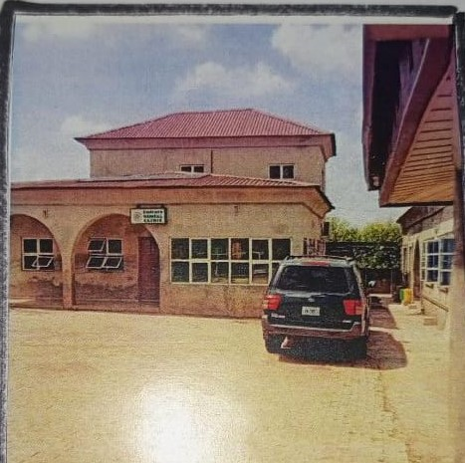

PLATE 3.8;SHOWINGFRONTVIEWOFCASESTUDYTHREE
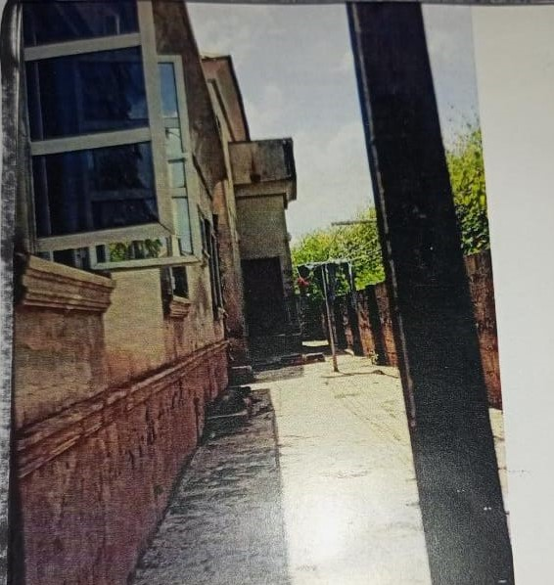

PLATE 3.9;SHOWINGRIGHTOFCASESTUDYTHREE

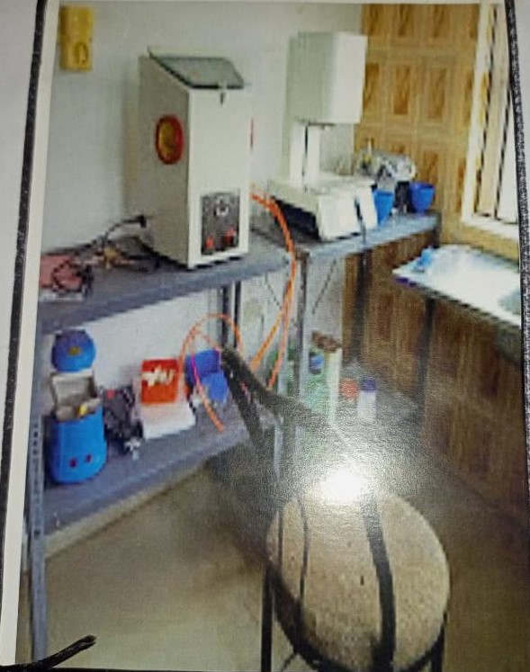

PLATE 3.10;SHOWINGSURGERYROOMOFCASESTUDYTHREE

3.6 ONLINE CASE STUDY
ONLINE CASE STUDY ONE
PROJECT NAME: IMAGE DENTAL CLINIC
LOCATION: AT TAKHQSSOUSI, AL MATHAR ASH SHAMALI,RIYADH 11564,SAUDI ARABIA
ARCHITECT: PADILLA NICAS ARQUITECTAS
YEAR: 2013
AREA: 485m
ONLINE CASE STUDY TWO
PROJECT NAME: DENTAL CLINIC
LOCATION: JARKOV,UKRAINE
ARCHITECT: DROZDOV&PARTNERS
YEAR: 2018
AREA: 359m
DEDUCTION FROM CASE STUDIES
During my visit to the dental clinics. I was opportunities to see what was obtain in the clinic, I made a proper studies of their related function and analysis were made to their present situation with the aim of incorporation with their merit in my own final proposal.
The following were deduce from my case study
- Adequate natural ventilation and lighting.
- Good architectural landscaping.
- The units in the hospital should be properly and well linked.
- There is need for consultation rooms.
- Parking spaces should be well defined.
- Good drainage system.

