CHAPTER THREE
3.1 CASE STUDIES
This is are search or an exercise that is carried out on existing building which is similar to the one researcher is writing on. The objective of a case study is to take a critical appraisal of existing related project with a view to identify the positive and negative aspect of such projects. It is only with time that a project can be adjusted so that it can be successful. The information obtained from the appraisal will guide the designer of new and similar project, the positive aspect of it shall be incorporated in the view proposal while attempts will be made to solve the problem of negative aspects. It is only through this that a designer can better enhance the quality and efficiency of building in the society. For a comprehensive analysis their case studies have been conducted.
3.2 Selected Case Studies
Case studies are of paramount important. It is an experimental research or analysis carried out on existing building or group of building functionally similar to the one which there search is working.
For any technical design to be meaningful there is always the need for preliminary research effort to be made on this proposal as a very necessary ground work.
The following case study of some poultry farm.

  - Case Study One

ILORINKWARASTATE
Location: EYENKORIN, OLORUNDA AREA, ILORIN, KWARASTATE OBSEVERATION
MERITS
- Availability of land for proper site zoining
- NaturalVentilationandLightingPotential
- EnvironmentalLearningOpportunity
DEMERITS
- AccessibilityChallenges
- EnvironmentalImpactConcerns
- ClimaticChallenges(Heat&Rainfall)
- InfrastructureDeficiency.

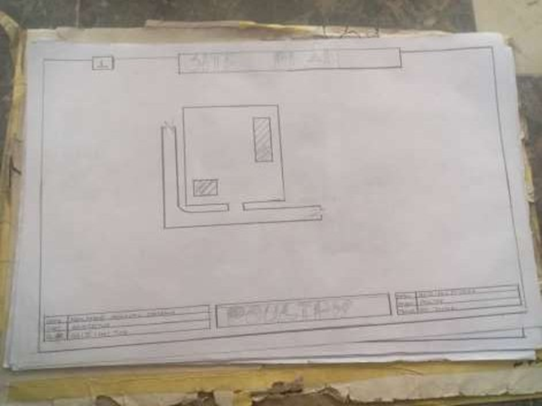
FIG3.1: SHOWINGLOCATIONPLANOFCASESTUDYONE

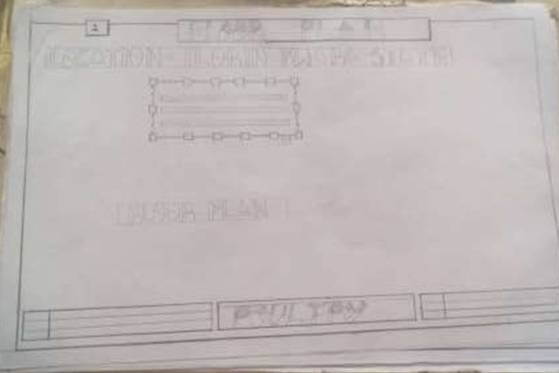
FIG 3.2: SHOWINGFLOORPLANOFCASESTUDYONE

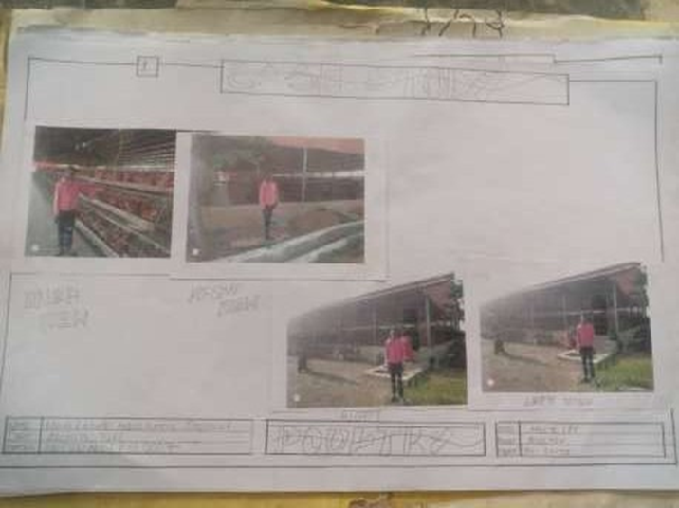

PLATE 3.1: SHOWING FRONT VIEW OF CASE STUDY ONE

3.4 CASE STUDY TWO
Location: OGBOMOSO, OYO STATE OBSERVATION
MERITS
• Spacious and Well-Organized Layout
• Good Road Network (Varies by Specific Location in Ogun)
• Moderate Topography
• Environmental Study Opportunity

DEMERIT
• Inconsistent Infrastructure (Depending on Location)
• Environmental Pollution Risks
• Climatic Factors (Rainfall & Heat)
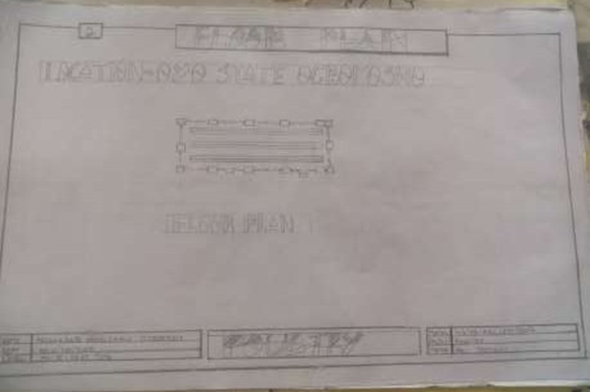

FIG 3.3: SHOWING LOCATION PLAN OFCASE STUDY TWO

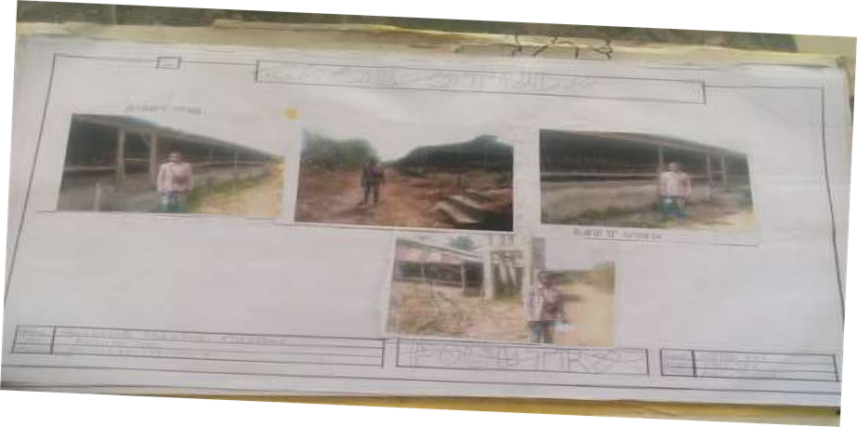
PLATE 3.2: SHOWING THE VIEWS OF CASE STUDY TWO

3.5 CASE STUDY THREE
Location: IFE OSUN OSUN SATATE
MERITS
- Spacious and Well-Organized Layout
- Environmental Learning Opportunity
DEMITS
- Not Easy To Access
- Lack Of Toilet In The Building

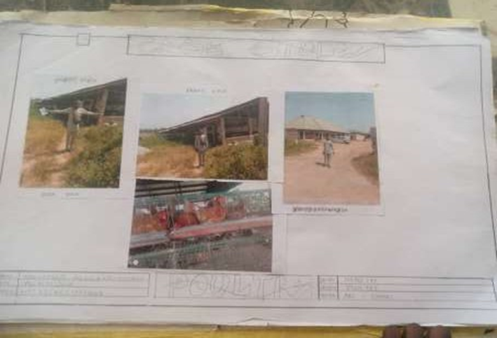
PLATE 3.3: SHOWING THE VIEW OF CASE STUDY THREE

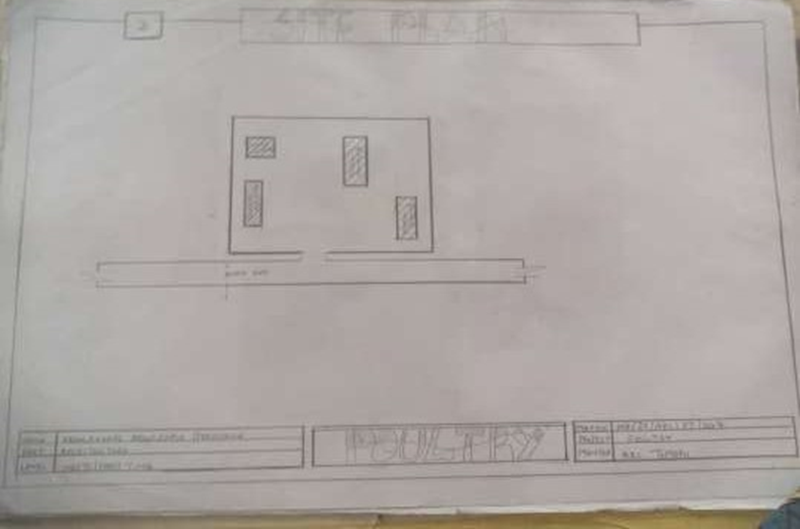
FIG 3.5: SHOWING THE SITE PLAN OF CASE STUDY THREE
3.6 ONLINE CASE STUDY
ONLINE CASE STUDY ONE
PROJECT NAME: ZHENG HOUSE
LOCATION: MOGANSHAN CHINA
ARCHITECT: FAR WORKSHOP
YEAR: 2024
AREA: 500m2

ONLINE CASE STUDY TWO
PROJECT NAME:
LOCATION: KECAMATAN CILANDAK, INDONESIA
ARCHITECT: RAD+ar (RESEARCH ARTISTIC DESIGN+ARCHITECTURE)
LEAD ARCHITECT: ANTONIUS RICHARD RUSLI, DANIEL SUSANTO
YEAR: 2024
AREA: 900m2

DEDUCTION FROM CASE STUDIES
During my visit to the poultry farm. I was opportunities to see what was obtain in the poultry farm, I made a proper studies of their related function and analysis were made to their present situation with the aim of incorporation with their merit in my own final proposal.
The following were deduce from my case study
* Critical Role of Ventilation and Orientation.
* Need for Sustainable Building Materials.
* Drainage is a Major Design Consideration.
* Importance of Proper Site Layout.
* Waste Management Requires Architectural Attention

