CHAPTER THREE
MATERIALS AND METHODS
3.1 Materials
The following materials were used for the construction of the hybrid dryer:
- Cocoa (Theobroma cacao)
Freshly fermented cocoa (Theobroma cacao) seeds serve as the raw material to be dried in the dryer. Approximately 20kg of wet cocoa beans were sourced locally for testing at Ondo State, Nigeria. The cocoa seeds initially had a moisture content of about 55% and required drying to a safe storage moisture level of 6–8%.
- Drying Chamber
- The drying chamber serves as the primary enclosure where the cocoa (Theobroma cacao)
seeds are dried. This chamber is designed to maintain optimal temperature and humidity conditions for the drying process. The internal design ensures even distribution of heat throughout the space, thereby enhancing the efficiency of the drying process. The chamber is constructed to accommodate different volumes of cocoa seed.
- Stainless Trays (2 Layers)
Stainless trays, arranged in two layers, are used to hold the cocoa seeds during the drying process. Stainless tray was chosen for its durability, resistance to corrosion, and ease of cleaning. The two-layer tray design allows for multiple batches of cocoa seeds to be dried simultaneously, thereby increasing the overall capacity of the dryer.
- Blower
The blower is employed to circulate air within the drying chamber. Proper air circulation ensures that heat is evenly distributed around the cocoa seeds, preventing uneven drying and promoting efficient moisture removal. The blower also assists in regulating temperature and humidity within the chamber, contributing to the control of drying conditions.
- Chimney
The chimney is used to expel hot air and moisture from the drying chamber. This is essential for maintaining optimal drying conditions and preventing excess humidity from compromising the drying process. The chimney ensures that the drying chamber remains well-ventilated, facilitating the expulsion of moisture and heat.
- Support Stand (Frame)
The support stand, or frame, provides the structural integrity of the entire drying system. The frame holds the solar collector, drying chamber, blower, and other components in place, ensuring the system remains stable during operation. It is designed to withstand the mechanical stresses of daily use and provide a robust foundation for the dryer.
- Thermohygrometer Sensor for Automation
The thermohygrometer sensor is an integral component of the automated system, used to monitor the temperature and humidity levels within the drying chamber. The data collected by the sensor allows for real-time adjustments to the drying conditions, ensuring that the cocoa seeds are dried under optimal temperature and humidity. This automation helps maintain consistent and controlled drying conditions, improving the overall efficiency of the drying process.
- Variable Speed Control
The variable speed control system is used to adjust the speed of the blower. By regulating the airflow within the drying chamber, the speed control ensures that the drying conditions remain consistent. The ability to fine-tune the blower speed allows for adjustments based on the moisture levels of the cocoa seeds, optimizing the drying process for different batches.
- Mild steel sheets
For fabricating the drying chamber due to their good thermal conductivity and structural strength
- Solar Collector (Glass)
The solar collector, constructed using glass, is responsible for capturing solar energy to heat the drying chamber. The glass material allows maximum transmission of solar radiation, ensuring the collector absorbs sufficient heat from the sun. The energy captured by the solar collector is transferred to the drying chamber to facilitate the drying of cocoa seeds.
- Battery
used for storing solar energy harvested during the day, ensuring uninterrupted operation of the dryer during low sunlight or cloudy weather conditions. A battery capacity labelled 12V/18Ah/20HR was used. Meaning:
Voltage : 12 volts, Capacity(Ah) 18 Ampere hours
Rated over 20HR: it can deliver its rated capacity(18Ah) over 20 hours of discharge
- Angle irons
For constructing the supporting frame to provide strength and stability.
- Black matte paint
Applied to interior walls to improve solar heat absorption
- Fiber Glass
This was used to lag the sides of the drying chamber to prevent heat loss.
3.1.1 Tools and Equipment
1. Electric Arc Welding Machine: it was employed during the fabrication of the drying chamber, supporting frame and tray assembly. It was used to join metal components with high strength and durability ensuring structural integrity of the dryer.
- Grinder/Cutting Machine: It is a power tool with a rotating abrasive disc or blade which was used for cutting and smoothing metal.It is used to cut metal sheets, pipes, or rods to required sizes and for grinding welds to smooth finishes.
- Drilling Machine: It is a machine tool which was used for used to drill holes into materials (metal, wood, etc.). It is used to create holes for bolts, screws, or other fittings in your project components.
- Screwdriver Set: It is a set of hand tools with different tips (flat, Phillips, etc.) which was used for driving screws. It is used for tightening or loosening screws during assembly or adjustments of electrical and mechanical parts.
- Spanner Set: It is a set of tools which was used for for tightening or loosening nuts and bolts. It is essential for assembling and disassembling mechanical parts such as frames, joints, or supports.
- Multimeter (for testing connections): it is an electronic measuring instrument that combines several functions (voltage, current, resistance testing). It was used to check electrical circuits, test battery voltage, or ensure proper connections in the solar-powered system
- Pliers: It is a hand tool with gripping jaws, sometimes with cutting edges.it was used for holding objects firmly, bending wires, or cutting small materials.
- Measuring Tape: It is a flexible ruler used to measure distances or dimensions. It is used to take accurate measurements of components during fabrication or assembly.
- File (for finishing edges):It is a hand tool with a roughened surface used for smoothing or shaping metal.It is used to smoothen sharp edges after cutting or welding metal parts.
- Paintbrush/Spray Gun: it is a tool used to apply paint or protective coatings. It is used for finishing touches to protect metal surfaces from rust and improve aesthetics.
- Soldering Iron (for electronic parts): It is a hand tool that heats up to melt solder (a metal alloy) for joining electronic components. It is used in assembling or repairing the electronic parts of your project like sensors, circuits, or connections.

3.2 Design Considerations
The design and development of the hybrid dryer were guided by several critical factors to ensure effective drying, energy efficiency, sustainability, and adaptability to local conditions. These considerations are outlined below:
3.2.1 Drying Temperature Range
Cocoa beans require a careful drying process to preserve their flavor quality and prevent case hardening. The target temperature range for effective drying was set between 40°C and 60°C. Temperatures above 60°C can degrade flavor precursors and cause the beans to develop a smoky or burnt taste, while temperatures below 40°C prolong drying time and may encourage mold growth. The system was therefore designed to achieve and maintain this range using solar energy, with the help of a thermal storage mechanism for cloudy conditions.
3.2.2 Moisture Content Reduction
Freshly fermented cocoa beans typically have a moisture content of 50–60% (wet basis). For proper storage and to prevent microbial growth, this moisture content needs to be reduced to 6–8% (wet basis). The dryer was designed to achieve this reduction within 48 to 72 hours, depending on the intensity of solar radiation and ambient conditions, thereby improving efficiency compared to traditional sun drying which may take up to 7 days.
3.2.3 Energy Source and Sustainability
The decision to use solar energy was based on its renewable nature and abundant availability in cocoa-producing regions of Nigeria, which typically receive 4–7 kWh/m²/day of solar insolation. Photovoltaic (PV) panels were selected to power electrical components such as fans, temperature and humidity sensors, and the microcontroller-based automation system. Additionally, the system was designed with provision for battery storage to enable drying continuity during low sunlight or at night.
3.2.4 Airflow and Heat Distribution
Uniform airflow is critical for effective drying of cocoa beans to prevent uneven drying or spoilage. A forced convection system, consisting of a DC-powered fan, was incorporated to distribute heated air evenly within the drying chamber. Vents were strategically placed to allow the escape of moist air, preventing condensation which could otherwise compromise drying efficiency. The airflow system was designed to achieve an air velocity of 0.5–1.0 m/s, which is optimal for drying cocoa beans without dislodging them.
3.2.5 Material Selection
Material selection was driven by the need for thermal efficiency, durability, cost-effectiveness, and food safety. The drying chamber was constructed using mild steel sheets coated with black matte paint to enhance solar absorption. The insulation layer consisted of glass Fiber to minimize heat loss. The trays for holding cocoa beans were fabricated from stainless net mesh (food grade) to resist corrosion and allow free airflow around the beans.
The external frame was built with galvanized steel to ensure structural stability and resistance to environmental degradation.
3.2.6 Automation and Control System
An automation system was integrated to improve operational efficiency and precision. It consists of:
Temperature and humidity sensors for real-time monitoring.
A microcontroller programmed to regulate fan speed and control heating elements based on set parameters.
3.2.7 Size and Capacity
The dryer was designed for a small-scale capacity suitable for research and demonstration purposes. It has a drying chamber dimension of 0.855 m × 0.7 m × 0.32 m, accommodating approximately 5–10 kg of wet cocoa beans per batch. This size was chosen to allow easy fabrication and testing while making the system scalable for commercial applications in future designs.
3.2.8 Environmental and Economic Considerations
The design accounted for environmental friendliness by utilizing renewable energy and minimizing greenhouse gas emissions. Economically, the system was optimized to be affordable for smallholder cocoa farmers by selecting locally available materials and components wherever possible.
3.2.9 Safety Considerations
Safety features such as insulated wiring, a protective casing for the solar panel and battery, and heat-resistant materials were incorporated to prevent electrical hazards and thermal burns during operation.

3.3 Design Calculations
The design of the hybrid dryer requires determining key parameters to ensure optimal functionality.
The following calculations were carried out before fabrication:
3.3.1 Volume of the Drying Chamber
The total internal volume of the drying chamber is determined using the formula:
V_{chamber} = L x B x H
Where:
L = 0.855m (length of chamber)
B= 0.7m (width of chamber)
H= 0.32m (height of chamber)
Therfore: V_{chamber} = 0.855x0.7x0.32
V_{chamber} = 0.192m³
3.3.2 Volume of each tray
The drying chamber contains three trays arranged horizontally with some clearance between them for adequate airflow.
Each tray occupies a length and width similar to the chamber internal dimensions, while the depth of each tray is 0.05m for a shallow layer of cocoa beans to facililitate efficient drying.
The volume of one tray is calculated as:
V_{tray} = Ltray × Btray × Htray
L_{tray} = 0.855m
B_{tray} = 0.7 m,
H_{tray} = 0.05 m
V_{tray} = 0.855 × 0.7 × 0.05 = 0.0299 m³ = 0.03 m³
3.3.3 Volume of Cocoa Beans Per Tray
the volume occupied by cocoa beans on each tray depends on their bulk density and the quantity placed on each tray.
The bulk density of wet cocoa beans is approximately 600kg/m³
If each tray holds 3kg of wet cocoa beans, the volume occupied by the beans is:
V_{beans} = 3 / 600 = 0.005 m³
So, each tray’s cocoa beans occupy is approximately 0.005m³

3.4 Design Layout
The experimental design for this study was structured using a two factor factorial design to evaluate the effect of the drying parameters on the drying rate and drying efficiency of cocoa seeds. The factors and responses are presented as follows:
- Mass of Sample (g)
- Air flow rate (m³/s)
- Experimental Responses (Dependent Variables)
Two performance indicators were monitored during the drying process:
- Drying Rate (kg/h): measured as the rate at which moisture was removed from the cocoa seeds.
- Drying efficiency (%): calculated as the ratio of useful energy utilized for moisture removal to the total energy supplied.
- Experimental Runs
A total of 13 experimental runs were carried out as presented in Table 3.1. The runs were randomized to minimize the experimental bias and ensure the independence of observations. The experimental matrix includes various combinations of the two factors and their respective levels.

Table 3.1: Experimental Design Matrix (Box-behnken Design) with the Factors and Responses For The Cocoa Seed Drying Process
 |  | Factor 1 | Factor 2 | Response 1 | Response 2
Std | Run | A:Mass of Sample | B:Air Flow Rate | Drying Rate | Drying Efficiency
 |  | g |  | Kg/h | %
3 | 1 | 1000 | 0.6
9 | 2 | 2000 | 0.5
12 | 3 | 2000 | 0.5
7 | 4 | 2000 | 0.4
4 | 5 | 3000 | 0.6
2 | 6 | 3000 | 0.4
13 | 7 | 2000 | 0.5
1 | 8 | 1000 | 0.4
11 | 9 | 2000 | 0.5
5 | 10 | 1000 | 0.5
10 | 11 | 2000 | 0.5
6 | 12 | 3000 | 0.5
8 | 13 | 2000 | 0.6

3.5 Working Principle
The hybrid dryer operates on the principle of utilizing solar energy to generate and maintain sufficient heat within a drying chamber, while forced convection ensures uniform airflow around the cocoa seeds to achieve effective and consistent drying.
The system is designed to harness solar energy through photovoltaic (PV) panels, which supply electrical power to auxiliary components such as fans, sensors, and the control system. The heated air, generated and circulated within the chamber, facilitates the removal of moisture from the cocoa seeds until the desired final moisture content is achieved.
The detailed working process is as follows:
3.5.1 Solar Energy Harvesting
The photovoltaic (PV) panels capture solar radiation and convert it into electrical energy. This energy powers the entire system, including the fans for air circulation and the microcontroller-based automation system. Excess energy can be stored in a battery bank to ensure continuous operation during periods of low sunlight or at night.
3.5.2 Air Heating and Circulation
Ambient air enters the system through inlets and is heated by solar energy absorbed within the chamber walls. A DC-powered fan is activated by the control system to force heated air into the drying chamber.
This forced convection system ensures uniform distribution of heat throughout the chamber, preventing uneven drying of cocoa seeds and eliminating cold spots.
3.5.3 Moisture Removal
As the heated air comes into contact with the wet cocoa seeds spread on trays, it absorbs moisture from the seeds. The moisture-laden air is expelled through strategically placed vents, allowing fresh heated air to enter and continue the drying process. This cycle continues until the moisture content of the cocoa seeds is reduced from approximately 55% to the desired safe storage level of 6–8%.
3.5.4 Automation and Control
The system employs sensors to monitor key parameters such as temperature and humidity inside the drying chamber. These sensors relay data to a microcontroller, which automatically regulates fan speed and heating operation to maintain optimal drying conditions within the chamber.
3.5.5 Tray Arrangement and Drying Efficiency
The cocoa seeds are spread evenly in thin layers on two netted trays arranged vertically in the chamber. The forced airflow passes through the perforations in the trays, allowing heated air to reach all seeds uniformly. The shallow depth of cocoa beans per tray helps to prevent clumping and ensures rapid moisture removal.
3.6 Construction and Fabrication Procedures
The construction and fabrication of the hybrid dryer involved systematic steps to ensure the development of a functional and durable system. The process began with sourcing appropriate materials, followed by cutting, shaping, assembling, and integrating the control system. The procedures are outlined as follows:

3.6.1 Sourcing of Materials
All materials required for the fabrication of the dryer were carefully selected based on availability, durability, thermal efficiency, and food safety considerations. Key materials include mild steel sheets, stainless steel mesh, angle irons, fiber glass, photovoltaic (PV) panels, DC fan, sensors, microcontroller,battery and cocoa. These materials were procured from local suppliers to minimize cost and ensure easy replication.
3.6.2 Fabrication of Drying Chamber
The drying chamber was constructed using mild steel sheets due to their good thermal conductivity and ease of fabrication. The steps involved:
- Cutting mild steel sheets into panels corresponding to the chamber dimensions: 0.855 m (length) × 0.7 m (width) × 0.32 m (height).
- Welding the panels together using Electric Arc welding to form a rectangular box, leaving openings for air inlets and outlets.
- Coating the interior surfaces with black matte paint to enhance solar heat absorption.
- Adding an inner lining of fiber glass insulation between double walls to minimize heat loss.
- Fixing a transparent glass top cover in triangular form to allow solar radiation penetration.
3.6.3 Fabrication of Drying Trays
- Two drying trays were fabricated using food-grade netting mesh to prevent rusting and allow free airflow around the cocoa seeds.
- The trays were cut to dimensions slightly smaller than the internal chamber size to fit snugly while leaving space for airflow.
- The net mesh was stretched and welded onto a rectangular mild steel frame.
3.6.4 Construction of Supporting Frame
A sturdy supporting frame was constructed using angle irons to elevate the drying chamber and provide stability. The frame is 910mm in height. Angle irons were cut and welded into a rectangular frame with four vertical supports, cross-bracings were added for enhanced stability. The entire frame was coated with anti-rust paint for protection against environmental factors.
3.6.5 Installation of Solar Energy Components
The renewable energy system was installed as follows:
Mounting photovoltaic (PV) panels at an optimal tilt angle to maximize solar radiation capture. Connecting the PV panels to a charge controller, battery bank, and inverter. Wiring the system to supply power to the DC fan, sensors, microcontroller.
3.6.6 Assembly of Control System
The automation system was assembled and integrated into the dryer. This included:
- Installing temperature and humidity sensors inside the drying chamber to monitor environmental conditions.
- Connecting the sensors to the microcontroller, programmed to regulate the fan based on pre-set drying conditions.
3.6.7 Final Assembly and Testing
After all components were fabricated and assembled: The drying chamber, trays, and supporting frame were fully assembled.
Solar panels and control systems were connected to ensure seamless power supply.
The system was tested with an initial batch of cocoa seeds to verify functionality, airflow uniformity, temperature regulation, and drying performance.
Adjustments were made where necessary to optimize operation.
3.7 Pictorial Image of the Hybrid Dryer

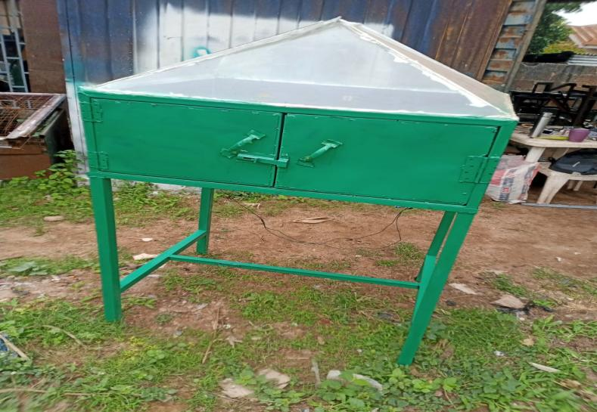
Plate 3.1: Hybrid Dryer

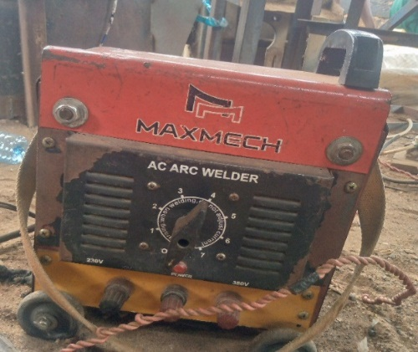
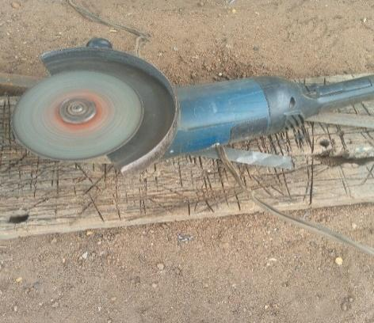
3.8 List Of Instrument

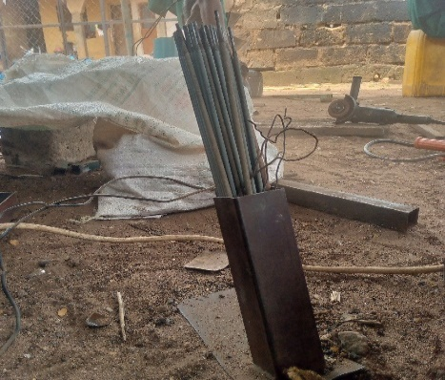
Plate 3.1:Electric Arc Welding plate 3.3: Grinder
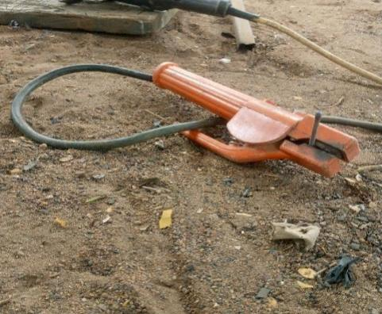

Plate 3.4: Thong plate 3.5 Electrodes

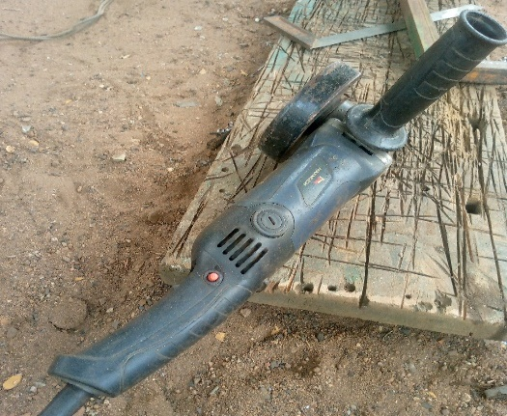
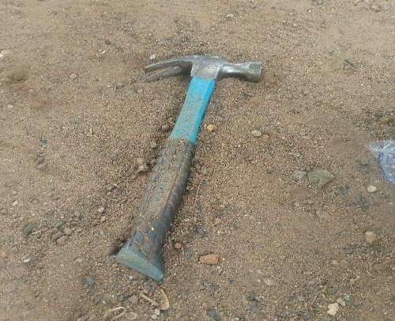

Plate 3.6: Small Grinder Plate 3.7 Hammer

