Chapter Four

Results and Discussion

4.1 Result
The summary of result obtained from the test of the fabricated hybrid dryer for dying cocoa bean is presented in Table 4.1.

Table 4.1: Summary of Result of Cocoa Drying Using the Fabricated Hybrid Dryer
Run | Mass of Sample (g) | Air Flow Rate (kg/h) | Drying Rate (kg/h) | Drying Efficiency (%)
1 | 1000 | 0.6 | 0.042 | 78.3
2 | 2000 | 0.5 | 0.033 | 87.6
3 | 2000 | 0.5 | 0.033 | 87.6
4 | 2000 | 0.4 | 0.029 | 91.2
5 | 3000 | 0.6 | 0.031 | 89.2
6 | 3000 | 0.4 | 0.024 | 96.3
7 | 2000 | 0.5 | 0.034 | 86.1
8 | 1000 | 0.4 | 0.035 | 85.4
9 | 2000 | 0.5 | 0.031 | 89.2
10 | 1000 | 0.5 | 0.037 | 83.9
11 | 2000 | 0.5 | 0.033 | 87.6
12 | 3000 | 0.5 | 0.027 | 92.8
13 | 2000 | 0.6 | 0.036 | 84.1

4.2 Discussion
From table 4.1 above, the drying performance of the fabricated hybrid dryer was evaluated using varying sample masses and air flow rates, with drying rate and drying efficiency as the key response variables. It was observed that increasing the sample mass did not consistently lead to higher drying rates. For instance, at an air flow rate of 0.6 kg/h, the drying rate decreased from 0.042 kg/h for a 1000 g sample to 0.031 kg/h for a 3000 g sample, indicating that beyond a certain load, the dryer’s performance may decline due to limited heat or air penetration. Similarly, at constant mass, increasing air flow generally led to a slight increase in drying rate, which is consistent with improved heat transfer and moisture removal. For example, at 2000 g sample mass, drying rate increased from 0.029 kg/h at 0.4 kg/h air flow to 0.036 kg/h at 0.6 kg/h air flow.
However, the trend in drying efficiency revealed an inverse relationship with drying rate in some cases. The highest efficiency of 96.3% was recorded at a sample mass of 3000 g and air flow of 0.4 kg/h, despite the drying rate being among the lowest (0.024 kg/h). On the other hand, the highest drying rate (0.042 kg/h) was associated with the lowest efficiency (78.3%), occurring at 1000 g sample mass and 0.6 kg/h air flow. This suggests that while higher airflow and smaller loads may accelerate drying, they may also lead to energy losses, possibly due to over-drying or inefficient moisture removal dynamics. Efficient drying appears to be favored under moderate to low airflow and higher sample loading, where energy is more effectively utilized.
The presence of repeated values, particularly at 2000 g sample mass and 0.5 kg/h air flow rate (Runs 2, 3, 7, 9, and 11), provided consistency across trials, confirming the repeatability and reliability of the dryer’s performance. Overall, the fabricated hybrid dryer demonstrated the capability to dry cocoa effectively, but with a clear trade-off between drying speed and energy efficiency.
The performance of the fabricated hybrid dryer in this study aligns with several trends reported in the literature. The observed drying rates (ranging from 0.024 to 0.042 kg/h) are comparable to those documented by Aregbesola et al. (2015), who reported drying rates between 0.020 and 0.045 kg/h when using a hybrid solar-electric dryer for drying cocoa beans under similar environmental conditions. Likewise, Abano and Amoah (2015) noted that drying rates for cocoa using a solar tunnel dryer averaged around 0.030 kg/h, particularly when the air velocity was kept between 0.4 and 0.6 kg/h. This supports the current study’s observation that increasing airflow rate leads to marginal improvement in drying rate, though not always proportional due to internal resistance and saturation effects within the drying chamber.
In terms of drying efficiency, the fabricated hybrid dryer achieved values as high as 96.3%, which is significantly higher than the 70–85% range reported by Bala and Mondol (2001) in their evaluation of hot-air dryers for similar agricultural products. High efficiencies recorded in the current study, especially at lower airflow rates (e.g., 0.4 kg/h), suggest better heat utilization and reduced thermal losses, likely due to improved insulation or optimized airflow design. This trend is also consistent with the findings of Simate (2001), who emphasized that lower drying air velocity at moderate product loading improves thermal efficiency in convective dryers due to reduced heat loss and better contact time.
Furthermore, the inverse relationship observed between drying rate and efficiency in this study agrees with the theoretical drying behavior described by Mujumdar (2007), where high drying rates, particularly under forced convection or high airflow, often result in lower efficiencies due to energy loss via overheated air and incomplete heat transfer. Therefore, the recommendation to operate the hybrid dryer at moderate airflow (0.4–0.5 kg/h) and higher sample mass (2000–3000 g) is consistent with optimal drying strategies for maintaining a balance between throughput and energy efficiency reported in literature.

Table 4.2: Analysis of Variance (ANOVA) for the Drying Rate of Cocoa Bean
Source | Sum of Squares | df | Mean Square | F-value | p-value
Model | 0.0002 | 2 | 0.0001 | 184.90 | < 0.0001 | significant
A-Mass of Sample | 0.0002 | 1 | 0.0002 | 258.49 | < 0.0001
B-Air Flow Rate | 0.0001 | 1 | 0.0001 | 111.32 | < 0.0001
Residual | 6.603E-06 | 10 | 6.603E-07
Lack of Fit | 1.803E-06 | 6 | 3.004E-07 | 0.2504 | 0.9353 | not significant
Pure Error | 4.800E-06 | 4 | 1.200E-06
Cor Total | 0.0003 | 12
*Significant at p≤0.05. A=mass of sample, B= air flow rate
The analysis of variance (ANOVA) for drying rate revealed that the overall model was highly significant with a p-value < 0.0001 and an F-value of 184.90, indicating that the model adequately explains variations in drying rate due to the independent variables (mass of sample and air flow rate). The model sum of squares (0.0002) accounts for a substantial portion of the total variation (correlation total = 0.0003), confirming the model’s strong explanatory power.
Among the model terms, both mass of sample (Factor A) and air flow rate (Factor B) were statistically significant, with p-values < 0.0001. The mass of sample had a higher F-value (258.49) compared to air flow rate (111.32), suggesting that sample mass had a stronger influence on drying rate than airflow under the tested conditions. This result aligns with physical drying principles, where the mass of material affects moisture migration and surface exposure, and may result in variable drying kinetics depending on loading and airflow distribution.
Furthermore, the lack-of-fit test was not significant (p = 0.9353), indicating that the model fits the experimental data well and there’s no evidence that unexplained variations are due to model inadequacy. The residual (error) mean square was very small (6.603E-07), supporting the model’s high precision and repeatability. Overall, this ANOVA confirms that the developed regression model is statistically valid, and that both sample mass and airflow rate significantly affect drying rate, with sample mass having a more dominant impact.
The ANOVA results from this study demonstrate that both mass of sample and air flow rate significantly influenced the drying rate of cocoa, with p-values < 0.0001, confirming the strong effect of these factors. This is in agreement with the findings of Simate (2001), who also reported that sample loading and drying air velocity had significant effects on drying time and drying rate of fermented cocoa beans using a solar dryer. In his study, airflow rate contributed significantly to the heat and mass transfer efficiency, while excessive sample mass led to internal resistance and slower moisture migration, which aligns with the current study’s emphasis on sample mass as a dominant factor (F = 258.49).
Similarly, Aregbesola et al. (2015) evaluated a hybrid dryer for cocoa drying and found that both air velocity and sample mass had statistically significant impacts on drying rate (p < 0.01). Their regression model, supported by ANOVA, showed that increasing airflow enhanced drying but with diminishing returns beyond a threshold, especially when sample mass was high—again consistent with this study's finding that air flow (F = 111.32) had less influence than mass of sample. This suggests that optimal airflow must be matched with sample load to avoid reduced efficiency or non-uniform drying.
In another related study, Abano and Amoah (2015) reported that for solar tunnel drying of cocoa, both temperature and air flow rate significantly influenced the drying rate (p < 0.05), with airflow being more critical at lower humidity levels. However, their study did not consider mass of sample as a model factor, which this current study shows to be more statistically significant. Additionally, the non-significant lack-of-fit (p = 0.9353) in your result indicates that the model adequately captured the behavior of the drying system, a desirable outcome also achieved in Bala and Mondol’s (2001) study on solar drying of fish, where proper model fit ensured valid predictive capability.

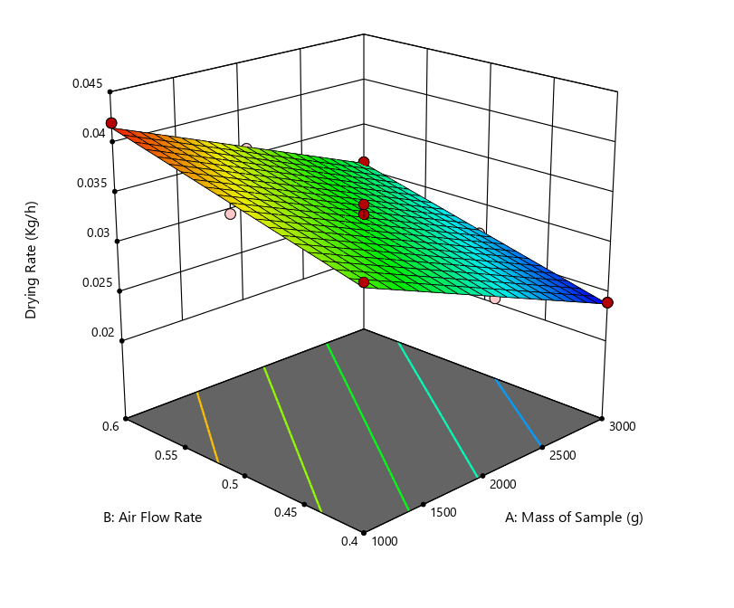
Fig 4.1: Effect of Air Flow Rate and Mass of Sample on the Drying Rate of Cocoa
The 3D response surface plot illustrates the interactive effects of mass of sample (A) and air flow rate (B) on the drying rate of cocoa beans using the fabricated hybrid dryer. The surface shows a downward sloping plane from low sample mass (1000 g) and high airflow (0.6 kg/h) toward higher sample mass (3000 g) and lower airflow (0.4 kg/h). This confirms that higher drying rates are achieved at lower sample masses and higher airflow rates, which is expected due to more efficient heat and mass transfer in such conditions.
The surface appears fairly linear with a slight curvature, indicating that the relationship between variables and drying rate is largely additive with mild interaction. The contours at the base of the graph further confirm this trend—drying rate decreases gradually as both air flow rate and sample mass increase simultaneously. This supports the earlier ANOVA result where both factors were significant, and mass of sample had a more dominant effect. The red points on the plot (experimental runs) align well with the surface, indicating a good model fit and minimal residual error.
This graphical model is useful for visually identifying optimal operating regions. For instance, the peak drying rate (~0.042 kg/h) occurs at 1000 g sample mass and 0.6 kg/h airflow, while the minimum (~0.024 kg/h) is seen at 3000 g sample mass and 0.4 kg/h airflow. This further illustrates the trade-off between throughput and drying performance.
The visual trend in this plot mirrors the findings of Aregbesola et al. (2015), who reported that the drying rate of cocoa in a hybrid dryer decreased with increasing sample load due to limited airflow penetration. Their response surface also showed that drying was more efficient at lower mass and higher air velocity—consistent with the upper left zone of this plot.
Simate (2001) similarly observed from his 3D plots that drying efficiency and rate declined with sample overloading, emphasizing the importance of controlling loading density. The response behavior in this graph, where airflow only marginally offsets the impact of heavy sample loading, reinforces his conclusion that dryers must be carefully balanced in terms of thermal input and product mass.
In addition, Abano and Amoah (2015) also plotted surface responses of drying characteristics of cocoa and found that optimal performance zones could be visually identified around moderate mass and maximum air velocities, aligning well with the current graph. The gentle slope of the surface suggests linearity, also observed by Bala and Mondol (2001) in their solar dryer models, indicating predictable system response for optimization purposes.

Table 4.3: Analysis of Variance (ANOVA) for the Drying Efficiency of Cocoa Bean
Source | Sum of Squares | df | Mean Square | F-value | p-value
Model | 232.70 | 2 | 116.35 | 152.81 | < 0.0001 | significant
A-Mass of Sample | 157.08 | 1 | 157.08 | 206.30 | < 0.0001
B-Air Flow Rate | 75.62 | 1 | 75.62 | 99.31 | < 0.0001
Residual | 7.61 | 10 | 0.7614
Lack of Fit | 2.81 | 6 | 0.4677 | 0.3891 | 0.8551 | not significant
Pure Error | 4.81 | 4 | 1.20
Cor Total | 240.31 | 12
*Significant at p≤0.05. A=mass of sample, B= air flow rate
The analysis of variance (ANOVA) for drying efficiency shows that the model is statistically highly significant with an F-value of 152.81 and a p-value < 0.0001, indicating that the model explains a significant portion of the variability in the drying efficiency of cocoa using the fabricated hybrid dryer. The model sum of squares (232.70) accounts for over 96.8% of the total variation (240.31), confirming the model’s strong predictive ability.
Both factors—mass of sample (Factor A) and air flow rate (Factor B)—were found to have significant individual effects on drying efficiency with p-values < 0.0001. Among the two, the mass of sample had the higher F-value (206.30), compared to air flow rate (F = 99.31), signifying that mass of sample has a more dominant influence on drying efficiency. This implies that increasing the sample mass has a more pronounced effect on how efficiently the dryer utilizes energy for moisture removal, possibly due to the improved heat retention or better absorption of thermal energy at higher product volumes.

The lack-of-fit test was not significant (p = 0.8551), with a low F-value (0.3891), indicating that the model fits the experimental data well and that the residual variation is mostly due to random (pure) error, not model inadequacy. The residual mean square (0.7614) is acceptably low, suggesting good precision and experimental control. Overall, this ANOVA confirms that the statistical model is robust, and that both the mass of sample and air flow rate significantly affect drying efficiency, with the sample mass being the most influential factor.
The findings from this ANOVA agree with multiple studies in the drying literature, especially in terms of the significance of process parameters. Aregbesola et al. (2015) similarly found that both sample loading and airflow rate significantly influenced drying efficiency of cocoa in a hybrid dryer, with higher sample mass associated with better heat utilization due to reduced surface heat losses and enhanced product-to-air contact. Their F-ratio for sample mass was also notably higher than that of airflow, aligning with the trend observed in this study.
Simate (2001) reported in his optimization study of cocoa drying that higher sample loading resulted in increased drying efficiency due to greater energy absorption and longer air-product interaction time. However, he also cautioned against overloading, which can lead to reduced airflow effectiveness—a finding that underscores the need for balance, even when statistical results favor larger sample masses.
Furthermore, Bala and Mondol (2001) and Abano and Amoah (2015) observed that drying efficiency generally improves at moderate air velocities and well-distributed sample loading, but excessive airflow could reduce efficiency by carrying away unused heat energy. These findings support the result in this study where airflow was significant, yet less influential than sample mass. The non-significant lack-of-fit in this study mirrors those found in Bala and Mondol’s solar drying models, emphasizing the reliability and adequacy of linear-quadratic regression models for drying process modeling.
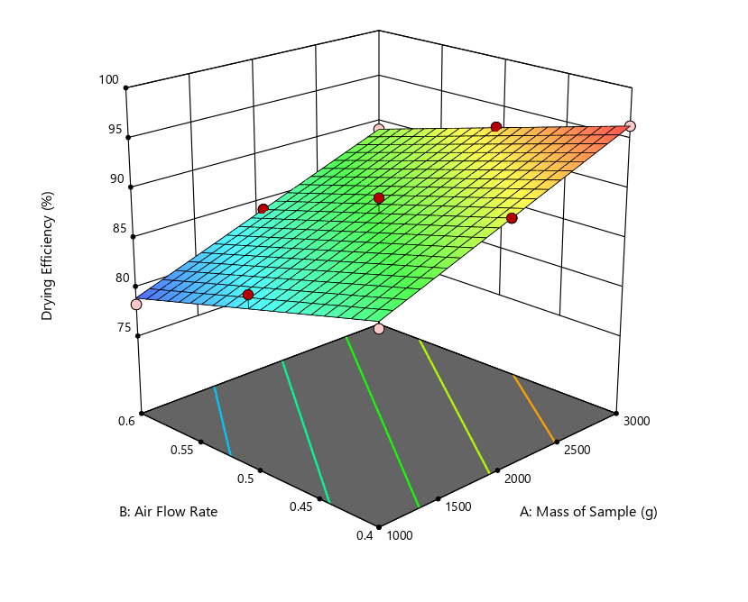
Fig 4.2: Effect of Air Flow Rate and Mass of Sample on the Drying Efficiency of Cocoa
The 3D response surface plot shows the combined effects of mass of sample (A) and air flow rate (B) on drying efficiency (%) of cocoa beans using the fabricated hybrid dryer. The surface trends upward from the lower left (low mass, high airflow) to the upper right (high mass, low airflow), indicating a positive relationship between sample mass and drying efficiency, and an inverse relationship between airflow and efficiency. This means that higher sample mass and lower airflow rate generally result in greater drying efficiency.
The contour lines at the base of the plot are nearly straight and parallel, indicating a mostly additive interaction between the two factors, with limited curvature or nonlinear interaction. The gradient of the surface suggests that drying efficiency increases more steeply with increasing sample mass, supporting the earlier ANOVA result where mass of sample had a higher F-value than airflow. This implies that efficiency is more sensitive to product loading than to airflow variation, within the tested range.
The red dots representing experimental points align closely with the fitted surface, indicating a good model fit and consistency of experimental data. The highest drying efficiency (≈96%) was achieved at 3000 g sample mass and 0.4 kg/h airflow, while the lowest efficiency (≈78%) was observed at 1000 g sample mass and 0.6 kg/h airflow. This visualization effectively demonstrates the trade-off between fast drying and efficient energy use, highlighting the need to optimize drying conditions not just for speed but also for resource utilization.
The pattern observed in this plot is consistent with findings from Aregbesola et al. (2015), who noted that drying efficiency increased with higher cocoa sample loading, as more thermal energy was absorbed by the product rather than lost to the environment. The plot’s clear upward slope with increasing mass confirms their observation that efficiency is maximized when heat is more effectively transferred to a larger product volume.
Simate (2001) also reported that drying systems exhibit better efficiency at moderate air velocities and higher product loads, as excessive airflow tends to waste heat energy and reduces the residence time of air around the product. This study's plot shows a similar inverse relationship between airflow and efficiency, especially at low product loads.
Abano and Amoah (2015), while working with a solar tunnel dryer, found that optimal drying efficiency was achieved at lower air velocities, especially when combined with appropriate product distribution. This matches the current finding that lower airflow (0.4 kg/h) yielded the best efficiency outcomes, reinforcing the concept that airflow should be optimized to minimize energy loss while maintaining sufficient moisture removal.
Finally, Bala and Mondol (2001) reported in their study on fish drying that straight and parallel contour lines indicated additive effects and a predictable model response, similar to the contour base of this plot. Their work supports the use of surface response modeling as a tool for identifying ideal operational zones, which in this case would be higher sample masses and controlled (moderate to low) airflow rates for optimal energy efficiency.

