CHAPTER FOUR
4.0 Results and Discussion
4.1 Results of Natural Moisture Content
The results of natural moisture content test are presented in table 2. the moisture content value range between 4.2% and 5.3%, indicating that the soil are relatively dry. According to Ola (1993), typical moisture content for lateritic soils range between 5% and 20% depending on the season and drainage condition. Therefore the sample fall within the lower end of the standard range implying well drained and stable conditions.

Table2: Natural Moisture Content Test of Collected Samples
Sample A | Sample B | Sample C
5.2% | 4.3% | 4.1%

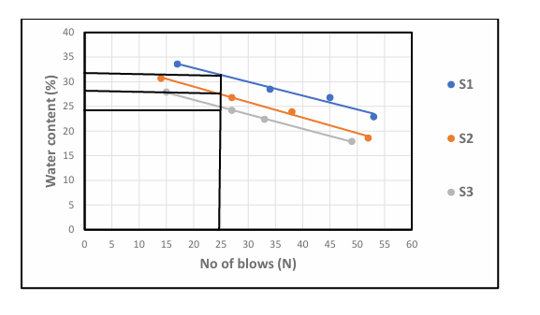
Fig.1: graph showing water content

4.2 results of bulk Density Test
The result of Bulk Density Test are presented in Table3. the bulk density values range from 1.63 to 1.76g/cm³ Murthy (2002) stated that bulk densities for compacted lateritic soils usually range from 1.6 to 2.0g/cm³. hence, the values obtained are within the acceptable range, with sample C showing the highest density , indicating better compaction and higher strength.
Table 3: Bulk Density of Collected Samples.
Sample A | Sample B | Sample C
1.63 | 1.73 | 1.76

4.3 Results of Dry Density Test
Two results of Dry Density value (1.58 - 1.69g/cm³) are also within the expected range for Engineering fill materials. According to Das (2010) dry densities for lateritic soils typically range from 1.5 to 2.0g/cm3, indicating that the test ad soils can offer adequate bearing capacity when properly compacted.
Table 4: Dry Density Test of collected samples
Sample A | Sample B | Sample C
1.58g/cm³ | 1.67g/cm³ | 1.69g/cm³

4.4 Result of Specific Gravity Tests
The specific gravity result are presented in table 5 specific gravity value ranged from 2.68 to 2.83 according to Das (2010), the typical specific gravity of lateritic soil falls between 2.60 and 2.85 which confirm that the soil predominantly mineral based with minimum organic contamination.
Table 5: Specific gravity test of collected samples
Sample A | Sample B | Sample C
2.68g/cm³ | 2.71g/cm³ | 2.83g/cm³

4.5 Results of Atterberg Limit Tests
Liquid Limit (LL): ranges from 22.3 % to 31.6% According to Das (2010), soil with liquid limit value less than 35% are classified as low plasticity soils. All the three samples fall within this categories, indicating low compresibility and moderate workability.

Plastic Limit (PL): value range from 14.6% to 18.2%, which is also consistent with the range expected for lateritic soil.

Plasticity Index (PI): value, calculated as the difference between LL am PL range from 6.9% to 13.4% Ola (1983) noted that lateritic soil generally have pl value ranging from 5% to 20% depending on the degree of weathering. Hence the PL values obtained fall within the expected range, indicating moderate plasticity with Sample A being more plastic than Sample B and Sample C.
Linear Shrinkage (LS): values range from 3.7% to 6.2% According to Adeyemi (1995), values below 10% suggest that the soils has low shrinks well potential, which is desirable for most construction purpose. Sample C has the lowest shrinkage value, suggesting it will be the most suitable under moisture variation

Table 6: Atterberg Limit Tests of collected samples
Sample | Liquid Limit % | Plastic Limit % | Plastic index | Linear Shrinkage %
Sample A | 31.6 % | 18.2% | 13.4% | 6.2%
Sample B | 22.3% | 15.4% | 6.9% | 4.8%
Sample C | 24.8% | 14.6% | 10.2% | 3.7%

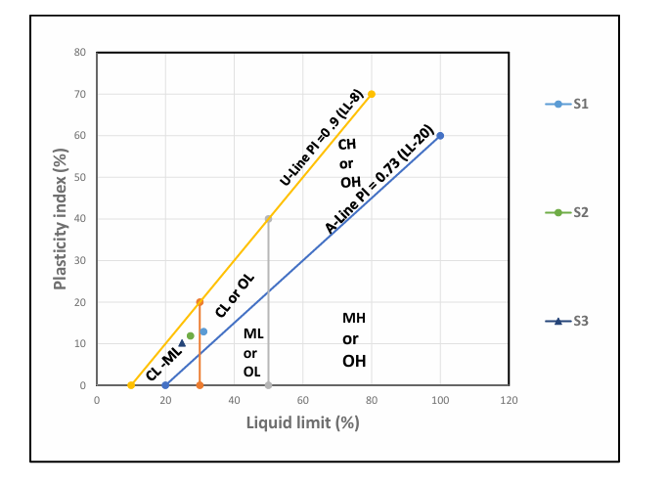
Fig 2: Graph Showing Plasticity Chart

4.6 Result of Grain Size Analysis
P1 has higher clay content (21%) hence classified has clayey sand
P2 and P3 have more silt and less clay, Thus, silty sand all sample have sand and dominant particle size making them sand based soils.
fine (<0.075mm) is highest in P1, which support it’s clayey nature.

Table 7: Summary of result of Grain Size Analysis of soil
Sample Location | Gravel (%) | Sand (%) | Silt (%) | Clay (%) | Fine (%) | Soil classification
P1 | 10 | 60 | 9 | 21 | 30 | Clayey sand
P2 | 12 | 62 | 15 | 11 | 20 | Silty sand
P3 | 13 | 63 | 17 | 7 | 24 | Silty sand

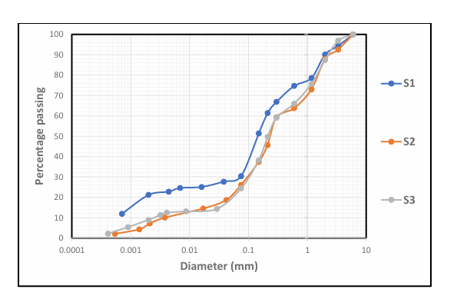
Fig. 3: Grain Size Analysis Graph
4.7 Result of Compaction Test
Table 8: Compaction Parameters of Maximum Dry Density (MDD) and Optimum Moisture Content (OMC)
Sample | MDD | OMC
A | 1.81 | 8
B | 1.89 | 7.5
C | 1.95 | 6

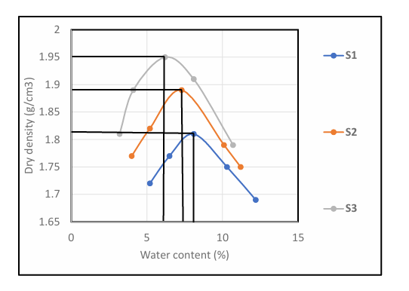
Fig. 4: Graph Showing Compaction Parameters
Table 9: Compaction and Ratings of Unified Soil Classification for Construction (ASTM 1557-91)
Visual Description | Maximum Dry Density (MDD)(g/cm³) | Optimum Moisture Content (OMC)(g/cm³) | Aticipated embankment performance | Value as Subgrade material | Value as Base Course
Granular material | 2.00 - 2.27 | 7 – 15 | Good to Excellent | Excellent | Good
Granular material with soil | 1.76 - 2.16 | 9 – 18 | Fair to Excellent | Good | Fair to Poor
Fine sand and sand | 1.76 - 1.84 | 9 – 15 | Fair to Good | Good to Fair | Poor
Sandy silts and silts | 1.36 -1.60 | 10 – 20 | Poor to Good | Fair to Poor | Not suitable
Elastic silts and clay | 1.36 - 1.60 | 20 -35 | Unsatisfactory | Poor | Not suitable
Silty clay | 1.52 - 1.92 | 10 – 30 | Poor to Good | Fair to Poor | Not suitable

Table 9: present the compaction parameters of collected samples. The (MDD) Maximum Dry Density for sample A is 1.81 for sample B 1.89 while sample C is 1.95. for Optimum Moisture Content (OMC), sample A is 8, Sample B is 7.5 sample C is 6. The three sample being sandy in nature can be range as range fair to good for embankment performance it is fair to poor for subgrade material are not suitable for base course.

CHAPTER FIVE
5.0 Conclusion and Recommendation
5.1 Conclusion

The geotechnical investigation of laterite within Kwara State Polytechnic campus revealed that the sampled soils possess engineering properties suitable for various civil engineering applications, especially as subgrade and fill materials. Laboratory tests such as particle size analysis, Atterberg limits, compaction indicated that the laterite falls within the acceptable range for road construction and foundation works under moderate loading conditions.
The results also show that the laterite exhibits good shear strength, moderate plasticity, and favorable compaction characteristics, making it a dependable material for use in local construction project.

5.2 Recommendation
In the view of the occurance rampant failure in public civil structures, the suitability of fill materials (which is mostly laterite in Nigeria) must be ascertained before use.
Also the improvement of samples other than Sample C should be considered. This should be done by the addition of locally available materials e.g limestone.

