CHAPTER TWO
2.2 LITERATURE REVIEW AND CASE STUDY
Office building complex have evolved significantly reflecting changes in technology, work culture, and environmental cancerous.
Early studies focused on functional aspect such as space planning and efficiency mid-century research explored architectural styles and the impact design on worker productivity. More recently, literature has emphasized the sustainability office building practice and focusing on the well-being of occupants.
Key theme includes:
- Sustainability: need certificate, energy efficiency and use of renewable resources
- Technology integration: smart building system data connectivity, and flexible work spaces.
- Work place design: open plans enclosed office the importance of natural light, and the provision of amenities
2.2 IMPORTANCE OF THE PROJECT
- Social and economic important: they serve as for business, generating job and contribution to local economy.
- Collaboration and networking : they create space for people to connect, share I deal and build relationships.
- Urban development: they contribute to the growth and modernization of cities.
- Innovation they encourage creativity and innovation by building defense talent together
- Sustainability: many complete now incorporate green building practice, promoting environment responsibility
- Infrastructure: there offer essential amenities like, parking space internet, and security
2.3 SELECTED CASE STUDY

The objectives of a case study is to appraised of the existing project with a view to identify positive aspect of such a project. The positive aspect shall be incorporated in the view proposal while attempt mode to solve the problems of negative aspects.
2.4 CONCLUSION
significant in a project of the magnitude and the essence is to study existing building both internal and external of the structure, in the process of student get acquainted with fact and nouns, functionality and space and merit and demerits of an existing structure.
At the end of exercise, the study will allow student to take necessary precaution against the failure of the proposal project
2.3.1 CASE STUDY ONE
Name: Abdulsalau Ayiyemojuba and associate office building
Location: Isale onireke Road, Ibadan, Oyo state.
MERITS
- Prime location for business networking
- Modern amenities including high-speed internet and power backup
- Aesthetically appealing design
DEMERITS
- Limited office space due high demand
- Higher mental rates compared to other location
- Lack of enough parking space
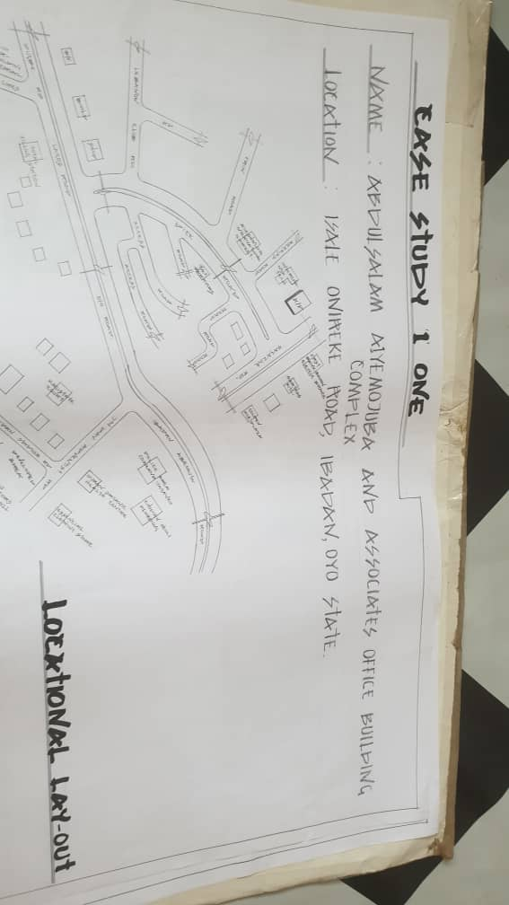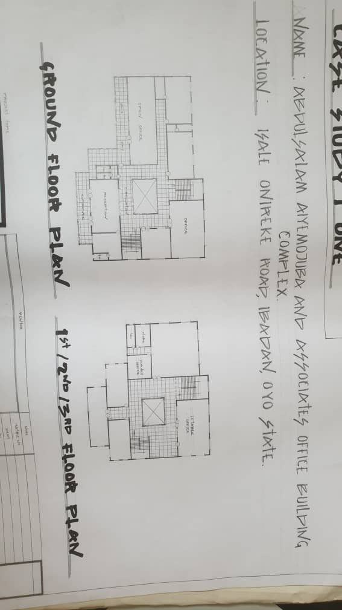

2.3.2 CASE STUDY TWO
Name: Opic Building
Location: At Ibara Abeokuta, Ogun State
MERIT
- Energy efficient and environmentally friendly
- Excellent parking and security facilities
- It easily to accessible
DEMERIT
- Expensive recent
- Know enough parking space
- Traffic congestion around the area
- Over overworking and limit space

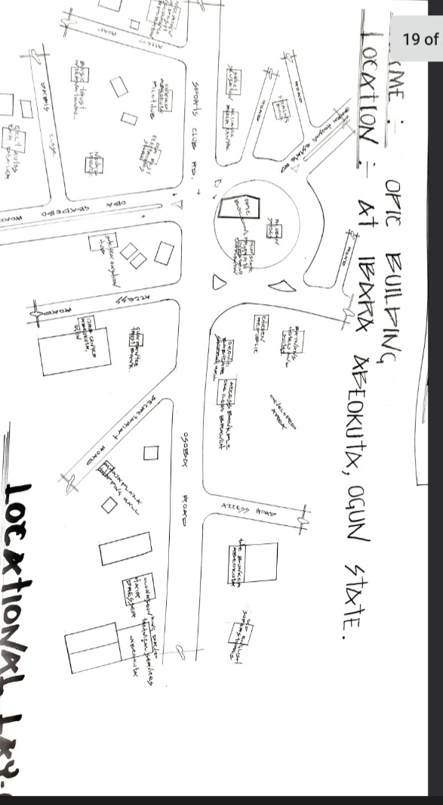
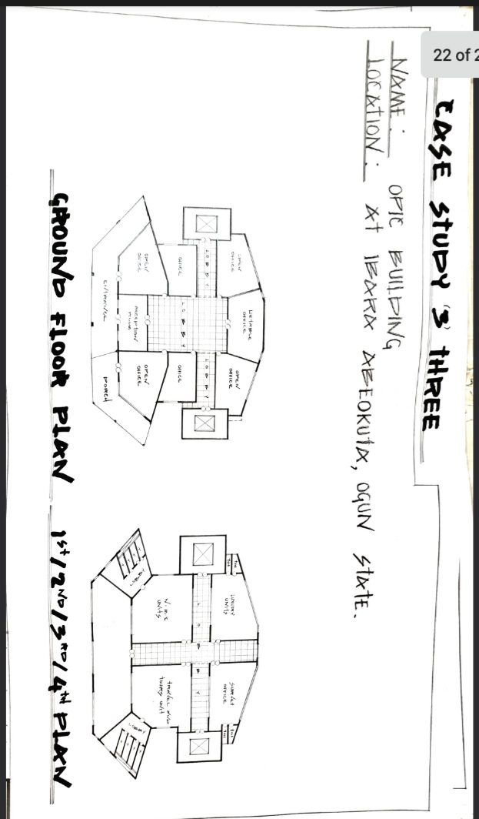
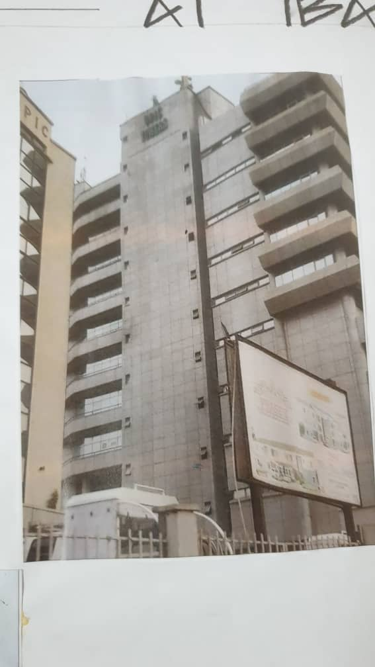
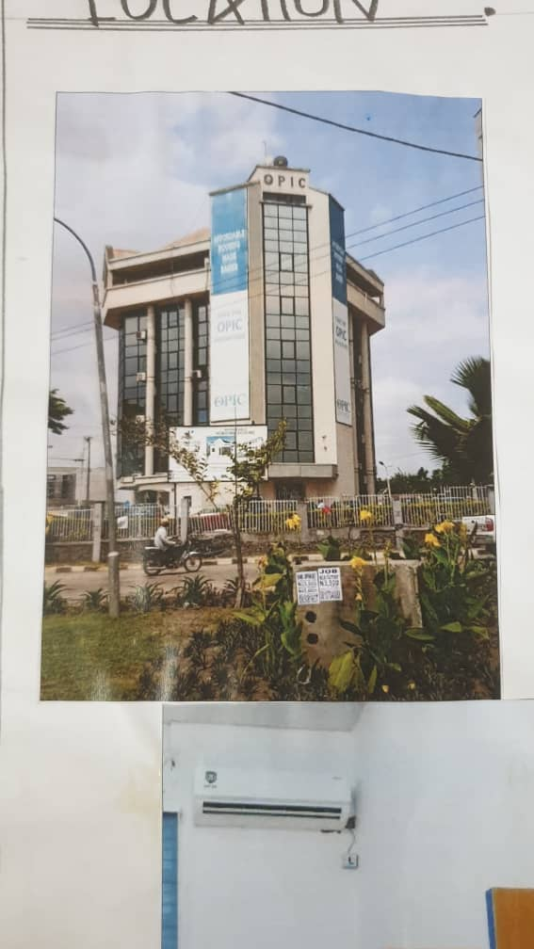
2.3.3 CASE STUDY THREE
Name: Alafia Complex
Location: Along Opomalu Isale, Ilorin, kwara State

MERIT
- It easily accessible
- It is well ventilated and lightning
DEMERIT
- No proper planning
- Traffic congestion
- No room for future expansion
- No future expansion in case of any another development
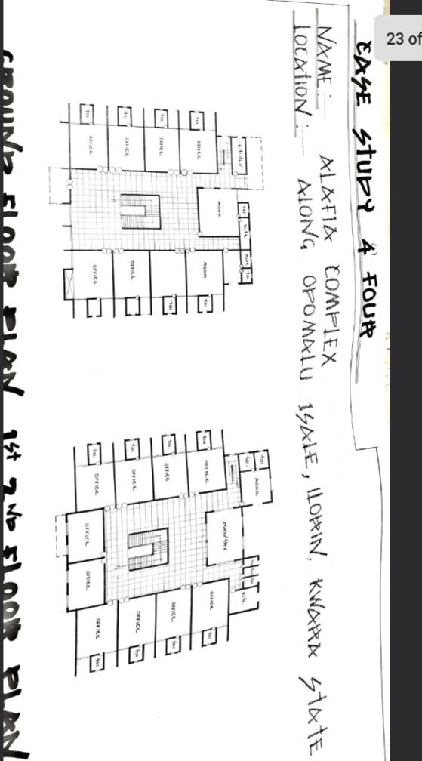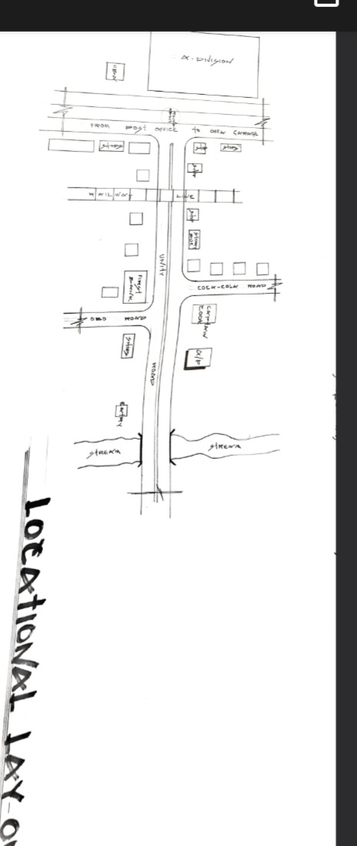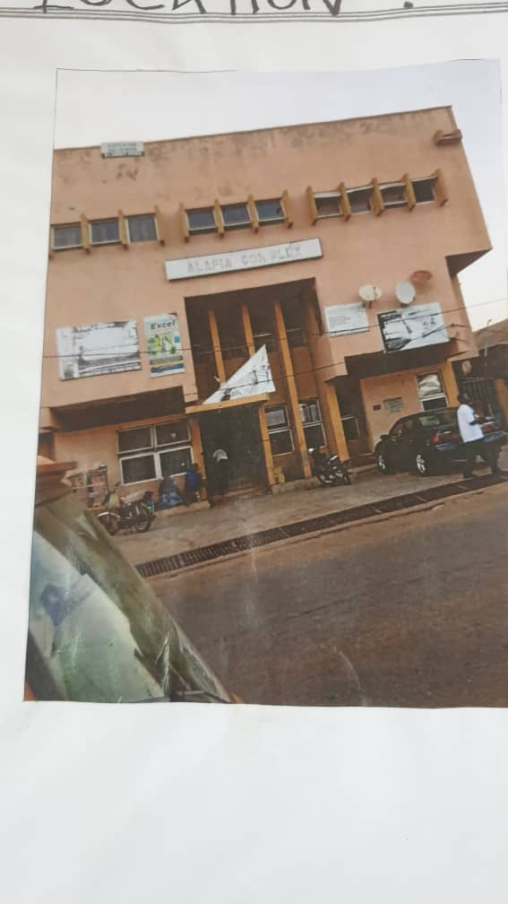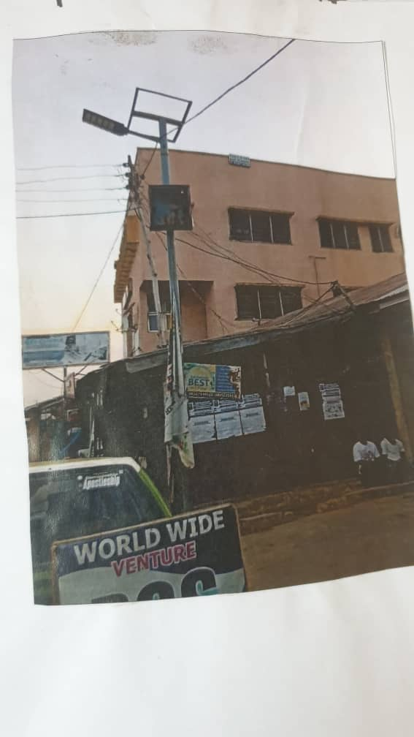
2.3.4 OLINE CASE STUDY ONE
NAME: MANCHESTER INTERNATIONAL OFFICE CENTRE
LOCATION: 11 STYAL RD WYTHENSHAWE MANCHESTER M 22 5WB

