A
TECHNICAL REPORT
ON
STUDENT INDUSTRIAL WORK EXPERIENCE SCHEME (SIWES)
TRAINING PROGRAMME
(AUGUST TO NOVEMBER 2024)
HELD AT
UNIVERSITY OF ILORIN DIRECTORATE OF CORPORATE AFFAIRS
COMPILED BY
KOLAWOLE ABASS OLAYINKA
ND/23/MAC/PT/1012
IN
PARTIAL FULFILMENT OF THE REQUIREMENT FOR THE AWARD OF NATIONAL DIPLOMA (ND) IN MASS COMMUNICATION
SUBMITTED TO:
DEPARTMENT OF MASS COMMUNICATION
INSTITUTE OF INFORMATION AND COMMUNICATION TECHNOLOGY
KWARA STATE POLYTECHNIC, ILORIN
2024/2025

CERTIFICATION
I, Kolawole Abass Olayinka, with Matric Number ND/23/MAC/PT/1012, of the Mass Communication Department, hereby declare that I have successfully completed 14 weeks of Students’ Industrial Work Experience Scheme (SIWES) at the University of Ilorin Directorate of Corporate Affairs, Ilorin, Kwara State.

DEDICATION
I, Kolawole Abass Olayinka, with Matric Number ND/23/MC/PT/1012, of the Mass Communication Department, hereby declare that I have successfully completed 14 weeks of Students’ Industrial Work Experience Scheme (SIWES) at University of Ilorin (Directorate of Corporate Affairs) Ilorin, Kwara State.

ACKNOWLEDGMENT
I express profound gratitude to Almighty Allah for granting me the opportunity to complete my SIWES training successfully. I appreciate My Parents(Mr & Mrs Olayiwola) , My Family( Eng. Raji Adegoke ,Prof. Halimat Adegoke , Eng. Rajah Dynamics) for their unwavering support and encouragement throughout my industrial training. May Almighty Allah continue to shower his blessings and reward you.
I also extend my appreciation to My Siblings and Seniors (Bankole Yusuf Williams, Kareem Ibrahim Opeyemi, Isiaq Rasaq Temitope, Muhammed Hassan, Obanla Ridwan Obadara, Odejide Promise, Rashidat Ewatomi, Mosunmola Ajibade Esther) for their guidance and support.
Special thanks to my friend and colleague Agbroko Ufuoma Samuel who had been like a brother to me during my stay at my traning center . I also appreciate and my colleagues at my unit of Directorate of Corporate Affairs. I am grateful to Mr. Kunle Akogun (Head of the Directorate of Corporate) , Mr. Mustafa Abubakar (My direct Supervisor) and the entire staff of Corporate Affairs, particularly the UNILORIN Bulletin Unit and the studio unit for their valuable guidance and warm reception.

PREFACE
The Student Industrial Work Experience Scheme (SIWES) was introduced into the nation's tertiary education curricular because of the belief that there is value in putting into practice what has been learned beforehand. There was also the belief that SIWES would help students to acquire on understanding of the society and meet to interaction with different people outside their institution.
It is in this light that the Student Industrial Work Experience Scheme for Polytechnics in Nigeria as stated in the National Board for Technical Education Syllabus aims to produce citizenry conscious of its role in a wider world, proud of its antecedent and prepared for effective leadership role in diversified or society, thereby, ensuring a positive contribution on interaction, greatness and trying or becoming effective in their field of studies or field of specialization.
TABLE OF CONTENT
Title page
Certification
Dedication
Acknowledgment
Preface
Table of content
Abstract
CHAPTER ONE
1.0 Introduction to SIWES
1.1 Concept of SIWES
1.2 History of SIWES
1.3 Aims and Objectives of SIWES
CHAPTER TWO
2.0 Description of the Organization
2.1 Historical Background of the Organization
2.2 Major Activities of the Organization
2.3 Goals and Objectives of the Organization
2.4 Department In The Organization
CHAPTER THREE
3.1 Technical Training and Experience Gained

CHAPTER FOUR
4.1 Executive Summary
CHAPTER FIVE
5.1 My Achievements
5.2 Problems encountered during the program
5.3 Appraisal and Conclusion
5.3 Recommendation
Abstract
This report gives the introduction of SIWES, aims of SIWES, Historical background of SIWES. It also provide the different departments in Radio Kwara and their functions, and it as well provides my SIWES experience at my place of attachment. The theory and practical I was able carried out during my Industrial Training. It also gives us the summary, conclusion and recommendation of the SIWES programme.
CHAPTER ONE
1.0 INTRODUCTION OF SIWES
The Students Industrial Work Experience Scheme (SIWES) for the 2022/2023 academic session kicked off in the month of August 2023 and was concluded (3) months in the month of November, 2023. The industrial attachment program is solely aimed at improving in working skills of students in tertiary institutions as well as effecting, learning, participation and observation into proactive in variable fields with respect to grasp very useful practical knowledge which not only makes them employable but also aids in the perfect understanding of theories and operation in their different profession. It is a corporative industrial internship program that involves industries, the Federal Government of Nigeria, Industrial Trainning Fund (ITF), and Nigeria Universities Commission (NUC). The program is of very high importance considering the lack of adequate practical equipment for learning in most Nigeria tertiary institutions and its self proven as it has been part and parcel of the countries system of education for over 28 years.
1.1 CONCEPT OF SIWES
The Student Industrial Work Experience Scheme (SIWES) of the Nigeria Polytechnic and colleges of technologies is an arrangement in which practical is integrated with theory.
The Students Industrial Work Experience Scheme (SIWES) is a unit under the Vice-Chancellor’s Office. It was established in 2016. The Students Industrial Work Experience Scheme (SIWES) is a skills training programme designed to expose and prepare students of universities and other tertiary institutions for the Industrial Work situation they are likely to meet after graduation.
The Students Industrial Work Experience Scheme (SIWES), is the accepted training programme, which is part of the approved Minimum Academic Standard in the various degree programmes for all Nigerian Universities. The scheme is aimed at bridging the existing gap between theory and practice of Sciences, Agriculture, Medical Sciences (including Nursing), Engineering and Technology, Management, Information and Communication Technology, and other professional educational programmes in the Nigerian tertiary institutions. It is aimed at exposing students to machines and equipment, professional work methods, and ways of safeguarding the work areas and workers in industries, offices, laboratories, hospitals, and other organizations.
It is a cooperative industrial internship program that involves institutions of higher learning, industries, the Federal Government of Nigeria, the Industrial Training Fund (ITF), and the Nigerian Universities Commission (NUC).
It is also established by the Industrial Training Fund (ITF) in 1974 to bridge the gap between theory and practical. The programme has a nice focus on the development of industrial students in the world of work. Also how theory and practical are social skills -and insight in the world of work to create awareness and prospect are the challenges the programme tries to tackle to cope with the development process of the student.
1.2 HISTORY OF SIWES
SIWES was founded in 1973 by ITF (Industrial Training Funds) to address the problem of tertiary institution graduates' lack of appropriate skills for employment in Nigerian industries. The Students' Industrial Work Experience Scheme (SIWES) was founded to be a skill training programme to help expose and prepare students of universities, Polytechnics and colleges of education for the industrial work situation to be met after graduation.
This system facilitates the transfer from the classroom to the workplace and aids in the application of knowledge. The program allows students to become acquainted with and exposed to the experience required in handling and operating equipment and machinery that are typically not available at their schools.
Prior to the establishment of this scheme, there was a rising concern and trend among industrialists that graduates from higher education institutions lacked appropriate practical experience for employment. Students who entered Nigerian universities to study science and technology were not previously trained in the practical aspects of their chosen fields. As a result of their lack of work experience, they had difficulty finding work.
As a result, employers believed that theoretical education in higher education was unresponsive to the needs of labor employers. Thousands of Nigerians faced this difficulty till 1973. The fund's main motivation for establishing and designing the scheme in 1973/74 was launched against this context.
The ITF (Industrial Training Fund) organization decided to aid all interested Nigerian students and created the SIWES program. The federal government officially approved and presented it in 1974. During its early years, the scheme was entirely supported by the ITF, but as the financial commitment became too much for the fund, it withdrew in 1978. The National Universities Commission (NUC) and the National Board for Technical Education (NBTE) were given control of the scheme by the federal government in 1979. The federal government handed over supervision and implementation of the scheme to ITF in November 1984. It was taken over by the Industrial Training Fund (ITF) in July 1985, with the federal government bearing entire responsibility for funding.
1.3 AIMS AND OBJECTIVE OF SIWES
The Industrial Training Fund’s Policy Document No. 1 of 1973 which established SIWES outlined the objectives of the scheme as:
- Provide an avenue for students in Institutions of higher learning to acquire industrial skills and experience in their respective courses of study.
- Prepare students for the Industrial Work situation they are likely to experience after graduation.
- Expose students to work methods and techniques of handling equipment and machinery that may not be available in their Institutions.
- Make the transition from school to the world of work easier; and enhance students’ networks for later job placements.
- Provide students with an opportunity to apply their knowledge to real work situations, thereby bridging the gap between theory and practice; and
- Enlist and strengthen Employers’ involvement in the entire educational process; thereby preparing the students for employment in Industry and Commerce.

CHAPTER TWO
2.0 DESCRIPTION OF THE ESTABLISHMENT OF ATTACHMENT
Directorate of Corporate Affairs office is one of the units under the office of the vice chancellor. The major function is to project the image of the university to the outside world. The organs of communicating to the outside world is through the UNILORIN FM and Bulletin . It is also the communicating unit of the university with the general public.
Towards this end, the Directorate serves as the clearing house for all strategic public engagement with the mass media; coordinates public communication campaigns and events, maintaining steady presence and positive projection of the university in mass media, monitors public communication process and provide fresh information to the public on activities of the whole university as well as give occasional clarification on issues as they relate to the university.
2.1 HISTORY OF THE DIRECTORATE OF CORPORATE AFFAIRS
Directorate of Corporate Affairs formerly known as Directorate of Information and Protocol, is one of the units under the office of the vice chancellor headed by Mr Kunle I. Akogun a consummate journalist of several years of media experience , the directorate also supervise the Unilorin 89.3 FM Radio, a well rated multiple award winning 24 hours digital broadcast station established in August 2009, the radio was officially commissioned on October 2011 and it is equipped with state-of-the-art studio facilities and crops of professionals who are dedicated to moving the station forward that makes it a wonderful campus radio station.
The directorate currently serves as sectarian to come key committees of the university which handles all important ceremonies of the university including the convocation ceremony, among others; the library and publications committee which regulates the publications of academic staff and handles the publication of center point journal editorial board, the governing board of the university primary school, and the step B project amongst others.

2.2 MAJOR ACTIVITIES OF THE ORGANIZATION
The major activities of the organization is based on informing people on what is going on in the society also to educate them on how to behave morally in the society and to entertain people to their maximum satisfaction and to back all the functions the mass communication department is the back bone of the organization cannot function effectively.
Some of these activities also include the following:
- To maintain denotes for the distribution of books and literature periodicals.
- No other can come for the business of spreading and education in the state better than the state itself.
- To help enlighten the public and to act as avenue of information between the public and the government.
- To assist in creating an atmosphere of peace and brotherhood affection among the people of Kwara State and other State in Nigeria at large, to live in peace and develop their resources in most effective manner.
- To give publicity to the art and culture of the people.
  - GOALS AND OBJECTIVES OF THE ORGANIZATION /ESTABLISHMENT
The following are the objectives of Directorate of Corporate Affairs :
- It serves as the clearing house for all strategic public communication issuing out of the university
- It also advices the vice chancellor on strategic engagement with mass media
- Coordinates public communication campaign and events
- Maintain steady presence and positive projection of the university in the mass media
- Monitor public communication process and provide fresh information to the public on the activities of the university.

2.4 VARIOUS DEPARTMENTS/UNITS OF CORPORATE AFFAIRS
The Directorate of Corporate Affairs University of Ilorin is made up of various departments and sections whose services makes up day to day activities of the organization . The following departments make up the Directorate of Corporate Affairs
- DEPARTMENT: The bulletin department is the print arm of the directorate which is in charge of the weekly bulletin publication. The bulletin consists of carefully selected and edited stories including events and programmes happening in the University of Ilorin. Also, Newspapers, the institution’s weekly expenditure, vacancies in the institution as well as promotions under the bulletin production are photography and graphic design section. The photography section makes available photos from different events especially from the institution while the graphics design section plans and design pages of the weekly bulletin. They arrange columns and stories appropriately with the use of applications such as Microsoft office word, Corel draw and photshop . Also included in the bulletin is ‘Unilorin in the news” section where news concerning University of Ilorin is sourced for in Nigeria daily newspaper .
- RADIO UNIT: The radio unit ( UNILORIN FM) is the broadcast arm of the organization transmitting on the frequency of 89.3. Information from the section teaches the university community and its external publics. Its programmes include Education, Health information and Entertainment
Under the Radio unit are the following sections;
- NEWS RESEARCH AND CURRENT AFFAIRS: This section gathers information from
Events happening in the institution and its environment and brings it to the knowledge of listeners, news as it unfolds as well as news across the globe. The station keeps listeners up-to-date with timely and necessary information as well as report from different departments in the institution. They get news from daily newspapers, station programmes, internet, press releases etc
- PRODUCTION UNIT: This section is made up of personnel who are usually found in the studio, operating engines and other studio equipment thereby making the studio’s activities heard. They stay at alert, attentive and corporate with persons in the voice booth. Equipment such as; Audio console/mixer, Digital computer system, monitors (speakers). Headphones and headphone distributor , SD Recorder , Tuner, Micro phone and Microphone stands, Mp3 player etc are found in the production studio
- MARKETING UNIT: The marketing unit is responsible for marketing information about the station to its audience. They seek to get commercials and averts for the station. They also schedule time for such commercials in the day. The unit is otherwise called ‘SALES UNIT’
- TECHNICAL UNIT: The technical unit at the station ensures the proper functioning of equipment in the station, They make sure engines are in good conditions as well as other gadget in use. They also maintain and repair the facility equipment in the organization
- PROTOCOL UNIT: The protocol unit is attached to the vice chancellor’s office to report and keep the Directorate abreast of the information from the office of the vice chancellor

CHAPTER THREE
3.1 TECHNICAL TRAINING EXPERIENCE
The days I spent at the University of Ilorin Directorate of Corporate Affairs were immensely valuable and transformative. This experience allowed me to become more exposed to real-world work, as I was able to actively participate in various assignments and tasks given at the office. I attended numerous events, where I learned the fundamentals of reporting and news writing for bulletins. Throughout my stay, I built my confidence and developed crucial skills that will benefit me in my career.
Experience Overview
During my SIWES, I had the privilege of attending various events that required coverage by the Corporate Affairs team. These events taught me essential aspects of event reporting, allowing me to gather all the relevant details for a successful news report. One of the most enriching parts of my experience was learning how to conduct interviews and write news reports. I was guided by experts in the field, who taught me the importance of the 5Ws and H (Who, What, Where, When, Why, and How), the inverted pyramid structure, and the “KISS” principle (Keep It Short and Simple). These techniques, reinforced in the news writing room, were invaluable.
Additionally, I gained administrative experience in the office, which primarily involved dispatching letters and essential documents to various departments. I also assisted in transcribing audio files into written formats, facilitating easier integration of content into news stories.
Furthermore, I took part in the daily newspaper review, where I gathered relevant news about the University from various newspapers and online sources. These were frequently referenced in our weekly bulletin publications. For one month, I also had the opportunity to work at the radio station, Unilorin FM. This experience taught me a great deal about the studio environment, including using different instruments, operating the computer and console during live programs, and cueing music during broadcasts.

CHAPTER FOUR
4.1 EXECUTIVE SUMMARY
The students industrial work experience scheme (SIWES) is a training fund (ITF) in 1973 to bridge the gap between theory and practical oriented among students of engineering, technology, social science and medical science on Nigeria higher institution of learning.
It provides for the job practical experience for students as they are expose to work method and machinery that may not be Available in their institution.
At inception in 1974, the scheme started with 748 from 11 institution and 104 eligible course by 2008. 210 student participate in the course from 219 institution over the 112 eligible course. However the rapid growth and exposition of SIWES has occurred against the backdrop of successive economic crisis which have affected the smooth operation and administration of the scheme.
Most industries are operating below in storage capacity while other are completely shutdown in Nigeria. This has impacted negatively on the scheme as higher institution of learning find it increasingly difficult to secure placement for students industries where they could acquire the much practical experience.

CHAPTER FIVE
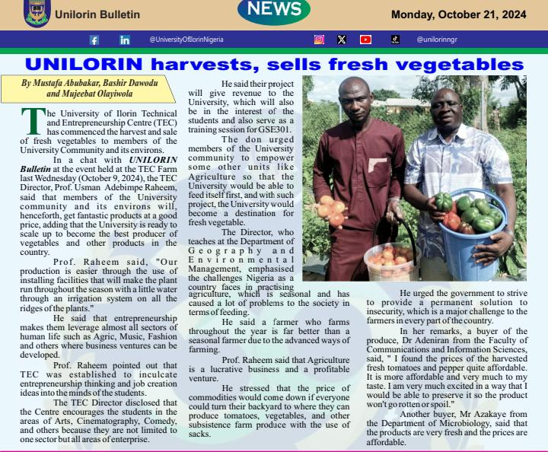
5.1 My Achievements
I contributed to news story published in the Unilorin Bulletin, alongside other reporters from our organization
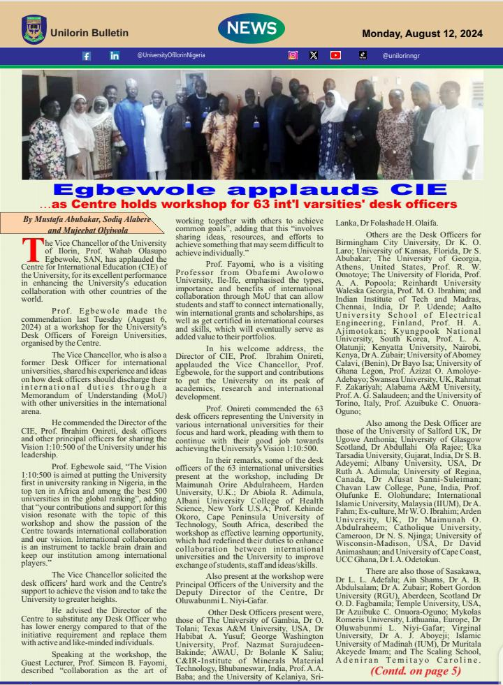
INTERVIEW AT UTME CENTER
By
Abass kolawole
Mr Muhammad Ayodele Atanba (A representative elder at the “POST UTME “ center.
His autobiography was took by him :He graduated in 2023 from Art Education department which he studied History education , He was a lead volunteer though out his school days and he continue to be the lead even after school , A former student He does things that bring joy to him and peace .
In his remarks ,he made mention of his organization which is named (Baba slump care foundation)he created it in 2011 and it was fully registered in 2018, He is a Marketer and a farmer, he sponsors over 30 student in school both in tertiary and secondary.
He is employed and also self employed , he works with a construction (Notable)company in Nigeria
He makes sure to make himself available for everyone around him , he gave assistance hand to those at the “POST UTME CENTER “
His group main objective is to maintain orderliness and ensuring there isn’t any form of casualty or any form of abused among those people that are coming to write the exam … and with their check and balances,it went smoothly.

EGBEWOLE APPLAUDS UNILORIN CIE
By
Abass kolawole and Mujeebat Olyiwola

The Vice Chancellor of the University of Ilorin, Prof. Wahab Olasupo Egbewole(SAN), has applauded the Centre for International Education(CIE) of the Unversity, for its excellent performance in enhancing the University international education collaboration with other countries of the world.
Prof. Egbewole made the statement last Tuesday (August 6, 2024) at the workshop for the University’s Desk Officers of International Universities organised by the Centre, held at the Centre’s seminar room.
Prof. Egbewole, who was also a former Desk Officer for Interrnational Universities, shared his experience and ideas on how desk officers should discharge their international duties through Memorandum of Understanding with other universities in the international arena.
He commended the Director of the Centre, Prof. Ibrahim Onireti, desk officers and other principal officers for sharing the vision 1:10:500 of the University under his leadership.
“The vision 1:10:500 is aimed at putting the University in first in universities ranking in Nigeria, top ten in Africa and among the best 500 universities in the global ranking. Your contributions and support for this vision resonate with the topic of this workshop and show the passion of the Centre toward international collaboration and our vision. International collaboration is an instrument to tackling brain drain and keep our intitution among international players”, he added.
Prof. Egbewole solicited the desk officers hardworking and the Centre’s support to achieve the vision and to take the University to its greater heights.
He adviced the Diretor of Centre to subtitute any Desk Officer that has a lower energy compare to that of the initiative requirement and replace them with active and like minded individuals.
END

5.2 Problems encountered during the program
The major challenge I faced during the four months program is that of transportation both scarcity of vehicles and financially. I always have a tough morning before getting a cab and later that of charges. The following are other problems i encountered or the challenges I faced during my SIWES Programme
i. The problems of securing a place of attachment as some of the organizations don’t want to accept SIWES students.
ii. Finance department of the company did not make proper provision to pay SIWES student nor do draft any allowance, packages so as to relief the expenses for the six months programme.
iii. Difficulty to understand some technical explanations as limited time is met for work done.
5.3 Appraisal and Conclusion
My experience during the period of industrial attachment has been an enriching and Innovative one. The SIWES scheme is indeed an innovative concept and looking back I am glad that I worked at “University of Ilorin Directorate of Corporate Affairs”. The experiences have been far rewarding and the report summarizes the details. From the full details on the experience which I had during the training program which gave me the privilege to relate with senior professionals and other students from different institutions. The knowledge acquired is not only academic or technical skill as the case may be, I was also made to understand the importance of other fields of study and ultimately appreciate the roles they play to the success of any industry. The experience makes me appreciate the nature, benefits and intricacies of my chosen field of study both in the classroom and in the larger society.
In conclusion, my time at the University of Ilorin Directorate of Corporate Affairs was a wonderful, hands-on experience that significantly contributed to my professional development. I also gained valuable moral lessons that cannot be taught in a classroom. I thoroughly enjoyed this experience, which allowed me to build connections and socialize with my colleagues.

.
5.4 RECOMMENDATION
In view of my experience during my industrial training, the following recommendations are made to the students, university, industrial training fund (I.T.F) and the companies:
- Students should personally ensure that they get a good placement for the program in time to commence and gain the best from the six-months.
- Students should make sure that the entire period for the attachment is completed before bowing out of the program.
- Adequate time should be allocated for planning and preparation before events.
- Stipends should be provided to IT students to aid with transportation expenses.

References
Plasu. (2022). History of SIWES and Objectives of SIWES. Retrieved from https://mtu.edu.ng/centers/student%27s-industrial-work-experience-scheme.

