CHAPTER TWO
LITERATURE REVIEW

2.1 Overview
This chapter reviews the theoretical and empirical foundations of hybrid inverter systems with an emphasis on solar energy integration, energy storage technologies, power electronics, and the state of renewable energy adoption in Nigeria. It draws from scholarly articles, technical manuals, engineering standards, and real-world case studies to contextualize the design and deployment of a 4.2kVA hybrid inverter system.

2.2 Energy Demand and Power Reliability Challenges in Nigeria
Nigeria, with a population of over 200 million, has long struggled with an unreliable power supply. The country’s national grid is plagued by frequent outages, poor transmission infrastructure, and inadequate generation capacity. According to the Nigerian Electricity Regulatory Commission (NERC, 2021), only about 57% of the population has access to electricity, with much lower reliability in rural areas. Even in urban centers, daily blackouts are common, leading to heavy dependence on fossil-fuel generators (Oyedepo, 2012).These challenges have fueled interest in decentralized renewable energy solutions, especially solar photovoltaic (PV) systems. Hybrid inverter systems provide a realistic solution by bridging the reliability gap through energy storage and intelligent switching between multiple power sources.

2.3 Overview of Solar Energy Systems

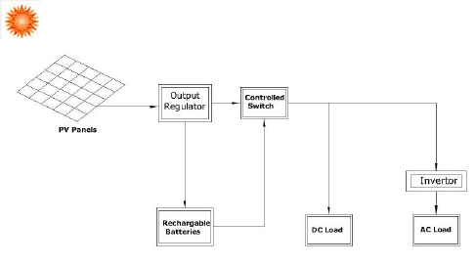

Figure 2.1: Basic Configuration of a Solar PV System
Solar energy systems are designed to capture sunlight and convert it into usable electrical energy. The basic components include:
- Photovoltaic (PV) Panels: Convert sunlight into direct current (DC).
- Inverter: Converts DC to alternating current (AC).
- Charge Controller: Regulates voltage and current to the batteries.
- Battery Bank: Stores excess energy for use during low sunlight or grid failure.
- Balance of System: Includes mounting, wiring, and protective devices.
Solar energy is abundant in Nigeria, with average daily solar radiation ranging between 3.5 to 7.0 kWh/m²/day (Ikejemba et al., 2016). This makes it highly suitable for off-grid and hybrid systems.

2.4 Hybrid Power Systems
A hybrid power system combines two or more energy sources to deliver electricity more reliably and efficiently. Commonly used hybrids include solar-diesel, solar-grid, solar-wind, and solar-battery systems. Hybrid inverters lie at the heart of such systems, managing input from multiple sources and optimizing output.
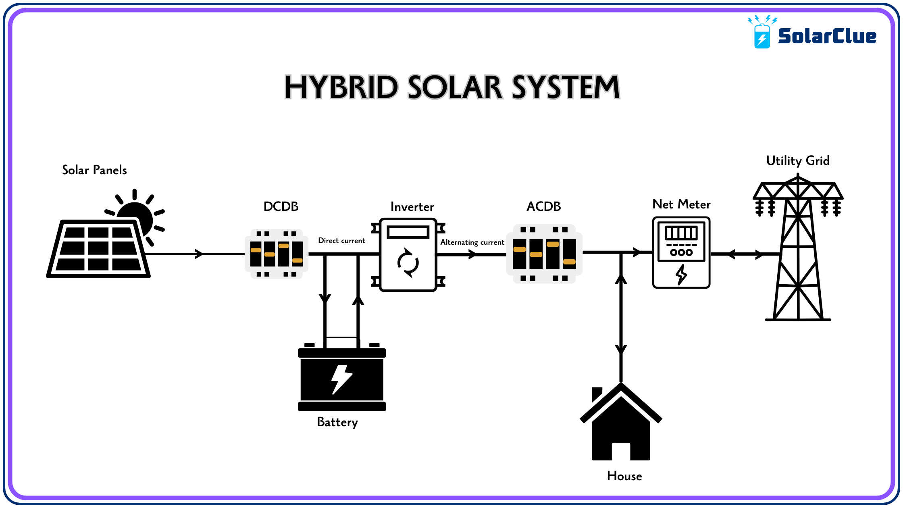
Figure 2.2: Schematic Layout of a Solar Hybrid System
Hybrid systems offer several advantages over single-source systems:
- Uninterrupted Power Supply through intelligent source switching.
- Improved Energy Efficiency via maximum power point tracking (MPPT).
- Cost Optimization by reducing generator or grid reliance.
- Environmental Benefits by integrating renewable sources (Hossain et al., 2019).

2.5 Inverter Technology
An inverter is a power electronic device that converts direct current (DC) into alternating current (AC). In solar applications, the inverter enables the use of DC energy stored in batteries or generated by PV panels to power AC appliances.

Types of Inverters
- Off-Grid Inverters: Operate independently of the national grid.
- Grid-Tied Inverters: Sync with the grid and may export excess power.
- Hybrid Inverters: Combine the capabilities of off-grid and grid-tied systems. They manage power from solar, battery, and grid sources and often support load prioritization, battery optimization, and net metering.
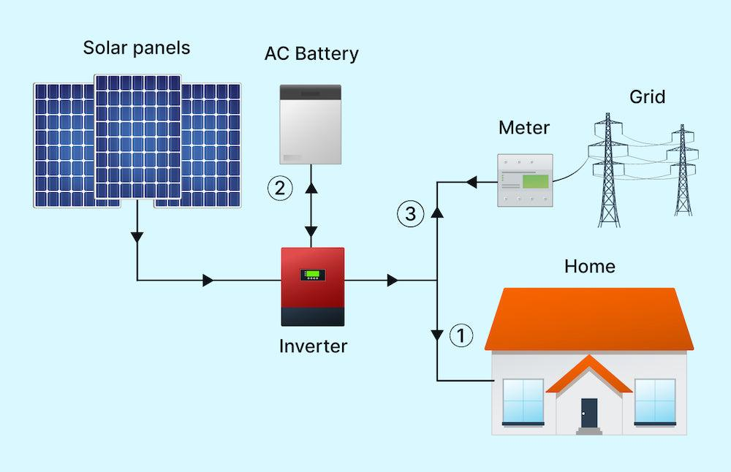
Figure 2.3: Types of Inverters Based on Functionality

Key Features of Hybrid Inverters
- MPPT tracking:Every solar panel has a Maximum Power Point (MPP) a specific combination of voltage and current at which the panel produces themostpower. However, this point changesthroughouttheday due to fluctuations in sunlight intensity, temperature, and shading. It is the real-time processof continuously adjustingthe electrical operating point of the solar panel to stay at or near that maximum power point, thereby maximizing the energy that is harvested and delivered to the battery or load.
- Battery management: Refers to the set of practices, technologies, and systems used to monitor, control, protect, and optimize battery performance in energy systemsespecially in hybrid inverter setups.
- Source prioritization (solar → battery → grid): refers to the intelligent sequence in which a hybrid inverter decides which power source to use first, in order to maximize efficiency, reduce costs, and extend system life.
- Load scheduling:is the process of planning when specificelectrical appliances should turn on or offto optimize energy usage in a solar or hybrid inverter system.
- Wi-Fi/IoT monitoring interfaces:are digital platforms that allow users to remotely monitor and control their hybrid inverter systemsusing internet-connected devices like smartphones, tablets, or computers.

2.6 Battery Storage Technologies
Energy storage is critical in hybrid systems, allowing energy generated during the day to be used at night or during grid failure.

Battery Types
- Lead-Acid Batteries: Affordable, widely used, but limited cycle life.
- Lithium-Ion Batteries: Longer lifespan, higher energy density, more expensive.
- Gel/AGM Batteries: Sealed lead-acid types with lower maintenance needs.
Battery selection depends on depth of discharge, efficiency, maintenance, cost, and lifecycle (Larcher&Tarascon, 2015).

2.6.2 Battery Sizing and Management
Correct battery sizing ensures the system can store sufficient energy to meet load demands. Oversized batteries increase cost, while undersized batteries lead to short backup times and accelerated degradation.

2.7 Energy Management Systems (EMS)
Modern hybrid systems rely on EMS to automate energy source prioritization, load shedding, charge-discharge cycles, and fault detection. A well-designed EMS:
- Enhances system lifespan
- Reduces energy losses
- Provides data for performance tracking
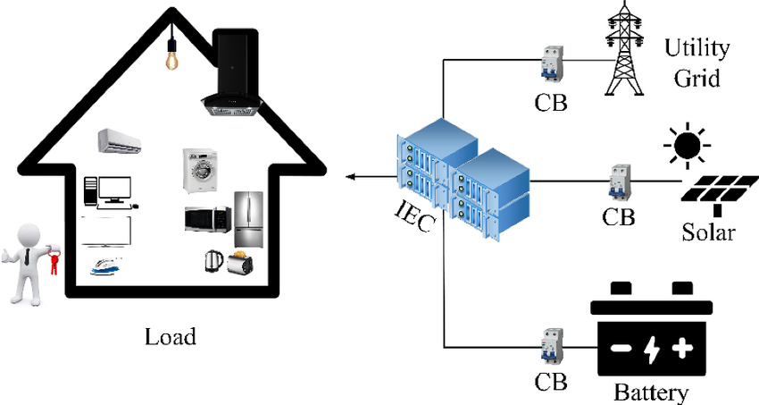
Figure 2.4: Architecture of an Energy Management System

Many hybrid inverters come with built-in EMS features and user-friendly mobile interfaces.

2.8 Component Sizing Techniques

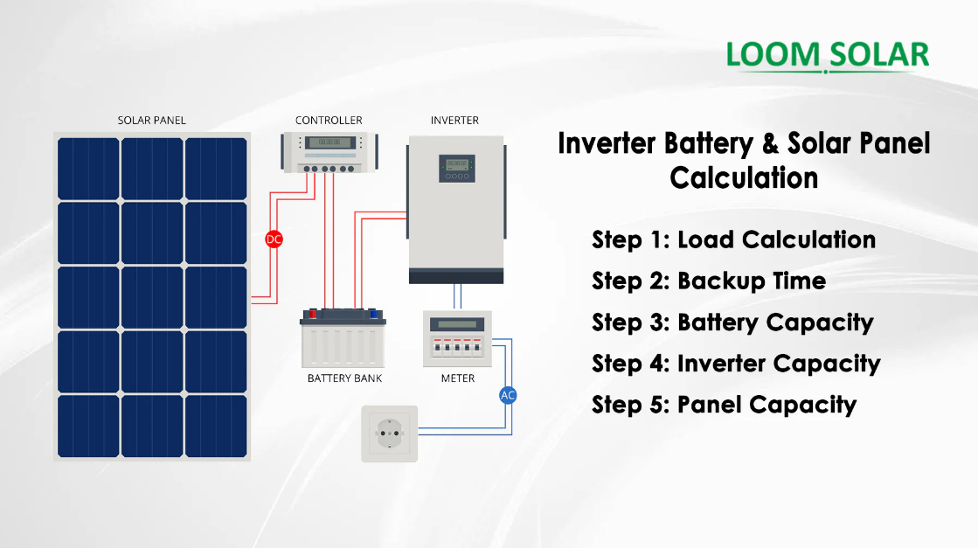

Figure 2.5: Manual Component Sizing Workflow for Hybrid Systems
Sizing is fundamental to system efficiency and includes the following steps:
- Load Analysis: Determining total daily energy demand (in Wh or kWh).
- Inverter Sizing: Must exceed peak load with a safety margin.
- Battery Sizing: Based on load, autonomy days, depth of discharge.
- PV Sizing: Depends on daily energy requirement and peak sun hours.
- Charge Controller Sizing: Based on array current and system voltage.
Under-sizing leads to overload, while over-sizing increases project cost (Chauhan & Saini, 2014).

2.9 Review of Related Works
Numerous studies have examined hybrid inverter system design and deployment in different contexts:
- Nwankwo et al. (2019) evaluated the economic feasibility of a 5kVA solar hybrid system in Abuja. They reported a 63% reduction in generator usage and a payback period of 5.8 years.
- Olatomiwa et al. (2016) proposed an optimal sizing model for hybrid systems in sub-Saharan Africa. Their simulation-based approach yielded 95% reliability.
- Ishola& Ajayi (2021) implemented a 3kVA hybrid inverter for rural homes and found that system uptime improved from 52% (grid only) to 96% (hybrid).
- Sambo (2009) emphasized the role of small-scale renewable installations in addressing Nigeria’s energy gap.
These works support the technical and economic feasibility of hybrid inverter systems and validate their adoption as a solution for energy-insecure regions.

2.10 Nigerian Context for Renewable Energy Deployment
Despite abundant solar resources, Nigeria’s renewable energy penetration remains low. Regulatory frameworks like the Renewable Energy Master Plan (REMP), the National Energy Policy (NEP), and the Electrification Roadmap (with Siemens) aim to promote off-grid solutions, but implementation is slow.
Barriers include:
- High initial cost
- Lack of skilled technicians
- Inconsistent government incentives
- Limited awareness
However, initiatives such as the Rural Electrification Agency (REA) and donor-funded mini-grid pilots have started driving awareness and adoption of hybrid systems, especially in rural areas (Ohunakin et al., 2014).

2.11 Environmental and Economic Benefits
Adopting hybrid inverters has both environmental and economic impacts:
- Reduces CO₂ emissionscompared to generators
- Lowers operational costsdue to zero fuel requirements
- Minimizes noise pollution
- Improves energy independence
These benefits contribute to SDG 7 (Affordable and Clean Energy) and SDG 13 (Climate Action).

2.12 Summary of Gaps and Contribution of This Study
While previous studies provide valuable insights, many focus on simulation or large-scale systems. This study addresses a practical gap: demonstrating thefield installation and real-time performance of a 4.2kVA hybrid inverter system in a Nigerian residential setting.
It contributes:
- A practical guide to sizing and installing hybrid systems
- Real-world performance data under Nigerian conditions
- A case for broader adoption of solar hybrid technology

