CHAPTER FOUR
DATA PRESENTATION, ANALYSIS AND RESULTS
4.1 Data presentation
The data use for this project work are displayed in the Table 4.1 below on 5-year smooth Nigeria surface air temperature (º C) data series.
Table 4.1. Data set on 5-year smooth Nigeria surface air temperature (º C) (1901 – 2023)
Source: World Bank
The graphical representation of the data series are shown in Figure 4.1 below;

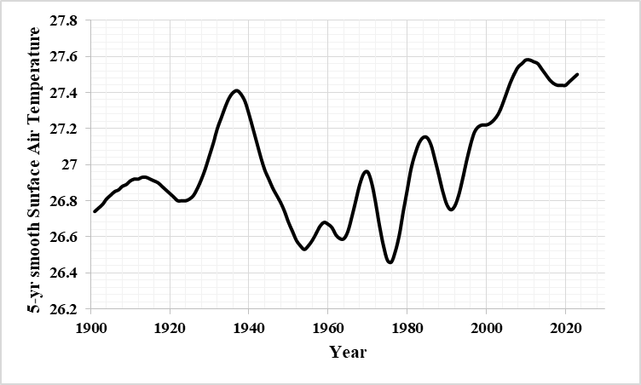
Figure 4.1. Time plot of 5-year smooth of surface air temperature

From Figure 4.1, it can be observed that the data series of surface air temperature exhibit irregular up and down movement over the years which steadily rise in the recent years.
This suggests that the surface air temperature will likely continue to increase in the near future.
4.2 Data analysis and results
Table 4.2. Descriptive statistics
Surface Air Temperature, Nigeria (1901-2023)
N | Valid | 123
Mean |  | 26.9933
Median |  | 26.9200
Mode |  | 26.92
Std. Deviation |  | .30640
Variance |  | .094
Skewness |  | .380
Std. Error of Skewness |  | .218
Kurtosis |  | -.936
Std. Error of Kurtosis |  | .433
Minimum |  | 26.46
Maximum |  | 27.58

From Table 4.2, the average for surface air temperature is about 27ºC with standard deviation of 0.31ºC indicating low variability within the data series over the year. The surface air temperature ranging from 26.46ºC to 27.58ºC highest experience along the series. Also, distribution of the data series is not normally distributed as shown in Figure 4.2 since the Skewness (0.38) ≠ zero and Kurtosis (- 0.936) < 3 which is the rule of thumb for normality.
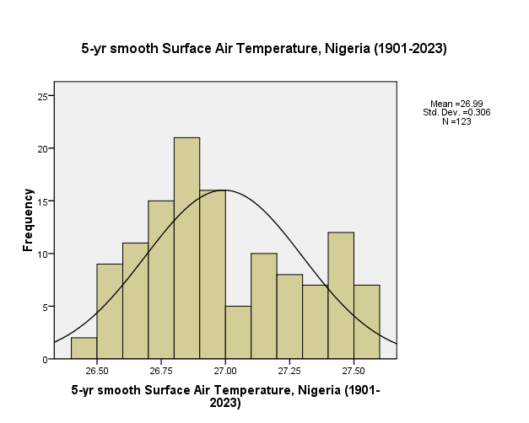
Figure 4.2. Normality plot of 5-year smooth surface air temperature
From Figure 4.2, it can be observed that the all the histogram bar did not fall under the normal curve which indicates the data series deviate from normality.
Table 4.3. Model Summary^{b}
Model | R | R Square | Adjusted R Square | Std. Error of the Estimate | Durbin-Watson
1 | .483ª | .233 | .227 | .26937 | .038
a. Predictors: (Constant), Time (Period)
b. Dependent Variable: 5-yr smooth Surface Air Temperature, Nigeria (1901-2023)
From Table 4.3, R (0.483) and R-squared (0.233) indicate a fairly relationship of the data series against time (year). Also, Durbin-Watson (0.038) statistic is relatively very low suggesting a moderate positive autocorrelation along the lags series.
Table 4.4. ANOVA^{b}
Model |  | Sum of Squares | df | Mean Square | F | Sig. (p-value)
1 | Regression | 2.674 | 1 | 2.674 | 36.849 | .000ª
1 | Residual | 8.780 | 121 | .073
1 | Total | 11.453 | 122
a. Predictors: (Constant), Time (Period)
b. Dependent Variable: 5-yr smooth Surface Air Temperature, Nigeria (1901-2023)

From Table 4.4, the null hypothesis (H₀) is rejected since the p-value (0.000) < α = 0.05 (level of significance) which suggests that the fitted model can adequately describe the data series. In other words, the model capture most information about the data series.

Table 4.5. Model Coefficientsª
Model |  | Unstandardized Coefficients |  | Standardized Coefficients | t | Sig. (p-value)
 |  | B | Std. Error | Beta | t | Sig. (p-value)
1 | (Constant) | 26.736 | .049 |  | 547.040 | .000
1 | Time (Period) | .0042 | .001 | .483 | 6.070 | .000
a. Dependent Variable: 5-yr smooth Surface Air Temperature, Nigeria (1901-2023)

From Table 4.5, all the coefficients of the fitted model are statistically significant since the p-value = 0.000 < α = 0.05 (level of significance). Hence, the fitted time series model can be written as
$$Y_{t}=26.736+0.0042t$$
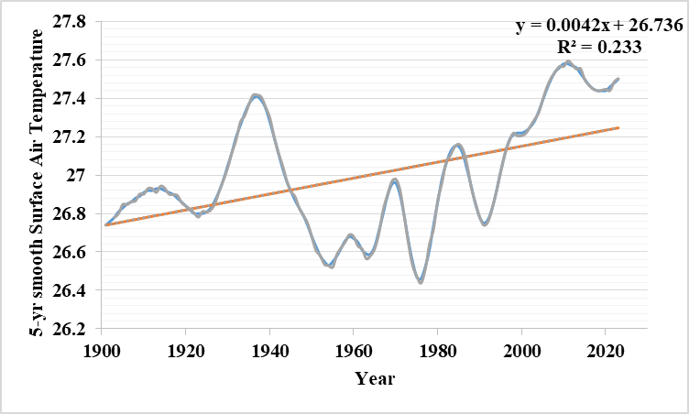
Figure 4.3. Plot of the observed and fitted linear model of the surface air temperature

The Figure 4.3 shows that the fitted linear model has a positive slope of 0.0042 which is the rate at which surface air temperature varies with respect to time over years. This implies that the surface air temperature will continue to increase in the near future based on the observed data series.
Table 4.6. Residuals Statisticsª
 | Minimum | Maximum | Mean | Std. Deviation | N
Predicted Value | 26.7400 | 27.2466 | 26.9933 | .14804 | 123
Residual | -.59147 | .52048 | .00000 | .26826 | 123
Std. Predicted Value | -1.711 | 1.711 | .000 | 1.000 | 123
Std. Residual | -2.196 | 1.932 | .000 | .996 | 123
a. Dependent Variable: 5-yr smooth Surface Air Temperature, Nigeria (1901-2023)

From Table 4.6, the mean of predicted surface air temperature is about 27ºC which is the same with the actual series mean value (27ºC). Also, the mean of the residuals is 0ºC with approximate value of 1 (0.996) as standard deviation of the residuals which suggests independent of the observed data series over time and the fitted model can adequately describe the data series. That is, the fitted can be considered as a good fit to surface air temperature.

