CHAPTER THREE
DESIGN METHODOLOGY

3.0 Introduction
This chapter entails the design and calculations involved in the implementation of an extension socket with an uninterruptible universal serial bus port.

3.1 The Block Diagram of the Project

Switches/fuse
13A Electrical
Sockets
220
VAC
12V Step-down
Transformer

Rectifier

Universal Serial Bus port
USB
Micro
Controller
Regulator
Batteries

Fig. 3.1 Block diagram of the project

Stages of the Project
- An electrical voltage is fed from an alternating current circuit, a fuse is connected to prevent the excess flow of electric current
- The source energizes the six phases of the 13A sockets and a step down transformer receive its input from the input of the 13A socket
- The power from the step down transformer is rectified to change the state of the Alternating current (AC) to a Direct current (DC) to charge up the inbuilt battery (Lithium) which will store charges to be able to serve the universal serial bus ports when there is power outage
- The Micro-controller controls other electronic components in the circuit
- A regulator is connected to maintain a voltage level required from the battery to power the circuit as well as the micro-controller that requires 5V
3.2 Mode of Constructing the Project
The first thing is to create holes on the Adaptable box for the creation of an interface for the six phase 13A sockets and two for the USB ports, mapping out accurately and neatly aligned which fits the setting of an extension box. This is followed by measurement and cutting of cable length to be used for the extension box (The cable with thickness of 3.5mm in diameter is peeled by the use of pliers so as to bring out the cores to connect to the socket core. The cores are: the red cable (live), the black cable (neutral), yellow cable (earth) and each socket has its own independent switch. The designed circuit for the working operation of the USB port is arrange systematically with other components into the adaptable box. The box is screwed and readily available for use.
3.3 Calculation/ Connection Used for the Design
3.2.1 Parallel Wiring Connection
The parallel connection entails connecting components of a circuit in parallel so that when a component is removed from the others, the circuit continues to work. In other words, both end of each cableare connected directly. Also, same voltage passes through the parallel connection and the current flowing through circuit is the sum of all the current flowing through the components.
V= V1=V2=V3₋₋₋₋₋₋₋₋₋₋₋₋Vn .1
The equivalent resistance of parallel connection is given as:
1/R_{T} = 1/R₁ + 1/R₂ ₋₋₋₋₋₋₋₋₋₋ 1/R_{n} .2
The total inductance of non-coupled inductors in parallel is equal to the reciprocal of the sum of the reciprocals of their individual inductances
1/L_{T} = 1/L₁ + 1/L₂ ₋₋₋₋₋₋₋₋₋₋ 1/L_{n} .3
The total capacitance of capacitors in parallel is equal to the sum of their individual capacitances
C_{T}= C₁ = C₁ = C₃₋₋₋₋₋₋₋₋₋₋₋₋C_{n} .4
3.2.2 Series Wiring Connection
Cablesare connected in series when they are connected end to end. The series connection involves connecting components of a circuit such that when a component is removed, others stop working. This is because same current flows through the series connection and the voltage is the sum of all the voltage drops across the components.
I_{T}= I₁ = I₁ = I₃₋₋₋₋₋₋₋₋₋₋₋₋I_{n} .5
The equivalent resistance of series connection is given as:
R_{T}= R₁ = R₁ = R₃₋₋₋₋₋₋₋₋₋₋₋₋R_{n} .6
Total conductance of series circuits of pure resistors is given as
1/G_{T} = 1/G₁ + 1/G₂ ₋₋₋₋₋₋₋₋₋₋ 1/G_{n} .7
Also, the total inductance of non-coupled inductors in series is equal to the sum of their individual inductances

L_{T}= L₁ = L₁ = L₃₋₋₋₋₋₋₋₋₋₋₋₋L_{n} .8

The total capacitance of capacitors in series is equal to the reciprocal of the sum of the reciprocals of their individual capacitances
1/C_{T} = 1/C₁ + 1/C₂ ₋₋₋₋₋₋₋₋₋₋ 1/C_{n} .9

3.2.3 Resistivity
This is the resistance of a cable with unit length and unit cross sectional area. The resistance of a conductor depends on the nature of the material, temperature and size of the samples (length and cross-sectional area).
Mathematically,

Rα l/A .10

Where l=length A= cross sectional area
From equation 1

R=ρl/A .11

ρ=constant of proportionality also known as resistivity of the material measured in ohm meter (mΩ)
Electrical conductivity is a measure of the extent to which a material will allow current to flow easily through it when a potential difference is applied at a specific temperature. It is the reciprocal of resistivity given as
σ=1/ρ .12
Where
σ = electrical conductivity in (Ωm)⁻¹
The rate at which metals conduct electric current is a function of its resistance to current. The resistance of a resistor is said to be linear if the current through the resistor is proportional to the potential difference across its terminals
From Ohm’s law
I=V/R .13
Also,
I=E/(R+r) .14

Where
I: main current in amperes,
V: applied voltage in volt,
r: internal resistance in ohm,
R: combined resistance in ohm, and
E: electromotive force in volt

The quantity Q of electric current I that passes through a metallic conductor for time t is given as
Q=It .15

While the electrical work done when electricity flows from one point to another is given
W=IVt 16
The amount of electrical work done also known as electrical power is given by the relation ;
P=I²R 17
P=V² /R 18

3.3 Circuit Diagram of the Project

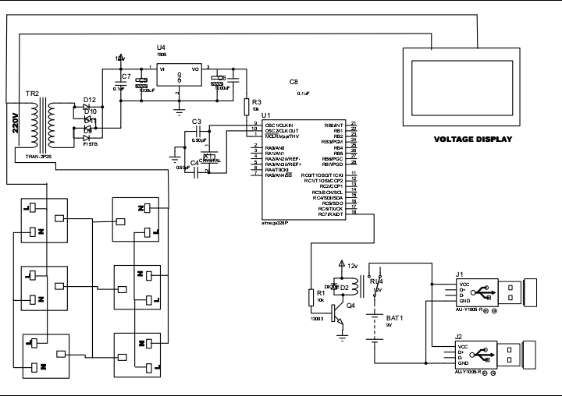

Fig. 3.2 Circuit diagram of the project

