CHAPTER ONE
1.1 Location and Accessibility
Alagbede daba is a rural community situated within the Moro local government area of approximately 3,772 square kilometer and had a population of 108,792 people (2006, census). It is situated approximately 25 kilometer, North west of malete, a town known for housing the Kwara State University. Alagbede daba community is about 60km from Ilorin. The route is essentially from Ilorin - Shao- Malete - Alagbede.
Alagbede daba like many other communities in Moro L.G.A, faces significant infrastructural challenges and access to the community is primarily through unpaved road which can become particularly difficult to navigate during the rainy season due to the dust on pathways since the road is an untiled road, some paths are also sloapy making it difficult for cars to pass through. The lack of reliable transportation hampers mobility and limits access to essential services in the area and the community's proximity to gold mining operations makes it susceptible to environmental challenges.
The area is underlain by rocks of the basement complex of Nigeria and in fact forms the southern extension of the North western end of Yauri gold field, resulting from the development of the intercontinental Anka Yauri-Iseyin (AYI) trans current fault during the pan African (Grant et al., 1985). Structural features mapped in the area include folds, faults, and joints. Discordant and concordant shear planes are partly healed with Vein quartz ranging from 2-8m depth (Turner, 1983).

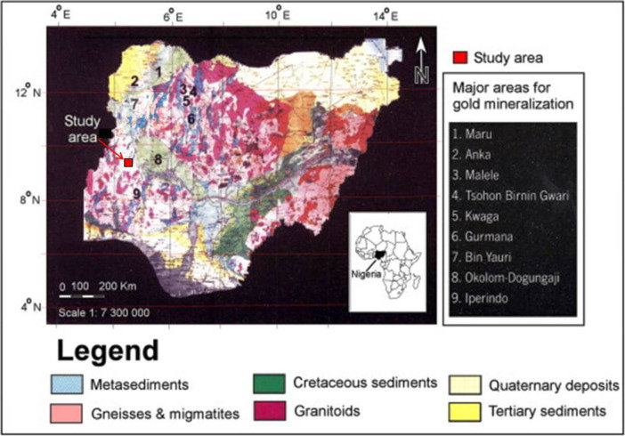
Figure 1. Geological Map of Nigeria Showing Study Area (Ajadi et al. 2018).
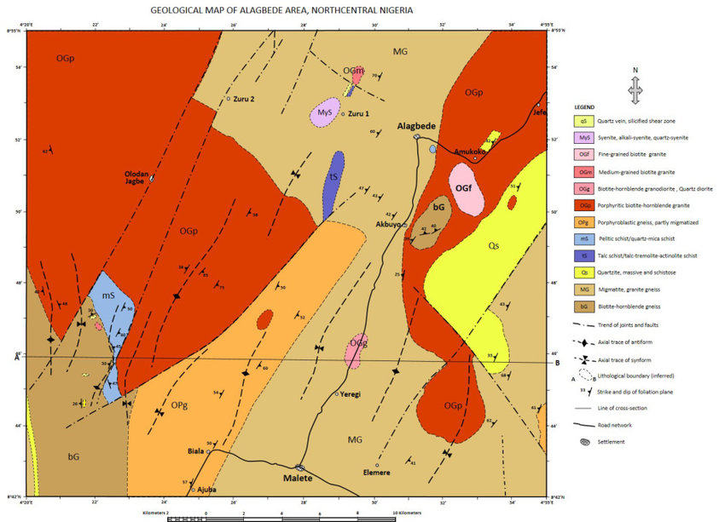
Figure 2: Geological Map Showing Alagbede Daba Area(Bayode et al., 2023)

1.2 Climate and Vegetation
Alagbede daba community in Moro local government area of kwara state government experiences a tropical climate with distinct wet and dry season. Specifically, Alagbede daba community within Moro experiencing high humidity and warm temperatures throughout the year, the regions climate is characterized by the temperature which ranges from 20C to 30C throughout the year and the wet season typically occurs from May to October, with most rainfall concentrated in these months (Kwara State government, 2020). The dry season from November to April is marked by dry harmattan wind. The area receives approximately 1302mm of rainfall annually, with an average temperatures reaching 34C (EPA, 2020). The humidity is around 70percent and UV index is 7, with 88 dry days per year. Alagbede daba forest reserve has a mix of tree species, but specific types are not well documented. However, nearby regions have herophytic trees with short seasonal grasses. this vegetation tyle dominates the region (EPA, 2020).
The surrounding areas practice Agriculture with crops like cassava, rice and sorghum being common. Home gardening is also a prevalent practice in nearby regions. human activities like farming and urbanization can impact vegetation cover leading to deforestation and loss of biodiversity (Climate, 2019). The areas natural resources include: Yam, Cassava, Corn, Groundnut and Rice.
1.3 Relief and Drainage
The relief and drainage of Alagbede daba community in Moro local government area of Kwara State can be understood based on the regions geography, and the area features a mine of planes and gentle slopes, characteristic of the savannah region. The elevation ranges from approximately 200 to 400 meters above sea level (Adebayo, 2019).
The area is drained by nearby rivers, such as the Niger river or it's tributaries which includes water from the river Niger which flow into the community and contribute water, sediment, and nutrients to the main river, helping to shape it's course and support aquatic ecosystems. they may also be dams, lakes or ponds in the area, which can support agriculture, fishing and other local activities.
1.4 Aim
The aim of this study is to evaluate the impact of gold mining on the waters of Alagbede daba community Moro local government area of kwara state.
1.5 Objectives
The objectives of this project work are to
i. determine the physical and chemical properties of the waters in Alagbede daba community.
ii. evaluate the health risks associated with gold mining activities in the study area.
1.5 Scope and Limitations
The focus of this is study is to evaluate the impact of gold mining and determine the pH, electric conductivity (EC) Temperature, Total dissolve solvent (TDS) and heavy metals on the waters of Alagbede daba community, Moro local government area of kwara state.
This study has several limitations, firstly the study will only focus on the Alagbede daba community and the findings may not be generalized to other communities. Secondly, the study will only determine the physical and chemical properties of the waters of the community and will not determine the biological properties. Finally, the study will be conducted over a relatively short period of time and may not capture the long term impact of gold mining on the waters of the community.

1.7 Justification
The community's reliance on the water of Alagbede daba for drinking, fishing and irrigation makes it essential to evaluate the impact of gold mining on the waters of the community. the findings of this study will provide valuable insight for the community and also provide strategies for the environmental and health impacts of gold mining.
1.8 Statement of the Problem
Gold mining has become a rapidly expanding activity in the Alagbede daba community, predominantly through small scale and artisanal operations while mining offers potential economic benefits, it's environmental consequences particularly on water resources are increasingly alarming
Resident rely heavily on surface water (streams, rains) and shallow wells for daily domestic and agricultural use. However, these water sources are under threat from pollution due to unregulated mining activities. this study evaluates the presents condition of the water sources, with the view to determining their stability and risk factors.

