POTENCY OF FUSARIUM GRAMINEARUM TOXIN

BY

ABDULWAHAB AINA MARYAM
HND/23/SLT/FT/0100

A PROJECT SUBMITTED TO THE DEPARTMENT OF SCIENCE LABORATORY TECHNOLOGY, INSTITUTE OF APPLIED SCIENCES, KWARA STATE POLYTECHNIC, ILORIN

IN PARTIAL FULFILMENT OF THE REQUIREMENTS OF THE AWARD OF HIGHER NATIONAL DIPLOMA (HND) IN SCIENCE LABORATORY TECHNOLOGY (SLT), MICROBIOLOGY UNIT

JULY, 202
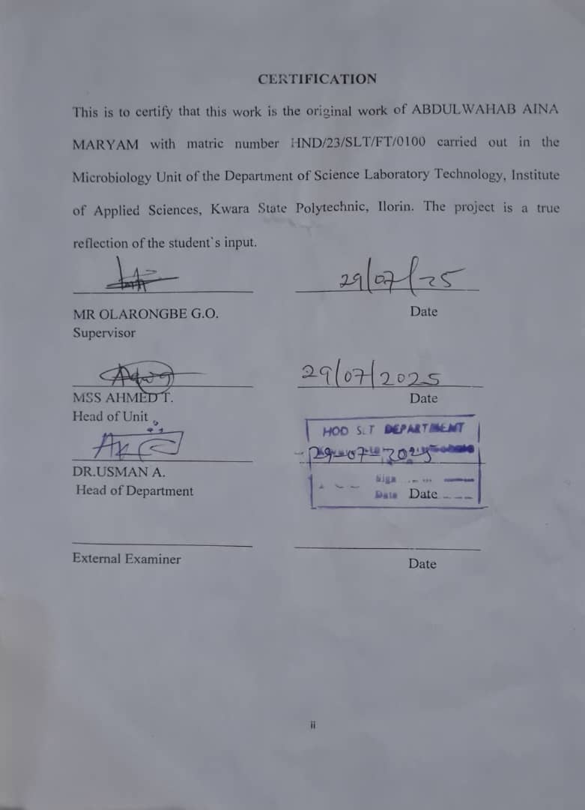
DEDICATION
I dedicate this work to Almighty Allah for his guidance and mercy throughout the course of this research and to my beloved family whose unwavering support and encouragement kept me going.
.

ACKNOWLEDGEMENTS
All praise is given to Almighty Allah for granting me life, strength and wisdom to successfully complete this project research.
My sincerest gratitude goes to my supervisor (Mr. Olarongbe G. O) for his guidance and support throughout this project research. Your valuable feedback and encouragement have been instrumental in my success. Thank you for providing me with the opportunity to learn and excel under your leadership.
To my loving parents Mr and Mrs Abdulwahab I appreciate you for your unwavering support, word of encouragement and love. A very special appreciation goes to my brothers and sisters, mum twins, dad fareedat, mum ayo, dad farhan mum yushroh and my adorable nephew (Abdulazeez) thank you all for believing in me, for pushing me to pursue my dreams, thanks for being there through thick and thin your love and support means the world to me and your presence in my life has been a constant source of strength and inspiration am forever grateful to have you all in my life. Almighty Allah will bless you all abundantly
I will also like to thank all the laboratory technician and technical staff of the department of microbiology for their support and assistant during the practical aspect of the research. Your cooperation and help are deeply appreciated.

Lastly my appreciation goes to my friends who has contributed either through funds, prayers and word of encouragement I love you all so much.

TABLE OF CONTENTS

TITLE PAGE -------------------------------------------------------------------------- i
CERTIFICATION ---------------------------------------------------------------------ii
DEDICATION ------------------------------------------------------------------------iii
ACKNOWLEDGEMENTS ----------------------------------------------------------v
TABLE OF CONTENTS ------------------------------------------------------------viii
LIST OF TABLES ----------------------------------------------------------------------ix
LIST OF FIGURES ---------------------------------------------------------------------ix
ABSTRACT ------------------------------------------------------------------------------x
CHAPTER ONE
1.0 Introduction -------------------------------------------------------------------------6
1.1 Literature Review------------------------------------------------------------------8
1.2 Statement of Problem--------------------------------------------------------------9
1.3 Justification of Study--------------------------------------------------------------9
1.4 Aims and Objective----------------------------------------------------------------10

CHAPTER TWO
2.0 Materials and Methods -----------------------------------------------------------11
2.1 Material Used ---------------------------------------------------------------------11
2.2 Sterilization of Equipment and Environment ---------------------------------11
2.3 Samples Collection ----------------------------------------------------------------12
2.4 Media Preparation for fungal isolation -----------------------------------------12
2.4.1 Preparation of Potato Dextrose Agar -------------------------------------------12
2.4.2 Preparation of Potato Dextrose Broth-------------------------------------------13
25 Isolation of Fusarium gramenearium from maize------------------------------14
2.6 Characterization and Identification of Fusarium gramenearium --------------14
2.7 Sub-culturing and Extraction of Fusarium gramenearium----------------------15
2.8 Administration and Evaluation of the Potency of the Toxin in White Rats-15
CHAPTER THREE
3.0 Results
3.1 Characterization and Identification of Fungal Isolate ------------------------17
3.2 Weekly clinical Observation in Experimental rats -----------------------------19
3.3 Post-Mortem Gross Pathological Findings ------------------------------------- 20
CHAPTER FOUR
4.0 Discussion and Conclusion
4.1 Discussion -------------------------------------------------------------------- ---23
4.2 Conclusion ------------------------------------------------------------------------23
REFERENCES

LIST OF TABLES
Table 1: Characterization and Identification of Fusarium gramenarium Isolate after culturing

Table 2 Daily Observation for 100% Conc. Toxin Administration in Rats

Table 3 Daily Observation for 80% Conc. Toxin Administration in Rats

Table 4 Daily Observation for 60% Conc. Toxin Administration in Rats

Table 5 Daily Observation for 50% Conc. Toxin Administration in Rats
Table 6: Post-Mortem Findings in Experimental Rats

LIST OF FIGURES
Figure 1: Showing Microscopic view
Figure 2: Images of postmortem findings in experimental rats

ABSTRACT
Fusarium graminearum is a mycotoxigenic fungus that often infects cereal crops, generating strong toxins such deoxynivalenol (DON), zearalenone (ZEN), and fusarenon-X (FX). This study looked at how dangerous the F. graminearum toxin was when it was taken from infected maize samples and given to albino rats in controlled laboratory circumstances at different concentrations (100%, 80%, 60%, and 50%). Clinical investigations showed that the harmful effects got worse with higher doses. These symptoms included less movement, difficulty breathing, dullness of the eyes, and death at the greatest concentration. The investigation after death showed that important organs like the liver, kidney, and gut were getting worse, which confirmed systemic poisoning. Rats that were exposed to lesser amounts showed less severe but nonetheless noticeable physiological impairment. These results add to what we already know about the health consequences of F. graminearum toxins and show how important it is to keep an eye on and control mycotoxins in food systems to protect the health of people and animals.
Keyword: Fusarium graminearum, deoxynivalenol (DON), zearalenone (ZEN), mycotoxins, food safety, toxicology, organ damage.

