CHAPTER THREE
METHODOLOGY
3.1 Preamble
This research project was designed and implemented in two phases: hardware development and system simulation. The methodology includes sourcing components locally in Ilorin, Kwara State, Nigeria, assembling the circuit, programming the Arduino, and testing the system in a simulated environment.
3.2 Materials and Their Sources in Ilorin
Table 3.1 List of Materials and their sources
Component | Specification | Source in Ilorin
Arduino Uno | ATmega328P microcontroller board | Kwaratech Electronics, Tanke Junction
Ultrasonic Sensors (2x) | HC-SR04, range: 2cm – 400cm | JKK Electronics, Challenge Bookshop Complex
Servo Motors (2x) | SG90 Micro Servo | TechCity Hub, Unity Road
LEDs (Red & Green) | 5mm, 2V | Ilorin Electronics Market, Taiwo Isale
Buzzer | 5V Piezoelectric Buzzer | JustElectronics, GRA Junction
Jumper Wires | Male-to-Male, Male-to-Female | Unity Road Market
Breadboard | 830-point | Kwaratech Electronics, Tanke Junction
Resistors | 220Ω, 330Ω | JKK Electronics
Power Supply | 9V Battery or 5V USB Adapter | TechCity Hub or Spar Mall
Laptop with Arduino IDE | For programming and simulation | University of Ilorin ICT Lab / Personal Laptop
3.3 Research Procedure
Step 1: Component Acquisition
Electronic components were identified based on compatibility with Arduino. Vendors across Ilorin (Tanke, Taiwo, Unity Road) provided reliable access to affordable and tested hardware.
Step 2: Circuit Design and Assembly
- A schematic was drawn with Arduino Uno as the main controller.
- The entry ultrasonic sensor was placed before the crossing, and the exit sensor after it, to detect train approach and departure.
- Two servo motors controlled mock barrier gates.
- LEDs represented traffic lights (Red and Green).
- A buzzer provided audible warnings.
All connections were made on a breadboard using jumper wires, with current-limiting resistors for the LEDs.
Step 3: Arduino Programming (C/C++)
- Programming was done using Arduino IDE in C/C++ language. The logic flow followed:
- When the entry sensor detects a train (distance < 30 cm):
- Buzzer is activated.
- Red light turns ON.
- Servo motor lowers the gate.
- When the exit sensor detects the train has left:
- Buzzer turns OFF.
- Green light turns ON.
- Servo motor raises the gate.
Sample Code Snippet:
#include <Servo.h>
Servo gate;
const int triggerPin = 9;
const int echoPin = 10;
const int redLed = 6;
const int greenLed = 7;
const int buzzer = 5;
void setup() {
pinMode(triggerPin, OUTPUT);
pinMode(echoPin, INPUT);
pinMode(redLed, OUTPUT);
pinMode(greenLed, OUTPUT);
pinMode(buzzer, OUTPUT);
gate.attach(3); // Servo connected to pin 3
Serial.begin(9600);
}
void loop() {
long duration;
int distance;
digitalWrite(triggerPin, LOW);
delayMicroseconds(2);
digitalWrite(triggerPin, HIGH);
delayMicroseconds(10);
digitalWrite(triggerPin, LOW);
duration = pulseIn(echoPin, HIGH);
distance = duration * 0.034 / 2;
if (distance < 30) {
digitalWrite(redLed, HIGH);
digitalWrite(greenLed, LOW);
digitalWrite(buzzer, HIGH);
gate.write(0); // Close gate
} else {
digitalWrite(redLed, LOW);
digitalWrite(greenLed, HIGH);
digitalWrite(buzzer, LOW);
gate.write(90); // Open gate
}
delay(100);
}
Step 4: System Testing and Calibration
- Sensors were tested for accurate readings under different object distances.
- Trigger distances were calibrated to detect model trains at 20–30 cm.
- The servo motor’s closed and open angles were set to 0° and 90°, respectively.
- The buzzer’s timing was adjusted to avoid unnecessary noise post-departure.
Step 5: Simulation on Tinkercad
- Autodesk Tinkercad was used to simulate the entire circuit virtually.
- Components were placed in a simulated environment.
- The same Arduino code was uploaded to test barrier operations and sensor responses.
- Real-time debugging was done using the Serial Monitor and visual observations.
Step 6: Evaluation and Troubleshooting
- The system was tested repeatedly for consistency.
- Any false triggers from sensors were addressed by: Adjusting sensor alignment, adding debounce delays in the code, using software averaging for distance measurements.
Step 7: Documentation and Analysis
- All findings and behaviors were documented.
- Observations confirmed that the system met its intended objectives.
- Identified areas for improvement (e.g., sensor sensitivity to light and sound interference).

Components | Specifications | Source in Ilorin
Arduino Uno | ATmega328P microcontroller board  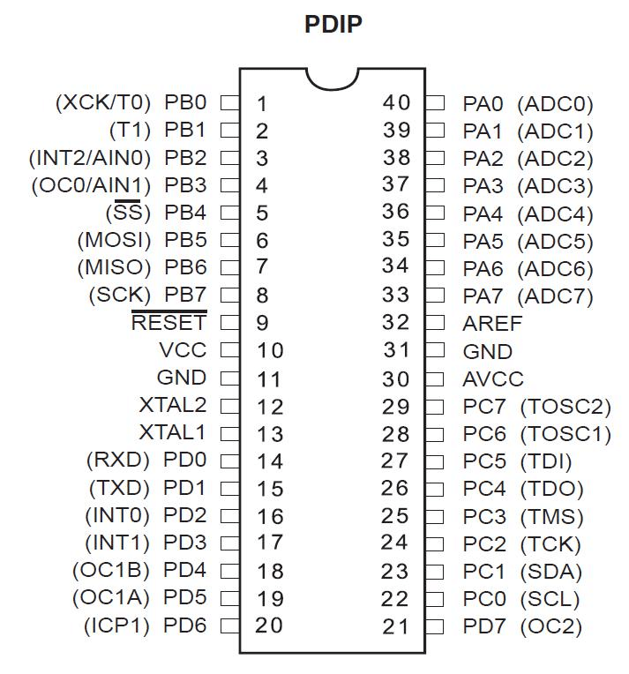 | Kwaratech Electronics, Tanke Junction
Ultrasonic Sensors (2x) | 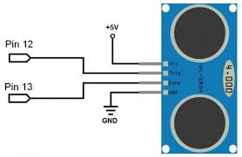HC-SR04, range:2cm-400cm | JKK Electronics, Challenge Bookshop Complex
Servo Motors (2x) | SG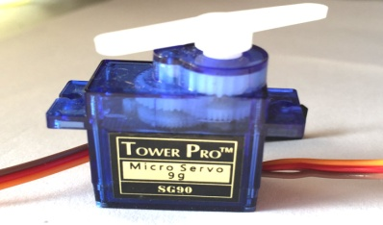90 Micro Server | TechCity Hub, Unity Road
LEDs (Red &Green) |  | Ilorin Elcetronics Market, Taiwo Isale
  5mm,2V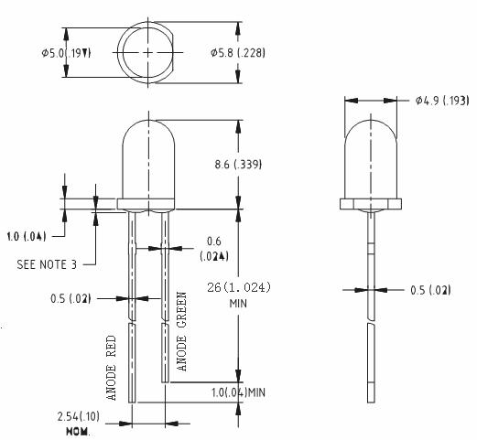
Buzzer | 5vl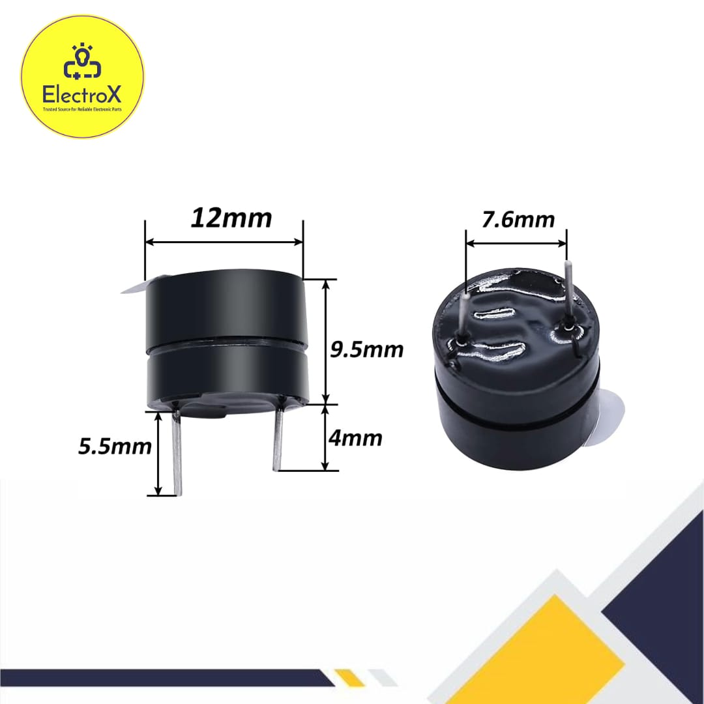V Piezoelectric Buzzer | JustElectronic GRA Junction
Jumper Wires | 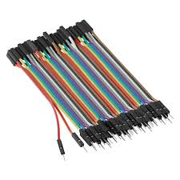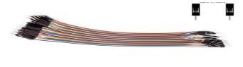Male-to-Male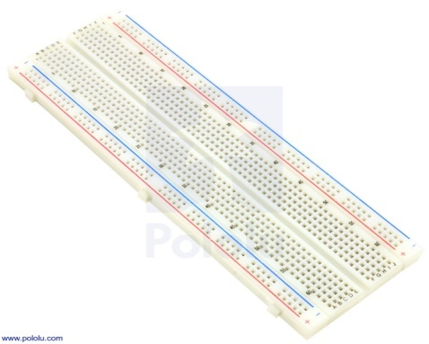, Male -to-Female | Unity Road Market
Breadboard | 830-point | Kwaratech Electronics, Tanke Junction
Resistors | 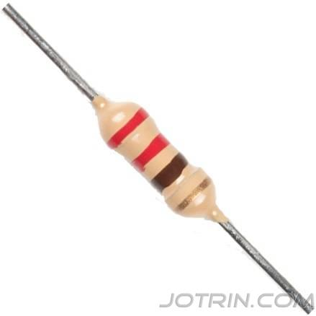22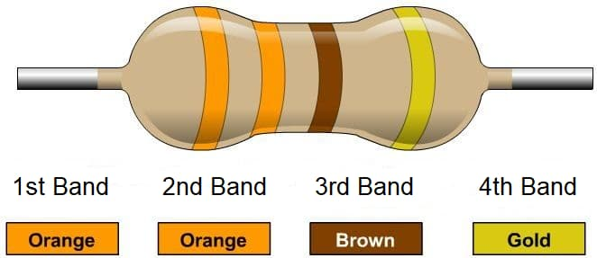0,330 | JKK Electronics
Power Supply | 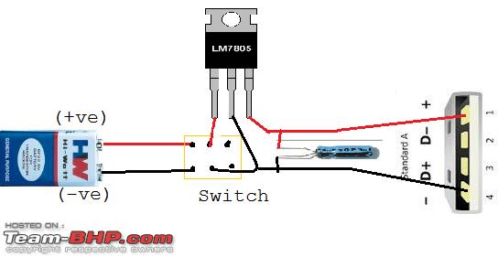9V Battery or 5V USB Adaptor | TechCity Hub or Spar Mall
Laptop with Arduino IDE | 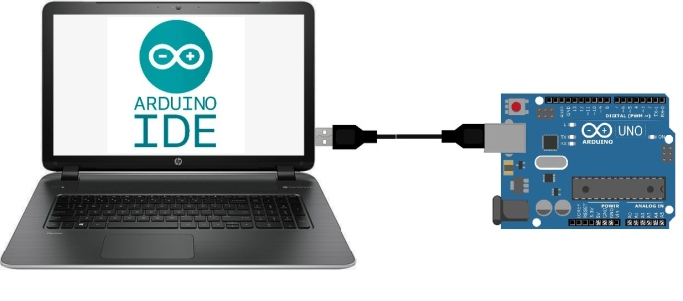For Programming and Simulation | University of Ilorin ICT Lab/Personal Laptop

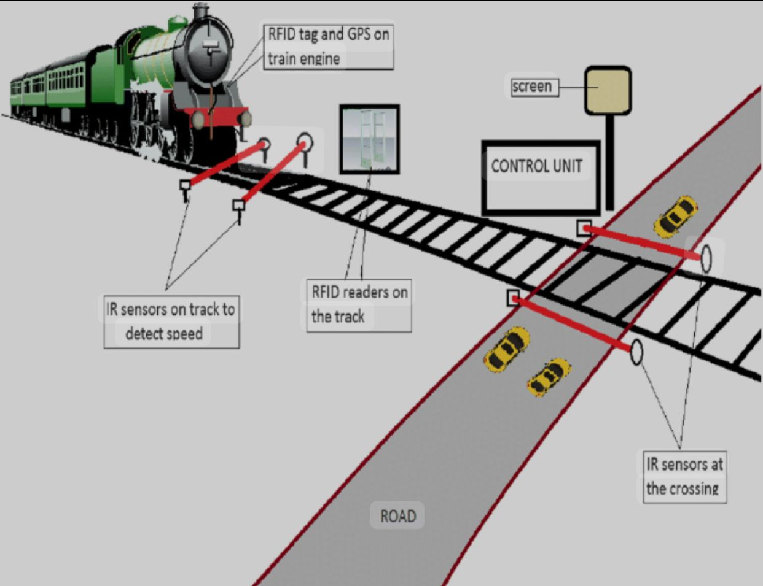S

