CHAPTER FOUR
TESTING, PRINCIPLE OF OPERATION AND DISCUSSION
4.1 PRINCINPLE OF OPERATION
- When the inverter is powered on, the processor IC (PIC 16672-1/sp) initializes and begins executing its programmed instructions.
- The processor continuously monitors various parameters such as input voltage, output load, temperature, and system status.
- The processor generates PWM (Pulse Width Modulation) signals based on the desired output voltage and frequency settings. These signals control the switching of the inverter active section switch (likely MOSFETs or IGBTs), regulating the output voltage and frequency.
- The voltage regulator (L7805CV) ensures a stable 5-volt supply voltage to power the processor IC and other components in the circuit.
- The switching output side, consisting of relays and transistors, is controlled by the processor to manage various loads or external devices connected to the inverter output. The relays may switch between different output configurations or provide power to different loads based on system requirements.
- The circuitry may include protection mechanisms such as Over-voltage protection, Over-current protection, and temperature monitoring to ensure safe and reliable operation of the inverter system.
- The system indicator provides visual or audible feedback to the user about the status of the inverter system, indicating whether it's operating normally, in standby mode, or experiencing an issue.
- The processor may incorporate feedback control loops to adjust the PWM signals based on real-time measurements of output voltage and frequency, ensuring stable and accurate output under varying load conditions

4.2 RESULTS

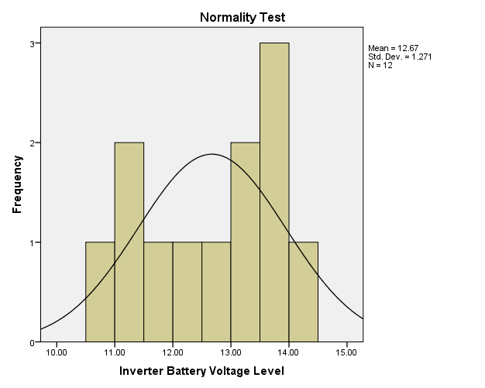

(a)

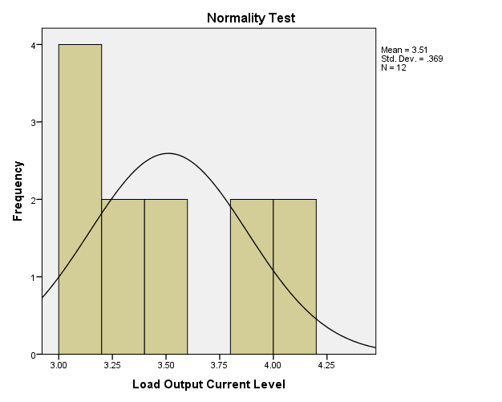
(b)

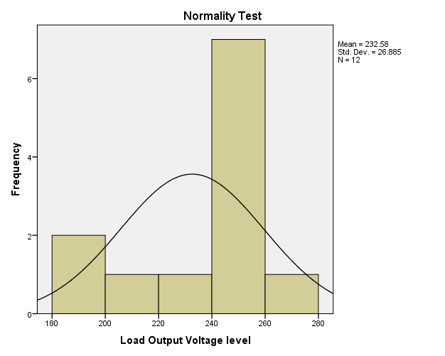

(c)

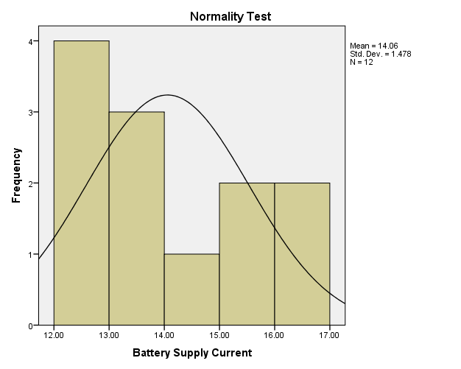
(d)
Figure 4.0: Normality Test for the Measured Values of 3kVA Locally Designed and Constructed Inverter (a) Inverter Battery Voltage Level (b) Load Output Current Level (c) Load Output Voltage Level and (d) Battery Supply Current.

(a)

(b)

(c)

(d)

Figure 4.1: Metric Parameters Observation over Time (a) Load Voltage Variation (b) Battery Voltage Variation (c) Battery Current Variation and (d) Load Current Variation.

Table 2.0: Model Summary
Model | R | R Square | Adjusted R Square | Std. Error of the Estimate
1 | .965ª | .930 | .904 | .22852
Predictors (Constant), Load Output Current Level, Measurement Time, Load Output Voltage Level

Table 3.0: Modeling Coefficients

Model Variables |  | Unstandardized Coefficients |  | Standardized Coefficients | t | Sig.
 |  | B | Std. Error | Beta | t | Sig.
1 | (Constant) | 18.472 | 5.851 |  | 3.157 | .013
1 | Measurement Time | .012 | .003 | 1.184 | 3.582 | .007
1 | Load Output Voltage level | -.034 | .011 | -1.216 | -2.974 | .018
1 | Load Output Current Level | -2.906 | 1.062 | -1.453 | -2.737 | .026
Dependent Variable: Perfomance Level

4.3 DISCUSSIONS AND EQUATION MODELLING
Generally, measurements are known to be liable to outliers, sometimes called error. Errors arise due to imperfection on the part of human and machines that are used to obtain the numeric data. In this research work, a normality test was run on SPSS-23 software simulator to check for the normality test of the measured data in Table 1.0 as presented in Figure 1.0. The Figures show that the metric data are normal and they are completely devoid of outliers, hence they possess some level of credence when used in the investigation of the 3kVA performance and equation modeling analysis. Figure 4.1 shows the depiction of the metric parameters variation with time. In Figure 4.0 (a), the graph depiction shows that the inverter provides support when maximally loaded for about four (4) hours, however, the inverter output voltage only drops by 20 volts in nearly two (2) hours. This indicates a very good performance by the inverter, although, afterward the output drops drastically with a compensation for the load sustainability through the corresponding increase in the battery current level as shown in Figure 4.0(c). Table 2.0 on the other hand comprises the model summary and it shows the Adjusted R square value, which indicate that the metric parameters that were keyed in to the SPSS-23 software were 90.4% capable of determining the success of the inverter performance and it was therefore adjudged okay. Table 3.0 shows the modeling coefficients for the metric parameter that was keyed in to SPSS software. At this stage, it is worth mentioning that, all the components used as well as the metric parameters obtained are all ohmic in nature (i.e they obey ohm’s law, having a voltage – current linear relationship), with this credence, a linear regression equation was adopted for the equation modeling formulation. Fundamentally, the equation modeling therefore takes a form of general regression equation of the form:
where P(invt) is the inverter performance, K is the constant value in the modeling coefficient table, K₁ is the constant of measurement time at time t, K₂ is the constant of the load output voltage and K₃ is the constant of load output current. In this regard, the performance equation for the 3KVA inverter is equal to
2
With the equation modeling derived, the performance of a 3kVA locally designed and constructed inverter can be determined at any time t of operation of the inverter with the load output voltage measured (V_{OL}) at time t and the load output current (I_{OL}) at time t
The 3kVA inverter system demonstrated good performance under test conditions. The use of high-quality components such as IGBTs, regulated voltage supplies, and appropriate feedback systems enhanced its functionality. The SPSS analysis confirmed the linearity of the system behavior, indicating it obeys Ohm’s Law and other basic electrical principles. The system also includes vital safety features such as over-voltage protection, short-circuit shutdown, and audible alarms for low battery. These make it ideal for use in sensitive environments like homes, offices, and hospitals.
Conclusively, the inverter fulfills its design objectives by offering reliable, uninterrupted power with performance metrics comparable to commercial systems.
4.4 FINAL PICTURES OF THE 3KVA INVERTER
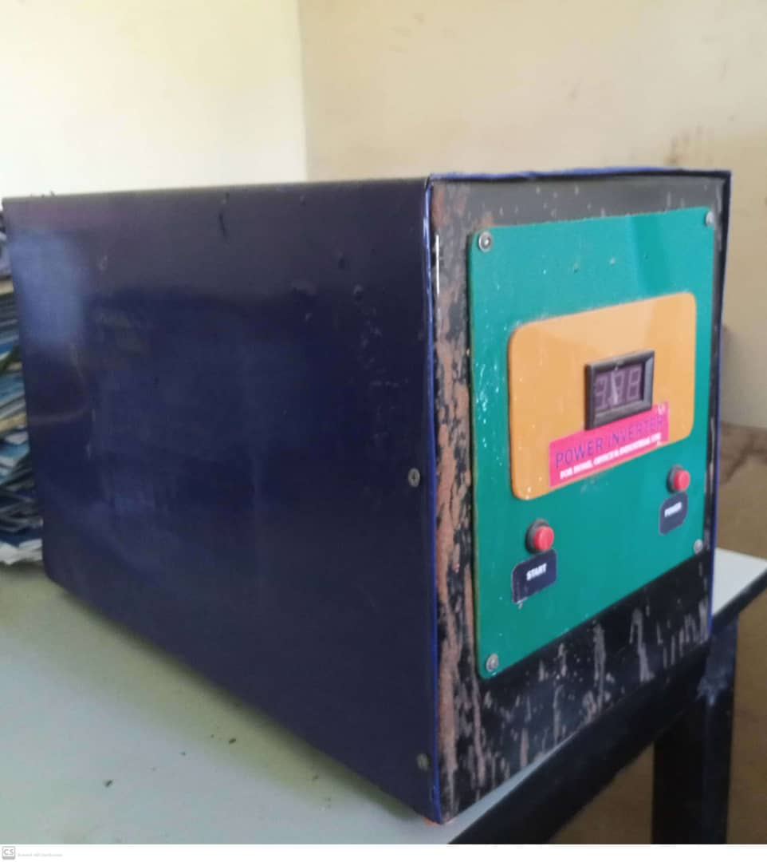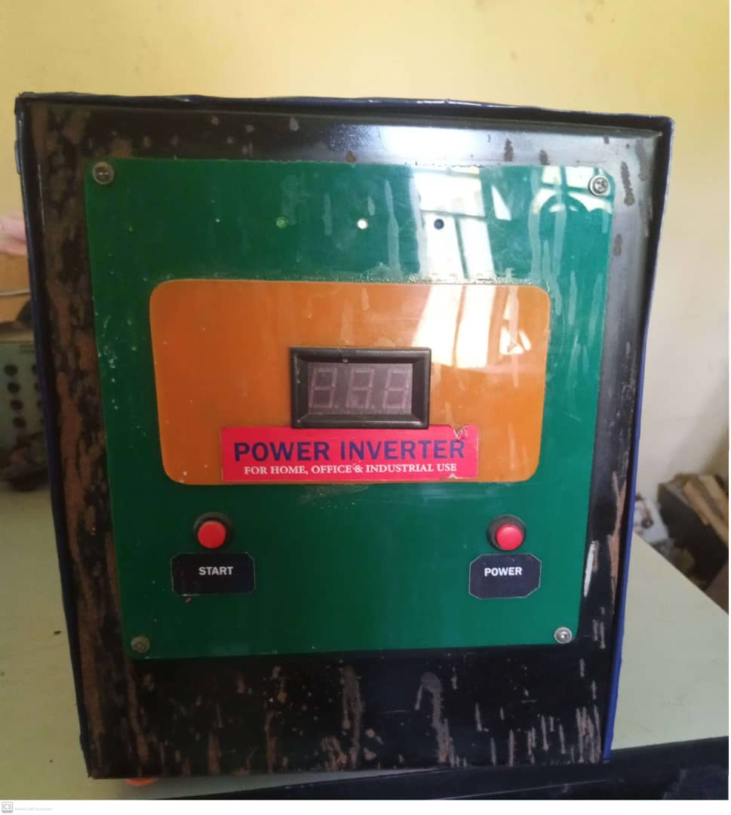
Fig. 4.3 Final picture of the 3KVA inverter System

