CHAPTER THREE
3.1 PROJECT METHODOLOGY
The methodology employed in the research project consist two main stages. First, the design and construction of the 3kVA locally made inverter and secondly, the performance analysis.
3.2 DESIGN AND CONSTRUCTION OF 3KVA INVERTER
Most of us take the mains Ac supply for granted and use it almost casually without giving the slightest thought of Its inherent shortcomings and the danger posed to sophisticated and sensitive electronic instruments and equipment. For ordinary household appliances such as incandescent lamps, tubes, fan, TV and fridge, the mains ac supply does not make such difference, but when used for computers, medical equipment and telecommunication systems, a clean, stable interruption free power supply is of the outmost importance of the myriad of devices, processes and system which rely on ac power, computer are probably the most sensitive to power disturbances and failure. Interruptions in power supply may cause contents of memory to be lost or corrupt. The central processing unit of the system may malfunction or fail. In order to protect a sensitive system from power losses and blackouts, an alternative power source is required that can switch into operation immediately when disruption of the mains occurs. An uninterruptible power supply (UPS) is just such an alternative source. A UPS generally consists of a rectifier, battery charger, a battery bank an inverter .the rectifier should have its input protected and should be capable of supplying power to the inverter when the commercial supply is either slightly below the normal voltage or slightly above. There are three distinct types of uninterruptible power supply system, namely, online UPS, offline UPS and electronic generators[8].
3.2 ONLINE UNINTERRUPTIBLE POWER SUPPLY SYSTEM
In the online UPS whether the mains power is on or off, the battery operating or connected to the inverter is on all the time and supplies the AC output voltage. When the mains power supply goes off, The UPS will be on only until the battery gets discharged, when the main power resumes, the battery will get discharged again.
3.3 OFFLINE UNINTERRUPTIBLE POWER SUPPLY SYSTEM
In the offline UPS and electronic generators UPS, their inverter is off when the power is present and the output voltage derived directly from the mains is the same as the mains supply voltage. The inverter turns on only when the main supply goes off. Recent demand survey shows that demand rate is in the order of electronic generators UPS, offline UPS and then online UPS. Although the offline and online UPS system are somewhat prefer in places where PC or computes are used, the demand for online ups systems is less than for offline UPS systems because of the online UPS system is higher.
3.4 ELECTRONIC OF THE CIRCUIT DIAGRAM
This section explicitly dealt with some of the electrical technicalities that were considered in the making of the project. Some explanation takes authority or support from manufacturer guide or handbook and datasheet of some the components used.

3.4.1 THE TRANSFORMER
The input to the primary winding of the transformer (T1) is 240V. The secondary winding can be raised up to 27 volts if the value is at least 24 volts running 4 amps, the fuse (FS1) acts as a mini circuit breaker for protection against short circuits or a detective battery cell in fact. The presence of electricity will cause the LED1 to light. The light of LED will set off upon power outage and UPS battery will take over. The circuit was designed to offer more flexible pattern where in it can be customized by using different regulators and batteries to produce regulated and unregulated voltage. Utilizing two 24volts batteries in series and positive input 7815 regulator can control a 27v supply.

3.5 THE ELECTRONICS OF AN INVERTER SYSTEM
The basic principle in terms of operation of a UPS is a device that can convert the chemical energy stored in a battery to electrical energy. Although the process of conversion (inverting) require some stages to be fulfilled, some of the stages are discuss next.
- THE RECTIFICATION STAGE: It is a rectifier stage which simply means the conversion of alternating signal (AC) into direct signal (DC). It has two main functions. Firstly the alternating current (AC) into direct current (DC), through the supply of filtered load, or the supply inverter. Secondly, to provide battery charging voltage, therefore it also plays a role in the charging section.
- BATTERIES BANK: The batteries are used as a storage energy device, which consist of several cells in series, with a capacity to maintain its size which determine the discharge (supply) time. Its main function is that when electricity is normal, the energy converted into chemical energy stored in the battery interval; when the electricity tails, the chemical energy provided to the inverter or the load.
- INVERTING STAGE: Generally, inverting is a direct current (DC) to alternating current (AC) process. It mainly consists of the oscillation stage.
- STATIC SWITCH: It is a contact typed switch, in this project design, FET and electromechanical rely are employ for the switch stages.
- OSCILLATOR STAGE:- this is a stage that receivers voltage from the battery, this is a stage where the circuit generate frequency from D.C to A.C .This is a device (stage) that increase the power of a signal. It does this by taking energy from a power supply and control the output this to match the impute signal shape but with lager amplitude.in this case (sense) from amplifier modulates the output of the power supply. This stage is couple with some electronic services like transistor, resistor, capacitor, variable resistor; integrate circuit (IC) etc. And we make use of IC with Chirp. All the output it will generate it will not more than 5volts (7805).
- INTEGRATED CIRCUIT: - it can also called I.C in clip they are very complex in construction. An IC has a pin which in numbered anticlockwise round the chip starting at notch in dot. In this circuit, we make use of CD4047 with 14 legs.
- BIPOLAR JUNCTION TRANSISTOR (BJT): this has base, collector and emitter as a terminal. The base a very than layer, has server doping atom them emitter and connector, this very small current emitter collector flow.
- DRIVER STAGE: This is where lower voltage is converted to high current through use of Mosfet. This Mosfet is the main component in this stage, and it has three terminal, the source, drain and gate, (S.D.G). When the drives stage received the signal it will free or force the gate in order to generate high current .This mosfet it couple with 1000ohms resistor connected to the mosphet. In the circuit we have six (6) mosfet connected together and 6 resistor as well.
- TRANSFORMER STAGE: We make use of transformer in this stage, this is a stage Where we generate and final (AC) alternative current i.e. 220V 50Hz. This stage is mainly made if transformer, but to know the transformer is been constructed it couple
with some component and follows some laws that give it.
3.6 DESIGN EQUATIONS AND CALCULATIONS
This section presents the fundamental design equations and calculations used for the locally designed and constructed 3kVA pure sine wave inverter system. These calculations are based on standard power electronics principles and align with established references from reputable sources in the field.

1. Output Power Requirement
The rated power of the inverter is 3kVA. Since it is a single-phase system, the relationship between power, voltage, and current is given by:
P = V × I × Power Factor
Assuming Power Factor (pf) = 1:
I = $\frac{p}{v}$ = $\frac{3000VA}{220V}$ = 13.64 A Rashid, M. H. (2013)

2. Inverter Efficiency
Efficiency (η) is defined as:
η = $\frac{Pout}{Pin}$ × 100%
Assuming 90% efficiency:
P_in = $\frac{Pout}{η}$ = $\frac{3000}{0.9}$ = 3333.33W Mohan, N et. al, (2003)

3. Battery Current Requirement
Given DC Input Voltage VDC = 24 V:
IDC = $\frac{Pin}{VDC}$ = $\frac{3333.3}{24}$ = 138.89 A

4. Battery Capacity (Ah)
For 2 hours of backup time:
Battery Capacity = IDC × Time = 138.89 × 2 = 277.78 Ah
Use two 12V/200Ah batteries in series.

5. Transformer Turns Ratio
Transformer that steps up from 24V DC to 220V AC:
Turns Ratio = $\frac{Ns}{Np}$ = $\frac{Vs}{Vp}$ = $\frac{220}{24}$ = 9.17
If Np = 15 turns, then Ns = 15 × 9.17 =138 turns Nelson, J. D. (2004).

6. PWM Frequency
To ensure low harmonic distortion, the typical PWM frequency used is around 20 kHz.
Bose, B. K. (2002).

7. Output Voltage Regulation
To maintain voltage stability under varying loads:
Vout = Vref × (1 +$\frac{R1}{R2}$ )

8. Heat Dissipation in MOSFETs
Power loss in switching device:
P loss = V DS(on) × I D × Duty Cycle

Summary of Component Ratings
Component | Rating / Value
Inverter Power | 3kVA (3000 VA)
DC Input Voltage | 24V (2 × 12V Batteries)
AC Output Voltage | 220V, 50 Hz
Battery Capacity | 2 × 12V, 200Ah (in series)
Transformer Ratio | 1 : 9.17 (24V to 220V)
MOSFETs | e.g., IRF3205, 6 in parallel
PWM Frequency | ~20 kHz
Output Waveform | Pure sine wave
Voltage Regulator | L7805 (5V supply for ICs)

3.7 CIRCUIT DIAGRAM
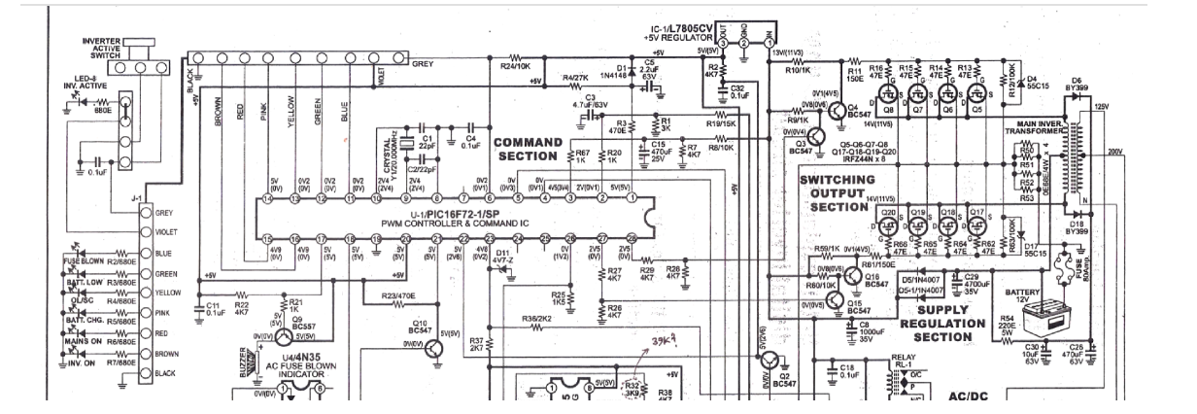
Figure 3.1 Circuit Diagram for 3kVA Inverter system

3.7.1 EXPLANATION OF THE CIRCUIT DIAGRAM
- Inverter Active Section Switch: This i the part of the circuit responsible for switching the DC power from the input (usually a battery or DC power source) into AC power output. It might include MOSFETs or IGBTs (Insulated Gate Bipolar Transistors) configured in a way that allows them to switch on and off rapidly, creating an alternating current.
- System Indicator: This is a component or set of components that indicate the status of the inverter system, such as whether it's operating correctly, in standby mode, or experiencing an issue.
- Processor IC (PIC 16672-1/sp): This is the main controller of the inverter system. It's a micro-controller, specifically a PIC (Peripheral Interface Controller), which is likely programmed to manage various functions of the inverter, such as generating PWM (Pulse Width Modulation) signals to control the switching of the active section, monitoring system parameters, and possibly communicating with external devices.
- Command Section: This part of the circuit contains resistors, capacitors, transistors, and possibly other components that are used to interface the processor IC with the rest of the circuit. It may include circuitry for signal conditioning, level shifting, or protection.
- Regulator (L7805CV): This is a voltage regulator IC (Integrated Circuit) that ensures a stable 5-volt supply voltage to power the processor IC and possibly other components in the circuit.
- Switching Output Side: This section of the circuit consists of relays and transistors that are used to control various loads or external devices connected to the inverter output. The relays may be used for switching between different output configurations or for providing power to different loads.
- Supply Regulation Section: This section includes components such as capacitors, diodes, and possibly voltage regulators, which are used to regulate and stabilize the DC power supply to different parts of the circuit.
- Main Transformer Section: This is the part of the circuit that includes the main transformer, which is responsible for converting the DC input power into AC output power. The transformer may include multiple windings for different voltage levels and may be designed for step-up or step-down operation depending on the application.

