CHAPTER THREE
MATERIALS AND METHODOLOGY
3.1 Preamble
This research project was designed and implemented in two phases: hardware development and system simulation. The methodology includes sourcing components locally in Ilorin, Kwara State, Nigeria, assembling the circuit, programming the Arduino, and testing the system in a simulated environment.
3.2 Materials and Their Sources in Ilorin
Table3.1ListofMaterialsandtheirsources
Component | Specification | SourceinIlorin
Arduino Uno | AT mega 328 P micro controller board | Kwara tech Electronics,Tanke Junction
Ultrasonic Sensors (2x) | HC-SR04, range: 2cm-400cm | JKK Electronics, Challenge Bookshop Complex
Servo Motors (2x) | SG90 Micro Servo | Tech city Hub, Unity Road
LEDs (Red and Green) | 5mm, 2V | Ilorin Electronics Market, Taiwo Isale
Buzzer | 5V Piezo electric Buzzer | Just Electronics, GRA Junction
Jumper Wires | Male-to-Male, Male-to-Female | Unity Road Market
Bread board | 830-point | Kwara tech Electronics Tanke Junction
Resistors | 220Ω,330Ω | JKK Electronics
Power Supply | 9V Battery or 5V USB Adapter | Tech City Hubor Spar Mall
Laptop with Arduino IDE | For Programming and Simulation | University of Ilorin ICT Lab/Personal Laptop

3.3 RESEARCH PROCEDURE
Step1: Component Acquisition
Electronic components were identified based on compatibility with Arduino. Vendors across Ilorin (Tanke, Taiwo, Unity Road) provided reliable access to affordable and tested hardware.
Step2: Circuit Design and Assembly
- A schematic was drawn with Arduino Uno as the main controller.
- The entry ultrasonic sensor was placed before the crossing, and the exit sensor after it, to detect train approach and departure.
- Two servo motors controlled mock barrier gates.
- LEDs represented traffic lights (Red and Green).
- A buzzer provided audible warnings.
All connections were made on a bread board using jumper wires, with current-limiting resistors for the LEDs.
Step3: Arduino Programming (C/C++)
- Programming was done using Arduino IDE in C/C++ language. The logic flow followed:
- When the entry sensor detects a train (distance < 30cm):
- Buzzer is activated.
- Red light turns ON.
- Servo motor lowers the gate,
- When the exit sensor detects the train has left:
- Buzzer turns OFF.
- Green light turns ON.
- Servo motor raises the gate.
Sample Code Snippet:
#include < Servo.h>
Servo gate;
const int triggerPin = 9;
const in techoPin = 10;
const int redLed = 6;
const int greenLed = 7;
const int buzzer = 5;
void setup(){
pinMode(triggerPin, OUTPUT);
pinMode(echoPin, INPUT);
pinMode(redLed, OUTPUT);
pinMode(greenLed, OUTPUT);
pinMode(buzzer, OUTPUT);
gate.attach(3);// Servo connected to pin 3
Serial.begin(9600);
}
Void loop(){
long duration;
int distance;
digitalWrite(triggerPin, LOW);
delayMicroseconds(2);
digitalWrite(triggerPin, HIGH);
delayMicroseconds(10);
digitalWrite(triggerPin, LOW);
duration = pulseIn(echoPin, HIGH);
distance = duration *0.034/2;
if (distance <30){
digitalWrite(redLed, HIGH);
digitalWrite(greenLed, LOW);
digitalWrite(buzzer, HIGH);
gate.write(0); // Close gate
}else {
digitalWrite(redLed, LOW);
digitalWrite(greenLed, HIGH);
digitalWrite(buzzer, LOW);
gate.write(90); // Open gate
}
delay(100);
}
Step4: System Testing and Calibration
- Sensors were tested for accurate readings under different object distances.
- Trigger distances were calibrated to detect model trains at 20-30cm.
- The servo motor’s closed and open angles were set to 0º and 90º, respectively.
- The buzzer’s timing was adjusted to avoid unnecessary noise post-departure.
Step5: Simulation on Tinker cad
- Auto desk Tinker cad was used to simulate the entire circuit virtually.
- Components were placed in a simulated environment.
- The same Arduino code was uploaded to test barrier operations and sensor responses.
- Real-time debugging was done using the Serial Monitor and visual observations.
Step6: Evaluation and Troubleshooting
- The system was tested repeatedly for consistency.
- Any false triggers from sensors were addressed by: Adjusting sensor alignment, adding debounce delays in the code, using software averaging for distance measurements.
Step7: Documentation and Analysis
- All findings and behaviors were documented.
- Observations confirmed that the system met its intended objectives.
- Identified are as for improvement (e.g., sensor sensitivity to light and sound interference).

Component | Specification | Source in Ilorin
Arduino Uno | ATmega328P microcontroller board  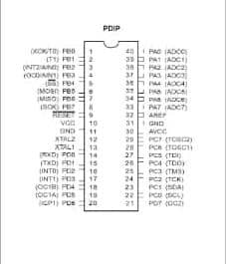 | Kwaratech Electronics, Tanke Junction
Ultrasonic Sensors (2x) | HC-SR04, range:2cm–400cm  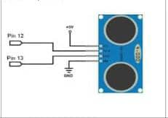 | JKK Electronics, Challenge Bookshop Complex
Servo Motors (2x) | SG90 Micro Servo 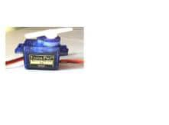 | Tech City Hub, Unity Road
LEDs (Red & Green) | 5mm, 2V  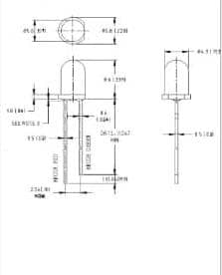 | Ilorin Electronics Market, Taiwo Isale
Buzzer | 5V Piezo electric Buzzer  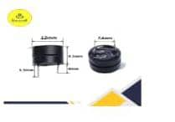 | Just Electronic, GRA Junction
Jumper Wires | Male-to-Male, Male-to-Female  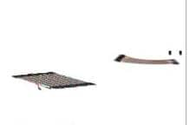 | Unity Road Market
Bread board | 830-point  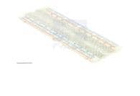 | Kwaratech Electronics, Tanke Junction
Resistors | 220, 330  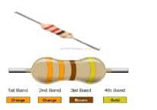 | JKK Electronics
Power Supply | 9V Battery or 5VUSB Adapter  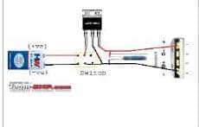 | Tech City Hubor Spar Mall
Laptop with ArduinoIDE | For programming and simulation  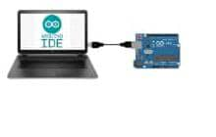 | University of Ilorin ICT Lab/Personal Laptop

