Components | Specifications | Source in Ilorin
Arduino Uno | ATmega328P microcontroller board  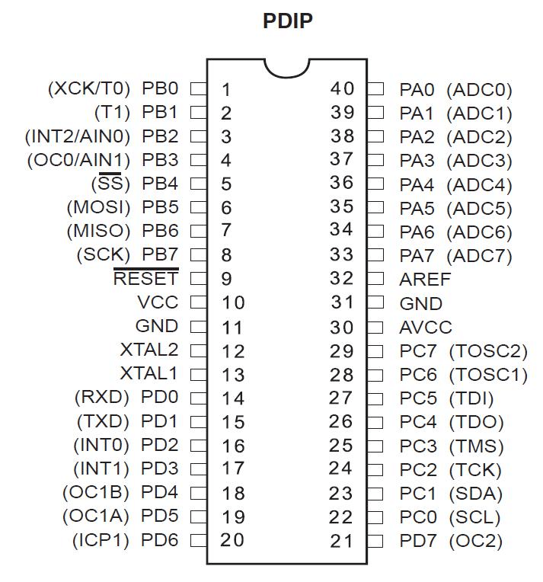 | Kwaratech Electronics, Tanke Junction
Ultrasonic Sensors (2x) | 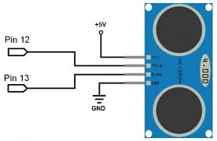HC-SR04, range:2cm-400cm | JKK Electronics, Challenge Bookshop Complex
Servo Motors (2x) | SG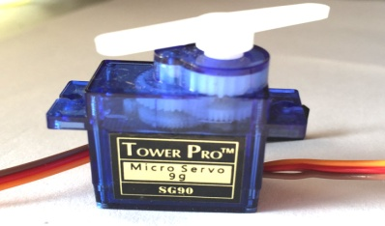90 Micro Server | TechCity Hub, Unity Road
LEDs (Red &Green) |  | Ilorin Elcetronics Market, Taiwo Isale
  5mm,2V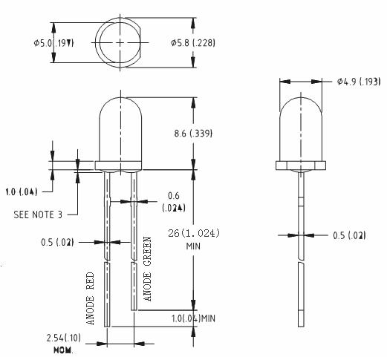
Buzzer | 5vl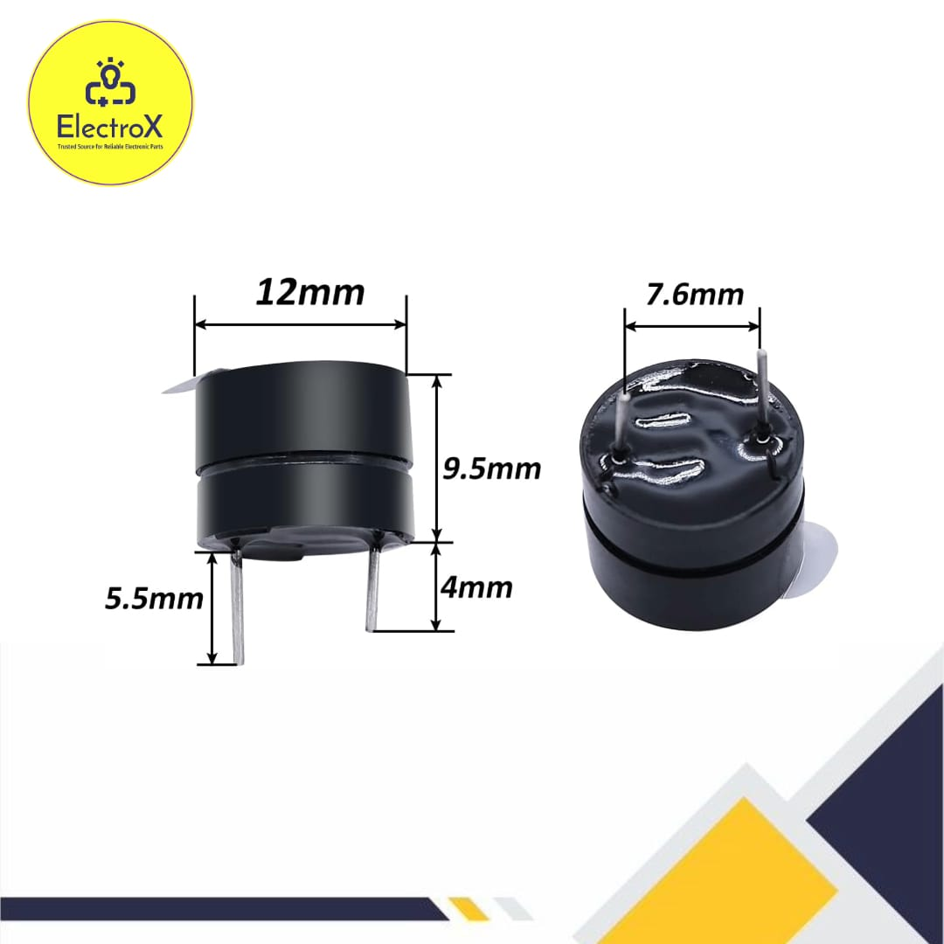V Piezoelectric Buzzer | JustElectronic GRA Junction
Jumper Wires | 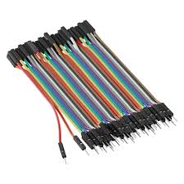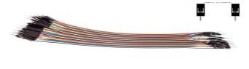Male-to-Male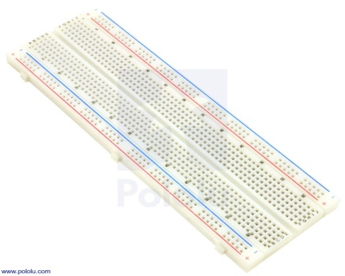, Male -to-Female | Unity Road Market
Breadboard | 830-point | Kwaratech Electronics, Tanke Junction
Resistors | 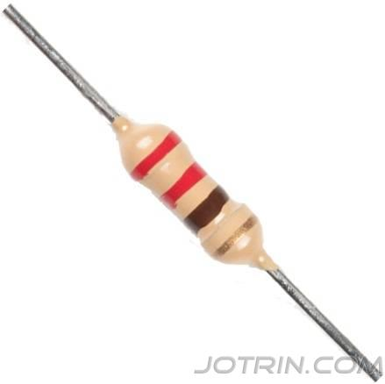22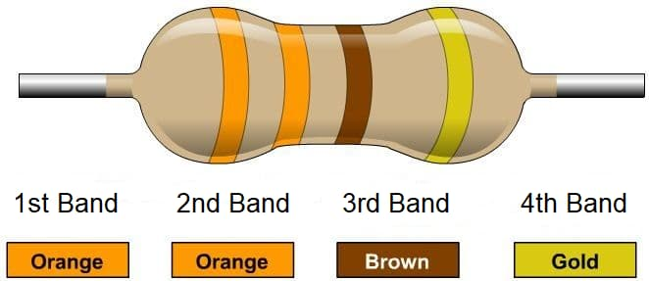0,330 | JKK Electronics
Power Supply | 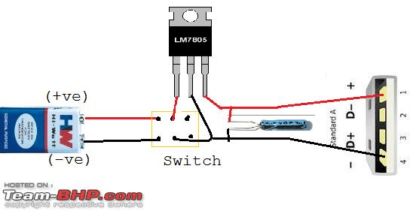9V Battery or 5V USB Adaptor | TechCity Hub or Spar Mall
Laptop with Arduino IDE | 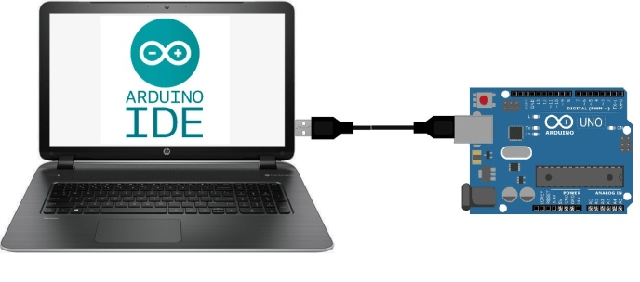For Programming and Simulation | University of Ilorin ICT Lab/Personal Laptop

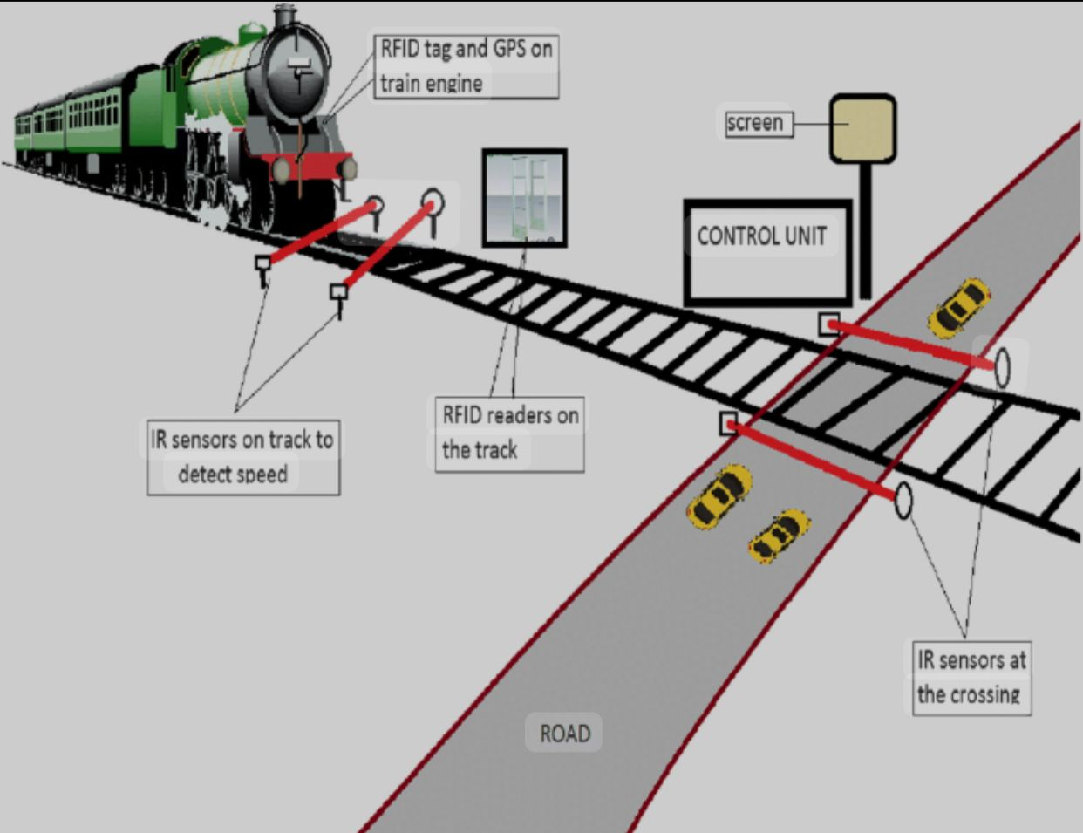S

