
TECHNICAL REPORT
ON
STUDENTS’ INDUSTRIAL WORK EXPERIENCE
SCHEME (SIWES)
Undertaken at
ADE ELETRICIAN AND ELECTRONIC TECHNOLOGY
AT OSERE JUNCTION, SAW-MIL, ILORIN

Written by
ADENIYI OLUWATIMILEYINJOB
ND/23/EEE/PT/0091
DEPARTMENT OF ELECTRICAL AND ELECTRONIC ENGINEERING
KWARA STATE POLYTECHNIC
Submitted To:
DEPARTMENT OF ELECTRICAL AND ELECTRONIC ENGINEERING INSTITUTE OF TECHNOLOGY, KWARA STATE POLYTECHNIC, P.M.B. 1376 ILORIN
IN PARTIAL FULFILLMENT OF THE REQUIREMENT FORAWARD OF NATIONAL DIPLOMA (ND) CERTIFICATE IN ELECTRICAL AND ELECTRONIC ENGINEERING
AUGUST-DECEMBER 2024

DEDICATION
This report is dedicated to Almighty God the creator and the finisher of our faith, the one who strengthen and spare my life to complete my SIWES programme. May his name be glorified forever? And to my lovely parent in person of Mr and Mrs Adedokun for their spiritual moral and financial support towards the completion of the programme.
ACKNOWLEDGEMENT
My gratitude and sincere appreciation goes to Almighty God for his guidance and protection over my family, also for the strength and wisdom granted to me throughout my SIWES programme.
I wish to express my profound gratitude to my SIWES supervisor and other lecturers in the Electrical and Electronics department.
I also give thanks to the Adam crew, starting from the owner of the company, Engineer Adam and my other colleagues.
I also appreciate the effort of my parent of Mr and Mrs Adedokun over me. I pray God will keep blessing them.

CHAPTER ONE
1.0 INTRODUCTION

1.1 BRIEF HISTORY OF STUDENTS WORK EXPERIENCE SCHEME (SIWES)

SIWES is the accepted skill training programme which forms part of the approved minimum academic standards in the various degree programmes for all the Nigerian universities. It is an effort to bridge the gap existing between theory and practical of engineering and technology, science, agriculture, media management and other professional education programme in the Nigerian tertiary institutions.
The Students Industrial Work Experience Scheme (SIWES) was initiated in 1973 by the Industrial Training Fund (ITF). This was in response to the mandate given to the ITF through decree 47 of 1971, charging it with the responsibility of promoting and encouraging the acquisition of skills in the industry and commerce with the view to generating a pool of trained indigenous manpower sufficient to meet the need of the nation’s economy. The Industrial Fund (ITF) introduced the scheme for employers to be involved in the entire educational process of preparing student for employment in our various industries with the vision "To be the foremost skills training and development organization in Nigeria and one of the best in the world" and mission "To set and regulate training standards and offer direct training interventions in industrial and commercial skills training and development, using a corps of highly competent professional staff, modern techniques and technology".
1.2 AIMS AND OBJECTIVES OF SIWES:
The aim of SIWES is to put students through the labour market for them to apply and incorporate their classroom knowledge into the working practice of engineering and technology and other fields.

The objectives of SIWES programme include:
- The opportunity of being familiarized and exposed to the mode of work, handling of
- To impact practical method of performing professional functions to undergraduate of the tertiary institutions
- Provision of an enabling environment where student can develop personal attributes such as critical thinking, creativity, leadership, time management, presentation skills and interpersonal skill and other.
- It make student appreciate the roles of their professions which enable them be a creators of change and contribute to grow of the economy and national development.

BENEFITS AND CHALLENGES OF SIWES
- It’s gives opportunity for student to be in direct contract with junior, immediate and senior professional staff in the industry.
- There are several benefits derived from SIWES, some of which are:
- Its gives student opportunity of getting employment if such student if such student prove himself worthy of getting employed, and for the industries to evaluate the prospective employers.
- Successful SIWES operation provides the government the opportunity of reducing the importation of expatriate Engineers and professional personnel.

CHAPTER TWO

2.0 THE ORGANIZATION CHARTS

DIRECTOR

SECRETARY

I.T STUDENT

ELECTRICAL WORKSHOP SIWES STUDENT

2.1 UNIT OF THE ORGANIZATION AND THEIR SPECIFICATION

i. Electrical installation ii. Transformer etc.

2.2 TOOLS USED IN ELECTRICAL INSTALLATION AND THERE USES
FIXING TAPE: It is used to pull standard or solid wire through mutual PVC conduit
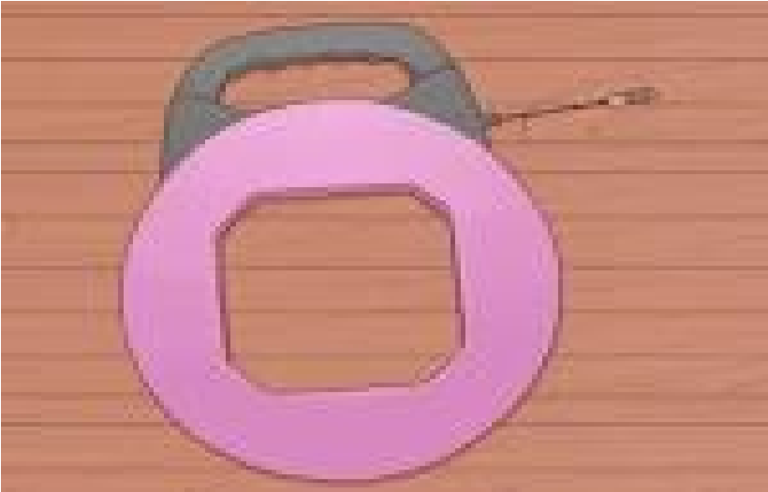

TAPE MEASURE: it is used to measure height for switches and outlets.

HAMMER: it is used to secure boxes equipped with nail on brackets studs in a home. Its also used to clip down wires in surface wiring.


VOLTMETER: it is used to check voltages and verify that circuits are indeed “live”

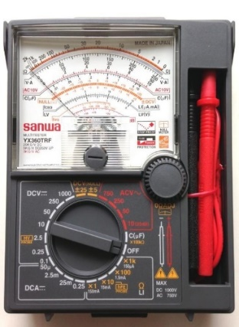

GLOVES: it is used to guide against electrical and mechanical damages to the body.


ALLEN KEYS SETS: it is used to lighted Allen headed screws in electrical works.
BLADE/KNIFE: it is used to cut the installation off the insulated wire.
STAR SCREWDRIVER OR (PHILLIPS SCREWDRIVER): it has a blade for installing star head screw. The tips look like a plus sign.
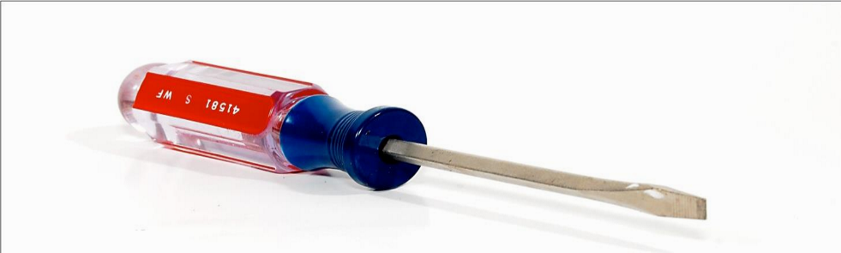

TESTER: it is a tool used to detect the flow of current in the system or in a cable and it comprises of three components inside which are the bulb, insulators and lead.

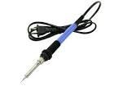
SOLDERING IRON: it is used for soldering of a panel with the use of the soldering bit.

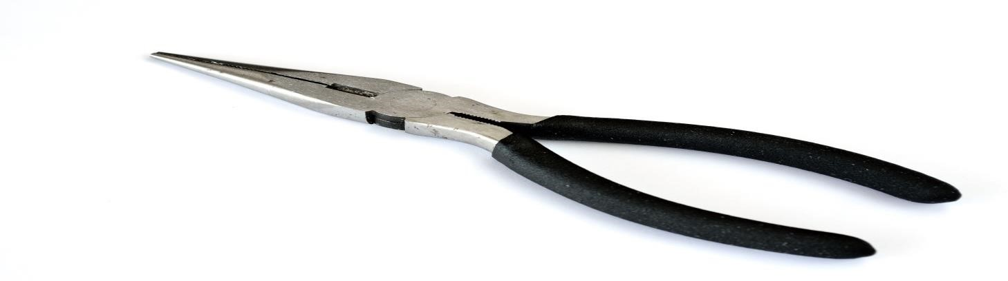
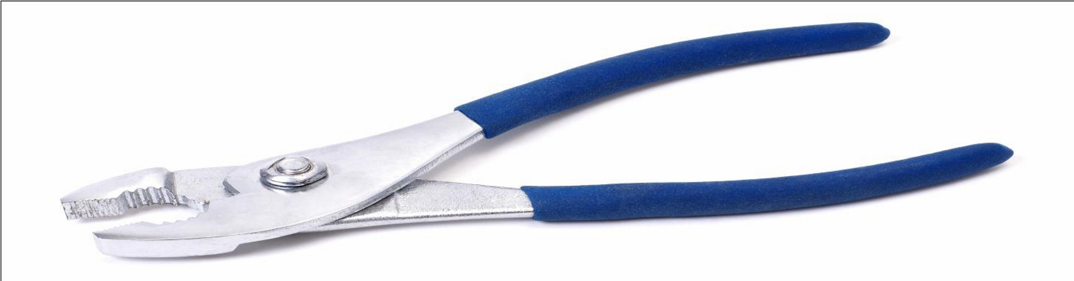
PLIER: it is used for cutting, disconnecting or for remover of installation material like rubber from the conductor, it can also be used to hold material firmly in order to couple the material together. There are various types of pliers which are the Long Nose Pliers and Cutting Pliers.
2.3

ACCESSORIE
S USED IN ELECTRICAL INSTALLATION

Accessory is any device other than a lighting fitting associated with the wiring and current using appliance of an installation
SWITCH: it’s a device other than a fuse or circuit breaker for closing and opening a circuit. They are various types of switch they are one gang way switch, two gang one way switch, three gang one way switch, two gang two way switches etc.
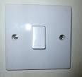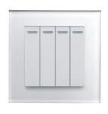

LIGHTING FITTING: It is a device that contains a lamp or lamps together with any holder, shade or reflector, for example wall bracket fitting, lamp holder, a fluorescent.
JOINT BOX: it is a box connecting two or more length of conduit duct and trunking example T joint, U joint, Through box, etc.
CIRCUIT BREAKRS: It is a mechanical device for making and breaking a circuit both under normal and abnormal condition, such as those of a short circuit, the circuit being broken automatically.
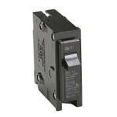
JUNCTION BOX: It is a forming part of a wiring of an installation (usually surface) provided to contain joints in the conductor.

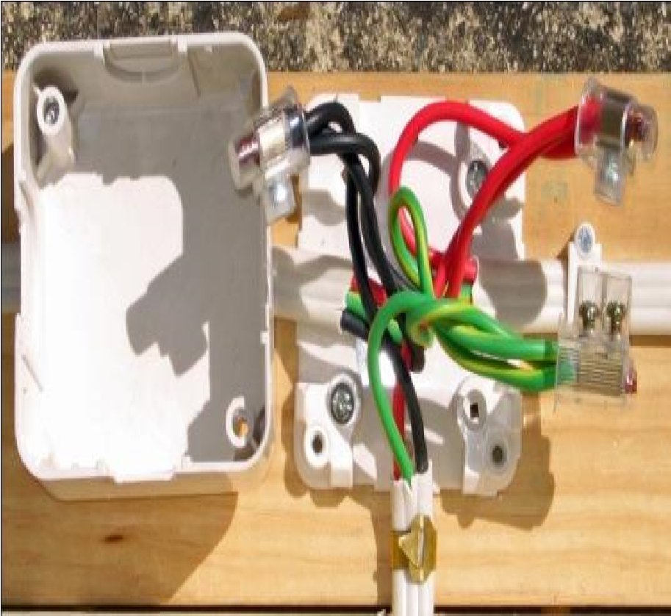
DISTRIBUTION BOARD: It is a device that all breakers switches are inside or device where all mains from each destination are being taped into.
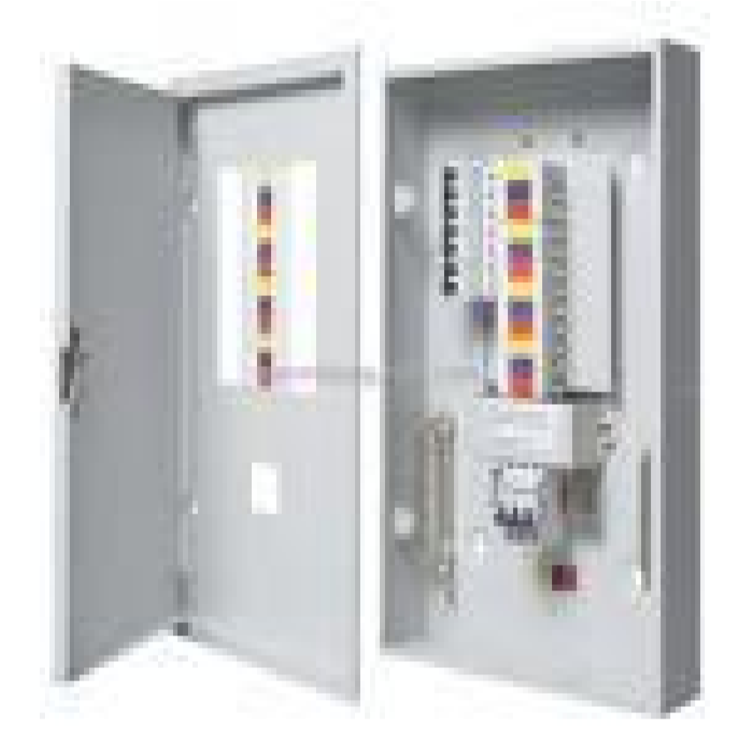
SOCKET: It is a device that connect a plug or electronics device to electric circuit examples are,
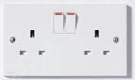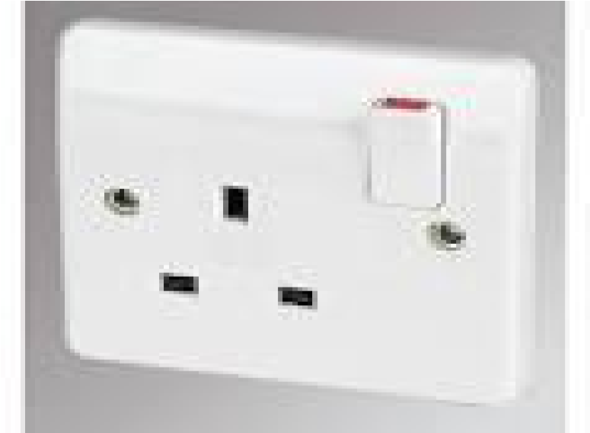
13
amp socket, 15 amp socket etc.

CHANGE OVER SWITCH: It is a device that changes electrical supply from one main to other.
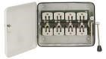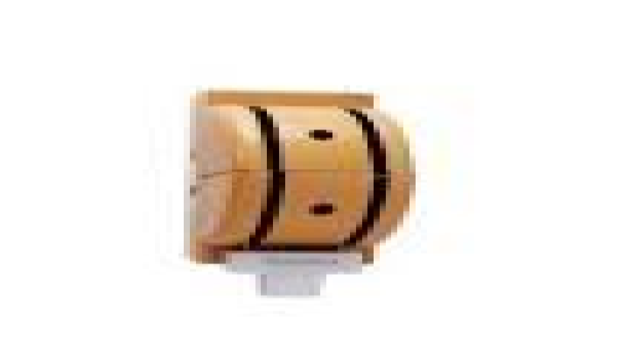

2.4 CABLES USED IN ELECTRICAL INSTALLATION
It is a length of insulated single conductor (solid or stranded) or two or more such conductor, each provided with its own insulation which are laid up together. The insulated conductor may or may not be provided with all overall covering for mechanical protections.
1.5mm (3029) wire: - this is used for lighting
2.5mm wire: - it is used for 13amp socket outlet
4mm wire: - it is used for AC and cooker socket outlet
10mm wire: - it is used for connection of meter or change over to distribution board
16mm wire: - it is used for connection of power supply from the electric pole to the meter.

CHAPTER THREE
3.1 TO REPLACE A WASHING MACHINE CAPACITOR
To replace a washing machine capacitor, you need to:
- Disconnect power:
Unplug the washing machine from the power outlet.
- Access the capacitor:
Remove any panels or covers necessary to access the capacitor, usually located near the motor.
- Locate the capacitor:
Identify the capacitor, which is a cylindrical component with wires attached.
- Discharge the capacitor:
Use a screwdriver with an insulated handle to touch both capacitor terminals together, releasing any stored electrical charge.
- Remove old capacitor:
Loosen and remove the screws holding the capacitor in place, disconnect the wires attached to it, and carefully remove the old capacitor.

- Note wire connections:
Before removing the wires completely, carefully note the position of each wire on the old capacitor to ensure proper reconnection.
- Select new capacitor:
Choose a replacement capacitor with the same microfarad (uF) rating and voltage as the old one.
• Connect new capacitor:
Attach the wires to the new capacitor according to the noted positions from the old one, ensuring correct polarity.
- Secure mounting:
Mount the new capacitor in the same position as the old one, tightening the screws securely.
- Reassemble and test:
Reattach any panels removed, plug the washing machine back in, and test its functionality.
Important considerations:
- Safety first:
Always discharge the capacitor before handling it to avoid electrical shock.
- Match specifications:
Ensure the new capacitor has the same microfarad rating and voltage as the old one.
- Professional help:
If you are unsure about replacing the capacitor, consider seeking assistance from a qualified appliance repair technician
3.2 HOW TO REPAIR STREET LIGHT
To repair a street light, a technician would typically: identify the issue causing the outage (like a faulty bulb, damaged wiring, or a malfunctioning fixture), access the light fixture safely, replace the damaged component, secure all connections, and test the light to ensure it's functioning properly; this usually involves using specialized tools like ladders, insulated gloves, and sometimes a bucket truck depending on the height of the light pole.
Key steps in street light repair:
- Assess the problem:
- Check if the bulb is burnt out.
- Inspect the wiring for any damage or loose connections.
- Examine the fixture for signs of wear or malfunctioning components.
- Access the light fixture:
- Use a ladder or bucket truck to reach the light fixture safely.
- Secure the ladder properly and follow safety protocols.
- Replace faulty components:
- If the bulb is the issue, carefully remove the old bulb and install a new one.
- If wiring is damaged, cut out the damaged section and splice in new wire, ensuring proper insulation.
- If the fixture itself is malfunctioning, depending on the severity, it may need to be repaired or replaced.
- Secure connections:
- Tighten all wire connections to prevent loose wires or potential sparking.
- Ensure all connections are properly insulated.
- Test the light:
- Turn on the power to the street light and check if it is functioning correctly.
- Look for any flickering or dimness, which might indicate a problem that needs further attention.
Important considerations:
- Safety first:
Always wear appropriate safety gear like insulated gloves, safety glasses, and high-visibility clothing.
- Proper training:
Street light repair should be performed by qualified technicians with proper training and knowledge of electrical systems.
- Local regulations:
Adhere to any local regulations or permitting requirements for street light maintenance

3.3 TO REPLACE AN ELECTRIC POLE
To replace an electric pole, the primary steps include: obtaining necessary permits, safely de-energizing the lines, removing the old pole, installing the new pole, reattaching electrical equipment, restoring power, and conducting a final inspection; all while ensuring proper safety protocols are followed throughout the process.
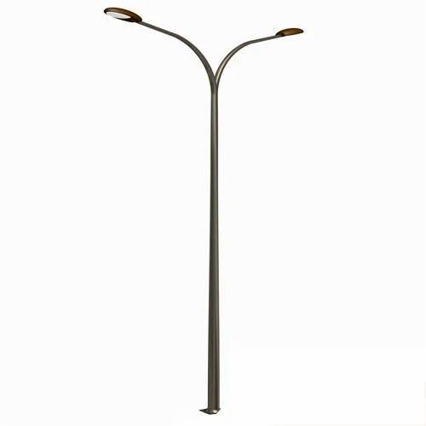
Detailed steps:
- Planning and Permitting:
- Contact the utility company to coordinate the replacement and obtain any required permits.
- Assess the condition of the existing pole and determine the need for replacement.
- Choose a qualified electrician or utility crew to perform the work.
- Preparation and Safety:
- Mark the location of the new pole to ensure proper placement.
- Set up safety barriers and warning signs to isolate the work area.
- De-energize the power lines by shutting off the circuit at the appropriate switch.
- Removing the Old Pole:
- Carefully disconnect all electrical equipment attached to the old pole, including wires, transformers, and insulators.
- Use appropriate equipment to safely remove the old pole from the ground, ensuring no damage to surrounding structures.
- Properly dispose of the old pole according to local regulations.
- Installing the New Pole:
- Position the new pole in the designated location.
- Securely set the pole in the ground using concrete or other appropriate anchoring methods.
- Ensure the pole is properly aligned and level.
- Reattaching Electrical Equipment:
- Carefully reattach all previously removed electrical equipment to the new pole, ensuring correct placement and connections.
- Install new hardware or components as needed.
- Final Inspection and Power Restoration:
- Conduct a thorough inspection of the new pole and all connections to verify proper installation and safety compliance.
- Energize the power lines and restore electricity to the affected area.
- Document the work completed and any necessary details.
Important Considerations:
- Weather conditions: Avoid replacing poles during severe weather conditions.
- Traffic management: Implement necessary traffic control measures if the replacement is near a road.
- Local regulations: Always follow all local electrical codes and permitting 3.4 TO REPAIR A STANDING FAN
- Disconnect power:
Unplug the fan from the power source.
- Disassemble the fan:
- Remove the front fan guard by loosening screws.
- Access the motor housing by removing screws holding the plastic cover.
- Carefully detach the fan blades from the motor shaft.
- Inspect components:
- Visually check for any damage to the blades, motor housing, or wiring.
- Check the motor shaft for wear and tear.
- Examine the capacitor for any bulging or leaks.
- Clean and lubricate parts:
- Use a damp cloth to clean the blades and motor housing.
- Apply a small amount of lubricating oil to the motor shaft bearings.
- Check for faulty components:
- Motor: Test if the motor spins freely by hand. If not, it may need replacement.
- Capacitor: Check if the capacitor is functioning properly by testing its capacitance with a multimeter.
- Switch: Verify that the power switch is working correctly.
- Replace faulty parts:
- If any components are damaged or malfunctioning, replace them with new ones of the same specifications.
- Reassemble the fan:
- Attach the fan blades back to the motor shaft.
- Securely reattach the motor housing cover with screws.
- Reinstall the front fan guard.
- Test functionality:
- Plug the fan back in and test if it operates properly at different speed settings.
Important considerations:
- Safety first: Always disconnect power before working on the fan.
- Refer to manual: Consult the user manual for specific instructions regarding your fan model.
- Professional help: If you are not comfortable repairing the fan yourself, consider seeking assistance from a qualified appliance technician

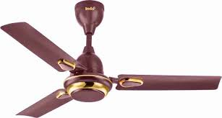

CHAPTER FOUR
4.1 TRANSFORMER AND ITS TYPES.
A transformer is high voltage (HV) electro-magnetic equipment used to transfer electrical energy from high voltage low current, to low voltage high current and vice versa, without changing the both transmitted power and frequency. A transformer is a passive component that transfers electrical energy from one electrical circuit to another or multiple circuits. A transformer transfers electrical energy which contains both current and voltage from one circuit to another, the circuit is made of a wound conductor namely primary and secondary coil, between these two circuits or wound conductors, one receives electrical energy in high current voltage low current and transmit the power to another circuit in low voltage high current, names primary and secondary coils respectively. There are two major types of transformer in transmission and distribution of electricity namely; Step-up and step-down transformers.
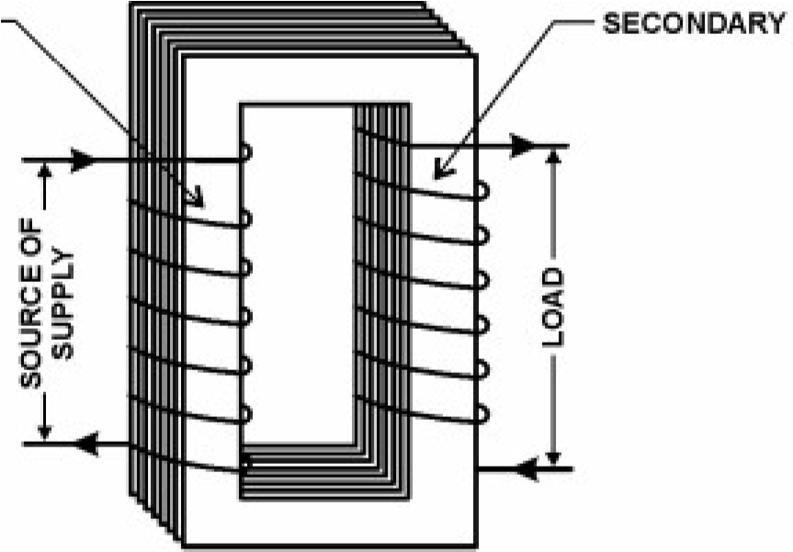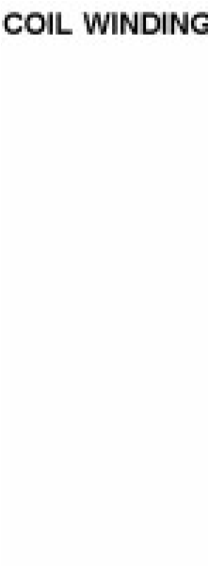

Transformer
Step-up transformer; A step-up transformer is a type of transformer that transfer electrical energy from one circuit to another in low voltage high current to high voltage low current usually of transmission. The primary winding component of a step up transformer receives an electrical energy in low voltage high current, there by transmitting the energy to the secondary winding in high voltage and low current. The reason behind the transmission of electrical energy using a step-up transformer is to reduce/minimises power lose during transmission. Distances in transmitting electrical power have an effect on the transmitted power in correspondence to the ohmic law. In an ohmic conductor the increasing length of the conductor is inversely proportional to the potential difference p.d, with this reason energy is transmitted from the generation to the transmission in high voltage low current to minimises the power lose/conductor lose.
Step-down transformer; A step down transformer is a type of transformer that receives electrical power in high voltage low current in its primary winding, and transmits power to the secondary in low voltage high current for a domestic consumption.
3.2 PRINCIPLE OF OPERATION OF A TRANFORMER.
Transformer function is based on the principle that electrical energy is transferred efficiently by magnetic induction from one circuit to another. When one winding of a transformer is energized from an alternating current (AC) source, an alternating magnetic field is established in the transformer core. Alternating magnetic lines of force, called “flux,” circulate through the core. With a second winding around the same core, a voltage is induced by the alternating flux lines. A circuit, connected to the terminals of the second winding, results in current flow. Each phase of a transformer is composed of two separate coil windings wound on a common core. The low-voltage winding is placed nearest the core; the high-voltage winding is then placed around both the low-voltage winding and core. See figure 2 which shows internal construction of one phase. The core is typically made from very thin steel laminations, each coated with insulation. By insulating between individual laminations, losses are reduced. The steel core provides a low resistance path for magnetic flux. Both high- and low-voltage windings are insulated from the core and from each other, and leads are brought out through insulating bushings. A three-phase transformer typically has a core with three legs and has both high-voltage and low-voltage windings around each leg. Special paper and wood are used for insulation and internal structural support.
Transformer action depends upon magnetic lines of force (flux) mentioned above. At the instant a transformer primary is energized with AC, a flow of electrons (current) begins.

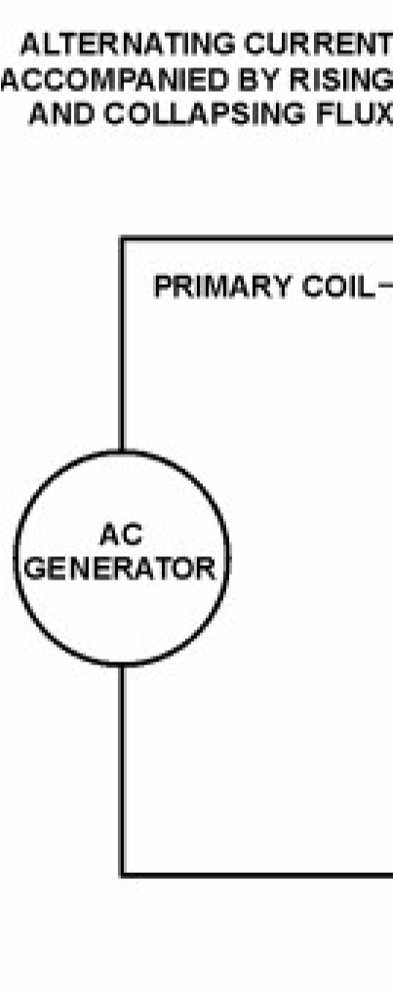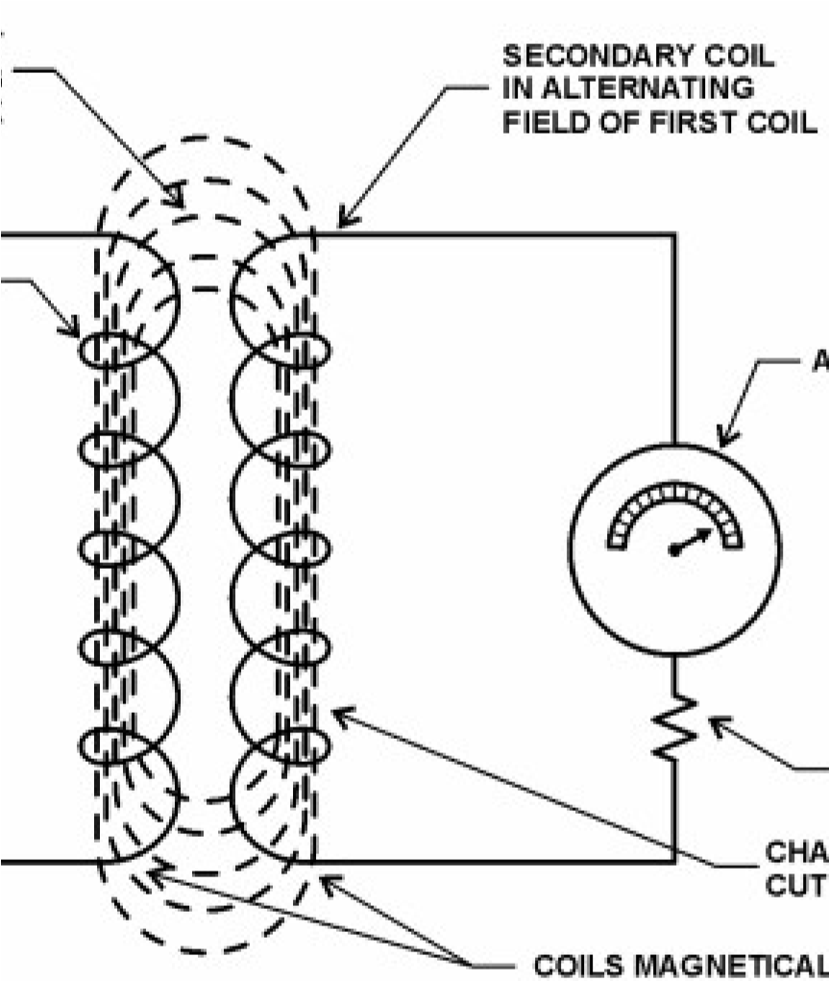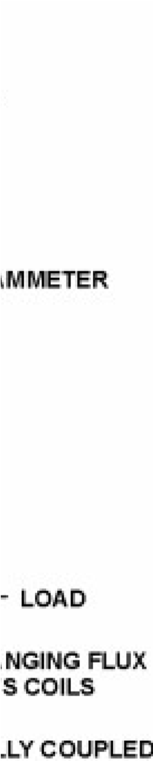

Fig2. Principle operation of a transformer
3.3 COMPONENTS AND PARTS OF A TRANSFORMER.
The components and parts of a transformer include;
Bushings; this are ceramic materials used to insulate terminals in the transformer, it consist of HV bushings (primary side) and LV bushings for (secondary side and neutral).
Taps; this is a component part of a transformer, used in increasing/decreasing voltage in either primary or secondary side.
.Conservator; it’s a part of transformer used in storing power oil.
Indicator; used in evaluating oil in a transformer.
Switch gear; it’s a switching mechanism usually found in 50kva transformer used in switching ON/OFF load.
Specification plate; it’s a plate, specifying all ratings one must know about a transformer.
3.4 TRANSFORMER RATING.
Capacity (or rating) of a transformer is limited by the temperature that the insulation can tolerate. Ratings can be increased by reducing core and copper losses, by increasing the rate of heat dissipation (better cooling), or by improving transformer insulation so it will withstand higher temperatures.
3.4.1 Power rating.
A physically larger transformer can dissipate more heat, due to the increased area and increased volume of oil. A transformer is only as strong as its weakest link, and the weakest link is the paper insulation, which begins to degrade around 100 °C. This means that a transformer must be operated with the “hottest spot” cooler than this degradation temperature, or service life is greatly reduced. Reclamation typically orders transformers larger than required, which aids in heat removal and increases transformer life. Ratings of transformers are obtained by simply multiplying the current times the voltage. Small transformers are rated in “VA,” volts times amperes. As size increases, 1 kilovolt ampere (kVA) means 1,000 volt-amperes, 1 megavolt ampere (MVA) means 1 million volt-amperes.
The impedance of a transformer is the total opposition offered an alternating current.
P (kva) = VIcos@, WHERE COS @= Phase difference/ power factor.
Z = V/I
Z% = Zv/V x 100
2.4.2 Voltage rating.
Transformer is also rated based on input and output voltage, for instance, a transformer can be designed so as its input/primary voltage will accept a 33kv, or 11kv, and gives from the secondary output a 0.415kv. There for such transformers can be rated as, 33/0.415kv and 11/0.415.
3.5 VECTOR GROUPS.
The connection of all the windings in a three-phase transformer is indicated by a vector group symbol. This symbol indicates the winding connections and their relative phase displacement by means of a numerical index (e.g. Dny11). The "clock method" is used to produce the numerical index of the vector group, with each hour representing 30 electrical degrees. The numerical index of the vector group comes from the clock hour figure the phase voltage hand (2U) is at when the phase voltage hand of the high-voltage winding (1U) is at 12 o’clock. The system’s phase sequence should be 1U, IV, 1W, or R, S and T. The following are common three-phase connections.
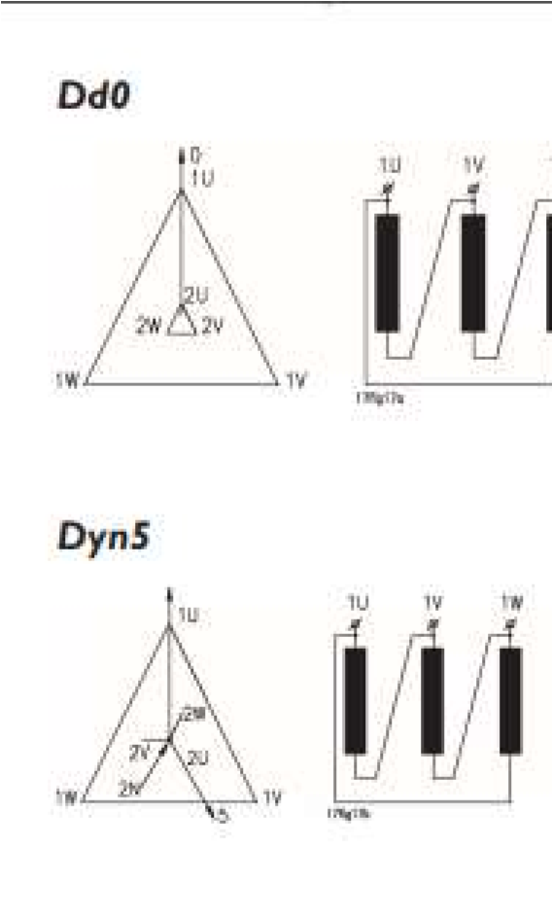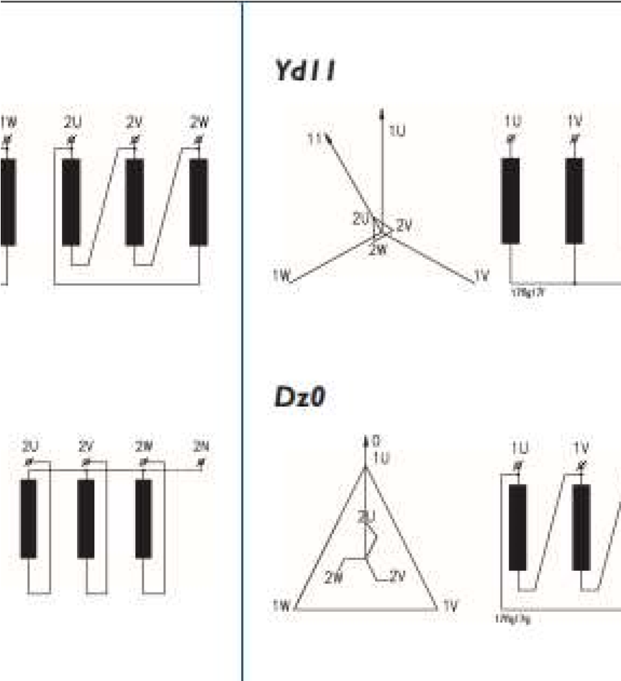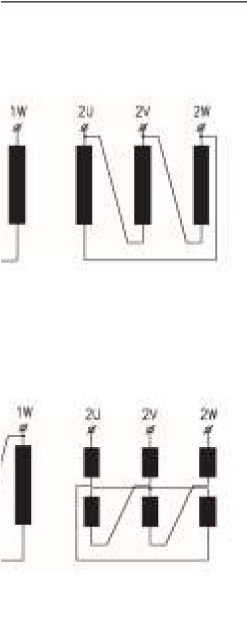

Fig.3 Transformer vector connection
3.6 TRANSFORMER CONNECTION.
In theory a three-phase transformer works like three separate single-phase transformers with shared limbs in which the magnetic circuit for the outer limbs is longer than for the centre limb. The voltage transformation is determined by the ratio between the number of turns on the primary and secondary sides assuming what are known as even connections, Yy, Dd and Zz, and terminals as U1u2, V1v2, and W1w2.
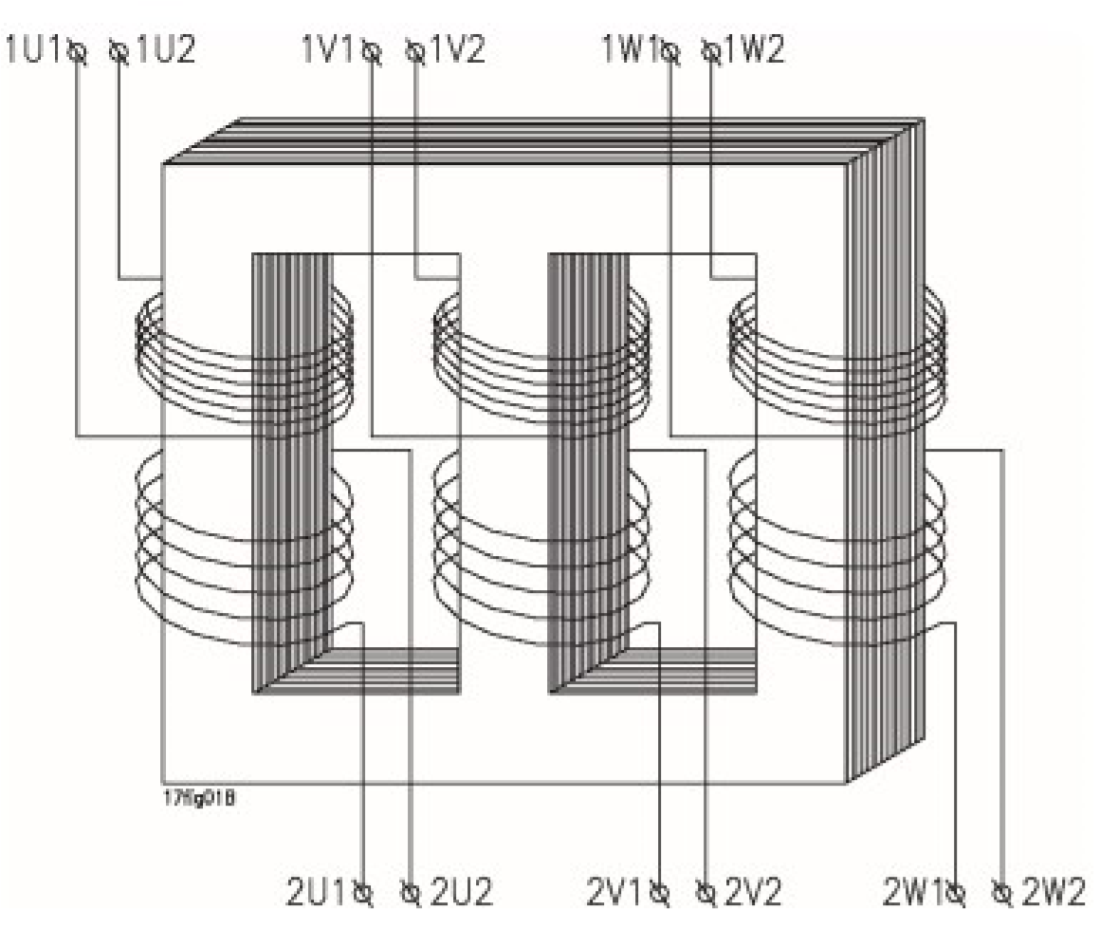

Fig.4 Connection and terminals
Star connection; In the case of star connection the three windings are connected together at their end points. The connection point represents the windings’ neutral point. Star connection is indicated by Y on the high-voltage side and y on the low-voltage side. This connection type is used for both low and high voltages and for low currents.
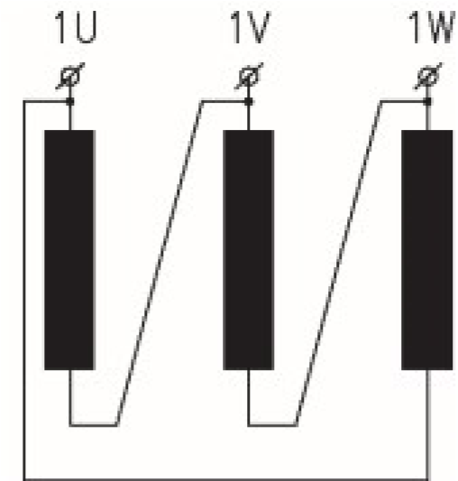Delta 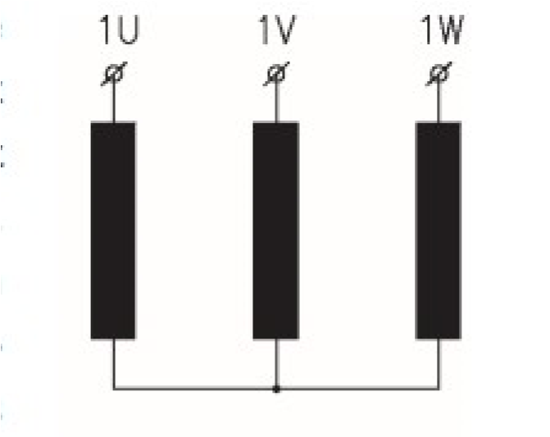star

Fig.5 Star and delta connection
Delta connection; In the case of delta connection the ends of the windings are connected together as shown in the diagram. We can see that both the ends are connected together. Delta connection is indicated by D or d. This connection type is used mainly for high rated currents and low voltages.
Zigzag connection; Each phase consists of two equal windings on unequal limbs. There will therefore be parts of two phases on each limb, with one winding on each limb being connected together at the end points. Zigzag connection is indicated by Z or z. This connection type requires 15.5% more windings than star or delta connection, resulting in a larger and more expensive transformer. It is mainly used where load unbalance can occur between the phases and neutral.
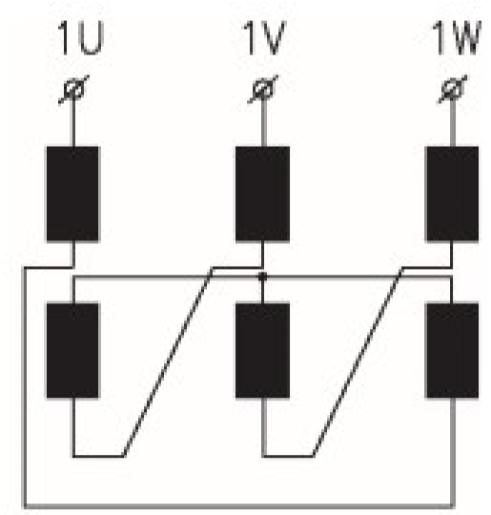
Fig.6
Zigzag connection.

3.7 TRANSFORMER OIL.
In addition to dissipating heat due to losses in a transformer, insulating oil which is highly synthesised polychlorinated biphenyl (PCB), provides a medium with high dielectric strength in which the coils and core are submerged. This allows the transformers to be more compact, which reduces costs. Insulating oil in good condition will withstand far more voltage across connections inside the transformer tank than will air. An arc would jump across the same spacing of internal energized components at a much lower voltage if the tank had only air. In addition, oil conducts heat away from energized components much better than air. Over time, oil degrades from normal operations, due to heat and contaminants. Oil cannot retain high dielectric strength when exposed to air or moisture. Dielectric strength declines with absorption of moisture and oxygen.
3.8 TRANSORMER CORE.
Transformer core is made up of the assembling of individual transformer laminations and coils. The assembling of these two major components creates the core of a transformer. In the 3-phase transformer system, the lamination, specifically the E-shape lamination is wound round by the LV-terminal/secondary winding, it is separated by an insulated paper rounded around the lamination separating the lamination and the LV (low voltage) winding. The LV- winding is then wound around by the HV-winding (high voltage), in between the LV-HV winding is a separator.

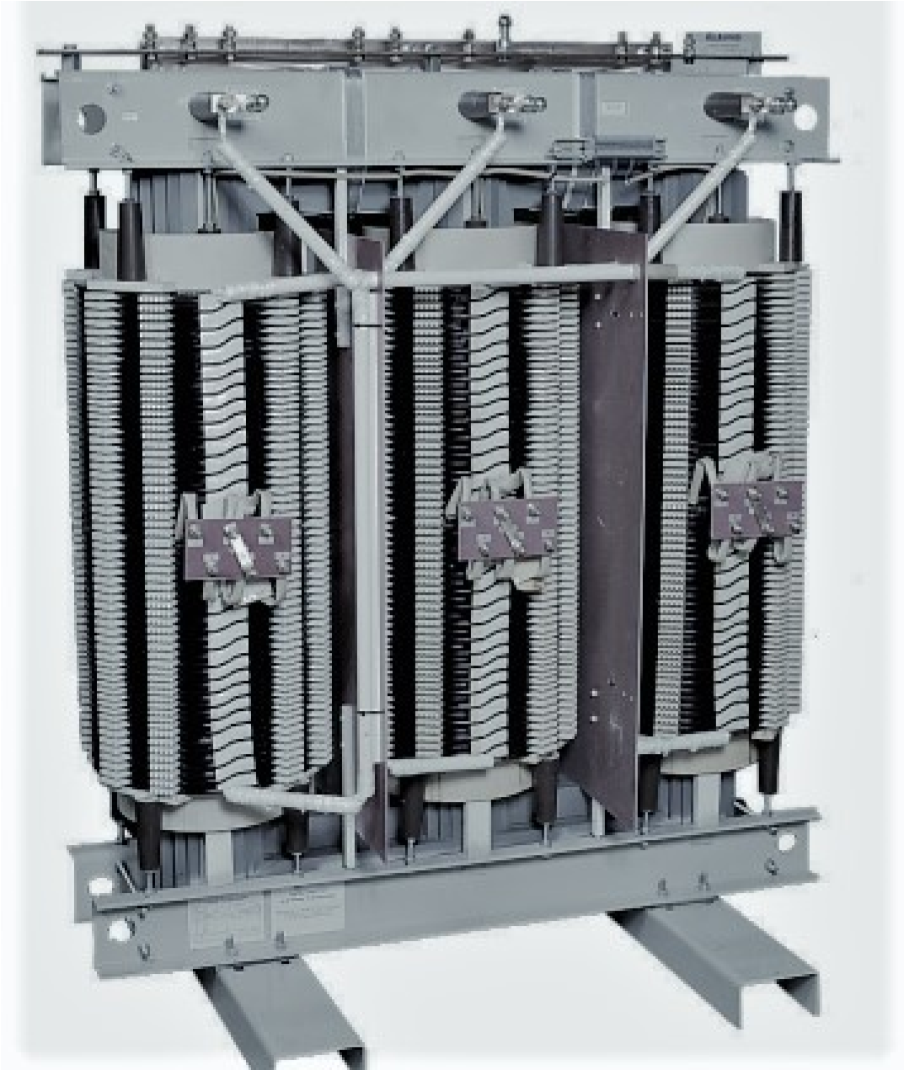
Fig.7 Transformer core

3.9 TRANSFORMER COILS AND TURNS RATIO.
Transformer core is made-up of two separate turns of wound conductors, separated by a wooden, rubber, or paper separator. The primary side is usually copper/aluminium conductors of different sizes, depending on the power the transformer can withstand. For instance, in 50kva, the primary consist of 1.0mm insulated copper/aluminium conductors or less, in 300kva, the primary coil consist of about 15mm insulated conductor or little less,. Therefore depending on a power, the primary winding conductors is normally an insulated wire, mean while the secondary section/LV is sometimes an aluminium sheet of about two feet width, twisted/rounded based on the required number of turns, such as in 500kva, the primary is an aluminium sheet consist of 28 turns of winding. In 50kva and sometimes 300kva, the LV winding made-up of a copper or aluminium rode twisted around the lamination based on the required turns the primary and the secondary turns of a transformer can be deduced by the used of turns ration formula which is;
N1/N2 = E1/E2 Where N1= No. Of turns in primary, N2= No. Of turns in se.
E1= P/ICOS@ E1= voltage in primary, E2= voltage in secondary.
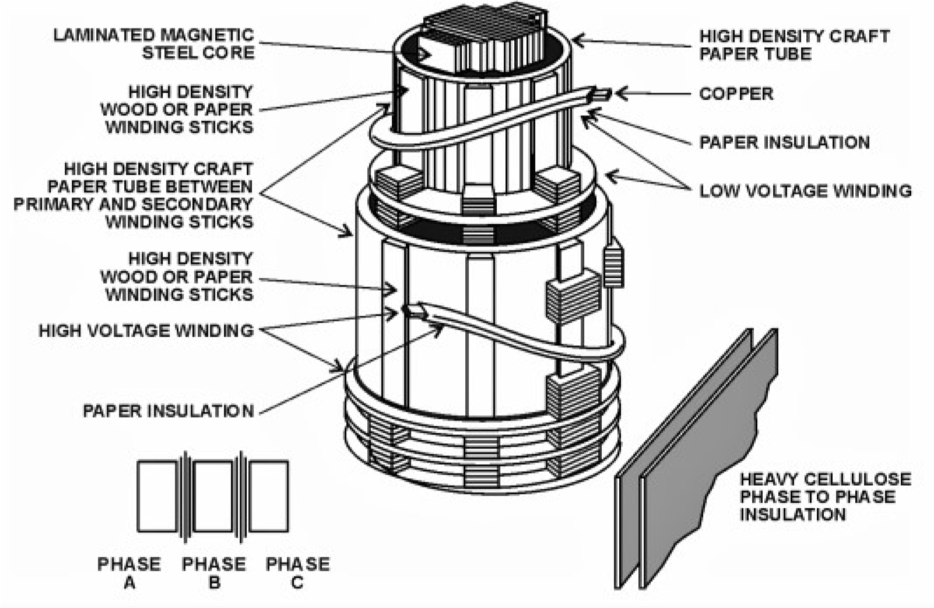
Fig.8 a single-phase transformer coil

CHAPTER FIVE

5.0 CONCLUSION, RECOMMENDATION AND REFERENCE
5.1 CONCLUSION
As a student, this program has increased my potentials and work attitude needed to guide me through my discipline after school whether I will work as self-employed or be in the industry. The program also enables the student to practicalise all they have learnt without practicals in their institutions, and also exposes them to a working environment experience, team work and work ethics.
It also helps the student to choose the specialization of their choice; either they love to focus on Telecommunications, Electricals, Electronics, Manufacturing, etc. Therefore, every student should take maximum use of the opportunity because it is important to them as future professionals.
5.2 RECOMMENDATION
In view of my experiences during the period of my industrial training, the following recommendations are made to students, universities, Industrial Training Fund (ITF) and the companies.
- Students must ensure they get a good placement for the training in time and gain the best knowledge from the 6-months period.
- Students should develop interest and focus during this period and make sure the six months elapse before backing out.
- It is hard to get a placement for the training by the students, however, the universities have a vital role to play by ensuring the they have good relationships with companies, firms and organizations so they can assist in placing the student in these firms on a yearly basis.
- Supervision should also be intensified by the I.T.F. to make the program more effective.
- The firms, industries or organizations should ensure they are well-structured and equipped so that they can give the students the best of the needed experiences.

