CHAPTER ONE
  - INTRODUCTION
Land policy plays a crucial role in shaping the real estate sector, influencing the availability, affordability, and sustainability of land for development (World Bank, 2019). Effective land policies can promote sustainable development, reduce inequality, and support economic growth, while poorly designed policies can lead to land speculation, displacement of communities, and environmental degradation (UN-Habitat, 2018). The real estate sector, which is a significant contributor to many economies, is heavily influenced by land policy, with the sector's growth and development often dependent on the availability of land, the security of tenure, and the regulatory framework governing land use (Payne & Durand-Lasserve, 2018).
In Nigeria, the land policy framework has undergone significant changes over the years, with the government introducing various reforms aimed at improving land administration, increasing access to land for development, and promoting sustainable land use (Federal Ministry of Lands, Housing and Urban Development, 2017). The Land Use Act of 1978, which vests all land in the state, has been a major instrument of land policy in Nigeria, with the government using it to regulate land use and allocation (Akinmoladun&Oluwoye, 2019). However, the implementation of this policy has been criticized for being bureaucratic, corrupt, and lacking in transparency (Olawumi&Akinmoladun, 2020).
The global world has a significant impact on land policies, with many countries adopting best practice and lessons from developed countries. For example, in the United States, the government has implemented policies to promote sustainable land use, such as zoning regulations and environmental impact assessments (National Association of Home Builders, 2020). In the United Kingdom, the government has introduced policies to increase the supply of affordable housing, such as the Affordable Homes Programme (UK Government, 2020). In Australia, the government has implemented policies to promote sustainable land use, such as the National Urban Policy (Australian Government, 2018).
In Africa, land policies have been shaped by the continent's unique challenges and opportunities. For example, in South Africa, the government has implemented policies to promote land reform and redistribution, such as the Restitution of Land Rights Act (Republic of South Africa, 2019). In Ghana, the government has introduced policies to improve land administration, such as the Land Administration Project (Government of Ghana, 2017). In Rwanda, the government has implemented policies to promote sustainable land use, such as the Land Policy (Government of Rwanda, 2015).
This study will examine the effect of land policy on real estate development in Ilorin, picking Alagbon Phase2 after Oke-Andi junction. The study area is chosen due to it facing ownership and management conflict between the government and landowners.
The study is necessary because it will provide insights into the challenges and opportunities facing the real estate sector in Ilorin, and inform the design of policies and programs that promote sustainable land use and development.
The study will highlight the impact of land policy on real estate development and identify best practices for promoting sustainable land use. The study will also reveal some of the issues associated with poor land policy implementation, such as overcrowding, poor infrastructure, and environmental degradation.
1.2 STATEMENT OF PROBLEM
The real estate sector in Nigeria, particularly in Ilorin, is faced with numerous challenges that hinder its development and sustainability. Despite the government's efforts to introduce reforms and policies aimed at improving land administration and promoting sustainable land use, the sector continues to grapple with issues such as land speculation, displacement of communities, and environmental degradation.
One of the major problems facing the real estate sector in Ilorin is the lack of effective land policy implementation. The Land Use Act of 1978, which is the primary instrument of land policy in Nigeria, has been criticized for being bureaucratic, corrupt, and lacking in transparency. This has resulted in poor land administration, insecurity of tenure, and disputes over land ownership.
Another significant problem is the rapid urbanization and population growth in Ilorin, which has put pressure on the existing infrastructure and services. The city is experiencing rapid development, but this development is often unplanned and unsustainable, leading to issues such as overcrowding, poor infrastructure, and environmental degradation.
Scholars have extensively studied the topic of real estate development in Nigeria, highlighting various challenges and opportunities in the sector. Some key areas of focus include land policy and reform, urbanization and population growth, sustainable development, and market trends and risks. Researchers such as Akinmoladun and Oluwoye (2019) have examined the impact of the Land Use Act of 1978 on real estate development, noting that while it aimed to usher in a new land reform, it has become a hindrance to development due to its embedment in the Constitution and bureaucratic implementation.
Studies by Oduwaye (2015) and Nubi (2017) have shown that rapid urbanization and population growth are driving demand for residential, commercial, and industrial developments in Nigeria's major cities, such as Lagos and Abuja. Scholars like Olawumi and Akinmoladun (2020) have emphasized the importance of incorporating sustainable design practices, energy-efficient systems, and environmentally friendly materials in real estate development to reduce environmental impact and enhance long-term value. Additionally, researchers like Oloyede and Omirin (2018) have analyzed market trends, risks, and challenges facing real estate developers in Nigeria, including market fluctuations, construction delays, and unforeseen expenses.
Despite the extensive research, some areas remain underexplored. More research is needed to understand the practical challenges faced by real estate developers in Nigeria, particularly in implementing land policies and navigating regulatory frameworks. Further study is required on the role of community engagement in real estate development, including how developers can build positive relationships with local communities and address their concerns (Afolabi, 2020). Additional research is necessary to develop effective strategies for integrating sustainable development practices into real estate development projects in Nigeria, considering the country's unique challenges and opportunities (Ujoh, 2019). Moreover, more research is needed to understand the impact of land policy on real estate development in different regions of Nigeria, including rural areas and smaller cities (Ogunba, 2018). By addressing these gaps, future research can provide valuable insights for policymakers, developers, and other stakeholders to promote sustainable and effective real estate development in Nigeria.
The study area is a prime example of the impact of land policy on real estate development. The study on the effect of land policy on real estate development in Ilorin, with specific reference toAlagbon Phase2 aims to contribute to the existing body of knowledge on land policy and real estate development. The study will examine the impact of land policy on land availability, tenure security, and regulatory frameworks, and explore the implications of these factors for real estate development in the study areas. The findings of this study will provide valuable insights for policymakers, developers, and other stakeholders to promote sustainable and effective real estate development in Nigeria.
1.3 RESEARCH QUESTIONS
The study will address the following research questions:
1. What is the effect of land policy on land availability for real estate development in Ilorin?
2. How does land policy impact tenure security and regulatory frameworks in Ilorin?
3. What are the challenges and opportunities facing real estate developers in the study area, and how does land policy affect these challenges and opportunities?
1.4 AIM AND OBJECTIVES OF THE STUDY
1.4.1 AIM
The study aims to examine the impact of land policy on real estate development in Alagbon area of Ilorin, with a view to identifying policy-related constraints and opportunities that influence sustainable property development.
1.4.2 OBJECTIVES:
The specific objectives of this study are to:
- review the existing land policies governing land acquisition and development in Ilorin, with specific reference to the Alagbon area.
- assess the influence of land policy implementation on the pace and pattern of real estate development in the study area.
- identify the challenges faced by real estate developers and investors as a result of land policy provisions or enforcement in Alagbon.
- evaluate the level of compliance with land policies and regulations by property developers in the area.
- suggest policy reforms or planning strategies that can enhance real estate development in Alagbon and similar urban areas in Ilorin.
1.5 SIGNIFICANCE OF THE STUDY
The significance of this study lies in its potential to shed light on the complex relationships between land policy, real estate development, and sustainable development in Nigeria. By examining the impact of land policy on real estate development in Ilorin, this study will provide valuable insights into the challenges and opportunities facing the sector, and identify potential solutions to promote sustainable development.
The study's findings will be significant for policymakers, as they will provide evidence-based insights into the effectiveness of current land policies and recommendations for improvement. This will enable policymakers to make informed decisions about land policy reforms and ensure that the sector is operating in a way that promotes sustainable development and economic growth.
The study's focus on sustainable development will also highlight the importance of incorporating sustainable practices into real estate development. This will provide insights into how land policy can be used to promote sustainable development, reducing the environmental impact of development and enhancing the quality of life for residents.
Furthermore, the study's findings will have implications for economic development in Nigeria. The real estate sector is a significant contributor to the country's GDP, and the study's findings will provide insights into how land policy can be used to promote economic growth and development.
Overall, the significance of this study lies in its potential to contribute to the development of effective policies and strategies for promoting sustainable real estate development in Nigeria. By providing valuable insights into the impact of land policy on real estate development, this study will benefit various stakeholders, including policymakers, real estate developers, investors, and communities, and will contribute to the broader goals of sustainable development and economic growth.
1.6 SCOPE OF THE STUDY
The scope of this study is to investigate the impact of land policy on real estate development in Ilorin, specifically focusing on Alagbon Phase2 behind Oke-Andi junction as case studies.
This study will examine the existing land policy framework and its implementation in this area, assessing the effects of land policy on property values, development activity, and housing affordability. By exploring the impact of land policy on real estate development in the study area, the study aims to provide valuable insights into the complex relationships between land policy, land use, and real estate development outcomes.
The study's scope includes a comprehensive analysis of land policy instruments, real estate development outcomes, and stakeholder perspectives in the area
1.7 LIMITATION OF THE STUDY
This study on the effect of land policy on real estate development in Alagbon Phase2 has several limitations. One of the primary limitations is the geographical scope of the study, which is limited to Ilorin. This means that the findings of the study may not be generalizable to other cities or regions, and may not be applicable to areas with different economic, social, or cultural contexts.
Another limitation of the study is the case study approach, which focuses on one specific area. While this approach allows for an in-depth examination of the impact of land policy on real estate development in these areas, it may not be representative of all areas in Ilorin. The study's findings may be influenced by the unique characteristics of the study areaand may not be applicable to other areas with different land use patterns, development pressures, or stakeholder interests.
The study may also be limited by the availability and accuracy of data on land policy, real estate development, and related variables. Data limitations may affect the validity and reliability of the study's findings, and may limit the ability to draw conclusive inferences about the impact of land policy on real estate development in Ilorin. Furthermore, the study's timeframe may also be a limitation, as it may not capture long-term effects of land policy on real estate development.
Additionally, the study's reliance on stakeholder perspectives may also be a limitation. The perspectives and biases of stakeholders interviewed may not reflect the views of all stakeholders, and may influence the study's findings. The study's methodology, including data collection and analysis methods, may also have limitations that affect the validity and reliability of the findings. These limitations highlight the need for caution when interpreting the study's findings and applying them to other contexts.
1.8 STUDY AREA
The study area is Ilorin Metropolis, which is the capital city of Kwara State, Nigeria. Ilorin metropolis consists four Local Government Areas (LGAs) namely; Ilorin East, Ilorin West, Ilorin South and Asa. Ilorin is located approximately between latitude 8º30’ and 8º50’ North of the Equator and longitude 4º20’ and 4º35’East of the Greenwich Meridian (Figure 1.1). Ilorin is the gateway city between the southern and northern Nigeria with an approximate land area of 100kilometres square (Kwara State Diary, 2012). Ilorin city climate is humid under the influence of the two trade winds prevailing over the country, characterized with high temperature throughout the year (Ajibade, 2002). Ilorin enjoys wet and dry seasons. The daily average temperatures are in January with 25ºC May 27.5 ºC and September 22.5 ºC. The wet season is between May and October with two peak periods in June and September while the dry season spans between November and April. The mean annual rainfall is 1,200mm (Olanrewaju, 2012). The temperature in Ilorin is uniformly high throughout the year. The nature of soil at the study area is sandy-loamy soil, which favours certain species of trees, and grasses, couple with the climatic condition to which the sandy area falls made it to fall into Guinea Savannah. Deciduous trees of mixed trait such as silk, cotton characterize this type of vegetation and tall grasses like Elephant grass are noticeable in Ilorin.
1.8.1 Transportation and Communication Network
The inter-city and intra-city transportation for Ilorin could be identified as road, rail and air transport. Usually these modes of transport are supposed to complement each other for an efficient and effective co-ordination of the activities within the city. The first major development of a road network on Ilorin was subsequently by the Federal Government, which constructed the present Lagos Road Abdul Azeez Atta road and Emir’s Road. These roads are stretches of the Lagos - Ilorin - Kaduna trunk road that links the southern and northern parts of the country together.Ilorin comprises of three major roads that are Emir's Road, Gambari/ Muritala Mohammed Road/Post Office Round About and Amilegbe Road/Ipata Market. Among the roads that forms the arterial within the study area are Emir's/Gambari junction, Edun/OpoMalu road, Muritala road/Emir's road. There is also a railway line transversing the town. The railway line serves as a link to both the North and the West. Most of the commercial activities of the town take place alone the major roads of the study area. All the same, road transport dominates human movement in Ilorin and is characterized by para-transit modes such as mini-buses, taxi and motor cycles. By road, llorin is equidistant to all major population centers north and south of Nigeria. Ilorin also has airport facilities. Although the Ilorin International Airport has been re- designated and equipped as International Cargo Airport, there are scheduled commercial flights to and from Ilorin by Overland and Capital Airlines with current destinations include Lagos, Abuja and Jos.

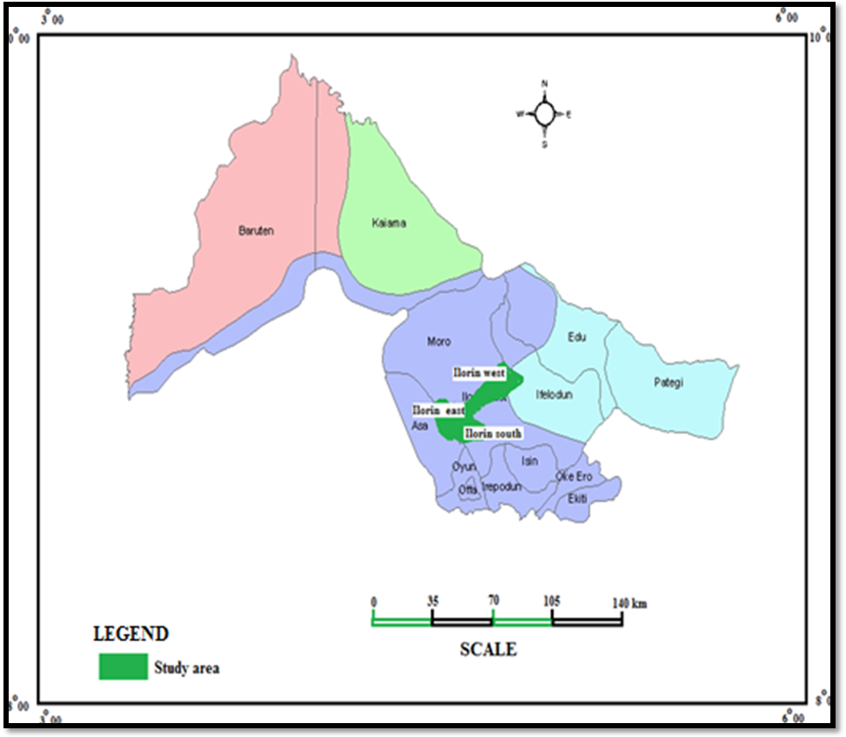
Fig 1.1: Ilorin L.G.A. within Kwara State context.
Source: - Kwara State Town Planning Authority (2025).
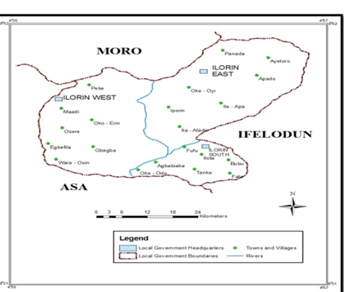
Fig 1. 2: Ilorin Township within the L.G.As

Source: - Kwara State Town Planning Authority (2025).

1.9 DEFINITION OF TERMS
Here are the definitions with sources:
1. Policy: A set of principles, guidelines, and rules that guide decision-making and action in a particular area, such as government, business, or organization. (Oxford Dictionary, n.d.)
2. Land Policy: A set of principles, laws, and regulations that govern the use, ownership, and management of land, including policies related to land acquisition, allocation, and development. (World Bank, 2019)
3. Real Estate: Property consisting of land, buildings, and other improvements, including residential, commercial, and industrial properties.
4. Development: The process of building, improving, or expanding physical infrastructure, such as buildings, roads, and utilities, to support economic and social activity. (United Nations, 2018)
5. Sustainably: In a way that meets the needs of the present without compromising the ability of future generations to meet their own needs, minimizing harm to the environment and conserving natural resources. (Brundtland Commission, 1987)
6. Sustainable Development: A process of development that balances economic, social, and environmental considerations, meeting the needs of the present without compromising the ability of future generations to meet their own needs. (United Nations, 2015)
7. Economic Growth: An increase in the production of goods and services in an economy over time, often measured by an increase in Gross Domestic Product (GDP).
8. Land Speculation: The practice of buying land with the expectation of selling it at a higher price in the future, often without any intention of developing or using the land productively. (UNCHS, 2001)
9. Environmental Degradation: The deterioration of the natural environment, including air, water, and land pollution, deforestation, and loss of biodiversity, often caused by human activities.
10. Land Use: The way in which land is used or managed, including agricultural, residential, commercial, industrial, and conservation uses, and the planning and regulation of land use to achieve social, economic, and environmental goals. (Food and Agriculture Organization, 2019)

