

KWARA STATE POLYTECHNIC, ILORIN INSTITUTION OF INFORMATION COMMUNICATION TECHNOLOGY

A TECHNICAL REPORT ON STUDENT INDUSTRIAL WORK EXPERIENCE SCHEME (SIWES)

Undertaken at

RICHVIEW TECHNOLOGY COMPUTER IT

ISOLO-OSHODI, LAGOS STATE

Submitted to

THE DEPARTMENT OF COMPUTER SCIENCE

Written By: MUHAMMED ABDULLAHI MAYOWA

Matric Number: ND/23/COM/PT/0383

IN PARTIAL FULFILMENT OF THE REQUIREMENTS FOR THE AWARD OF ORDINARY NATIONAL DIPLOMA IN COMPTER SCIENCE(OND).

PERIOD OF ATTACHMENT: AUGUST - NOVEMBER 2024

ACKNOWLEDGEMENT

I thank Almighty ALLAH, the creator of Heaven and Earth for granting me the grace and privilege to be able to complete this SIWES program successfully and on schedule.
I also acknowledge the effort of my parent (Mr. and Mrs. MUHAMMED) for their moral and financial support during the industrial training. I also acknowledge the effort of my industrial based supervisor (Mr, Timileyin) for his full support and motivation in computer website design, Networking and development during the industrial training.

DEDICATION

The Student Industrial work experience scheme (SIWES) is dedicated to Almighty God who has being the alpha and omega starting from the beginning to the end of the training and also to my parent for their financial support during the course of the industrial training.

ABSTRACT

This report is a summary of all work experience I have been able to gather during my SIWES training programme at RICHVIEW TECHNOLOGY COMPUTER IT
The report contains my all my experience in front-end development in relation to HTML, CSS, Java Script and Networking.
The internship experience focused on acquiring practical skills by developing web applications while simultaneously addressing potential Networking. Various web development technologies, including HTML, CSS, JavaScript and Networking were utilized to create dynamic and responsive user interfaces.The Web Development SIWES program offers a comprehensive learning experience in building and maintaining websites, focusing on the essential skills needed to design, develop, and optimize dynamic web applications. Over the course of the program, participants gained hands-on experience with front-end and back-end technologies. Emphasis was placed on creating responsive, user-friendly designs and implementing efficient coding practices.

TABLE OF CONTENT

CHAPTER ONE: INTRODUCTION
  - History of Establishment ......................................................................................................
  - Object of Establishment .......................................................................................................

CHAPTER TWO: DESCRIPTION OF THE ESTABLISHMENT OF ATTACHMENT

  - History of Establishment ......................................................................................................
  - Object of Establishment .......................................................................................................
  - Mission of the company.............................................................................................. …….
  - Organization Structure .........................................................................................................
  - Company Area Of Specialization.........................................................................................

CHAPTER THREE: INTODUCTION TO WEB DESIGN
  - Work Done.……............................................................................................................. ….
  - Web Design Department.……........................................................................................ ….
  - Definition Of Terms .……...................................................................................................
(a) Website (b) Webpage (c) HTTP (d) URL
  - Introduction to web Development……........................................................................ ….
    - Frontend Development ……................................................................................. ….
    - Back-end Development……................................................................................. ….
    - Full - Stack Development……..............................................................................….
  - Frontend Developmentt……........................................................................................ ….
    - Hyper Text Markup Language (HTML)....................................................................
    - HTML and Its Properties............................................................................................
    - HTML Tages..............................................................................................................
    - HTML DOM..............................................................................................................

CHAPTER FOUR: INTRODUCTION TO NETWORKING…………………………………
4.0 Networking.....................................................................................................……..............
4.1 Network Topology................................................................................................................
4.3 Network Equipment..............................................................................................................
4.4 IP Addressing.......................................................................................……………………..
4.5 Troubleshooting skills.................................................................………….,,......................

CHAPTER FIVE: SUMMARY, CONCLUTION AND RECOMMEDATION

  - Summary...............................................................................................................................
  - Concusion..............................................................................................................................
  - Recommedation.....................................................................................................................

CHAPTER ONE INTRODUCTION

1.0 HISTORY OF SIWES

The Student Industrial Work Experience Scheme (SIWES) is program which forms part of the academic standards in the degree program for Nigerian Universities. The Federal Government of Nigeria introduced the policy on Industrial training, called the Student Industrial Work Experience Scheme (SIWES) IN 1974. The Industrial Training Fund (ITF) is in charge of this program which is under the umbrella of the Ministry of Education. SIWES was designed to help students acquire the necessary practical education/experience in their fields of study and other related professions.
This is an effort which was created in order to compliment the theory taught in the classrooms of the Nigerian tertiary institutions. This objective of the program is exposing students to the use of various machines and equipment’s, professional work methods and ways of safeguarding the work areas in industries as well as other organizations. SIWES was established to impact practical knowledge to students with respect to their various disciplines.

This training is funded by the Federal Government of Nigeria and coordinated by the Industrial Training Fund (ITF) and the National Universities Commission (NUC). The SIWES program involves the student, the Universities and the industries.

OBJECTIVES OF SIWES

The objective of SIWES among others include to:

    - provide an avenue for students in institutions of higher learning to acquire industrial skills and experience in their approved course of study;
    - Prepare students for the industrial work s situation which they are likely to meet after graduation. Expose students to work methods and techniques in handling equipment and machinery in their institutions.
    - Provide students with an opportunity to apply their knowledge in real work situation thereby bridging the gap between theory and practices.
    - Enlist and strengthen employers’ involvement in the entire education process and prepare students for employment in industry and commerce.

CHAPTER TWO

  - DESCRIPTION OF THE ESTABLISHMENT OF ATTACHMENT

RICEVIEW TECHNOLOGY COMPUTER IT is a fully indigenous and non- governmental company that provides clients with quality, cost effective and innovative IT and security solutions, Located at Isolo - Oshodi, Lagos State. RICEVIEW TECHNOLOGY COMPUTER IT focuses on total client satisfaction. The Company has built reputable standard over the years from her vast technical knowledge and competence, in project management and execution.

OBJECTIVES OF ESTABLISHMENT

To be a first choice Information and Communication Technology (ICT) company with the idea of rendering unmatchable excellent professional solution to our clients in line with emerging technology.

MISSION OF THE COMPANY

Our reason for existing as a company is to provide unbeatable first choice consistent professional service solution.

CORE VALUES
    - Integrity
    - Services
    - Commitment
    - Excellence
    - Professionalism

ORGANZATION STRUCTURE OF RICHVIW TECHNOLOGY COMPUTER IT
GENERAL MANAGER
HEAD OF ADMIN. OPERATION
NETWORKING AND DEVELOPMENT
GRAPHIC
TERM
SIWES
CUSTOMER
REPRESENTATIVE

  - COMPANY AREA OF SPECIALIZATION

With a team of professional Computer programmers, web development, data science, Graphic designers, UI/UX, and Networking, the Company has a reputable recognition in the following areas:

Software Development
Their customer-centered approach enables their developers to capture your business requirements and develop a fully customized software solution that solves your unique business needs.
If you are looking for a reliable software development company to enhance your business performance, that differentiates you from your competitors and helps you become more cost efficient, they are in a better position to do that. Their software services have helped their clients achieve the following:
- High quality solutions that tailor fit the business requirements

- Scalable solution that grows with client requirement
- Streamlining customer business work-flow

- Productivity Improvement

- Reduction in overheads and increase in return on investment (ROI)

Website Design
They are set to work as a professional that helps both individuals and companies create and manage their online presence in a dynamic, efficient and unique way which makes you, your product or company stand tall in this virtual world. Your website is the vehicle that targets, attracts, and qualifies your visitors before turning those visitors into monetized customers. The pages and applications that make up your web presence are critical to your web strategy, and RICHVIEW TECHNOLOGY COMPUTER IT can help you create a solution that accomplishes your goals. From site redesigns to end to end custom applications, they can put together a solution that you can be confident in from all sides of your web marketing strategy.

- Networking
This department is saddled with the responsibility of designing the entire network; provide network service to clients of data, voice and video. Staff in this unit includes network engineers and system analysts.

- Graphic Design
Graphic Design is a field of computer science that involves the visual communication of ideas and messages through the use of typography, color, and images. It involves the creation of visual elements such as logos, graphics, icons, and graphics for websites, magazines, newspapers, and other media.

UI/UX DESIGN

Our company specializes in creating intuitive and engaging User Interface (UI) and User Experience (UX) designs that enhance digital interactions. We focus on understanding user behavior, preferences, and needs to develop solutions that are not only aesthetically pleasing but also highly functional

CHAPTER THREE

WORK DONE

During my four-month SIWES training at [RICHVIEW TECHNOLOGY COMPUTER IT], I worked as a web development and Networking intern. My responsibilities are to assisting in the design and development of web application using [HTMLand NETWORKING,] in web development.

WEB DESIGN DEPARTMENT

This department was where my Industrial Training took place where i was grounded and expose to the website world especially the creation of websites taking me step by step with practical all through the process.

DEFINITION O F TERMS

The following are terms that were made use of, in this department

WEBSITE:

A website is a set of related webpages containing content such as texts, images, videos, audios, etc. A website is hosted on at least one web server, accessible via a network such as the internet or a private LAN through an internet address known as a URL (Universal Resource Locator). A publicly accessible websites collectively constitutes the World Wide Web (WWW).

WEBPAGE:
A webpage is a document, typically written in plain text interspersed with formatting instructions of hypertext nark up language (HTML, XHTML). A webpage may incorporate elements from other websites with suitable anchors. Webpages are accessed and transported with the hypertext transfer protocol (HTTP), which may occasionally employ encryption (HTTP secure, HTTPS) to provide security and privacy for the use of the webpage content. The user’s application often a web browser renders the page content according to its HTML mark-up instructions into a display terminal.

HTTP:

This stands for Hyper Text Transfer Protocol which is the set of rules for transferring files (text, graphic, images, sound, video, and other multimedia files) on the World Wide Web.

URL:

This stands for Uniform Resource Locator and as the name suggests, it provides a way to locate a resource on the web, the hypertext system that operates over the internet.

INTRODUCTION TO WEB DEVELOPMENT
Web Development is the process of building and maintaining website, web application and mobile application using various programming language, framework and tools. It is divided into (3) which involve:
- Frontend development
- Backend development
- Full – stack development

- Frontend development: creating user interface user experience and client side logic using html, CSS, and JavaScript. And framework likes react angular, or value
- Back-end development: building server-side logic database integration and API connectivity using language like java, python, ruby, and framework like node.js.
- Full- stack development: combining frontend and backend development to create a complete web application

Web development involves various aspects such as:

- Web design
- User experience (ux) design
- Web security
- Mobile application development
- Web assembly

Web developer uses various tools such as:

- Text editor (e.g. visual studio code)
- Integrated development environment (IDE)
- Database management system
- Testing framework

FRONTEND DEVELOPMENT
HTML (HYPERTEXT MARKUP LANGUAGE)

Html (Hypertext Markup Language): is the standard markup language used to create web page it’s the backbone of a website, providing the structure and content that the web browser render the user. It defines the structure and layout of a web page, html consists of series of element, represented tags (< >), these elements include:
- Heading ( h1 – h6 )
- Image ( img )
- Span (span)
- Title (title)
- Paragraph ( p )
- Form (form input, select) etc

HTML AND ITS PROPERTIES

HTML stands for Hypertext Mark-up Language, and it is the most widely used language to write Web Pages.

  - Hypertext refers to the way in which Web pages (HTML documents) are linked together. Thus, the link available on a webpage is called Hypertext.
  - As its name suggests, HTML is a Markup Language which means you use HTML to simply "mark-up" a text document with tags that tell a Web browser how to structure it to display.
Originally, HTML was developed with the intent of defining the structure of documents like
headings, paragraphs, lists, and so forth to facilitate the sharing of scientific information between researchers.
Now, HTML is being widely used to format web pages with the help of different tags available in HTML language.

HTML TAGS:
As told earlier, HTML is a markup language and makes use of various tags to format the content.
These tags are enclosed within angle braces <Tag Name>. Except few tags, most of the tags have their corresponding closing tags. For example, <html>has its closing tag</html>and
<body>tag has its closing tag </body>tag etc

Tag | Description
<html> | This tag encloses the complete HTML document and mainly comprises of document header which is represented by  <head>...</head> and document body which is represented by  <body>...</body> tags.
<head> | This tag represents the document's header which can keep other  HTML tags like <title>, <link>, <script language  =”javascript”> etc.
<title> | The <title> tag is used inside the <head> tag to mention the  document title.
<body> | This tag represents the document's body which keeps other HTML tags like <h1>, <div>, <p>, <table> etc.
<h1> | This tag represents a heading
<p> | This tag represents a paragraph.
<b>, <i>, <li>, <ul> | Bold, italic, list, unordered list
The following are the names of tags and their description

CHAPTER FOUR

INTRODUCTION TO NETWORKING

Network are component involve in connecting computer and application across small and large distance. Each computer on the network has access to the files and peripheral device (such as printers or modems) on all the other computers on the network.

4.1 NETWORK TOPOLOGY
Common topology found in networking includes mesh topology star topology, bus topology, ring topology, and others. Network topology refers to the layout of the transmission medium and devices on a network. Topologies use either a point to point or multipoint connection scheme.

A connection scheme indicates how many devices are connected to a transmission media segment or an individual cable. An example of point-to-point connection scheme is a modem/ printer connected to computer, direct cable connection between two computers. An example of a multi point connection scheme is a star or bus topology network.

Star Topology
This is a local area network topology where all the nodes are connected individually to a central connecting device called a hub or switch. Signals travel from the nodes to the hub which then sends signals to other nodes on the network. A star topology network is scale able –i.e. it can be design and redesign easily.

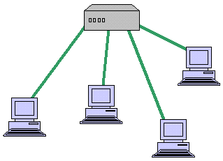

Bus Topology
A LAN topology where each node is connected to a single main bus cable, is transmits data to all the nodes on the network. The bus is actually a series of cable segments running from one node to the other. Break or faulty piece of cable anywhere on the segment prevents all the computers on the segment from being able to communicate.
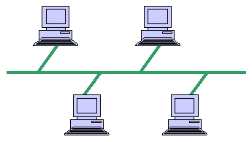

Mesh Topology
This is a network topology where every node on the network has a separate wire connecting it to every other node on the network. It provides each device with a point-to-point connection to every other device in the network. This type of network has a high fault tolerance because failure of one node does not affect data transmission between other nodes.
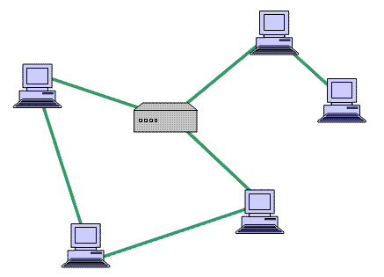
At NOC the topology adopted is the mesh topology.

4.2 TRANSMISSION MEDIA
• Wired media
• Wireless media
,,
Wired Media
These are media which require the use of wires, lines and cables to transmit communication signals. During my industrial training at NOC, I encountered majorly three different types of wired network media namely:
Coaxial cable
A coaxial cable is an alternative for protecting data from noise. Coaxial cables do not produce external electric and magnetic fields and are not affected by them. This makes them ideally suited, although more expensive, for transmitting signals.
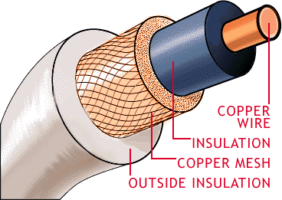
Twisted pair cable
In a twisted pair there are eight copper wire that are coated with different colours; the colours are mix/orange, orange, mix/blue, blue, mix/green, green, mix/brown and brown.
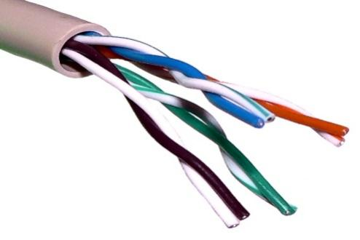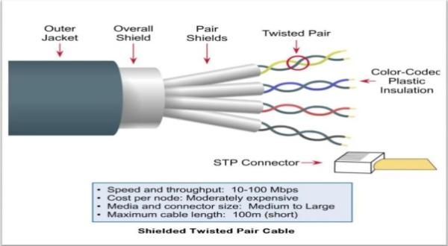

Fibre optic cable
At NOC the backbone upon which the network is built is fibre optic.
It is made of glass fibres instead of wire; it consists of a centre glass core surrounded by several layers of protective material. The outer insulating jacket is made of Teflon or PVC. The fibre optic cables transmit light rather than electronic signals, thereby eliminating the problem of electrical interference.
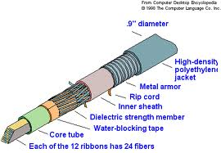
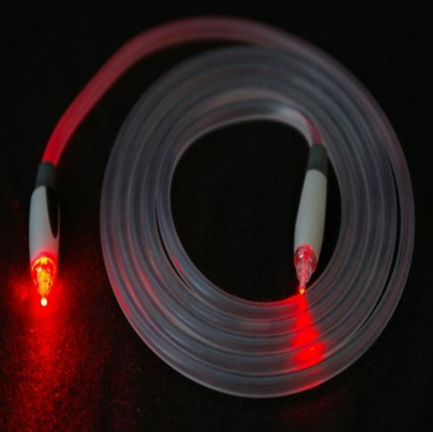

Optical fibres come in two types:
• Single-mode fibres
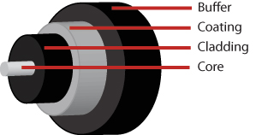
• Multi-mode fibres
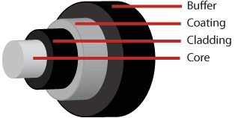
Single-mode fibres have small cores while
Multi-mode fibres have larger cores. Used for short-distance communication links.
Wireless Media
To fully explore the wireless added dimension, Communication system designers have sought to use wireless media to reduce infrastructure cost and complexity, when compared to wired communication systems. There is no need to construct miles of telephone line poles or cable trenches. During my stay at NOC I was able to interact with the following devices:

4.3 NETWORK EQUIPMENT
Some network equipment:
Ethernet Radio
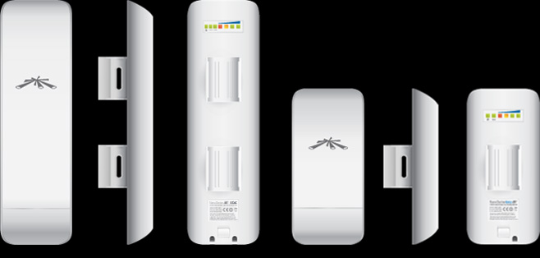
Is a device that sends and receive packets from one network to the other.

Router
A router is a device that forwards data packets between computer networks, creating an overlay internetwork. A router is connected to two or more data lines from different networks. When a data packet comes in one of the lines, the router reads the address information in the packet to determine its ultimate destination. Then, using information in its routing table or routing policy, it directs the packet to the next network on its journey.
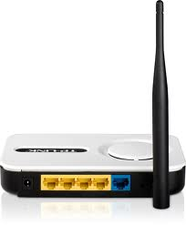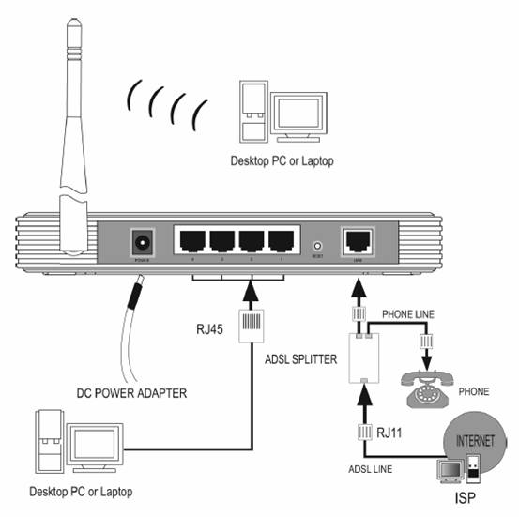

Switch
A network switch is a computer networking device that connects network segments or network devices. It serves mainly for extension.

Antenna
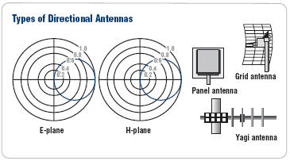
It’s a device that aid and enhances the signal strength and quality. Antennas are not used alone; it is always attached to something mostly to an antennas. An antenna is of two types in terms of direction Directional and Omni-directional. Directional beams signal in one direction while Omni- directional beams signals in all direction. Antennas are better propagated horizontally.
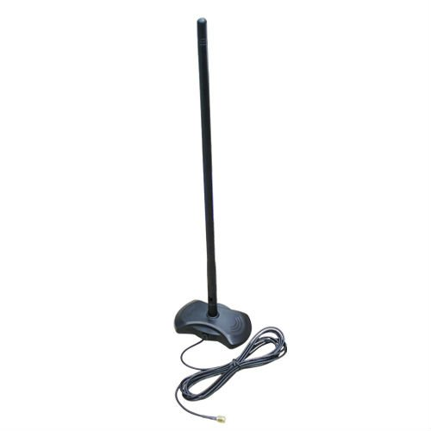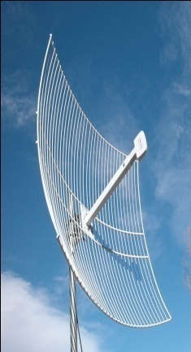

Unidirectional antenna parabolic grid antenna

Twisted pair Cable
Twisted pair is the ordinary copper wire that connects home and many business computers to the telephone company. To reduce crosstalk or electromagnetic induction between pairs of wires, two insulated copper wires are twisted around each other. Each connection on twisted pair requires both wires. Since some telephone sets or desktop locations require multiple connections, twisted pair is sometimes installed in two or more pairs, all within a single cable.
Connectors
Rj-45 plug is the common name for an 8P8C modular connector using 8 conductors which pin down wires in a twisted pair cable.
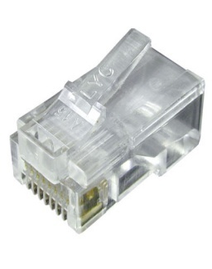
Crimping tool
Is a tool used to terminate category cables such as CAT1-CAT6 using an RJ-45 connector; it can also be used to cut cable to a desired length.
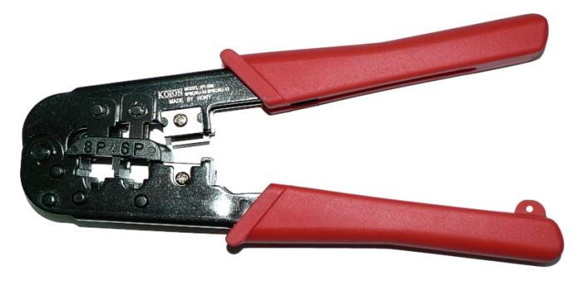
LAN cable tester
This is used to test if a category cable has been well terminated, or develop a fault.
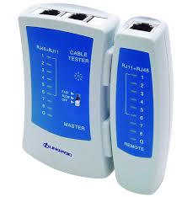

4.4 IP ADDRESSING
An IP address is a unique identifier that is assigned to a host on a network. It is also a unique identifier for a host or a node on a network. We have IPv4 and IPv6. The most used being IPv4 (with 32bits).

Functions of IP Addressing
- For location of a device on the network
- It is assigned to allow hosts on one network to communicate to hosts on another network
- IPv4 address is 32 bits divided in to four octets or bytes using dot ’.’

The ‘255’ above represent the network portion and the zeros represent the host portion.
4.5 TROUBLESHOOTING SKILLS
Troubleshooting is the process of finding problems and solving them.
Should a client unable to browse or unable to make calls via the IP phone, the check begins with the cable being used if client is connected via LAN cable, this is done using the LAN-cable tester, check the face plates to know if it is working, check the patched panel and switches on the distribution rack where they are kept. Ping the systems Ethernet port, ping the server etc.

CHAPTER FIVE

SUMMARY, CONCLUTION AND RECOMMEDATION

  - SUMMARY

The 4 months student industrial work experience scheme undergone at RICHVIEW TECHNOLOGY COMPUTER IT is world class which is web development and training, to mention a few exposed me to know gain more practical knowledge of programming. I was opportune to have learnt and experience lot in this field in so little time. It has also improved my curiosity to the field of computer science and ICT generally. This has gone a long way in equipping me in merging what was actually learnt on the field. The programme has been highly enlightening, beneficial, interesting and successful

CONCLUSION

My SIWES was a very successful one, I had an insight of the Information Technology world. I have now known the power of programming and graphics designing. With this, I will be able set a goal for myself to build a complete website and write codes for different programs. SIWES as a course has truly exposed me to the challenges faced in a growing I.T world that is dependent on computers.

RECOMMENDATION

- The school management should consider the fact that students find it difficult to be admitted to a particular organization for attachment and urge these organizations to accept students.
- The SIWES body should try as much as they can to assist students financially when carrying out this very industrial attachment.
- Place of attachment should try as much as possible to employ educated workers to avoid code-switching while lecturing.
- A mass enlightenment campaign should be carried out, to enable industries and establishments to know the importance of SIWES to the future of students and the society at large.

