CHAPTER TWO
2.0 LITERATURE REVIEW
Fabric recycling is the process of recovering old, used, or waste textiles and turning them into new, usable materials or products, with the rise of textile waste globally, fabric recycling has become essential for environmental sustainability and circular economy development. Fabric recycling is an important aspect of sustainable waste management in the textile and fashion industry. The process involves converting waste textiles and fabrics into reusable raw materials for new products. Several studies have been conducted globally to explore techniques, technologies, and impacts of fabric recycling on the environment and economy.
Shredding is a critical first step in the mechanical recycling process of fabrics. Shredding is the final step in the preparation process and entails cutting fabrics up into tiny pieces.It involves reducing textile waste into smaller pieces or fibres to prepare them for reuse in various applications, such as stuffing, insulation, or re-spinning. According to Wang (2010), shredding is the mechanical process of cutting or tearing textiles into smaller fragments using rotary or reciprocating blades. It is an essential part of the pre-treatment phase in fabric recycling.
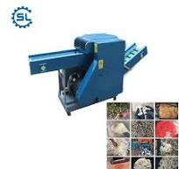
Fig 2.1 Fabric Shredding Machines
2.1 Components of Shredding Mechanisms and Machines
The major components of Shredding Machines include:
- Blade-based shredders: These machines use rotary blades mounted on a shaft to slice or tear fabrics.
- Hammer mills: Involve high-speed rotating hammers that beat the textile material into pieces.
- Granulators: Designed to further reduce shredded material into granules.
Naqvi et al. (2018) highlighted that shredders for textiles must be rugged and have features like reverse motion to handle fabric tangling or jamming.
2.2 Types of Fabrics and Shredding Behaviour
There are three major types of fabric namely natural, synthetic and blended types. Their shredding behaviours are different because of their properties. Muthu (2015) noted that blended fabrics and elastane-rich textiles are particularly challenging because of their elasticity and toughness. Different fabrics respond differently to shredding based on their structure:
Table 2.1 Fabric type and their Shredding Behaviour
Fabric Type | Shredding Behaviour
Cotton | Easily shredded but results in short fibres
Polyester | Stronger, more resistant to blade wear
Blends (e.g., cotton/poly) | May jam machines; difficult to shred evenly
Denim | Requires higher torque and stronger blades

2.3 Importance of Shredding in Recycling
Shredding in recycling of fabrics helps to:
- Reduce volume of textile waste.
- Prepare fabrics for downstream processes like carding, pelletizing, or felting.
- Increase surface area for chemical treatments in chemical recycling.
- Prevent clogging in machinery by producing uniform particle sizes.
2.4 Design Considerations for Shredders
In designing a shredding unit for portable applications, the following factors must be taken into consideration. Bartl (2011) emphasized the need for energy-efficient designs to make shredding affordable and sustainable for small-scale operations. Its include:
- Blade type and material (hardened steel or alloy)
- Rotational speed (optimized for different fabrics)
- Motor power (typically 1–5 HP for small-scale systems)
- Feeding system (manual, hopper, or conveyor)
- Safety (emergency stop switch, blade guards)
2.5 Concept of Fabric Recycling
Hawley, J.M. (2006) explained that fabric recycling refers to the recovery and reuse of textile waste through mechanical, chemical, or thermal means. According to her study, textile reuse and recycling can reduce landfill space, conserve resources, and lower greenhouse gas emissions. Kant, R. (2012) also highlighted the environmental burden caused by textile production and stressed the need for a strong recycling infrastructure to manage end-of-life garments and off-cuts.
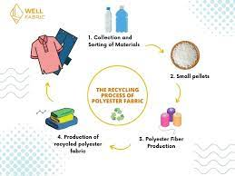
Fig 2.2 Recycle Fabric
2.6 Types of Fabric Recycling
2.6.1 Mechanical Recycling
This involves physically processing textile waste to separate fibers, often through shredding or other mechanical means. These fibers can then be re-spun into new yarns for use in creating new fabrics or other products. Mechanical recycling is a highly adaptable process due to its flexibility with input materials. According to Naqvi et al. (2018), mechanical recycling involves physically shredding textiles into fibres without altering their chemical structure. It is widely used for cotton and wool but reduces the fibber quality due to fibber length loss.
F
f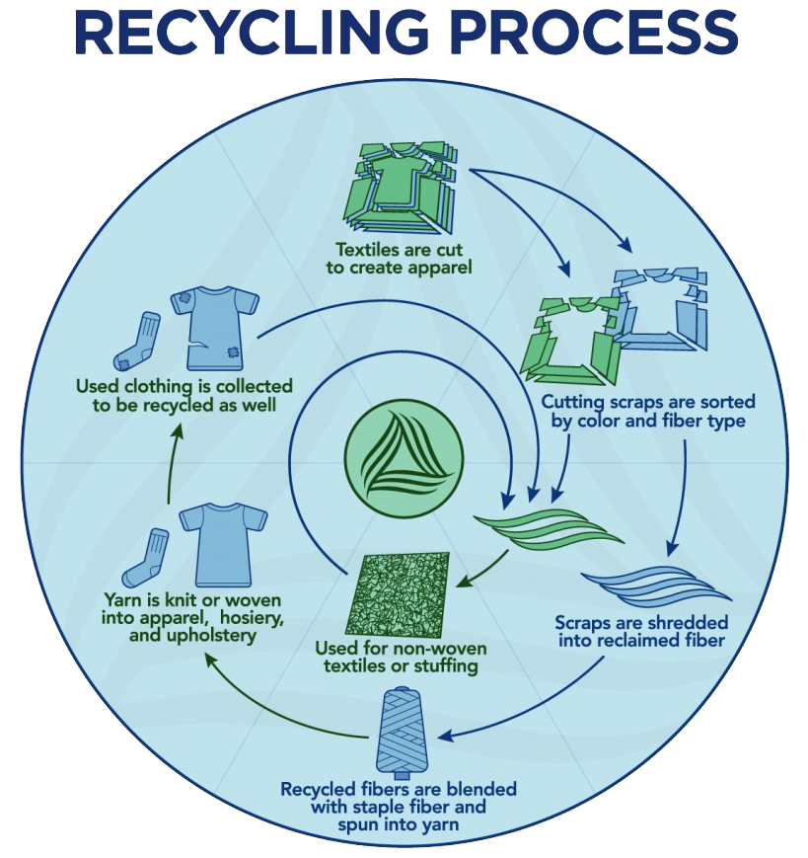
Fig 2.3 Recycling Process
2.6.2 Chemical Recycling
This method utilizes chemical solvents to dissolve and separate the fibers in textile waste. The dissolved fibers can then be recovered and reassembled into new textiles, ensuring that no tensile strength is lost. This method is particularly useful for blended fabrics, which can be more easily separated during the solvent process. Muthu, S.S. (2015) discussed chemical recycling as a process where synthetic fibres like polyester are depolymerized into monomers and repolymerized into virgin-quality fibre. This method is ideal for polyester but is energy-intensive and requires high capital investment.
2.6.3 Thermal Recycling
This process converts textile waste into heat, electricity, or syngas (a mixture of hydrogen and carbon monoxide) through high-temperature processes. This method can be used for both natural and synthetic textiles, but the energy output depends on the type and composition of the textile waste. Zamani, B. (2014) described thermal recycling as incinerating textiles to generate energy. While it reduces volume and provides power, it contributes to air pollution and CO₂ emissions, making it less desirable.
2.6.4 Modern Recycling Methods
2.6.4.1 Textile-to-Textile Recycling
This involves using pre-made or worn textiles to create new items, which can also be referred to as upcycling. This process can involve taking apart and reassembling garments to create new patterns and products.
2.6.4.2 Composting
Organic textile waste can be composted, converting it into a soil amendment.
2.6.4.3 Biochemical Recycling
This method uses microorganisms or enzymes to break down textile waste into simpler molecules that can be used to create new fibers.
2.6.4.4 Blended Fabrics
The recycling of blended fabrics, which are made from multiple types of fibers (e.g., polyester and cotton), can be challenging due to the difficulty of separating the different materials. However, advancements in chemical recycling are making it possible to separate blended fabrics more effectively.
2.7 Techniques and Technologies
Fabric recycling involves the recovery and reuse of textile materials to reduce waste, conserve resources, and promote environmental sustainability. Several techniques and technologies have been developed globally, which can be grouped into mechanical, chemical, thermal methods and other modern techniques. Wang, Y. (2010) emphasized advancements in textile shredders, carding machines, and automatic sorting systems that aid in the efficient recycling of fabric materials. She pointed out the limitations in differentiating fibre types, especially in blended textiles. Fletcher, K. (2008) proposed the use of modular design in garments, which makes it easier to disassemble clothing for recycling, thus reducing textile waste significantly. Baillie, C.A. and Brough, D. (2004) suggested incorporating natural fibres into composites using recycled fabrics, especially for automotive and construction applications.
Below are the main techniques and technologies used:
    - Mechanical Recycling Techniques
This is the most common and cost-effective method, particularly suitable for natural fibres like cotton and wool.
- Shredding: Textiles are cut and shredded into fibres or small pieces using mechanical shredders. These fibres can be reused in insulation, padding, or new textile products.
- Garneting: A process where textiles are broken down into fibrous form using rotating cylinders. It is widely used in recycling wool and cotton waste.
- Carding: After shredding, carding aligns the fibres to prepare them for spinning or blending with virgin fibres.
- Pulling: Used for knits and woollens, where the fabric is pulled apart rather than cut.
2.7.2 Chemical Recycling
This method uses chemical processes to break down synthetic textiles into their original monomers or base chemicals.
• Depolymerization: This applied to polyester and nylon; fibres are broken down into monomers, which can then be re-polymerized into new fibres.
• Solvent-Based Separation: Solvents are used to dissolve one component of a blended fabric ( dissolving polyester in a cotton-poly blend) to allow separation and recovery.
• Enzymatic Recycling: It uses enzymes to break down natural fibres like cotton and wool into glucose or amino acids.
2.7.3 Thermal Recycling (Energy Recovery)
It is used when textiles are no longer recyclable into useable fibres:
• Incineration with Energy Recovery: Fabric waste is burned in controlled facilities to generate heat or electricity. Though it reduces volume, it is less sustainable due to emissions.
• Pyrolysis: A high-temperature, oxygen-free process that converts synthetic textile waste into fuel, gas, or char.
2.7.4 Emerging and Hybrid Technologies
• Hydrothermal Processing: It involves using high-pressure steam and chemicals to break down textiles, especially blends.
• Microbial Decomposition: Genetically modified microbes are being developed to digest certain synthetic fibres like PET (polyester).
2.8 Benefits of Fabric Recycling
Bukhari et al. (2018) demonstrated that fabric recycling reduces energy and water consumption, lowers environmental pollution, and creates employment. Their study estimated that 1 kg of recycled cotton saves up to 20,000 litres of water. Goldsworthy, K. (2017) emphasized circular design principles and the integration of recycling processes into fashion supply chains. She advocated for early-stage design interventions to ease end-of-life recycling.
Fabric recycling offers numerous environmental, economic, and social benefits. It is an essential aspect of sustainable waste management and supports the circular economy by transforming textile waste into valuable resources.
Environmental Benefits
Reduces Landfill Waste: Recycling fabrics diverts textile waste from landfills, reducing the pressure on already overcrowded waste disposal sites.
Decreases Pollution: Prevents the open burning of textile waste, which releases harmful gases and toxins into the air, contributing to air and soil pollution.
Conserves Natural Resources: It reduces the demand for virgin fibres such as cotton, which require vast amounts of water, pesticides, and arable land.
Lowers Greenhouse Gas Emissions: Recycling textiles reduces emissions from fibber production, dyeing, and transportation of raw materials.
Economic Benefits
Creates Job Opportunities: The recycling industry supports employment in collection, sorting, processing, and resale, especially in small-scale and informal sectors.
Reduces Production Costs: Manufacturers can use recycled fibres as raw materials, which are often cheaper than virgin materials.
Encourages Local Enterprises: Small-scale recycling operations, like the use of a portable fabric recycling machine, can empower entrepreneurs and boost local economies.
Social Benefits
Promotes Community Awareness: Encourages people to adopt sustainable consumption habits and take responsibility for waste management.

Supports Charitable Causes: Recycled or repurposed textiles can be donated to people in need or repurposed for community development projects.
Technological and Industrial Benefits
Innovation in Textile Processing: It drives research and development of new recycling techniques and machinery.
Supports Circular Economy: Recycled textiles can be used in making insulation materials, padding, cleaning cloths, and even new fabrics, contributing to a closed-loop production cycle.
Space-Saving and Aesthetic Benefits
Reduces Clutter: Recycling old clothes and fabric waste helps in decluttering homes, workshops, and workspaces.
Promotes Upcycling and Creativity: Fabric waste can be transformed into crafts, rugs, bags, or artistic products, promoting creativity and resourcefulness.
2.9 Challenges in Fabric Recycling
Bartl, A. (2011) noted that contamination, dye residues, mixed fibre content, and lack of standardized collection methods are key obstacles in efficient fabric recycling. Sandin, G. and Peters, G.M. (2018) conducted a lifecycle assessment and discovered that recycled fabrics often have a high processing footprint unless done with renewable energy. Yousef, S. et al. (2020) addressed the difficulty in recycling mixed-fibre fabrics like cotton-polyester blends, which require complex separation techniques not yet economically feasible at scale.
2.10 Fabric Recycling in Developing Countries
Ogunniyi, D.S. (2019) studied textile recycling in Nigeria and found that informal tailors and small-scale fashion businesses generate a significant amount of scrap fabric with no structured disposal method. He recommended the development of portable recycling machines for community use. Akinlabi, E.T. and Akinlabi, S. (2021) emphasized the importance of local technology development to support decentralized fabric recycling, given the high cost of imported recycling machinery. Ellen MacArthur Foundation (2017) introduced the concept of a circular economy for textiles, promoting the reuse, recycling, and regeneration of materials in fashion. Their global report triggered widespread innovation in biodegradable fibres and closed-loop recycling systems. Teufel, L. and Wimmer, M. (2020) explored artificial intelligence and sensor-based sorting in textile recycling facilities, improving the accuracy of material identification and fibre separation

