CHAPTER ONE

1.1 INTRODUCTION
Education is a fundamental human right, essential for the development of individuals, communities, and societies. The Nigerian government has made efforts to provide access to quality education, but challenges persist, particularly in rural areas. Ilorin East Local Government of Kwara State, the study area, faces unique challenges in terms of access to education.
The distribution of government primary and secondary schools in the study area is uneven, leading to disparities in access to education. This uneven distribution can result in some areas having limited access to educational opportunities, while others have an oversupply of schools. This disparity can have significant implications for the educational outcomes of students in the studyarea.
Furthermore, the lack of effective planning and management of educational facilities can exacerbate the problem of uneven distribution. This can lead to inefficient use of resources, duplication of efforts, and ultimately, a decrease in the quality of education.
This study aims to analyze the distribution of government primary and secondary schools in Ilorin East Local Government of KwaraState, using surveying and GIS techniques. The study will examine the spatial distribution of schools, identify areas of inequality, and provide recommendations for improving the distribution of schools in the study area.
1.2 RESEARCH PROBLEMS
The un even distribution of schools in Ilorin East and Moro local government results in limited access to education in some areas, while others experience an oversupply. This imbalance can lead to inefficient use of resources, duplication of efforts, and a decrease in the overall quality of education. Consequently, students in underserved areas may face significant barriers to accessing quality education, hindering their academic performance and future opportunities.

1.3 AIM OF THE RESEARCH
The aim of this research work is to carryout spatial analysis and distribution of Government along Old jebba road, and part of Ilorin East , South, and Moro Local Government area of Kwara State

1.4 RESEARCH QUESTIONS
- What is the current spatial distribution of government primary and secondary schools in Ilorin East and Moro local government?
- What key factors influence the distribution of these schools?
- What strategies can be employed to improve the distribution of schools and enhance access to education?
1.4 RESEARCH OBJECTIVES
Specific Objectives
- To analyze the spatial distribution of government primary and secondary schools in Ilorin East Local Government Area of Kwara State.
  - This objective aims to examine the geographical distribution of schools in the study area, identifying patterns, clusters, and gaps in the distribution.
- To identify the factors influencing the distribution of government primary and secondary schools in the study area.
  - This objective seeks to investigate the factors that contribute to the uneven distribution of schools, such as population density, urbanization, and socio-economic factors.
- To evaluate the impact of the distribution of government primary and secondary schools on access to education in the study area.
  - This objective aims to assess the effects of the distribution of schools on the educational opportunities available to students in the study area, including issues of equity, quality, and accessibility.
- To develop a GIS-based model for optimizing the distribution of government primary and secondary schools in the study area.
  - This objective seeks to create a geographic information system (GIS) model that can help policymakers and educators optimize the distribution of schools, taking into account factors such as population growth, urbanization, and educational demand.
- To provide recommendations for improving the distribution of government primary and secondary schools in the study area.
  - This objective aims to offer practical suggestions for policymakers, educators, and other stakeholders to address the challenges and inequalities in the distribution of schools, ensuring that all students have access to quality educational opportunities.
General Objective
  - To contribute to the development of a more equitable and effective education system in Kwara State, Nigeria, by analyzing the distribution of government primary and secondary schools and providing recommendations for improvement.
1.5 SIGNIFICANCE OF THE STUDY
- Improve Access to Education: Identify areas with limited access and provide recommendations for improvement.
- Enhance Educational Planning: Inform policy-making and resource allocation at local and state levels.
- Reduce Inequalities*: Address disparities in educational opportunities and outcomes.
- Optimize Resource Allocation: Ensure efficient use of resources, such as funding, personnel, and infrastructure.
- Contribute to Literature: Add to the existing body of knowledge on educational geography, spatial analysis, and education planning.

1.6 SCOPE OF THE STUDY
- Geographical Scope: Focus on Ilorin East and Moro Local Government Area, Kwara State, Nigeria.
- Temporal Scope: Utilize data from 2020 to 2025.
- Spatial Scope: Examine the spatial distribution of government primary and secondary schools.
- Thematic Scope: Investigate school distribution, influential factors, impact on access, and GIS-based modeling.
By expanding on the original framework, this study aims to provide a comprehensive understanding of the challenges and opportunities in enhancing educational access in Ilorin East and Moro local government, Kwara state ilorin Nigeria.
Methodological Scope: The study will employ a mixed-methods approach, combining:
1. spatial analysis using GIS
2. Survey research
3. Statistical analysis
Limitations: The study will be limited to government primary and secondary schools in Ilorin East Local Government and Moro local government Area of Kwara State, Nigeria. Private schools and other types of educational institutions will not be included in the study.
By defining the scope of the study, we can ensure that the research remains focused, manageable, and achievable within the given timeframe and resources.
PERSONNEL
The following persons were involved in the supervision and execution of the project: -
OLAGUNJU SEGUN M. HND/23/SGI/FT/0003
OMOTOSHO JAMIU O. HND/23/SGI/FT/0005
OLATUNBOSUN ABOLADE C. HND/23/SGI/FT/0001
LAWALZAINAB O. HND/23/SGI/FT/0002
AKANFESARAFADEEN O. HND/23/SGI/FT/0004
ABIOLAAMINAT T. HND/23/SGI/FT/0010
As a group, we will be participating in all planning, field observations, processing of all field records, management and ensuring of safety of both personnel and equipment. All will be done under my supervisor’s guidance and supervision.

STUDY AREA
The project is Part of Ilorin East and Moro Local Government area of Kwara State, it’s about 14 kilometer distance long and some selected schools in Moro Local Government area of Kwara State, it falls on a larger geographical coordinate 04 33 24, 08 23 45 and 04 31 00, 08 22 09
N
NIGERIA
KWARA STATE
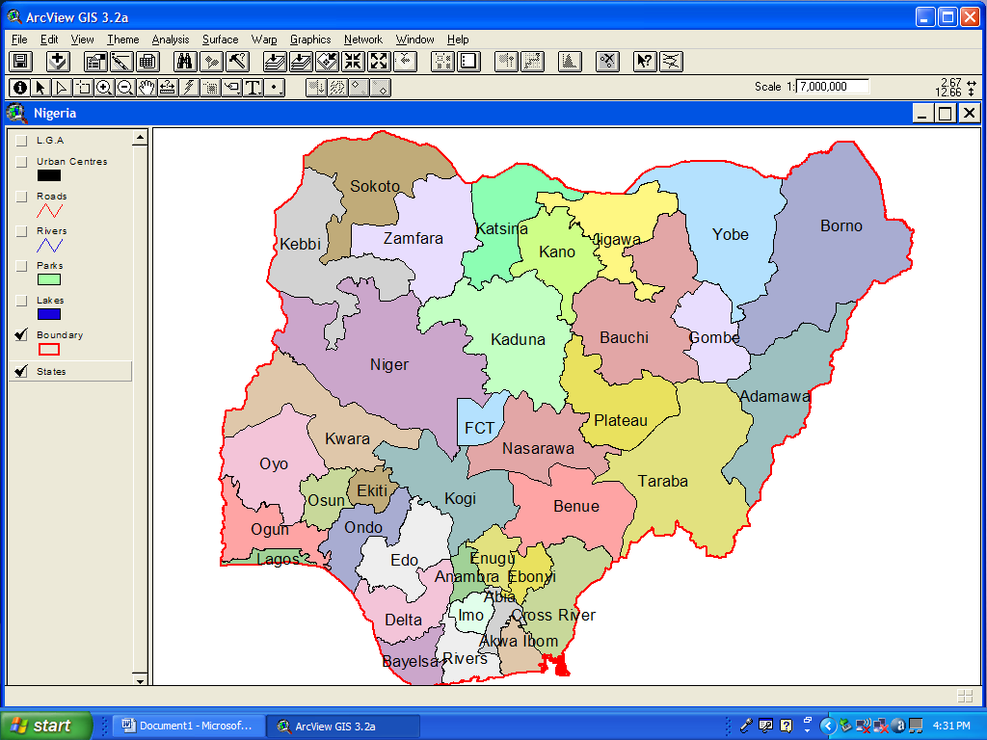
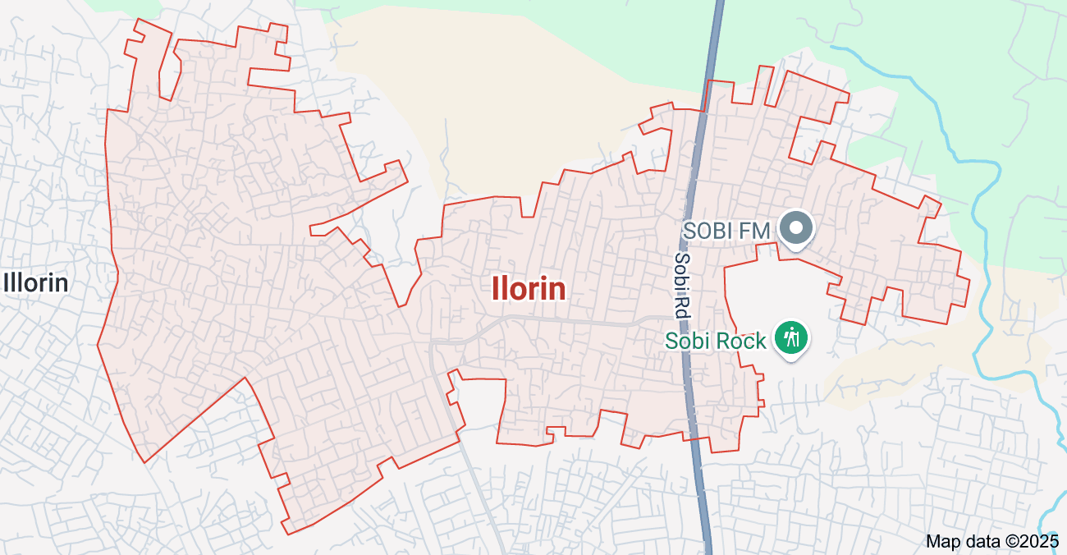

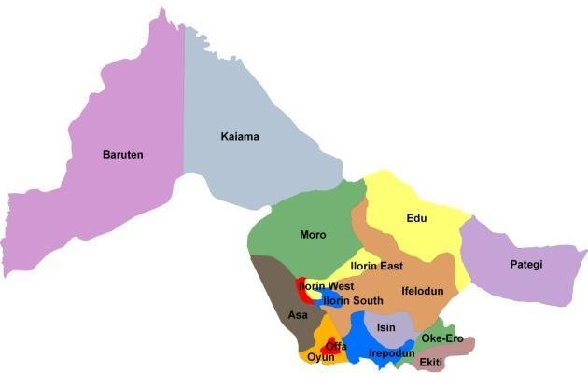

ILORIN

Figure 1.1 Shows the Map of the Study Area

