CHAPTER THREE

3.0 METHODOLOGY

This chapter deals with stages and techniques involved in the execution of the project task from the, reconnaissance to data capture, database design up to the analysis stage and information presentation.

3.1. RECONNAISSANCE/PLANNING
Reconnaissance is the preparatory aspect of the project known as preliminary survey or investigation. It involves the collection of all necessary information relating to the job as well as making visitation to the field in order to get the real picture of the project site. Reconnaissance is of two types, namely office and field reconnaissance.

3.1.1 OFFICE PLANNING
This involves the collection of all necessary data such as control points coordinates, permission letter as well as logistics and planning on how to embark on the project. Ground control data and information about the job were decided to be obtained using South Dual Frequency Global Positioning System owing to the nature and large area involved

Table.3.1 shows the Coordinates of controls
Station | Northing(m) | Easting(m) | Height(m)
PBIL3306 | 940288.197 | 678281.701 | 355.212
PBIL3304 | 940275.508 | 678254.250 | 350.532

Source: office of surveyor general kwara state
3.1.2 FIELD RECONNAISSANCE
This involved visiting the project site to have an overall view of the few of the schools to be surveyed. The station points were marked out along road junctions and at convenient points to be able to capture data of the area. At the end of the whole exercise, a sketch diagram known as recci diagram shown below in fig. 3.6. The type of analysis to be carried out was also known from the survey carried out. The configuration of the hardware and the software system required of the work were also known through field recci and also in the choice of appropriate model and structure to use.

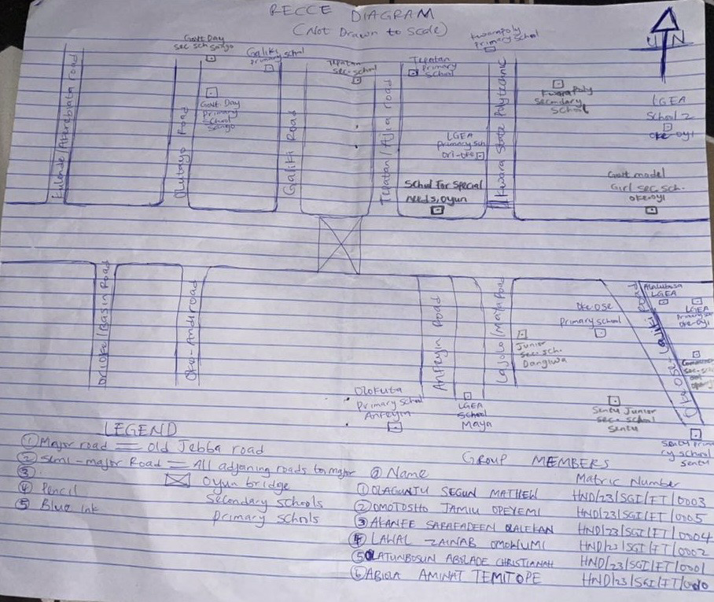
Fig. 3.1: shows Reece Diagram of the study area

3.1.2 EQUIPMENT USED AND SYSTEM SELECTION
EQUIPMENT USED
The equipment used for this project includes the following:
- 1 number of South Dual Frequency Global Positioning System and accessories
- 1 number of Downloading cable
- Computer system
- Field book and writing materials
SYSTEM SELECTION
HARDWARE REQUIREMENT
- Operating System: windows 10
- Device: HP laptop
- Model: Intel® core(TM)2 DUO
- Processor Speed: 2.40GHz
- RAM: 4.00 GB
- System type: 64-bit operating system
SOFTWARE REQUIREMENTS
1. Notepad
2. Microsoft excel
3. AutoCAD 2007 was used for plotting
4. ArcGis 10.2 was used for data analysis, spatial search and creation of database
5. Microsoft word 2007 for report writing
6. Microsoft power point for information presentation

3.1.3 TEST OF INSTRUMENTS
The only instrument test was the test of the South Dual Frequency Global Positioning System. South Dual Frequency Global Positioning System Base was set up on a station and the Rover was taken to two points A&B at an interval of about 30m to test for distance and coordinate accuracy.
All the necessary adjustment was carried out before the start of observation. The observation was done and the following data were recorded
Status (P): | Fixed
Horizontal Root Mean Square (H): | 0.014
Vertical Root Mean Square (V): | 0.021
Satellite Number (S): | 10+4
Communication Mode (Channel): | 4
Time (T) | 11:05:38

3.2 CONTROL CHECK
Control check was carried out on the beacons PBIL3306 and PBIL3304 in order to ensure whether they were still maintaining their original positions. The reference receiver (base receiver) was set on PBIL3306 while the rover receiver was set on PBIL 3304. The following are the result obtained

Table 3.7: Coordinate of the observed and the original values of PT 02
Station | Northing(m) | Easting(m) | Height(m) | Status | Remark
PBIL3304 | 940288.197 | 678281.701 | 355.212 |  | ORIGINAL
PBIL3304 | 940288.212 | 678281.681 | 350.532 | FIXED | OBSERVED
DISCREPANCY | 0.015 | 0.O20
Source: - field work
The result shows that the control pillars were in Situ and in good condition for the survey operation. In the case of the instrument, it can be concluded to be in good working condition.

3.3 DATA ACQUISITION
Basically, there are two ways of acquiring data for any project; these are primary data acquisition and secondary data acquisition.
Primary Data Acquisition
The primary data acquisition includes both spatial and attributes data. The data set of the spatial data was acquired through the use of South Dual Frequency Global Positioning System and the attribute data was acquired through social survey that involved asking questions from the residents anything concerning the utility in the area.

SECONDARYDATASOURCE
An imagery of the area was acquired through Updated Google earth; this was used to ascertain the extent of coverage of the project area.

3.3.1 GEOMETRIC DATA ACQUISITION
South Dual Frequency Global Positioning System was used for this geometric data acquisition. The base of South Dual Frequency Global Positioning System was set up on a Second Order Control at sangokulende area, number PBIL3306, we performed all necessary temporary, permanent adjustment, and instrument configuration was carried out, the existing coordinate of the occupied point was inserted on the data logger of the base instrument which is (940288.197). The rover of the instrument was configured with base station as follows:
- The unit of observation……..Minna Datum Zone 31P
- Ellipsoid…………………..Rinex
- Range …. 50km radius
- Observational procedure….. Stop and Go
After all setting was done; we start the observation by taking the rover to first point in Sango for coordinate acquisition to determine the other details. The coordinates were stored in the instrument memory of the rover which has been connected to the base. This process was repeated throughout the subsequent stations (schools).

3.3.2 ATTRIBUTE DATA ACQUISITION
We acquire attribute date through questionnaire feasibility studies, the following are data acquired:
- Total number of class rooms in each school
- Total of pupils/Student in each class
- Total number of Pupil/Students in each school
- Population of each locality/environment
- Ministry of Education guideline for sitting schools

3.4 DATA PROCESSING
This process described how data is converted into information. Data are organized into structure group and database. The data acquired were downloaded using South Dual Frequency Global Positioning System cable to transfer data into personal computer and AutoCAD 2016 with ArcGIS 10.1 version was used for all drawings and database creations.

3.5 DATABASE DESIGN

The database is the heart of a GIS. The process of designing such a database is called data modeling. Data Model is the simplification and representation of reality, that is the process by which the real world entities and their inter-relationships are analyzed and modelled in such a way that maximum benefits are derived while utilizing a minimum amount of data. A database is as an organized, integrated collection of non-redundant data stored so as to be capable of use by different logical paths. It involves the following segments: Reality, Conceptual design, logical design and physical design.KufoniyiOlajide (1998)
In database design, four basic steps were normally taken. These steps are:-
- View of reality.
- Translation of reality to conceptual model.
- Physical design.
- Translation of conceptual model to logical design.
VIEW OF REALITY
VIEW OF REALITY
VIEW OF REALITY
DESIGN PHASE
CONCEPTUAL DESIGN
LOGICAL DESIGN
PHYSICAL DESIGN
CONSTRUCTION
PHASE
REALITY

SPATIAL DATABASE

Fig 3.2: Design and Construction Phases of a Spatial Database (Kufoniyi, 1998)

3.5.1 VIEW OF REALITY
Realities were articulated based on geographical data within the study area with respect to Government schools distribution. In this case reality includes the Type of School, Number of classrooms, and population of students.
The creations of spatial database are in three phases. These are:-
- Conceptual design phase, that is the arrangement or decision on how the view of reality will be simplified to satisfy the information required.
- Logical design that is the representation of the data model, designed to reflect the recording of the data in computer system called data structure.
- Physical design phase, this is the implementation of the type of GIS software to map out the data for variable manipulation, which can also take care of non-spatial queries as done with any other normal database management system (DBMS).GIS database’s fashion from the fact that the data elements of the database are closely interwoven and therefore need to be structured for easy integration retrieval
According to Healey (1991), a proper database organization needs to ensure the following:-
  - Flexibility in the design to adapt to the needs of different users.
  - A system of validation checks to maintain the integrity and consistency of the data elements.
  - A controlled and standardized approach to data input and updating.
  - A level of security for minimizing damage to the data.
  - Reducing redundancy in data storage

3.5.2 CONCEPTUAL DESIGN
This is the representation of the human conceptualization of reality in simplified manner in such a way that a minimum amount of data is utilized to satisfy the project requirement to achieve its aim. The aim is to determine the basic entities, the spatial relationship and their corresponding attributes. What must be decided is how the entities are going to be represented but still satisfy the information requirement of the individual or organization concerned. The following were identified:
- The related data sets
- Basic geometric and thematic data components of the application, which are node, arc, polygon (polygon only came in for the perimeter of the study area)
- The basic spatial object, their attributes and interrelationship. These spatial object were points and lines

Fig. 3.4: Schools and its attribute
NODE

SCHOOLS
EASTINGS
NORTHINGS
SCHOOL NAME

3.5.3 LOGICAL DESIGN

This refers to the translation of conceptual model into logical design to represent a data model which can be acceptable by the computer that is the representation of data in a computer memory. In this stage, the data were structured to describe logically arrangement of data in the database. Relational data structure was chosen to implement the model because of its flexibility capability very wide deployment within and outside GIS.From the entity-relationship diagram, the following tables were designed.

Attribute of School table
S/NO | ATTRIBUTE COLUMN | DESCRIPTION
1 | S_ID | SCHOOL IDENTITY
2 | SCH_AREA | SCHOOL AREA
3 | SCH_STATUS | SCHOOL STATUS

3.5.4 PHYSICAL DESIGN
This is the representation of data format of implementation software which is usually done at the beginning of the database creation phase. The software used is ArcGIS 10.1

Table 3.11: Data Declaration
FIELD NAME | Data Type | FULL PROPERTIES Allow null values | Default values | Length | Geometry type | Grid
Shape | Geometry | Yes | Nil | Nil | Point
Id | integer | Yes | Nil | Nil | Nil
Location | Text | Yes | Nil | 25 | Nil
school_source | Text | Yes | Nil | 25 | Nil
Easting | Float | Yes | Nil | Nil | Nil
Northing | Float | Yes | Nil | Nil | Nil

3.5 DATABASE IMPLEMENTATION
The Arc GIS was lunched. The default table created for the graphics was then edited and other fields were formed .The table was populated to link schools, location and population with their attributes from where queries were made. The extract of attributes and topples created for the project are shown below

3.5.1 DATA SECURITY
This refers to the protection of data against unauthorized disclosure, alteration or destruction. The main aim is to protect the integrity of the data against system malfunctioning, virus, infection, technical hiccups or human error. Database security deals with all various aspect of protecting the database content, its owners and its users. Security measures include the use of fire proof vault, the preparation of microfilmed duplicates or regular creation of backup copies for all computer files and controlled access to sensitive areas.

3.5.2 DATA INTEGRITY
This is the process of ensuring that the data in the database is accurate and setting of certain constraint to prevent inconsistency in the database. Integrity of the database must be ensure at all times, thus care must be taken when inserting data and updating the database. The integrity enforced/utilized by Arc GIS 10.2 is that of data type constraint. The software prevents for example a text value from being entered in a field that was declared as number. Also to ensure quality in GIS, separate databases were created for graphic data and non-graphic data. They were linked via identification codes. In this way each file could be managed separately.

3.5.3 DATABASE MAINTENANCE
Proper keeping, updating and management of database ensure on its currency and fitness for the purpose for which the database was created. The quality of the database depends on its currency and its fitness for use as a decision support system and must be maintained.

