CHAPTER TWO
2.0 Theoretical Framework and Literature Review
2.1 Conceptual Review
Kidnapping is a global problem that affects countries all over the world—from the United States and Mexico to many countries in Africa, Asia, and beyond. Governments are working hard to address this problem and ensure that the perpetrators are captured and brought to justice.
Kidnapping refers to the abduction and captivity of a person, typically to obtain a ransom. Sometimes kidnappers hold their captives longer in order to demand more money from the victim's relatives or associates. It is a wicked act.
No matter the level of difficulty anyone is facing, that is not enough reason to choose kidnapping as an option to survive. There are many causes of kidnapping, including unemployment, poverty, religion, political issues, and so on. The practice can be reduced with governmental involvement.
Kidnapping in Nigeria
Kidnapping is not a new problem in Nigeria, and it is one of the country's biggest challenges. The country faces many problems, including unemployment, corruption, and low education rates—but it is kidnapping, thanks to high-profile incidents perpetrated by the Islamic militant group Boko Haram, that has drawn the world's attention. The facts show that the rate of kidnapping in this country is indeed high.
International organizations are joining Nigerian groups to combat this problem. Chad, Cameroon, and the United States have recently joined in the fight.
Boko Haram's kidnappings are motivated by both politics and religion, according to their own leaders as well as the Nigerian government.
The kidnappings are political because corrupt politicians want to destroy the government of the former President Goodluck Jonathan. The kidnappings are also religious because of the group's fundamentalist Islamic beliefs. The meaning of their name is “Western education is prohibited,” which explains why they continue to target schoolchildren. On the night of April 14, 2014, about 276 Chibok schoolgirls, ages 16 to 18, were kidnapped by this group.
A popular Christian musician in Nigeria, Chika Okpala, lamented the kidnapping of a friend in a song entitled “NdiNto” (meaning "the kidnappers"). He stated that when the perpetrators were asked why they did it, they said they needed money. They went on to explain that they did not have jobs due to high unemployment.
Sometimes, ordinary citizens participate in kidnappings in order to line their pockets, usually youths who are hired by rich men to do their dirty business. The criminals will target rich families and sometimes demand up to twenty million naira (the equivalent of about $119,000).
The government of the Nigerian state of Anambra issued a new law that changed the punishment for anyone caught kidnapping. The former governor of this state, Peter Obi, declared that offenders would be sentenced to death—and that anything purchased with ransom money, like a house or car, would be destroyed.

A Worldwide Issue
The rates of kidnapping in Europe, North America, and South America are attracting worldwide attention. The practice of kidnapping has become quite lucrative for some, and there are criminal groups that have made it their business model.
In Mexico, with its history of drug-related violence and police corruption, kidnapping is an old story. According to the U.S. Department of State, Mexico suffered an estimated 105,682 kidnappings in 2012, and in 2013 the number reached 131,946, the highest number on record.
The disappearance of children in the United States is not unheard of, either, and it is a problem that police and other agencies are working hard to address. According to the National Centre for Missing and Exploited Children, roughly 800,000 children are reported missing each year in this country

Kidnapping is seen as a lucrative business and the shortest means to wealth by those involved in this crime. The current wave of abductions across the country makes every person a potential target regardless of social class or economic status.
This is different from a number of historical kidnapping themes in the country:

Political Kidnappings
This refers to the political kidnapping which started in the petroleum industry in Nigeria's oil-rich Niger Delta region in the early 2000s:
In the Niger Delta, agitators took expatriates working with multinational oil giants hostage, to force oil companies operating there to carry out community development projects for the benefit of the host communities or force government into negotiations for more of economic benefits accruing to the federal treasury for the region.

Boko Haram Kidnappings
Kidnappings by jihadist terror group Boko Haram in Nigeria's northeast and northwest began in 2009 in concurrence with the conflicts in the region.
Abductions by Islamist terrorist Boko Haram are to further its agenda, recruit fighters, instil fear, gain more international popularity and force the government to negotiate with it for ransom which is one of the means of generating funds for its terrorist operation. Boko Haram have committed several mass kidnappings of students.
Their 2014 kidnapping of 276 teenage girls from a secondary school in Chibok, Borno State, was covered extensively by the international media, making millions of people aware of that specific crime and of the insurgency. Boko Haram often demand that victims' families or the government pay them ransoms, or that the government release prisoners from their group. ]Boko Haram has brainwashed and forced some of the young people it has kidnapped into joining them and carrying out attacks, including suicide bombings. Boko Haram force many young female victims to marry them.

Commercial Kidnappings
Kidnapping for ransom on a commercial scale became rampant in Nigeria in 2011 spread across all the 36 states and the country's capital, Abuja.
In February 2021, Nigerian journalist Adaobi Tricia Nwaubani wrote for the BBC News, "The Nigerian government seems to have suggested that it can no longer be relied on to keep citizens safe."

Kidnapping Instances

North

Zamfara State
Zamfara, one of the security dark spots in Nigeria is caught between herder-farmers clashes and kidnapping and banditry. In June 2019 a household was attacked by bandits seizing the man alongside his three wives and a 13-year-old son. In August the Director of Budget for the state was kidnapped while his deputy he had been travelling with was killed in the attack.
In 2019, the governor of Zamfara, Bello Matawalle initiated a peace and reconciliation plan to bring the bandits who attack and kidnap villagers back home offering them jobs in place of kidnapping and banditry. In August 2019 over 300 kidnapped victims who were held captive waiting for the payment of ransom on their heads by family members were freed. Days later another batch of 40 kidnap victims were freed.

Makurdi Kidnapping
On 24 April 2021, gunmen kidnapped students from the Federal University of Agriculture in Makurdi, in Benue State. According to eye witnesses, three students were kidnapped, but two students were confirmed kidnapped later. This is Nigeria's fifth kidnapping from an academic institution in 2021. It came just four days after the Greenfield University kidnapping. On 28 April 2021, the university released a statement confirming the return of the abducted students.According to the university’s spokesperson, the two students came back on 27 April 2021 unhurt.

South-East

Kidnapping of the Head of the Methodist Church in Nigeria.
The head of the Methodist church in Nigeria, Samuel Kanu was kidnaped on Sunday the 26th of May 2022. The kidnapping occurred along a highway in the southeastern state of Abia. He and a number of priests travelling to the Owerri airport after a church event, were abducted after their vehicle's tyres we punctured by the assailants' bullets.
They were abducted by a network of commercial kidnappers which claimed to oversee kidnappings in the region. The grouped consisted mostly of Fulani immigrants from a number of countries in the Sahel region such as Niger, Mali and Sudan.
These immigrants however had lived extensively in Nigeria and spoke Igbo - the native language of the region, very fluently.
Under real threats of death by decapitation (as was the fate of past un-cooperating victims), the priests were coerced into paying an eventual ransom of a hundred million Naira. This was done via phone calls to heads and members of the church.
The funds were intended for distribution among the members of the kidnapping group present, but most were to be sent to other senior members of the larger kidnapping network, as well as to their sponsors.
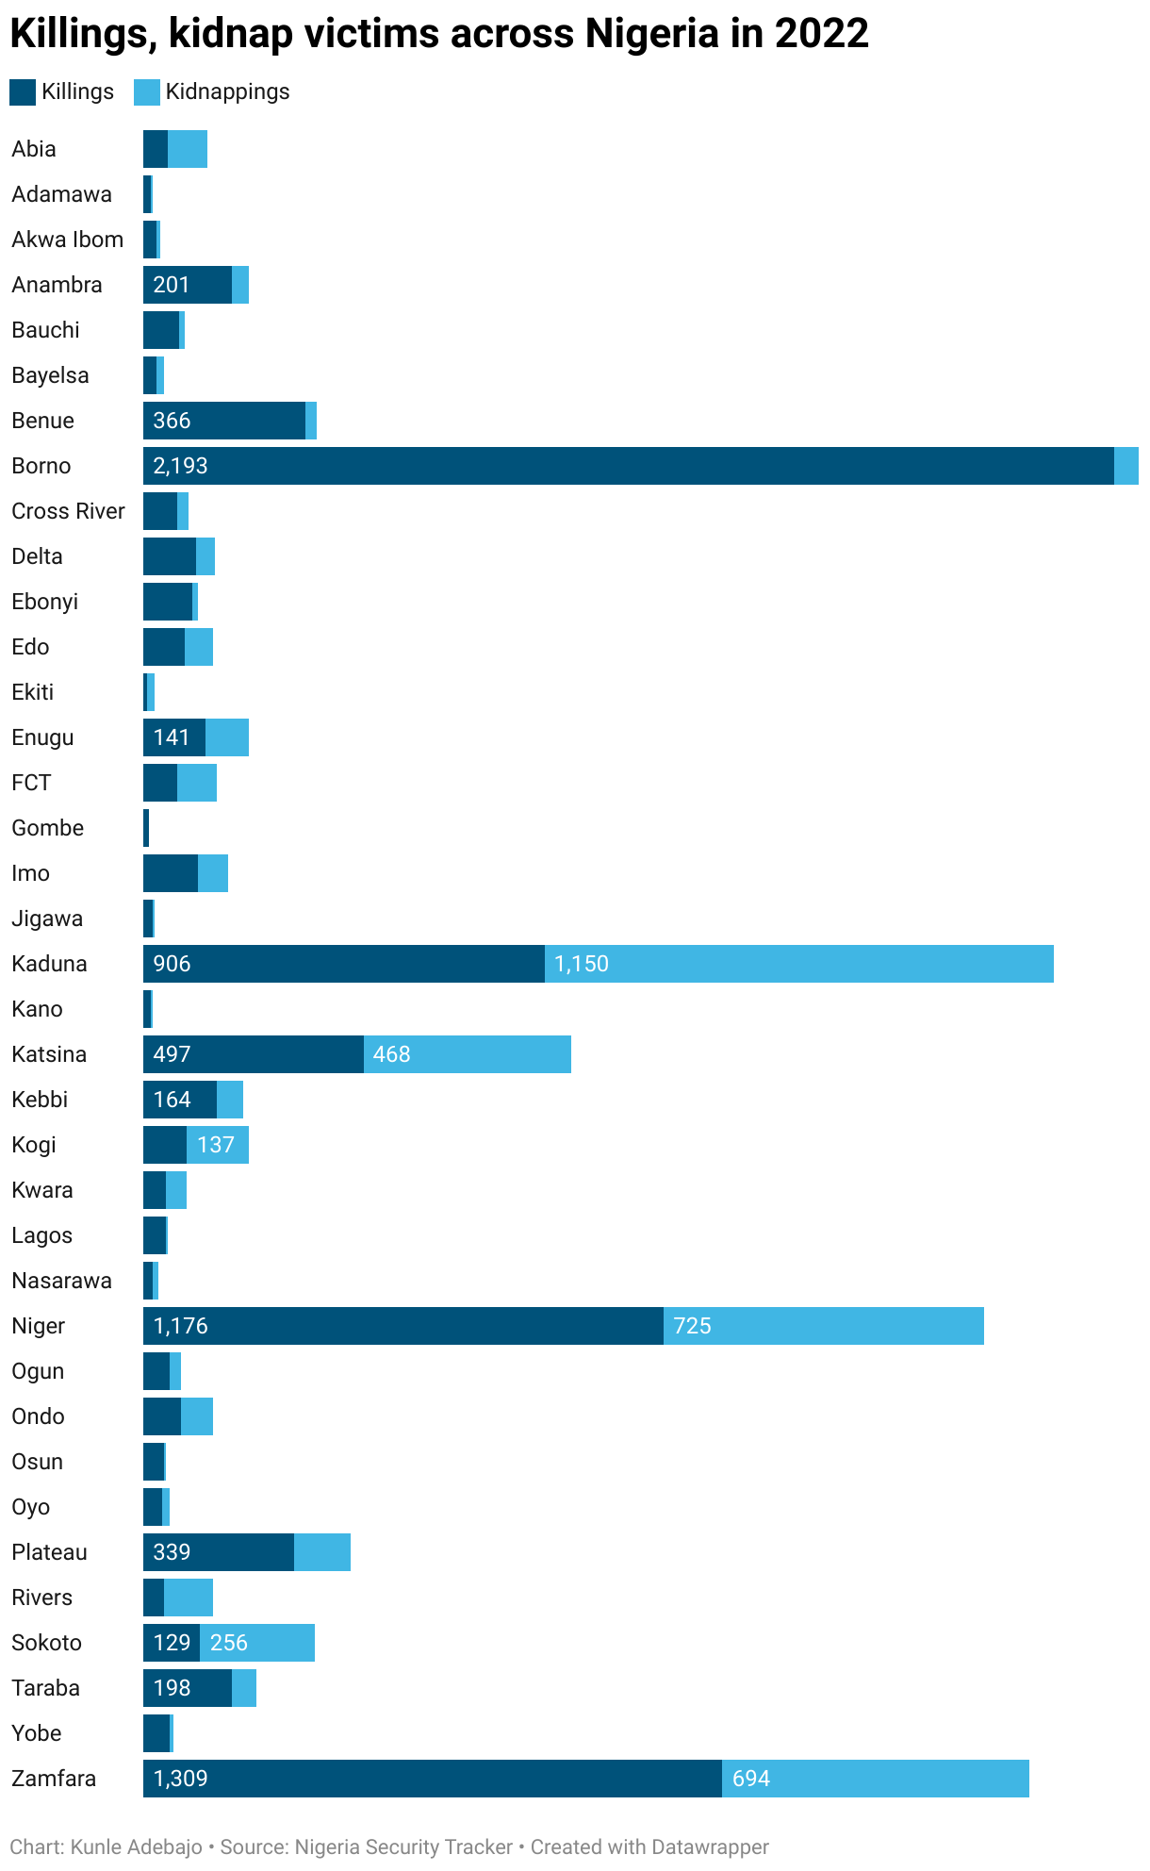

2.1.2 Causes of Kidnapping
Poverty
Poverty is usually the root cause of kidnapping. When a person is poor and hungry, he or she can be propelled to commit crimes to survive. They may think kidnapping is the only way to escape poverty. So they begin to target individuals capable of paying huge ransoms for their release.

Unemployment
Like poverty, unemployment leads one to see kidnapping as a more profitable way of making income. An idle mind is the devil’s workshop. When people are not adequately employed, they turn to other means, usually criminal activities, to sustain themselves.

Greed
The get-rich-quick syndrome, especially among the youths, has increased the kidnapping rates in Nigeria. These people fancy the luxurious things of life and want them by all means, even when they cannot afford them. They want to drive the poshest cars, live in mansions, throw expensive parties, and travel abroad for holidays. This lifestyle is often unattainable for most people. So many turn to kidnap rich people and demand huge ransoms to afford the life they dream of.

Dirty politics
They say politics is a dirty game. Most times, it’s true. Politicians are known to sponsor the kidnapping of their rivals to win a political position. They employ thugs and other criminal elements in society to do their dirty jobs for them. Some kidnapped victims don’t survive the ordeal as they end up being assassinated, while others will disappear without a trace.

Religion
Religion plays a huge role in the kidnapping rates in most countries. In Nigeria, the Boko Haram insurgents, an Islamic terrorist organisation, have kidnapped many people in northern Nigeria. The Chibok girls and Dapchi schoolgirls are just a few out of numerous cases of kidnapping inspired by religion.

Corruption
A country where corruption thrives is a hotbed of kidnapping. If a government is corrupt where officials embezzle public funds to enrich themselves instead of helping the masses, then the masses will turn to crime, ergo kidnapping, to survive. The funny thing is some of these greedy government officials end up becoming victims of kidnapping.
2.1.3 Types of Kidnapping
Basic Kidnapping
By far the most common form of kidnapping, this can be accomplished in the most part of the world with minimal preparation, with relatively low risk of failure. Kidnappers with generally target local businessmen or their families; those regarded as been "well-off", without having sufficient resources to spend a great deal of money on security precautions. The kidnapper’s goal is a fast, easy payoff. Generally, the ransoms requested are relatively easy for the victim's family or company to obtain.
High Net worth Individual Kidnapping
Generally, the intended target is studied for some time prior to the actual kidnapping, allowing the perpetrators to gather intelligence and security procedures and personal habits. After the victim has been taking, his or her family or employer is contacted with the ransom demand. Generally, a negotiation process occurs. As most of these incidents are perpetrated by experienced kidnapping gangs, the victim is generally released if ransom is paid. As a high-net-worth individuals become increasingly security-conscious, this type of kidnapping has been on the decline in recent years, in favor of less involved kidnappings with smaller, but easier to obtain payoffs.
Tiger Kidnapping
A crime involving a hostage-taking in order to force the victim to commit or assist in a theft. The hostage or hostages is/are held as until the victim has met the demands of the criminals. All of the victims work in a location where cash is being handled, such as bank, post Office, currency exchange firms etc.
Express Kidnapping
The victim is abducted, then forced to withdraw their ransom from a bank or ATM. If all goes well, the victim is released afterwards, generally after having been relieved for all valuables of on their person (and occasionally in their residence). This type of kidnapping is popular in urban areas, due to the prolific ATMs. In some cases, this will develop into a standard kidnapping, with further ransom demanded of the family or employer. In other cases, the victim is held overnight, to get around a one-day withdrawal limit.
Virtual Kidnapping
A virtual kidnapping is more income than actual kidnapping. The perpetrators will wait until their target is unreachable open back visiting an area with no cellular coverage, for example), then will contact the targets family or company claiming they have kidnapped the target and demanding an immediate ransom. The target eventually returns, unaware that anything untoward has occurred. Due to the need for haste the ransoms demanded are generally relatively modest. Another common technique is to call the target pretending to be a cellular phone company representative, and ask them to turn off their phone for a short while for a technical reason, during which the virtual kidnapping is conducted. Thus far, virtual kidnappings are commonly in Latin America, specifically Argentina, Brazil, and Colombia, and Mexico.
Politics Kidnapping
The kidnapping conducted to extort political concessions from governments or security forces. As monetary ransom is no longer enough, it is more difficult to negotiate kidnap victims freedom as in many cases the political concessions or demand cannot be met by the involved governments, putting the victim's life at greater risk.
Bride Kidnapping
A form of forced marriage when which the groom-to-be kidnaps his bride. In many cases the would-be couple has never met until the day of kidnapping. This way of marriage is practiced in the Caucasus region, Central Asia, and some Nations in Africa. In many cases Bride is raped in order to convince her to stay with her husband, as in many traditional cultures the loss of virginity is actually judged. In some cultures a bride price is customary, so the kidnapper contact his victim’s family to demand compensation

2.1.4 Impacts of Kidnapping
For the victims, there are many negative consequences of kidnapping, including:
- Psychological trauma
- Fear and lack of trust

Psychological Trauma
The negative psychological effects of being abducted are huge, especially for a child. Depression, anxiety, and post-traumatic stress syndrome (PTSD) may last a lifetime.

Fear and Lack of Trust
In a society where the incidence of kidnapping is high, fear limits people's lives and actions. They will always move with caution as they do not know who might be the next target. The rich surround themselves with security guards because of their fear of getting kidnapped.
Solutions
There are solutions that may help reduce the rate of kidnapping, including:
- Training strong anti-kidnapping agents
- Monitoring the activities of the police
- Serious punishment for offenders
- Job creation

Training Anti-Kidnapping Agents
Any country that wants to fight kidnapping successfully must hire and train capable agents to combat the issue. When law enforcement agencies are actively involved, the incidence of this crime can be lessened.

Monitoring the Police
Reports show that the police are involved in some kidnappings. Notable examples have occurred in Mexico. Eliminating the criminals within the ranks of law enforcement is key.

Seriously Punishments for Offenders
Mild punishment does nothing to deter criminals. When the government treats kidnappers harshly, fewer abductions will occur.

Job Creation
Generating jobs for citizens, especially for the youth, can have a huge impact on the fight against crime. When people are gainfully employed, they do not need to commit crimes.A
2.1.6 Newspaper Coverage of Kidnapping
Frame Patterns used by the Media in Crisis Situations
In content analytical study of the “Print Media Framing of Boko Haram Insurgency in Nigeria” (Okoro and Odoemelam, 2014), the following frames were used: response frame, political frame, human interest frame, conspiracy frame, attribution of responsibility frame, ethnicity frame, economic frame, labeling frame, ethnic frame and religious frame. Okoro and Odoemelam discovered that The Guardian, ThisDay and Vanguard newspapers reported Boko Haram insurgency in a predominantly policy response frame, while the Daily Sun laid emphasis on ethnic and religious frames (Okoro&Odoemelam, 2014). The media’s emphasis on the government’s quick response and effort to form new policies that would address the problem is constructive. The same year, a research on “The Mass Media Coverage of the Kidnap of the Chibok school girls” ( Amannah, Mba-Nwigoh, Ojo, and Nwigoh, 2014), revealed that there is a predominant use of conflict approach and lesser use of peace-oriented journalism by the mass media in reporting the Chibok girls kidnap. Scholars used categories such as neutrally objective, cause-promotion, conflict approach and peace journalism in their study and discovered that the media are yet to adopt proactive approach to reporting conflicts which supports the aim of this study. Also, in the analysis of the abduction of the Chibok girls in two southern and northern Nigeria-based newspapers, Ngwu and Ekwe (2015), used rescue efforts frame, powerlessness frame, hopelessness frame, political frame, religious frame, ethnic frame, conspiracy frame and economic frame. Result showed that hopelessness frame was used more in news reports. The media framed the situation as hopeless which is not constructive. From the results above, it can be deduced that the positive salience given to the government’s prompt response to curb Boko Haram insurgency in 2014, the negative framing of the security state of the country as a hopeless situation the same year (2014), and the negative report of the government’s indifference to the abduction of Chibok girls in 2014 support the assertion that the media tell the people what to Framing of the Abduction of Chibok Girls in The Guardian and The Nation Newspapers 4 International Journal of Communication: an Interdisciplinary Journal of Communication Studies, 22, September, 2017. Published by the Communication Studies Forum, Department of Mass Communication, University of Nigeria, Nsukka think about. In other words, the media frame information they want the people to think is more important whether it is constructive or not. A content analysis on the coverage of crisis in West Africa sub-region by three elite Nigerian national dailies and three leading magazines over two decades ago revealed that the media covered conflicts news stories well (Edeani, 1994). Unfortunately, news stories which contained constructive suggestions accounted for just 26 percent of all the contents of the newspapers and magazines (Edeani, 1994). Those that contained no suggestions represented 27 percent of the total content, while stories which were adjudged to be irrelevant to both constructiveness and non-constructiveness constituted the remaining 47 percent (Edeani 1994). Twenty years after, Owolabi and O’neill (2014), analysed the content of Nigerian press. The study revealed that the press has not performed creditably well in the coverage of poverty and related issues. Also, rural communities were neglected in news reports and the community news was found to be lacking in development contents (Owolabi&O’neill, 2014). Contents were mostly tragic occurrences like religious crisis and inter-tribal disputes (Owolabi&O’neill, 2014). Both results show that salience was not given to constructive news report, implying that the issues Edeani discovered over twenty years ago (that majority of the news content are not constructive) still feature till date. This could be as a result of lack of understanding of what and how to present information in a constructive manner. In a research by Lauren McCarty (2013) on “Framing famine: An Analysis of the US Media Coverage of the 2011 Famine in the Horn of Africa’’, Sei-Hill et al and Scheufele note that the key aspect of frame building and frame understanding is societal understanding. For an American audience, frames must adjust to the needs of the society or the framing will potentially be lost or misunderstood (McCarty, 2013). McCarty used two major frames: episodic and thematic frames. She further broke down the major frames into sub-frames and added factors that constitute the sub-frames. The factors are: causes of the famine; which showed nine factors that contributed to the famine. Blame for the famine; showed ten different factors that contributed to the famine. Solution to the famine showed 11 factors that could be used to end the famine of which the need to weaken terrorism and strengthen local government to improve famine conditions recorded the highest percentage (McCarty, 2013). These sub-frames are detailed enough to put into work programmes. Also, frames were tailored to the needs of the society and the policy of the government which yielded positive results. The media lay emphasis on frames they consider more important than others. Unfortunately, these frames are mostly not presented in a manner that is productive or that would proffer solution to the problem, which means that the effect of the news report may not yield the desired results. But Klaidman (1990, p. 119) while writing on health crisis says, “the media are frequently accused of reporting inadequately but this charge is vague, sweeping and usually unsubstantiated”. The real focus should be on how well we can legitimately expect the media to cover health crisis because there are standards for reporting a particular crisis of any sort (Klaidman, 1990). Therefore, the standard for reporting constructively is the gap this study sought to fill.

2.2 Theoretical Framework
Theory
A theory is a set of ideas formulated to explain social phenomenon. It could be in form of preposition or hypothesis but largely, the theory are statement of principles of a subject they could be conjectural.
A theory is simply a system of explanation. Thus; various scholars of communications science
McQuail (1983), a theory consists of a set of ideas of varying status and origin which seek to explain or interpret some phenomenon. Some scholars look at a theory as making meaning out of nothing. Through theories, sense or meaning can be made out of disturbing situations.
Hence the research will employ the use of: Framing Theory.
2.2.1 Framing Theory
The concept of framing is related to the agenda-setting tradition but expands the research by focusing on the essence of the issues at hand rather than on a particular topic. The basis of framing theory is that the media focuses attention on certain events and then places them within a field of meaning. Framing is an important topic since it can have a big influence and therefore the concept of framing expanded to organizations as well.
In essence, framing theory suggests that how something is presented to the audience (called “the frame”) influences the choices people make about how to process that information. Frames are abstractions that work to organize or structure message meaning. The most common use of frames is in terms of the frame the news or media place on the information they convey. They are thought to influence the perception of the news by the audience, in this way it could be construed as a form of second level agenda-setting – they not only tell the audience what to think about (agenda-setting theory), but also how to think about that issue (second level agenda setting, framing theory).
The theory was first put forth by Goffman, under the title of Frame Analysis. He put forth that people interpret what is going on around their world through their primary framework. This framework is regarded as primary as it is taken for granted by the user. Its usefulness as a framework does not depend on other frameworks.
Goffman states that there are two distinctions within primary frameworks: NATURAL + SOCIAL. Both play the role of helping individuals interpret data. So that their experiences can be understood in a wider social context. The difference between the two is functional.
Natural frameworks identify events as physical occurrences taking natural quote literally and not attributing any social forces to the causation of events. Social frameworks view events as socially driven occurrences, due to the whims, goals, and manipulations on the part of other social players (people). Social frameworks are built on the natural frameworks. These frameworks and the frames that they create in our communication greatly influence how data is interpreted, processed, and communicated. Goffman’s underlying assumption is that individuals are capable users of these frameworks on a day to day basis. Whether they are aware of them or not.
Framing techniques per Fairhurst and Sarr (1996):
- Metaphor: To frame a conceptual idea through comparison to something else.
- Stories (myths, legends): To frame a topic via narrative in a vivid and memorable way.
- Tradition (rituals, ceremonies): Cultural mores that imbue significance in the mundane, closely tied to artifacts.
- Slogan, jargon, and catchphrase: To frame an object with a catchy phrase to make it more memorable and relate-able.
- Artifact: Objects with intrinsic symbolic value – a visual/cultural phenomenon that holds more meaning than the object itself.
- Contrast: To describe an object in terms of what it is not.
- Spin: to present a concept in such a ways as to convey a value judgement (positive or negative) that might not be immediately apparent; to create an inherent bias by definition.
Framing is in many ways tied very closely to Agenda Setting theory. Both focus on how media draws the public’s eye to specific topics – in this way they set the agenda. But Framing takes this a step further in the way in which the news is presented creates a frame for that information. This is usually a conscious choice by journalists – in this case a frame refers to the way media as gatekeepers organize and present the ideas, events, and topics they cover.
Framing is the way a communication source defines and constructs any piece of communicated information. Framing is an unavoidable part of human communication – we all bring our own frames to our communications.
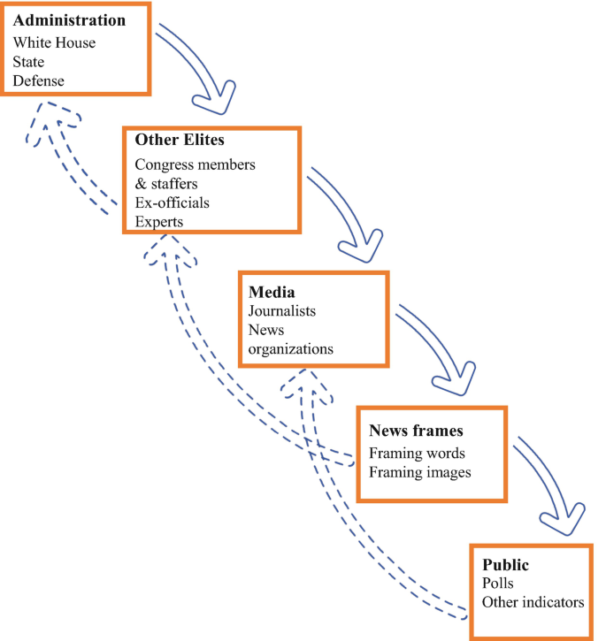 Framing Theory
2.2.2 Justification of Theory
Concisely, the focus here is on media framing of kidnapping cases in the Nigerian newspapers, which might contribute to regional, religious, cultural and social stereotype. Framing theory also takes salience into consideration. Salience is the act of making information more prominent, noticeable, meaningful or memorable in order to enhance the probability that the receivers of a message and process it and remember it (Entman, 1993). Frames “introduce or raise salience or apparent importance of certain ideas, activating schemas that encourage target audiences to think, feel, and decide in a particular way.” The nexus between these theories and the study is that, issue-attention cycle theory contains crucial insight into what is currently happening with public opinion about kidnapping in Nigeria today. Over long periods of time, kidnapping in Nigeria has potentially pique and drop on multiple occasions, with the media playing an influential role in exactly where and when this occurs. Thus, the theory holds a vital position in the understanding of how the press covered and report kidnapping cases in Nigeria. As such, media frames can also aid in changing the perception of the society on the coverage and reportage of kidnapping cases in Nigeria. The theory serves the research goal in the context of understanding the type of issue that attracts prominence by the press from August to October 2022. This is because ‘Framing Theory’ interrogate how the press tend to pay attention or frame stories that affect the society in the public domain and how attention is been shifted to such issues like the kidnapping cases in Nigeria.

2.3 Research Study Review
In a study conducted by Christian, Okwudiri and Chukwuemeka (2015) using mixed research methods- content analysis and survey methods to investigate how selected Nigerian newspapers (The Guardian, The Sun, The Trust and Leadership Newspapers) report the Chibok school girls’ kidnapping or abduction in Government Secondary School, ChibokBorno State found that Nigerian newspapers used frames like: rescue efforts frame, hopelessness frame, political frame, religious frame, ethnic frame, conspiracy frame and economic frame in their news reports of the abducted girls and of these frames used by Nigeria newspapers, the frame of hopelessness is mostly used by the selected papers.
The study also found that the South East residents who are print media audience believe that the way Nigerian press report the Chibok kidnapping or abduction influenced their perception of rescue effort negatively. Therefore, the researchers recommended that print media journalists and owners should understand that it does not do any country good when the media concentrate only on government frustration in the face of terrorism. Since it is established that terrorism thrives when media organisation project it as succeeding, the media must learn to emphasize the strength of the government. The study recommends that other studies should look at other media contents apart from news. This will give an enriched result of media framing of terrorism, especially the abducted girls.
Shuttet al., (2004) found that the threat of child kidnapping or abduction has been a socially constructed problem, resulting from mass media sensationalism and fabrication. In line with Spector and Kitsuse (2006), Shuttet al. (2004) support that the public has responded to this socially constructed problem by trying to fix it through several policy initiatives, such as Megan’s Law and Carlie’s Law. While these policy initiatives certainly address the problems of nonfamily abductions and stereotypical kidnappings, they fail to address the issue and root causes of family abductions, which comprise the largest portion of kidnapping incidents with the media playing a significant role in terms of frequency of coverage to kidnapping cases.
Muobike (2018) using the content analysis method and Entman’s Framing Theory as theoretical guide discovered in his study that the newspapers tend to give a new meaning or definition to the kidnapping or abduction like that of Chibok girls. The newspapers framed the problem as insecurity (64.4%) by giving salience to it, implying a gross existence of insecurity in the nation. He also believes that the government is part of the problem the nation has. Surprisingly, the media blamed Boko Haram to a very small extent (14.4%) implying that national insecurity could be caused by anybody and any group if the government does not put up measures to control it.
The findings point that kidnapping is a trend the country has been battling with diverse conflicts for more than two decades and the media are yet to report conflicts in a manner that will encourage the government and the governed to team together to solve the problem. It implies that there is a possibility that the media frame news from a realist’s perspective.
A Comparative Content Analysis of Press Coverage of Kidnapping Cases in Nigeria by. Aondover Eric Msughteraniel. Bayero University (Nigeria) PhD. Student, Department of Mass Communication, Bayero University, Kano, Nigeria. Doctoral student at BUK is a communication scholar. He has published papers in several national and international scholarly journals and attended and participated in several conferences and workshops on communication, media and journalism. He is a member of ACSPN and Social Science Research Council (FSSRC), USA. Their study uses content analysis to examine press coverage of kidnapping cases in Nigeria in the Daily Trust and The Guardian newspapers from August to October, 2020. The objectives of the study are to examine the frequency; prominence and direction so as to measure the extent of kidnapping cases by the selected newspapers. IssueAttention Cycle Theory and Framing Theory were used as theoretical framework. The basic assumption of the issue attention cycle theory is that issues regarding the environment tend to suddenly leap into prominence, remain there for a short time and then gradually fade from the center of public attention while Media Framing Theory believes that individual frame entails individual’s cognitive understanding of a given situation. The study found that the two newspapers reported kidnapping cases more in their inside pages with 52.6% (Daily Trust) and 46.8% (The Guardian).

