CHAPTER ONE

1.1 INTRODUCTION
Education is a fundamental human right, essential for the development of individuals, communities, and societies. The Nigerian government has made efforts to provide access to quality education, but challenges persist, particularly in rural areas. Ilorin East Local Government of Kwara State, the study area, faces unique challenges in terms of access to education.
The distribution of government primary and secondary schools in the study area is uneven, leading to disparities in access to education. This uneven distribution can result in some areas having limited access to educational opportunities, while others have an oversupply of schools. This disparity can have significant implications for the educational outcomes of students in the study area.
Furthermore, the lack of effective planning and management of educational facilities can exacerbate the problem of uneven distribution. This can lead to inefficient use of resources, duplication of efforts, and ultimately, a decrease in the quality of education.
This study aims to analyze the distribution of government primary and secondary schools in Ilorin East Local Government of KwaraState, using surveying and GIS techniques. The study will examine the spatial distribution of schools, identify areas of inequality, and provide recommendations for improving the distribution of schools in the study area.
1.2 Research Problem
The distribution of government primary and secondary schools in Ilorin East Local Government of Kwara State is uneven, leading to disparities in access to education. This uneven distribution can result in some areas having limited access to educational opportunities, while others have an oversupply of schools.
Specifically, the research problem can be stated as follows:
- Inequality in access to education: The uneven distribution of schools can lead to inequality in access to education, particularly for rural and disadvantaged communities.
- Inefficient use of resources: The lack of effective planning and management of educational facilities can lead to inefficient use of resources, duplication of efforts, and ultimately, a decrease in the quality of education.
- Limited educational opportunities: The limited access to educational opportunities can have long-term consequences for individuals, communities, and society as a whole.
This study aims to investigate the distribution of government primary and secondary schools in Ilorin East Local Government of Kwara State, with a view to identifying areas of inequality and providing recommendations for improving the distribution of schools in the study area.
1.3 Research Questions
- What is the spatial distribution of government primary and secondary schools in part of Ilorin East Local Government of Kwara State?
- What factors influence the distribution of these schools?
- What strategies can be employed to improve the distribution of schools in the study area?
1.4 Aim of the research
The aim of this research work is to carryout spatial analysis and distribution of Government along Old jebba road, and part of Ilorin East Local Government area of Kwara State.

1.5 Research objectives
Specific Objectives
1. To analyze the spatial distribution of government primary and secondary schools in Ilorin East Local Government Area of Kwara State.
- This objective aims to examine the geographical distribution of schools in the study area, identifying patterns, clusters, and gaps in the distribution.
2. To identify the factors influencing the distribution of government primary and secondary schools in the study area.
- This objective seeks to investigate the factors that contribute to the uneven distribution of schools, such as population density, urbanization, and socio-economic factors.
3. To evaluate the impact of the distribution of government primary and secondary schools on access to education in the study area.
- This objective aims to assess the effects of the distribution of schools on the educational opportunities available to students in the study area, including issues of equity, quality, and accessibility.
4. To develop a GIS-based model for optimizing the distribution of government primary and secondary schools in the study area.
- This objective seeks to create a geographic information system (GIS) model that can help policymakers and educators optimize the distribution of schools, taking into account factors such as population growth, urbanization, and educational demand.
5. To provide recommendations for improving the distribution of government primary and secondary schools in the study area.
- This objective aims to offer practical suggestions for policymakers, educators, and other stakeholders to address the challenges and inequalities in the distribution of schools, ensuring that all students have access to quality educational opportunities.
General Objective
- To contribute to the development of a more equitable and effective education system in Kwara State, Nigeria, by analyzing the distribution of government primary and secondary schools and providing recommendations for improvement.

1.6 Significance of the Study
The significance of this study lies in its potential to contribute to the improvement of education in Ilorin East Local Government Area of Kwara State, Nigeria. Specifically:
1. Improved access to education: By analyzing the distribution of government primary and secondary schools, this study can help identify areas where access to education is limited, and provide recommendations for improving access.
2. Enhanced educational planning: The study's findings can inform educational planning and policy-making at the local and state levels, ensuring that resources are allocated efficiently and effectively.
3. Reduced inequalities: By identifying and addressing inequalities in the distribution of schools, this study can help reduce disparities in educational opportunities and outcomes.
4. Better resource allocation: The study's recommendations can help optimize the allocation of resources, such as funding, personnel, and infrastructure, to support education in the study area.
5. Contribution to literature: This study can contribute to the existing body of knowledge on educational geography, spatial analysis, and education planning, providing insights and methodologies that can be applied in other contexts.
Overall, this study has the potential to make a positive impact on education in Ilorin East Local Government Area of Kwara State, Nigeria, and contribute to the broader field of educational research.

1.7 Study area

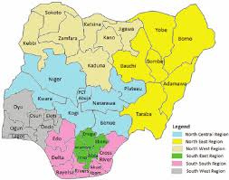
Ilorin East Local Government, one of 16 in Kwara State, has a rich history from pre-colonial trade to modern development. Key landmarks include the University of Ilorin.

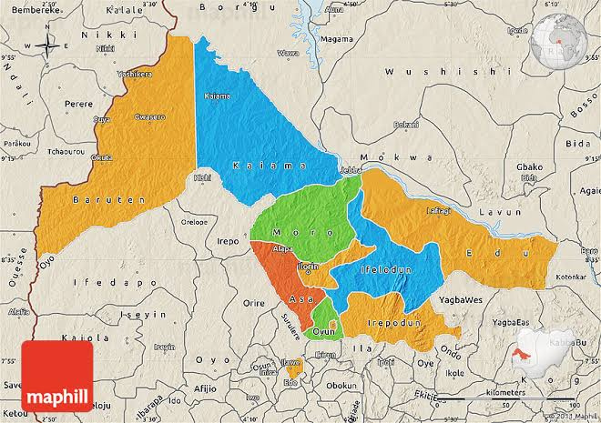
Map of Nigeria Map of kwara state

1.8 Scope of the Study
Geographical Scope: The study will focus on Ilorin East Local Government Area of Kwara State, Nigeria.
Temporal Scope: The study will utilize data from 2020 to 2025, covering a period of five years.
Spatial Scope: The study will examine the spatial distribution of government primary and secondary schools in the study area.
Thematic Scope: The study will investigate the following themes:
1. Distribution of government primary and secondary schools
2. Factors influencing the distribution of schools
3. Impact of school distribution on access to education
4. GIS-based modeling for optimizing school distribution
Methodological Scope: The study will employ a mixed-methods approach, combining:
1. spatial analysis using GIS
2. Survey research
3. Statistical analysis
Limitations: The study will be limited to government primary and secondary schools in Ilorin East Local Government Area of Kwara State, Nigeria. Private schools and other types of educational institutions will not be included in the study.
By defining the scope of the study, we can ensure that the research remains focused, manageable, and achievable within the given timeframe and resources.

1.8 PERSONNEL
The following persons were involved in the supervision and execution of the project: -
- OLATUNBOSUN ABOLADE C. HND/23/SGI/FT/001
- LAWAL ZAINAB O. HND/23/SGI/FT/002
- OLAGUNJU SEGUN M. HND/23/SGI/FT/003
- AKANFE SARAFADEEN O. HND/23/SGI/FT/004
- OMOTOSHO JAMIU O. HND/23/SGI/FT/005
- ABIOLA AMINAT T. HND/23/SGI/FT/010
As a group, we will be participating in all planning, field observations, processing of all field records, management and ensuring of safety of both personnel and equipment. All will be done under my supervisor’s guidance and supervision.

