CHAPTER FOUR
4.0 TESTING, RESULT, PROBLEMS ENCOUNTERED AND SOLUTION
4.1 TESTING OF THE COMPONENTS
Before the construction of the Extension socket, test was carried out on each of component that was used for the design of the USB unit. These tests are needed to be carried out in order to know the condition, whether the component is in good condition. Tests was carried out on the following components;
- Capacitor
- Transistor
- Transformer
- Integrated circuit
4.1.1 CAPACITOR TESTING
We tested the capacitor in both charging and discharging ways, a connection was done from the two legs of the capacitor to the power supply in orther to store charge and later short circuited in order to be discharged. There was an electrical spark noticed during the short circuit test which affirmed the good condition of the capacitor
4.1.2 TRANSISTOR TESTING
The transistor has three terminals namely; the base, the emitter and the collector. A test was carried out to distinguish the three terminals.
4.1.3 TRANSFORMER TEST
A load and continuity test was carried out on the stepdown transformer to affirm its state before it was used.
4.1.4 TESTING OF THE INTEGRATED CIRCUIT
A continuity test was carried out on the integrated circuit. The state of the IC was known on the multimeter.

4.2 FINAL PROJECT TESTING
The testing of the device was done in stages; the arrangement of the electronic components is mounted on the vero board before it was transferred to the printed circuit board (PCB) for soldering and coupling.
The tests performed on the device includes;
- Charging fully the lithium battery through the step down transformer to ensure that a 12V is passed the USB circuit.
- Performance of continuity tests on various components on the printed circuit board to detect any form of short circuiting
- Switching on the device and testing the effectiveness of the USB port.
4.3 RESULT
An extension socket with an uninterruptible USB port was adopted and constructed with the help of the locally available integrated circuits. The performance evaluation of the design and construction was based on how efficient the USB works when there is power outage, the lithium battery has high quality cells, about 4000 to 5000 cycles can be delivered at 1C and 80% Depth of discharge (DoD).
4.4 PROBLEM ENCOUNTERED
The problems encountered during the design and construction of this project work discuss in two fashions. Firstly, the problem encountered due to unavailability of electrical components in the local market and secondly, the technical problem.

- UNAVAILABILITY OF COMPONENTS
Local components are known to be the second best when it comes to functionality, these components will fairly perform the role assigned for in the designed circuit. Thus, most of the components used were gotten far away South and East.

- TECHNICAL PERSONNEL
In the course of the design work, some technical shortcomings were lacking. This may lead to temporary stoppage in the design layout, pending the outcome of a possible solution.

4.4 SOLUTION PROFFERED
The solutions proffered are necessary so as get the project work completed within the stated period. Itemize next are the solution proffered to the problems encountered.

4.4.1 COMPONENTS ADAPTION
In the case of unavailability of some components part, component’s adaption was done. Components adaptation is the process of combining two or more components together to perform the function of an unavailable component. Likewise, some components were sort for from Lagos and other neighboring states.
4.5 FINAL CONSTRUCTION STAGE
The final project work is able to perform the function it is design and constructed for; the device is able to charge multiple devices at the same time, the USB ports works when there is power as well as during a power outage. Hence, the project works perfectly with the concept of a converter.

4.5.1 SOLDERING/COUPLING STAGES
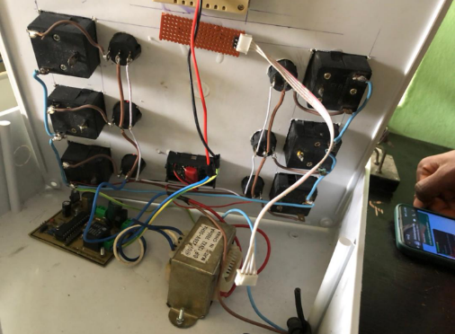
Fig.4.1. placing of the soldered project components

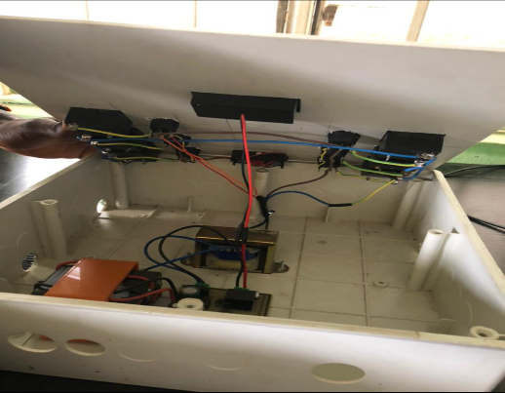
Fig. 4.2. Closing of the arranged soldered component of the project in the casing
4.5.2 FINAL INTERFACE OF THE PROJECT
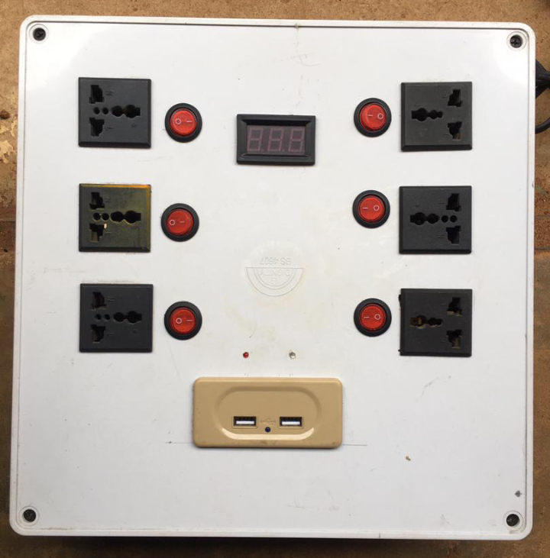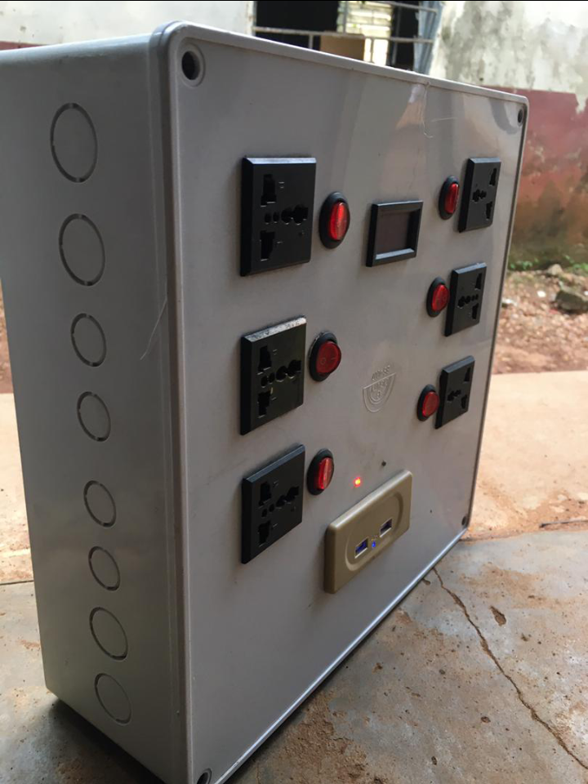

Fig4.3 final project interface

