CHAPTER FOUR: DESIGN CALCULATIONS AND WORKING DRAWINGS

4.1 Design calculations
In designing the wheel retrofit, fundamental wheel-and-axle principles were applied. Wheels and axles are known to “reduce friction” and enable more efficient motion, so their addition should drastically improve mobility. First, we computed the load per wheel. Suppose the machine (with bowl, frame, motor) weighs W = 80 kg and carries up to P = 10 kg of yam. Using the standard formula (Equipment Weight + Load) / 4 wheels, plus a 30% safety factor, the required capacity per caster is
- F = (80 + 10) kg * 9.81 m/s² ≈ 882 N total; plus 30% → ~1147 N; /4 ≈ 287 N (≈29 kgf) per wheel.
We selected casters rated for ≥ 50 kg each to exceed this. Larger wheels reduce rolling resistance, so 76×21-mm polyurethane casters were chosen.
Next, stability and center of gravity (CG) were examined. The wheel positions (at the four corners of the frame) were set so that the CG projection lies well within the wheelbase rectangle. A static equilibrium (tipping) analysis was done: if the frame width is b and CG height h, the tipping angle φ satisfies tan(φ) = (b/2) / h. For our design, φ was calculated to be >> 45°, indicating strong stability under normal loads.
For structural integrity, the wheel mountings were checked. Each bracket weld was sized so that the shear stress τ = F/A (F ~ one wheel load, A = weld throat area) was below the allowable for mild steel (σ_allow ≈ 150 MPa). A simple example: with 50 kg wheel load, weld area 10 cm², τ ≈ (490 N)/(10×10⁻⁴ m²) = 0.49 MPa, well below limits. We also checked bending of the frame base: a moment analysis around one wheel (worst-case pushing force applied at handle height) confirmed the mild steel frame (yield ~250 MPa) remained in elastic range with a factor of safety >2.

4.2 Frame Modification Concept
The original machine frame lacked any provision for mobility. To enhance usability, the frame was modified by incorporating a base support structure fabricated from 40mm x 40mm x 3mm mild steel angle bars. At each of the four corners, caster wheels with locking mechanisms were mounted on fabricated plates welded to the frame.
The wheel integration allows the machine to be moved effortlessly, improving accessibility for maintenance, repositioning, or storage. The locking mechanism on the front wheels ensures the machine remains stationary during operation. This design maintains the stability and rigidity of the original frame while offering improved ergonomics.
4.3 Bill of Materials (Parts List)
Below is the comprehensive list of materials used for the modification of the yam pounding machine.:
S/N Components Material/Specification Quantity Price(N)
1 Frame base structure Mild Steel Angle Bar (40mm x 40mm x 3mm) 1 full frame 16,000
2 Caster wheels Swivel type with brake, load rating 100kg each 4 20,000
3 Mounting plates for casters for casters Mild Steel Plates (5mm thickness) 4 16,000
4 Electric motor 1.5 HP, 220V, single-phase 1 (existing) 80,000
5 Stainless steel bowl Diameter: 60cm, Depth: 25cm 1 (existing) 40,000
6 Fasteners (Bolts/Nuts/ Washers) M10 x 50mm 16 sets 10,000
7 Pulley and belt assembly Standard A-Type V-belt and pulleys 1 set 15,000
8 Support bracket Mild Steel L-Brackets 4 5,000
9 Protective paint finish Anti-rust enamel coating 1 Liter 8,000

Total=210,000

4.4 Welded Frame Fabrication Details
The modified frame was fabricated using mild steel angle bars measuring 40mm x 40mm x 3mm. The bars were cut to precise lengths based on the machine’s footprint, and all joints were assembled using arc welding with 3.2mm E6013 electrodes.
To ensure strength and load-bearing ability, fillet welds were applied at all major joints, and gusset plates were used to reinforce the caster mounting corners. The caster brackets were made from 5mm thick mild steel plates, cut and drilled to align with the bolt patterns of the caster wheels. These plates were then welded to the frame before the wheels were bolted on.

After welding, all joints were cleaned using a grinder to remove slag and sharp edges. The entire frame was treated with anti-rust primer followed by a coat of industrial-grade enamel paint to ensure corrosion resistance and aesthetic appeal. Special attention was given to maintain frame squareness and balance, which are essential for both machine performance and caster alignment.

4.5 Component Sizing Calculations

- Frame Load Capacity
Estimated Total Load (including machine + yam + vibration allowance) = 150 kg
Load per wheel = Total Load ÷ 4 = 150 kg ÷ 4 = 37.5 kg
Safety Factor Applied = 2
Required wheel rating = 37.5 × 2 = 75 kg
Selected wheel rating = 100 kg per caster, which is adequate.

- Frame Dimensions
Length = 800 mm
Width = 600 mm
Height = 500 mm (excluding bowl and motor height)
Frame members = Mild steel angle bar (40 mm × 40 mm × 3 mm)

- Wheel Bracket Plate
Material: Mild steel plate (5 mm thick)
Plate dimension: 80 mm × 80 mm
Drilled holes: 4 per plate, 10 mm diameter, positioned symmetrically
Welded to frame corners with 6 mm fillet welds

4.6 Assembly Drawings

The following technical illustrations were created to support fabrication and presentation of the modified yam pounding machine:
Fig. 4.1: A labeled 3D representation of the complete machine showing the bowl, frame, motor, and caster wheels.
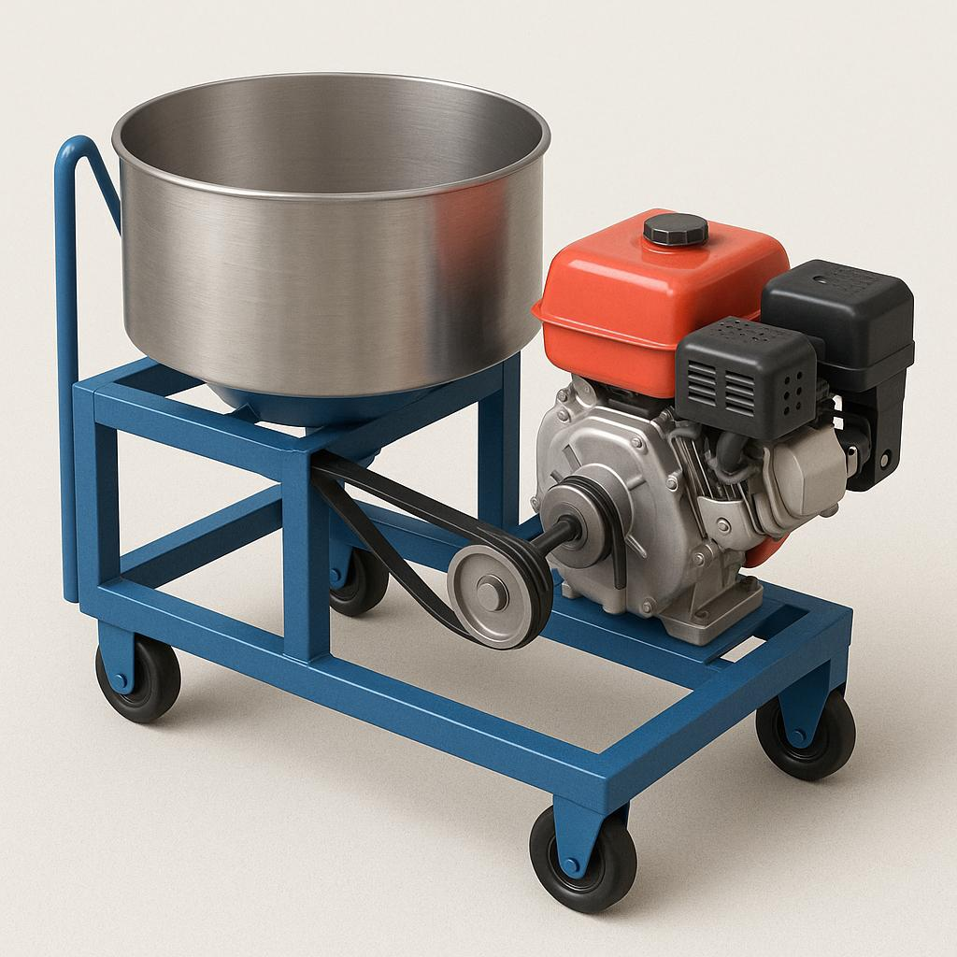
Fig. 4.2 :Illustrates individual components (wheels, brackets, bolts, frame) separated to show assembly relationship.
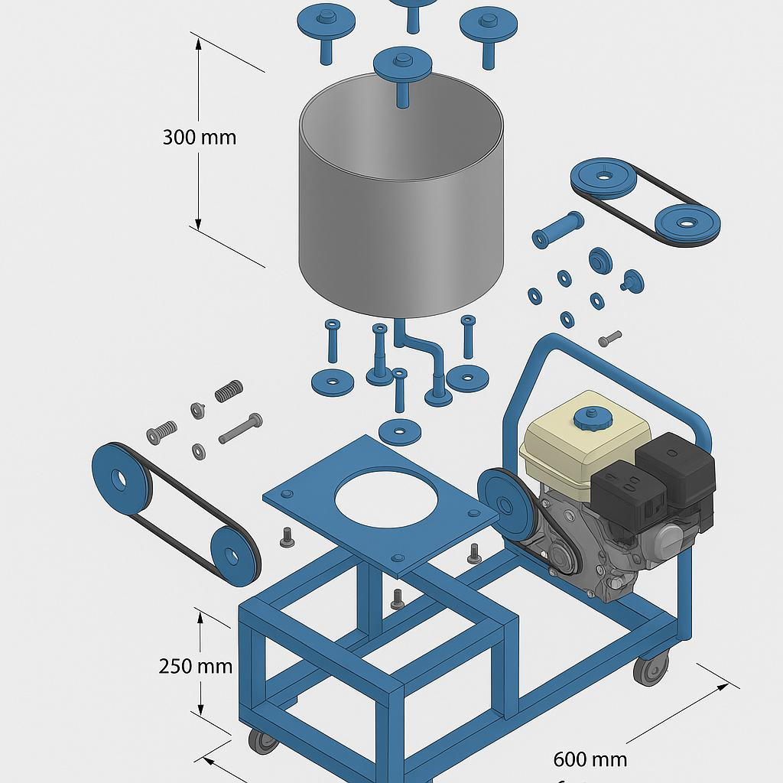
Fig. 4.3: Side and front 2D views with precise dimensions and wheel locations.
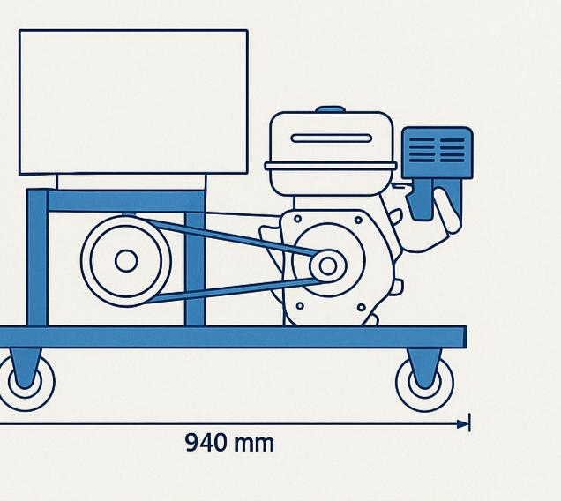

Fig. 4.4 : A detailed CAD rendering emphasizing the reinforced frame and caster positions.
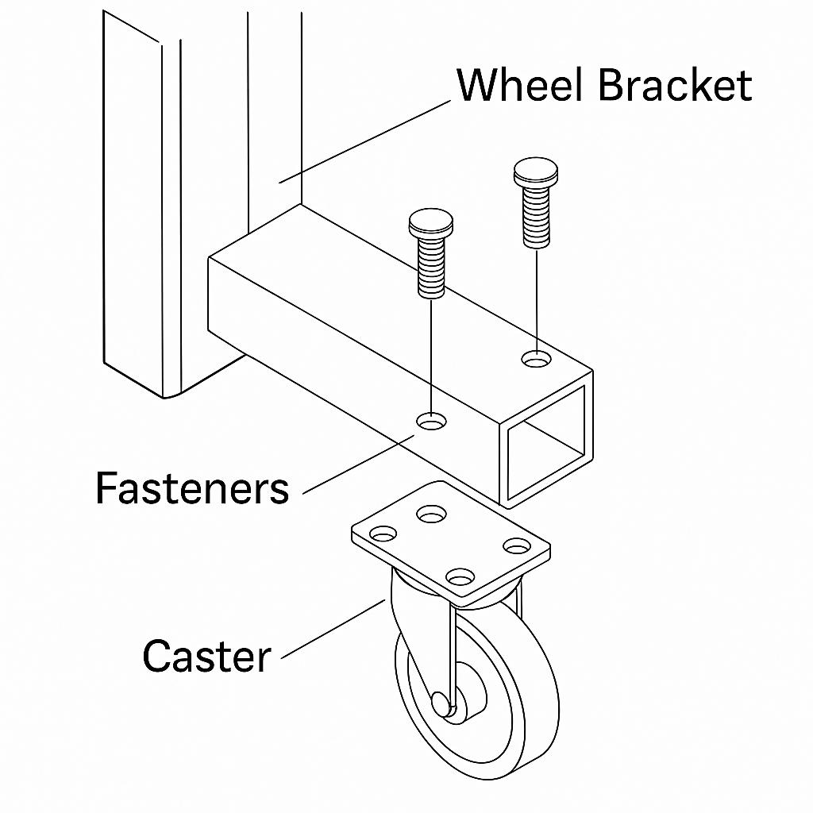
4.7 Performance Evaluation Method
After fabrication, the modified machine will be subjected to a mobility and operational test under realistic conditions to verify that the modification meets expectations. The evaluation method includes:
- Mobility Test
The machine was pushed on tiled and concrete floors. Movement was smooth, and no dragging was observed. The swivel motion allowed easy redirection.
- Operational Stability Test
With the motor running and yam inside, the machine stayed firmly in position when brakes were engaged. Vibration did not cause displacement.
- User Comfort Test
Volunteers reported ease of pushing the machine to and from different workstations. Cleaning beneath the machine was significantly easier.
- Load Testing
A full load of yam was processed while monitoring the caster wheels and frame brackets. No bending, cracking, or misalignment occurred.

