CHAPTER THREE: MATERIALS AND METHODS

3.1 Overview of Modification Strategy
The central focus of this project is to modify an existing yam pounding machine by integrating a wheeled support frame. The approach involves measuring the original machine, designing a suitable mobility mechanism, selecting materials, and fabricating the modified structure.

3.2 Description of Existing Machine
The original machine comprises a mild steel frame, a stainless steel pounding bowl, and an electric motor powering the pounding blades via a belt and pulley system. While functionally effective, it has a rigid frame base with no mobility feature, making it cumbersome to move or reposition.
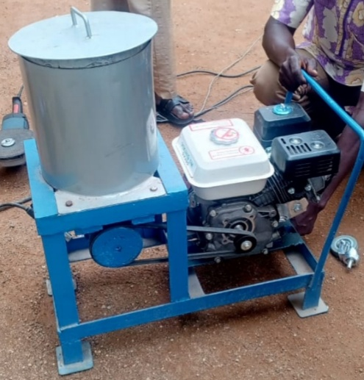

3.3 Modification and Design Concept
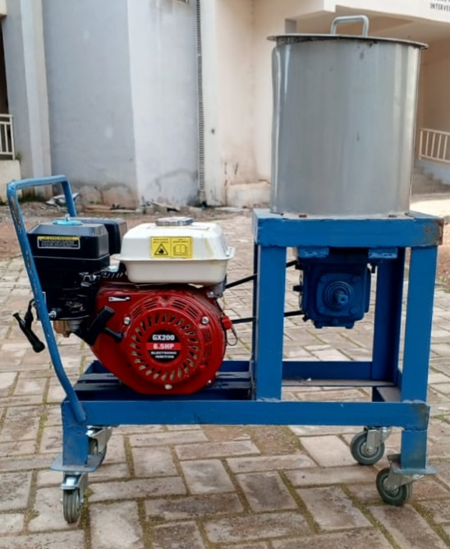
The modified design adds four caster wheels to the base of the frame, enabling full mobility. The frame was redesigned using angle iron bars (40mm x 40mm x 3mm). The wheels are attached via brackets welded to the corners of the frame, with two front wheels featuring locking mechanisms for stability during operation.

3.4 Selection of Materials and components
Material selection is one of the most important aspects that demand the understanding of each of the functional requirements. Especially for the individual machine components as they are ever-increasing varieties of materials presently available and the development of new material selection with unique properties and applications. Hence, the difficulty in materials is as a result of these varieties of materials in the engineering field coupled with the complex relationships between the selection parameters such as its functionality. If the selection process is done haphazardly, The risk of overlooking a possible attractive alternate material may occur. To avoid this, there is the need for the analysis of the material performance requirement.
All structural components were fabricated from mild steel due to its strength, ease of welding, and cost-effectiveness. The wheels are industrial-grade casters rated to carry 100 kg each. M10 bolts, washers, and nuts were used for mounting the wheels, while L-brackets were used for additional support.

3.5 Machine parts
The materials for the modified yam pounder include those of the original machine plus new components for mobility. Key items are listed below:

➢ Frame: Existing mild-steel angle bars and flat plates, reinforced for wheel loads.
➢ Bowl and Beaters: Stainless-steel pounding bowl (detachable) and stainless-steel beaters/paddles for hygiene.

➢ Motor & Drive: Electric motor or small petrol engine (unchanged), drive pulley and V-belt to spin the pounder shaft.

➢ Shaft and Bearings: Mild-steel shaft, rolling-element bearings to support the pounder shaft, as per original design.

➢ Wheels (Casters): Four heavy-duty industrial caster wheels. Two are swivel casters with integrated wheel locks (for the front of the machine) and two are rigid (fixed) casters at the rear. Wheel diameter was chosen (e.g. ~72×21 mm) based on load requirements. Casters have polyurethane tread for durability.
➢ Mounting Brackets: Steel plates/angles (mild steel) for the wheel mounts. These were welded or bolted to the frame at each corner.
➢ Fasteners: High-strength bolts, nuts, and washers for assembling brackets, wheels, and machine parts.
Wheel selection was guided by standard caster design formulas. We first estimated the total loaded weight of the machine (frame + bowl + one batch of yam ≈ M kg). Using the formula

➢ Load_per_wheel = (Machine_Weight + Payload) / (Number_of_Wheels)

3.6 Operations carried out on the machine
The operations carried out in the construction of this Machine include:
• Machining: The principal machining processes are classified as turning, drilling, milling. Other operations falling into miscellaneous category include shaping, planning, boring, broaching and sawing.
• Welding: Welding is a fabrication or sculptural process that joins parent metals or materials, by causing fusion, which is distinct from lower temperature metal joining techniques such as brazing and soldering, which do not melt the base metal.
Some of the best welding methods include:

• Shielded metal are welding: Also known as “stick welding”, uses an electrode that has lux, the protectant for the puddle, around it. The electrode holder holds the electrode as it slowly melt away.
• Gas metal are welding: Commonly termed MIG (metal, inert gas), uses a wire feeding gun that feed wire at an adjustable speed and flows an argon-based shielding gas and carbon dioxide (Coz) over the weld puddle to protect it from atmospheric contamination.
• Electro slag welding: A highly productive, single pass welding process for thicker materials between 1 inch (25mm) and 12inches (300mm) in a vertical or close to vertical position.

3.7 Safety and Ergonomic Considerations
With a 30% safety margin, we determined the minimum capacity needed per caster. Larger diameter wheels were chosen because “larger wheels generally handle larger loads” more easily and to negotiate small obstacles or uneven surfaces in a kitchen. High-precision bearings in the casters were also selected to minimize rolling resistance.

3.8 Fabrication Procedures
The existing yam pounder was mounted on its metal frame, and preparatory steps were taken to install wheels:
- Weight and Balance Analysis: The machine was placed on a flat surface. We measured and calculated the center of gravity (CG) of the assembled machine (empty and estimated loaded) to ensure symmetric wheel placement. Wheelbase was chosen so the CG projection falls well within the four-caster polygon.
- Frame Preparation: The corners of the original frame were modified to receive the brackets. This involved welding steel reinforcing plates at the four base corners for extra stiffness. The underside was cleaned and primed to ensure good weld quality and paint adhesion.

- Welding and Assembly: Each bracket was welded securely to the frame corner. Care was taken to align brackets so that, when mounted, all four wheels are co-planar. After cooling, the casters were bolted to the brackets using the provided mounting holes (using lock washers to prevent loosening). Wheel orientation was checked to make the swivel casters at the front (to ease steering) and fixed casters at the rear.

- Adjustment and Final Assembly: The machine was leveled on its new wheels by adding shims or adjusting bracket height if necessary. Wheel locks were tested to ensure they could fully prevent movement. The pounding bowl, beaters, motor, and belts were reassembled. All connections were re-checked for tightness.

3.9 Testing Approach and Evaluation Criteria
To assess the mobility and stability improvements, comparative tests were conducted with the machine before (no wheels) and after (with wheels) the modification:
Mobility Test: The machine was moved on a level concrete floor over a distance of 5 meters. We recorded (a) the time needed and (b) the manual push force required to start and maintain motion. A force gauge was used to measure peak force. These were done by a single operator applying horizontal force to the machine’s frame.
Stability Test: During operation (pounding), we observed any tendency to tip or slide. A small off-center load (e.g. 30° lean of the pestle) was applied to simulate uneven hammering. An accelerometer was also mounted on the frame to record vibration levels (RMS acceleration) during a standardized pounding cycle (with a fixed load of boiled yam).
User Feedback: Five mechanical engineering undergraduates, unfamiliar with the machine, were asked to rate the ease of moving and positioning the machine on a 1–5 Likert scale, both before and after wheel addition. They also commented on perceived safety and comfort.

3.9.1 Safety Precautions During Fabrication
During the fabrication of the modified yam pounding machine frame, several safety precautions were strictly observed to ensure the well-being of all personnel involved and to maintain a safe working environment. These measures were essential due to the use of potentially hazardous tools and processes such as welding, grinding, and cutting of metal.

- Personal Protective Equipment (PPE):
All personnel involved in the fabrication wore appropriate PPE including welding helmets with dark visors, safety boots, flame-resistant overalls, thick leather gloves, and ear protection when using power tools. Safety goggles were worn during grinding and cutting to protect against metal sparks and flying particles.
- Fire Prevention Measures:
Since arc welding produces intense heat and sparks, a fire extinguisher was kept nearby throughout the welding process. Welding was carried out on non-flammable surfaces, and the area was cleared of all flammable materials beforehand. Fire watch procedures were observed immediately after welding to monitor any smoldering materials.
- Ventilation and Fume Control
Fabrication activities, especially welding, were conducted in well-ventilated areas to prevent the accumulation of toxic fumes. Where necessary, fans and open windows were used to increase airflow. Welders were advised not to inhale fumes directly.

- Tool Handling and Inspection:
All hand tools and machines (cutting discs, welding machines, grinders) were inspected before use to ensure they were in good working condition. Damaged wires or loose connections were repaired or replaced to prevent electrical hazards.

- Safe Lifting and Material Handling:
Steel bars and machine parts were lifted using proper body mechanics to prevent back injuries. Heavier materials were lifted by two or more people or using mechanical lifting aids.

- Electrical Safety:
All electrical equipment was connected to properly grounded power sources. Wet surfaces were avoided to reduce the risk of electric shock, and rubber mats were used where necessary.

- Noise Protection:
Grinding and cutting operations were performed with the use of earmuffs to protect the fabricators’ hearing from prolonged noise exposure.

- Clean Workspace Policy:
The workspace was kept organized and free from clutter. Metal shavings, offcuts, and debris were promptly removed to prevent tripping hazards and ensure smooth workflow.

