CHAPTER FOUR
4.0 DATA DOWNLOADING, PROCESSING, ANALYSIS AND DISCUSSION
This chapter provides a detailed overview of the procedures involved in data download, data processing, correction, and data analysis conducted on the acquired data from the site and data presentation.
4.1 Data Download
All the recorded data was stored in the memory of the total station. To download the data, the total station was connected to a computer using a wired cable and downloading software. The software parameters were configured to match those of the instrument. The instrument's menu was accessed, and the memory manager was selected. From there, the "send data" option was chosen, and the file named "PRJT1" was located and downloaded to the computer through the software. The data was saved with a ".txt" file extension on the desktop of the laptop for further processing.
4.2 Data Editing
The downloaded geometric data were further processed to convert them into usable formats and improve their accuracy. The resulting coordinate data were edited using Notepad and Excel software. This file was then imported into AutoCAD2007 for additional processing.
4.3 Data Processing using Autocad 2007
Before using AutoCAD, we processed the coordinate data observed in the field by first transferring it into Notepad, then copying it into AutoCAD. The following steps outline the process for handling the data in AutoCAD:
- Launch AutoCAD on the computer.
- Click "New" from the application menu to start a new drawing.
- Type UNITS in the command line and press Enter.
- Select the desired unit type (e.g., decimal, architectural, engineering).
- In the menu bar, select the "Polyline" tool.
- Copy the data from Notepad and paste it into AutoCAD.
- Type Z (for zoom) and press Enter, then type E (for extents) and press Enter to adjust the view.
- 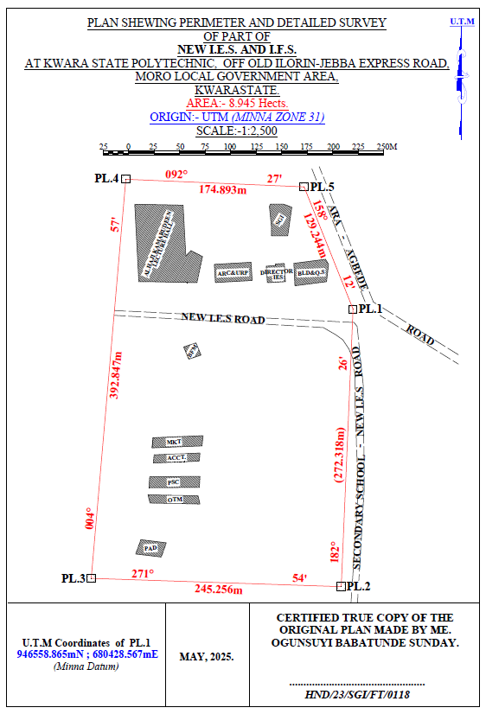
KAZEEM KABIRAT DAMILOLA
--------------------------------------
HND/23/SG/FT/0079
- Figure 3.7: Plan showing Perimeter and Detailed Survey.
- Area Computation using Cross Multiply Coordinates
- E1 N1
- E2 N2
- E3 N3
- E4 N4
- E5 N5
- E1 N6
- 680428.567 946558.865
- 680417.004 946286.792
- 680171.885 946294.956
- 680205.833 946686.334
- 680380.567 946678.865
- 680428.567 946558.865

- ∑ - ∑
- 2
- 460,787,138,011.03 – 460,786,959,116.36
- 2
- 178,894.67
- 2
- Area = 89,447.335 sqft
- Area = 8.945 hect.

4.4 Results and Discussion
Table 4.4: Total station and Digital level Spot height Readings and their differences
STATION | EASTING | NORTHING | HEIGHT |  | DIFF.
STATION | EASTING | NORTHING | T.S | LEVEL | DIFF.
PT1 | 680272.275 | 946497.781 | 355.749 | 355.715 | 0.034
PT2 | 680267.717 | 946479.907 | 356.403 | 356.362 | 0.041
PT3 | 680273.327 | 946450.469 | 354.811 | 354.772 | 0.039
PT4 | 680287.358 | 946434.349 | 354.268 | 354.208 | 0.060
PT5 | 680317.873 | 946433.648 | 355.036 | 354.984 | 0.052
PT6 | 680304.544 | 946455.727 | 355.710 | 355.668 | 0.042
PT7 | 680337.867 | 946463.436 | 355.448 | 355.386 | 0.062
PT8 | 680342.774 | 946441.708 | 356.295 | 356.240 | 0.055
PT9 | 680342.774 | 946441.708 | 356.736 | 356.680 | 0.056
PT10 | 680348.740 | 946443.460 | 355.971 | 355.931 | 0.040
PT11 | 680377.262 | 946451.836 | 355.725 | 355.673 | 0.052
PT12 | 680382.060 | 946482.711 | 355.318 | 355.277 | 0.041
PT13 | 680381.009 | 946518.108 | 354.819 | 354.766 | 0.053
PT14 | 680350.494 | 946509.345 | 355.174 | 355.128 | 0.046
PT15 | 680356.104 | 946484.813 | 355.033 | 355.005 | 0.028
PT16 | 680332.603 | 946480.960 | 355.228 | 355.188 | 0.040
PT17 | 680308.051 | 946470.796 | 355.517 | 355.464 | 0.053
PT18 | 680298.581 | 946490.422 | 355.834 | 355.802 | 0.032
PT19 | 680318.222 | 946506.191 | 355.726 | 355.678 | 0.048
PT20 | 680308.753 | 946526.168 | 356.148 | 356.096 | 0.052
Mean |  |  | 355.8163 | 355.7726 | 0.0437
Variance |  |  | 2.5758 | 2.5881 | 0.0123
Standard Deviation |  |  | 1.6049 | 1.6088 | 0.0039

Working Formulas for Mean, Variance and Standard Deviation Calculation
The mean is calculated as:
µ = ∑xi
n
µ= mean
xi = each point height
n = number of points
The variance is calculated as:
ꭤ²=∑(xi - µ)²
n
ꭤ²= variance
xi = each point height
µ= mean
n = number of points
The Standard Deviation is calculated as:
ꭤ = √ꭤ²
ꭤ= standard deviation
ꭤ²= variance
Mean calculation for Total Station Height readings
µ = ∑xi
n
µ=355.749+356.403+354.811+354.268+355.036+355.710+355.448+356.295+356.736+355.971+355.725+355.318+354.819+355.174+355.033+355.228+355.517+355.834+355.726+356.148
20
µ= 7116.326
20
µ=355.8163
Mean calculation for Reduced Level Height readings
µ=355.715+356.362+354.772+354.208+354.984+355.668+355.386+356.240+356.680+355.931+355.673+355.277+354.766+355.128+355.005+355.188+355.464+355.802+355.678+356.096
20
µ= 7115.452
20
µ = 355.7726
Mean calculation for Total Station Height readings - Mean calculation for level height readings 355.8163 – 355.7726 = 0.0437
ꭤ²=∑(xi - µ)²
n
ꭤ²=∑(xi - µ)²
n
0.0673²+0.5867²+1.0053²+1.5483²+0.5327²+0.2521²+0.1582²+0.4126²+0.9284²+0.0992²+0.1104²+0.1327²+1.0217²+0.6184²+0.7834²+0.4926²+0.2581²+0.0164²+0.0428²+0.3317
20
ꭤ²=51.516
20
ꭤ² =2.5758
Variance calculation for Reduced Level Height readings
0.576²+0.5894²+1.006²+1.5686²+0.5285²+0.2375²+0.1382²+0.4103²+0.9126²+0.0821²+0.1013+0.1104²+1.0102²+0.6014²+0.7695²+0.4818²+0.2443²+0.0071²+0.0289²+0.32047
20
ꭤ²=51.762
20
ꭤ² =2.5881
Variance calculation for total station – variance calculation for level height readings 2.5758 – 2.5881 = 0.0123
The Standard Deviation for Total Station Height readings:
ꭤ = √ꭤ²
ꭤ = √2.5758
ꭤ = 1.6049

The Standard Deviation for Reduced Level Height readings:
ꭤ = √2.5881
ꭤ = 1.6088
The standard deviation for total station – standard deviation for level height reading 1.6049 – 1.6088 = 0.0039

The table above shows the station Id, eastings, northings, total station height, digital level reduced level and the difference between the total station height and the digital level reduced level.
The comparison of the two pieces of equipment revealed variations within a specific range. The differences observed between the two pieces of equipment were found to be in the range of 0.028 to 0.062 meters. These differences indicate slight disparities in the measurements obtained from each instrument. Statistical analysis was performed to evaluate the mean, variance, and standard deviations of the observed differences. The mean difference was calculated to be 0.0437, indicating an average deviation between the measurements obtained by the two equipment. The variance, which quantifies the spread of the differences, was found to be 0.0123.
This value suggests that the variations in the measurements obtained by the two pieces of equipment were relatively consistent. The standard deviation, which provides a measure of the dispersion of the data, was determined to be 0.0039. This indicates that the differences between the measurements obtained from the two pieces of equipment had a moderate level of variability.
Overall, the results of the analysis demonstrate that there were slight variations between the measurements obtained from the two pieces of equipment. The mean, variance, and standard deviations provide insights into the magnitude and consistency of these differences, offering valuable information for assessing the accuracy and reliability of the equipment in question.

Figure 1:Bar chart showing heights obtained from the total station and level instrument

Figure 2:Histogram showing the difference in the two instrument’s result
The histogram presented above illustrates the distribution of deviations between the two methods being compared. The deviations are depicted in centimeter, showcasing the level of accuracy achieved by both methods. The histogram highlights that the deviations are tightly clustered and exhibit a consistent pattern.
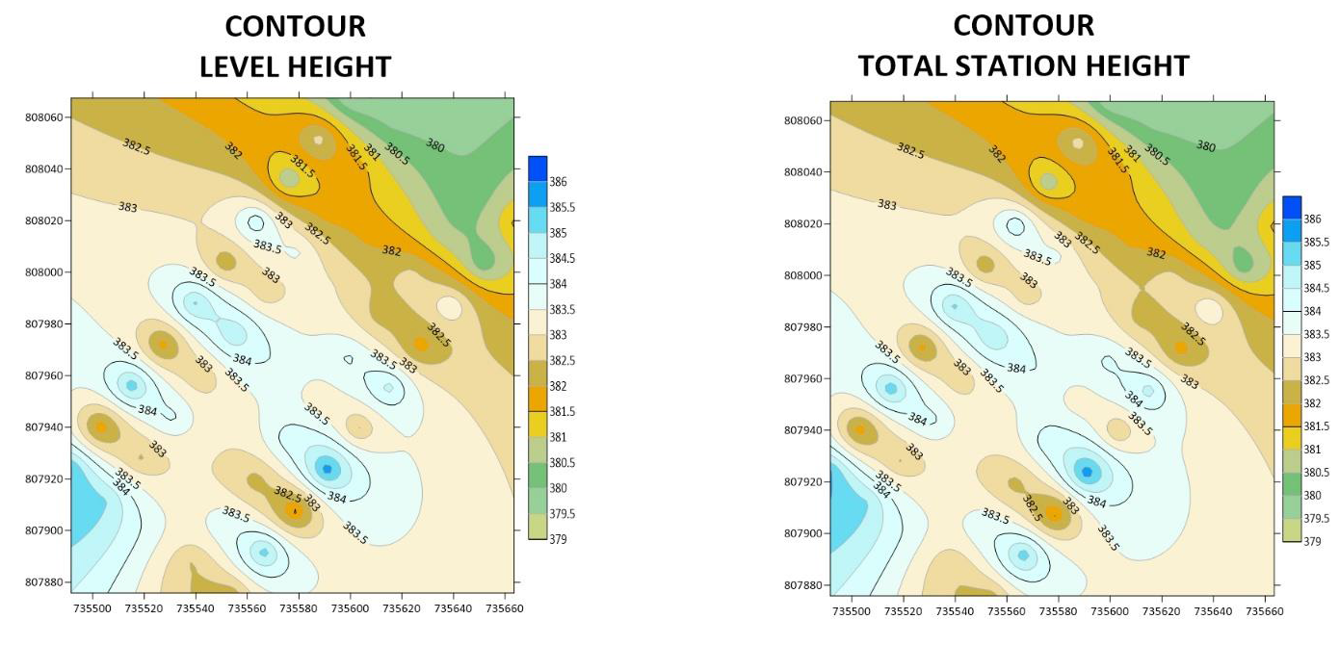Figure 3:. Showing the contour map obtained from the two instruments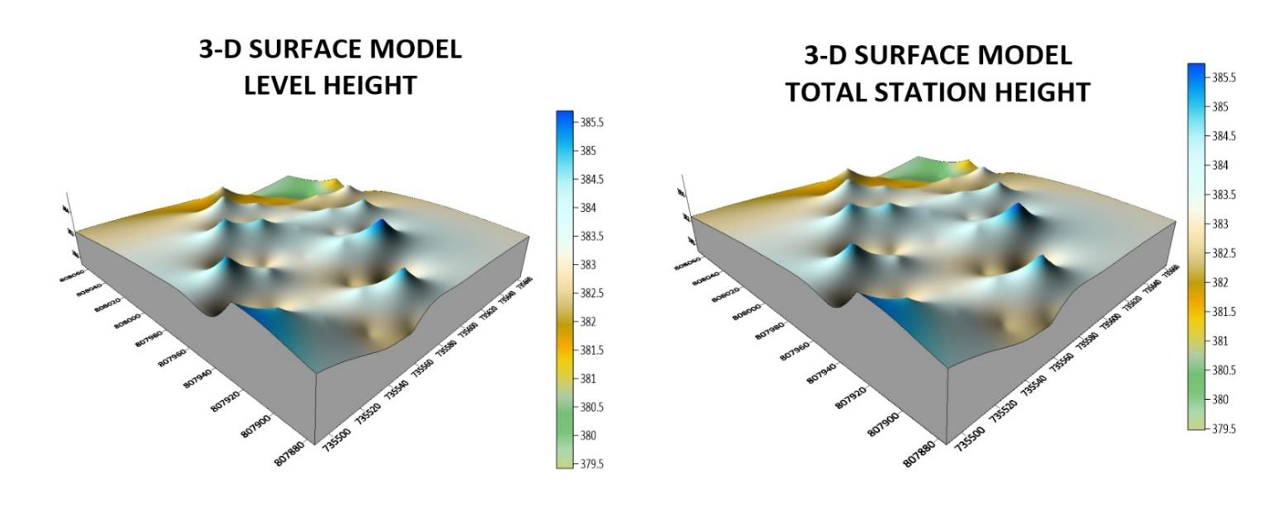Figure 4: Showing the 3D surface map obtained from the two instruments
3-D SURFACE MODEL USING TOTAL STATION
3-D SURFACE MODEL USING AUTO LEVEL
CONTOUR MAP USING TOTAL STATION
CONTOUR MAP USING AUTO LEVEL
The mean of the deviations, calculated to be 0.0437m, provides an indication of the average difference between the measurements obtained from the two methods. This value signifies a small average deviation, suggesting that the two methods generally yield similar results with minimal variation.
The histogram provides a visual representation of the data, allowing for a comprehensive understanding of the distribution of deviations. By examining the histogram, one can observe the concentration of deviations around the mean value, indicating a central tendency in the measurements obtained by the two methods.
The centimeter-level accuracy exhibited by the deviations underscores the precision of the measurement techniques employed. This level of accuracy is crucial, particularly in applications that require high precision, such as engineering, construction, or geospatial analysis. The contour maps presented above exhibit strikingly similar patterns, which serve as a testament to the high degree of precision achieved by the instruments used. The consistent and replicated patterns observed on the maps reinforce the reliability and accuracy of the measurements obtained.
The similarity in the contour patterns indicates that the instruments employed in the surveying process were able to capture the subtle variations in elevation with great precision.
This level of accuracy is crucial in applications such as topographic mapping, land surveying, and engineering, where even minor deviations can have significant implications. By displaying the contours of the surveyed area, the maps provide a visual representation of the landscape's topography and elevation changes.
The congruity in the contour lines across the maps signifies that the instruments effectively captured and recorded the elevation data, resulting in a reliable representation of the terrain
4.5 Statistical Analysis
A statistical investigation was carried out using Paired Two Samples as Means to test whether there is any significant difference in the performance of the two instruments for terrain height determination. The independent sample t-test is a member of the t-test family, which consists of tests that compare mean value(s) of continuous-level (interval or ratio data), normally distributed data (Hinton, 2004). The independent-sample t-test evaluates the difference between the means of two independent or unrelated groups. That is, we evaluate whether the means for the two independent groups are significantly different from each other.
Hypothesis
A hypothesis was set up and tested using an Independent – sample T-Test:
- Null Hypothesis: H0: There is no difference between the terrain height obtained from the total station and digital level instrument.
- Alternative Hypothesis: H1: There is a difference between terrain height obtained from total station and digital levelling instrument.
The null hypothesis is rejected if the calculated t value has a probability sig. (p) greater than the chosen significance level. An Independent sample T-Test was used in testing the hypothesis at a significance level of 0.05. Data analysis Package extension in Excel was activated and used in running the T-Test.
Table 4.5: T-Test: Two-Sample Assuming Unequal Variances
 | Digital Level | Total Station
Mean | 355.77262 | 355.81628
Variance | 2.588092118 | 2.575687471
Observations | 20 | 20
Pearson Correlation | 0.032104369 | 0.031950494
Hypothesized Mean Difference | 0.001605218 | 0.001597525
t Stat | 0.056215684 | 0.056208782
P(T<=t) one-tail | 0.145413689 | 0.144776257
P(T<=t) two-tail | 0.290982737 | 0.289552551
Sum | 7096.631 | 7095.814
Kurtosis | 2.049052417 | 2.0403051292
Skewness | 0.612867732 | 0.5907755549
Median | 354.772 | 354.811
Maximum | 356.680 | 356.736
Minimum | 354.208 | 354.268
Range | 2. 472 | 2.468
The statistical data provided supports our discussion by indicating a high degree of agreement and consistency between the digital level and total station measurements. The mean values are very close, the variances are similar, and the Pearson correlation coefficient indicates a strong linear relationship. The t-test results suggest that any observed difference between the two instruments' means is likely due to random variation rather than a significant discrepancy. After carrying out the project, we observe that digital level is more accurate than total station, although the different can be quite small.

