CHAPTER ONE
1.0 INTRODUCTION
1.1 Background to the Study
Surveying plays a crucial role in engineering, construction, and geospatial sciences, ensuring precise measurements for infrastructure development. Among the various surveying techniques, digital leveling and total station equipment are widely used due to their high accuracy and efficiency (Ghilani & Wolf, 2017). However, selecting the appropriate instrument depends on factors such as terrain, required precision, and project scope, necessitating a comparative evaluation of their accuracy and reliability in specific environments.
Digital leveling is a precise method of determining height differences between points using a digital level and a barcode staff. It minimizes human errors by automatically reading the staff and processing data, leading to enhanced precision and consistency (Uren & Price, 2019). This technique is commonly employed in construction projects requiring high vertical accuracy, such as road networks, bridges, and building foundations.
Total station equipment integrates electronic distance measurement (EDM), angle measurement, and data recording in a single instrument (Kavanagh & Glennon, 2020). It provides both horizontal and vertical measurements, making it suitable for a wide range of surveying applications, including topographic mapping, construction, and geodetic control networks. However, its accuracy may be influenced by atmospheric conditions, instrument calibration, and operator expertise.
The accuracy and reliability of surveying equipment are paramount, as errors in height measurement can lead to costly mistakes in construction and design (GhHilali & Yahya, 2019). In the context of Kwara State Polytechnic, where the terrain includes varied topography due to its location in Ilorin, the performance of digital levelling and total station equipment must be evaluated to determine their suitability for local conditions. Factors such as equipment calibration, operator skill, and environmental variables can significantly influence the outcomes of these tools, necessitating a comparative study.
Several studies have compared the accuracy of digital levelling and total station equipment. Research by Al-Kasasbeh et al. (2018) found that digital levelling achieves superior vertical accuracy compared to total stations, especially in long-distance levelling tasks. However, total stations offer advantages in speed and versatility, making them preferable for general survey applications.
Studies have highlighted the efficiency of total stations in reducing fieldwork time while maintaining acceptable accuracy (Osei & Amekudzi, 2021). The ability to store and process data digitally reduces human errors and enhances workflow efficiency. However, factors such as instrument calibration and environmental conditions can impact the reliability of measurements.
The choice between digital levelling and total station equipment is critical for surveying professionals. Understanding their strengths and limitations helps in selecting the appropriate instrument for specific tasks (El-Rabbany, 2019). This study aims to evaluate the comparative accuracy and reliability of both methods within part of Kwara State Polytechnic, Kwara State, to provide insights for optimal instrument selection in academic and professional surveying practices.
The study area, Kwara State Polytechnic, serves as a suitable environment for testing these instruments due to its diverse topography, infrastructural development, and academic engagement in surveying studies. By conducting precision measurements in various locations, the study assesses how factors such as terrain and instrument handling influence the performance of each method.
Furthermore, the findings of this study will contribute to the growing body of knowledge on surveying accuracy assessment, offering practical recommendations for future applications (Zhou et al., 2020). By comparing error margins, efficiency, and reliability, this research provides valuable insights for students, professionals, and researchers in the geospatial field.
1.2 Statement of Problem
The lack of localized comparative studies between digital levelling and total station equipment poses a challenge for decision-making regarding resource allocation and curriculum development at Kwara State Polytechnic. Although global studies suggest that both tools offer high accuracy, their reliability in terms of consistent performance and maintenance demands remains underexplored in the Nigerian tertiary education setting (Uren & Price, 2010). This knowledge gap could hinder the polytechnic’s ability to optimize its surveying practices, affecting the quality of infrastructural projects and the competence of graduates in the surveying and geo-informatics field, necessitating an empirical investigation to address these uncertainties.
1.3 Aim of the Project
This project aims to investigate the accuracy and reliability of Total station and levelling instrument and provide valuable insights for surveyors, engineers, and researchers seeking to optimize height measurement techniques.
1.4 Objectives of the Project
- Examine the differences in height measuring accuracy between digital leveling and total stations.
- Evaluate their dependability in various scenarios.
- Suggest the most accurate technique for measuring elevation.

1.5 Justification of the Project
The evaluation of digital levelling and total station equipment at Kwara State Polytechnic is justified by the growing need for precise and reliable surveying data in both academic and practical applications within the institution. As a technical training hub, the polytechnic relies on accurate topographic information for campus development projects, such as constructing new facilities or maintaining existing infrastructure, where even minor errors can lead to significant financial and structural consequences (Kavanagh & Mastin, 2013).
Despite the increasing use of total stations due to their speed and versatility, studies suggest that digital leveling provides superior accuracy in elevation measurements. However, many surveyors prefer total stations for convenience, potentially compromising precision in projects that require exact height data. This project is necessary to evaluate these differences and provide empirical evidence on the best approach for specific surveying applications, particularly within the study area of Kwara Polytechnic.
1.6 Scope of the Project
This study compares the precision and dependability of total station and digital leveling equipment for determining height in a particular area of Kwara Polytechnic. It will evaluate how well both equipment works in various operational and environmental settings, looking at things like measurement accuracy, error margins, and usability. The study will only collect, process, and evaluate field data within the study area and offer suggestions for the best height measurement methods for use in building and surveying applications.

1.7 Personnel
The project was assigned to and was successfully carried by the personnel listed below;
NAME | MATRIC. NO. | ROLE
Abdul Kareem Ramota Olawumi | HND/23/SGI/FT/0078 | Writer
Ganiyu Akeem Abiodun | HND/23/SGI/FT/0076 | Member
Kazeem Kabirat Damilola | HND/23/SGI/FT/0079 | Member
Adeoti Qudus Adebayo | HND/23/SGI/FT/0080 | Member
Adeleye Sheriffdeen Olawale | HND/23/SGI/FT/0081 | Member
Abdul Qudus Shukurah Temitope | HND/23/SGI/FT/0083 | Member
Ogunsuyi Babatunde Sunday | HND/23/SGI/FT/0118 | Member
Jimoh Halimah Titilayo | HND/22/SGI/FT/0082 | Member

1.8 Study Area
Kwara State Polytechnic is a significant provider of technical and vocational education and is situated in Ilorin, Nigeria. Spread across a wide area, it is roughly located at latitude 8.4791° N and longitude 4.5418° E. The institution's terrain consists of both flat and slightly undulating areas, making it suitable for studying height measurement techniques. With a mix of built-up structures and open spaces, Kwara Polytechnic provides a practical environment for evaluating digital leveling and total station accuracy.

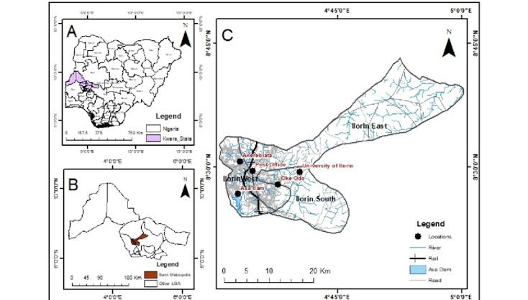
Figure 1.10: Study Area Map

