CHAPTER THREE

METHODOLOGY

3.1 Site Assessment and Preliminary Analysis
The first step in the installation process was a thorough site assessment to evaluate the environmental and structural conditions of the proposed installation area. The assessment involved:
- Measuring roof tilt and orientation: The roof was found to face south, which is ideal for solar panel placement in Nigeria.
- Checking for shading: Trees, water tanks, and nearby structures were analyzed to ensure they did not cast shadows on the intended solar panel location during peak sunlight hours.
- Structural inspection: The roof’s strength and stability were confirmed to support the weight of solar panels and mounting structures.
This stage was critical in determining the feasibility of installing the system and influencing component orientation for maximum solar yield.

3.2 Methodological Steps
The methodology follows these stages:
- Load Estimation and Profiling
- Sizing of System Components (Inverter, Batteries, Solar Panels)
- Selection of Components Based on Ratings
- Wiring Design and Electrical Integration
- Installation and Mounting
- System Testing and Commissioning
- Economic Feasibility Analysis
- Safety and Regulatory Compliance

3.3 Load Estimation
Load estimation is the foundation of every solar system design. It determines the required capacity of each component. This was done by:
- Listing all appliances to be powered by the system.
- Recording each appliance’s wattage and estimated usage time (hours per day).
- Calculating the total daily energy consumption in watt-hours (Wh).
Table 3.1: Sample Residential Load Estimation
Appliance | Quantity | Power Rating (W) | Usage (hrs/day) | Daily Energy (Wh)
LED Bulbs | 10 | 10 | 5 | 500
Ceiling Fans | 4 | 75 | 8 | 2400
Television | 1 | 100 | 5 | 500
Laptop | 1 | 60 | 6 | 360
Refrigerator | 1 | 200 | 10 | 2000
Router/Modem | 1 | 15 | 24 | 360
Total |  |  |  | 6120 Wh/day
Therefore, the total energy requirement is 6.1 kWh/day.

3.4 Inverter Sizing
The inverter converts stored DC electricity from the battery or PV panels into AC electricity for home use.

3.4.1 Inverter Capacity Calculation
The inverter must handle both the total wattage of running appliances and a surge margin for inductive loads (e.g., refrigerators, fans).
Inverter Capacity (W) = Total Load (W) × Safety Factor
Where:
Total Load (W) = Sum of power ratings of all appliances to be powered
Safety Factor = Typically 1.3 to 1.5 (to account for start-up surges and future expansion)
A 4.2kVA / 48V hybrid inverter was selected to ensure future scalability and provide adequate power during high usage.
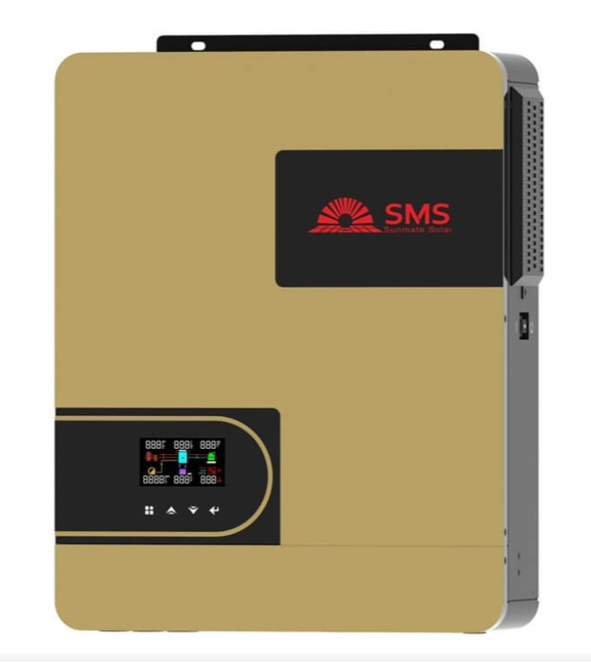
Fig. 3.1: Inverter (4.2kVA) Front View

3.5 Battery Bank Sizing
Battery sizing ensures that adequate energy is stored for night-time use or during low sunlight periods.
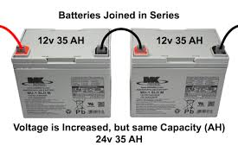
Fig. 3.2: Battery Bank (2 batteries connected)

3.5.1 Formula:
Battery Capacity (Ah)= $\frac{Daily Load (Wh) × Autonomy (Days)}{Specific Voltage \left(v\right) × Depth of Discharge (DOD)}$
Assumptions:
- Daily Load = 6,120 Wh
- Autonomy = 1.5 days
- Voltage = 48V
- DOD = 0.5 (for lead-acid batteries)
- Efficiency = 0.85
Battery Capacity=$\frac{Total Energy Needed (Wh)​}{System Voltage (V)}$

3.6 Solar Panel Sizing
The solar array must generate enough energy to meet the daily load while also charging the batteries.
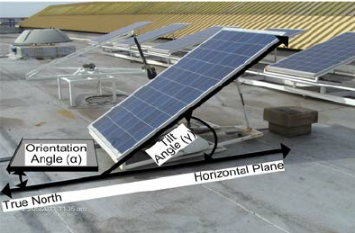
Fig. 3.3:Solar Panel Array on Rooftop

3.6.1 Formula:
Total PV Power (W) =​$\frac{Daily Load (Wh)​}{Sun hour per day}$
Assuming:
- Daily Load = 6120 Wh
- Sun hours = 5 hours
- Efficiency = 0.75

3.7 Charge Controller Sizing
Controller Current (A) =$\frac{TotalPVPower (W)}{SystemVoltage (V)}$
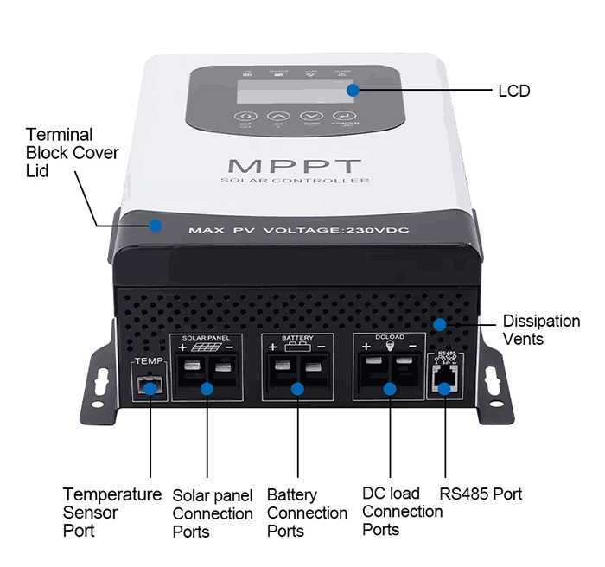
Fig. 3.4:Charge Controller (MPPT) Close-up
  - System Layout and Wiring Diagram (Described Verbally)
- Solar Array connected in series-parallel to MPPT controller
- MPPT Controller wired to Battery Bank
- Battery Bank connected to Hybrid Inverter (4.2kVA)
- Inverter Output wired to AC Distribution Board (load center)
- AC loads divided into critical and non-critical for load prioritization
- Earthing and Surge Protection Devices installed to ensure safety
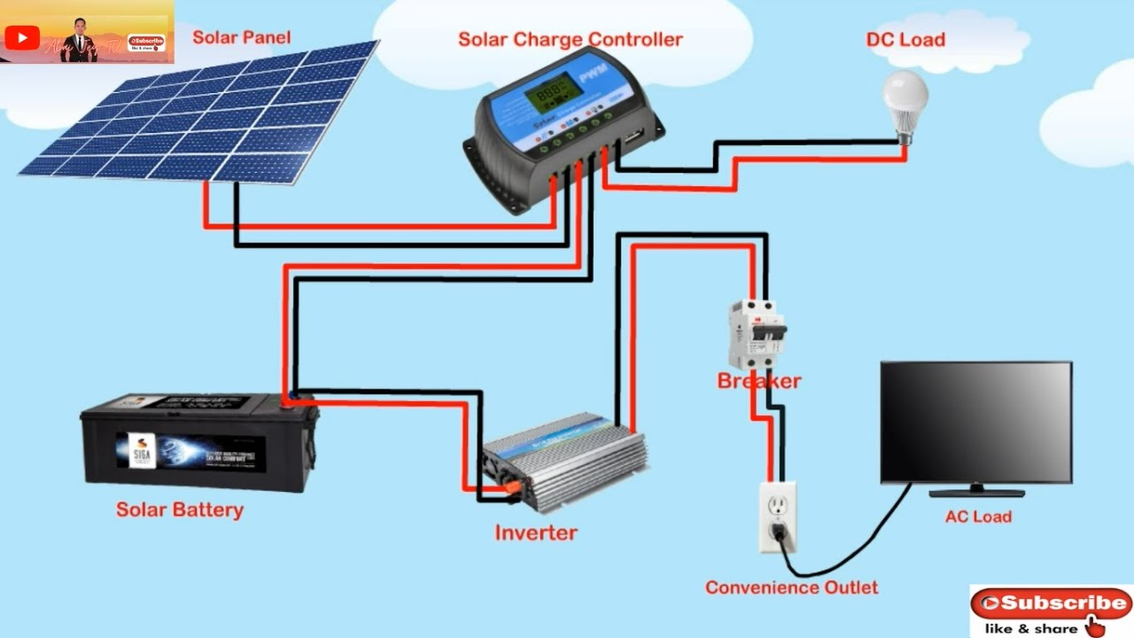
Fig. 3.5:System Wiring Diagram

3.9 Component Selection Criteria
    - Inverter
- Pure sine wave output: refers to the smooth, continuous wave of electricity that closely mimics the power supplied by the national grid. A pure sine wave inverter produces a clean and stable electrical signal that is safe for all types of appliances.
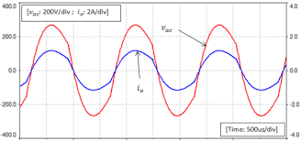
Fig. 3.6:Pure sine wave output
- Hybrid (solar + grid + battery input): is a smart device that can receive power from three different sources.A hybrid inverter intelligently switches between these sources based on availability and priority.
- Mobile app for monitoring:is a smartphone application that lets you track and manage your hybrid inverter system in real time. It provides remote access, so you can check your system from anywhere.
    - Batteries
- Deep-cycle lead-acid, 200Ah battery:is a type of rechargeable battery designed to deliver a steady amount of power over a long periodand beregularly discharged and recharged.Adeep-cycle lead-acid,200Ah batteryis ideal for solar and inverter systems, providingreliable backup power for several hours, especially for home or office loads.
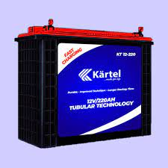
Fig. 3.7:Deep-cycle lead-acid battery
- Maintenance-free lowself-discharge:Does not require regular water refilling or electrolyte checks (maintenance-free) and loses very little charge when not in use (low self-discharge).
    - Solar Panels
- 350W monocrystalline type:refers to a solar panel that has a power rating of 350 watts (it can produce up to 350W under ideal sunlight) Is made from monocrystalline silicon, known for high efficiency and durability.
- Efficiency >19%: means the solar panel can convert more than 19% of sunlight that hits it into usable electricity. For every 100 watts of sunlight falling on the panel, it produces at least 19 watts of electrical power. This is considered high efficiency, typical of monocrystalline panels.
- 25-year output warranty:means the solar panel manufacturer guarantees that the panel will still produce at least 80–90% of its original powerafter25 yearsof use. It assures long-term performance, meaning the panel won’t degrade too quickly and will remain reliable for decades.
    - Accessories
- Changeover switch: this device allows you to manually or automatically switch between two power sources such as grid and inverter or generator and inverter. And it ensures a safe and smooth transfer of power without damaging appliances when one source fails or is turned off.
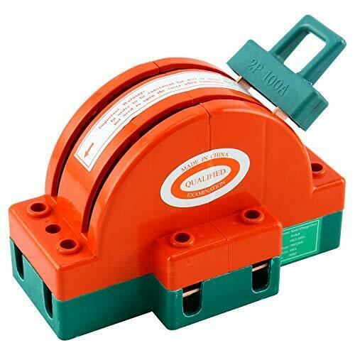
Fig. 3.8:Changeover switch
- DC/AC breakers: these are safety devices that protect electrical circuits from overload or short circuits in both direct current (DC) andalternating current (AC) parts of a system.DC/AC breakers are essential for protecting your inverter system from electrical faults and preventing damage or fire.
- Battery fuse blocks:these are protective components installed between the battery and the inverter or charge controller to prevent damage from overcurrent or short circuits. If too much current flows (due to a fault), the fuse blows and disconnects the battery, protecting the entire system.
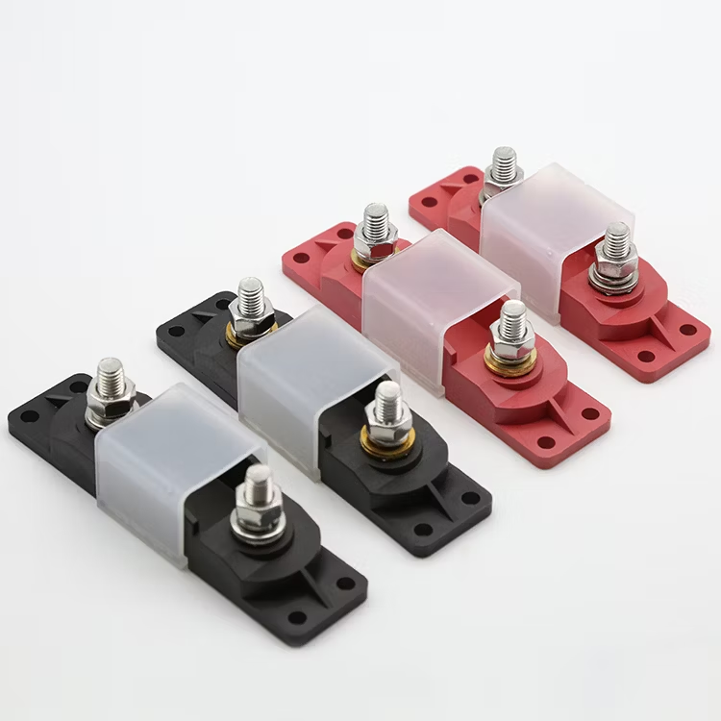
Fig. 3.9:Battery fuse blocks
- Cable lugs and conduit:they are components used for safe and organized electrical wiring in an inverter system. It ensures safe, durable, and neat wiring, reducing the risk of loose connections, short circuits, or cable wear.

3.10 Installation Procedure
- Mounting the Panels:
The panels were secured on an aluminum rail structure with stainless steel clamps, elevated to enhance airflow and cooling. Panels were tilted and aligned southward to maximize solar exposure.
- Battery Bank Setup:
Batteries were housed in a well-ventilated cabinet, elevated from the floor and arranged in series to create a 48V bank. Terminals were color-coded, greased, and fastened with anti-corrosive bolts.
- Inverter and Controller Installation:
The inverter was wall-mounted on a non-flammable wooden board, placed away from moisture, with adequate clearance for ventilation. The charge controller was placed nearby for minimal voltage loss.
- Wiring and Circuit Connections:
Fire-rated wires were routed through conduits. Connections were tested for polarity, insulation, and continuity. All breakers and fuses were installed and labeled clearly.
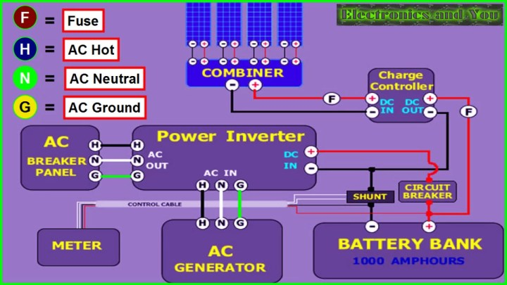
Fig. 3.10:Complete System Setup (installed inside a room)

3.11 Testing and System Monitoring
Once installation was completed, the system was commissioned and tested over 48 hours. This involved:
- Verifying inverter output voltage (steady at ~230V)
- Checking battery charge/discharge cycles
- Observing solar panel performance under varying sunlight
- Running load simulations to test runtime and efficiency
Monitoring tools included a mobile app, multimeter, clamp meter, and hydrometer for battery health (if flooded cells are used).
One of the parameters tested are listed below:
- Inverter load capacity
- Battery backup time
- Solar charging current and voltage
- MPPT controller efficiency
- System stability under load switching

3.12 Safety Measures and Compliance
To ensure long-term safety and performance, several measures were implemented:
- Earthing: All metal frames and the inverter system were grounded.
- SPDs: Installed on AC and DC sides to protect against lightning strikes and surges.
- Circuit Breakers: Used to isolate faults and prevent overcurrent.
- Labeling: Every circuit and breaker clearly marked for ease of maintenance.
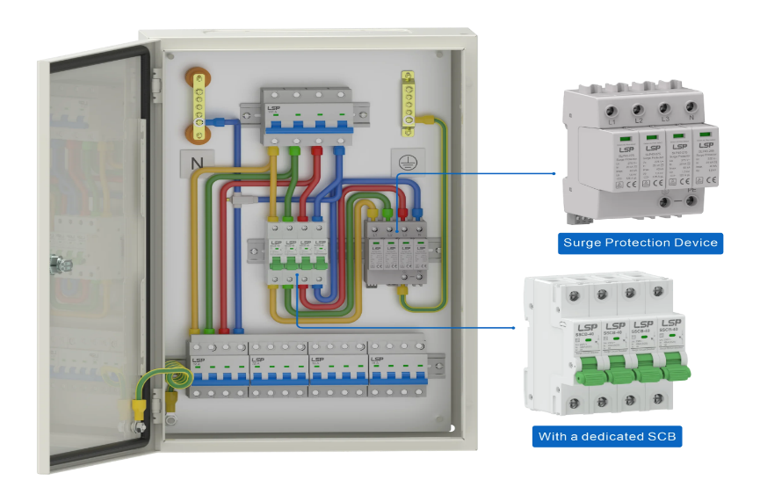
- PPE Use: Installers wore gloves, goggles, and boots throughout the process.

Fig. 3.11:Protective Devices (Circuit breakers, SPD, Earthing)
3.13 Environmental Considerations
Environmental factors play a crucial role in the design, sizing, and performance of a hybrid inverter system. In this study, deliberate effort was made to assess the installation environment and incorporate measures to enhance energy yield, protect components, and extend system lifespan.

3.14 Solar Panel Orientation and Tilt
The solar array was installed on a south-facing roof with a tilt angle of approximately 15–25°, which corresponds to the local latitude. This orientation maximizes solar irradiance capture throughout the year, especially between 10 a.m. and 3 p.m., when solar intensity peaks. By reducing shadowing effects from nearby structures and vegetation, panel output was optimized.

3.15Weather and Climatic Impact

The system was installed in a tropical climate, characterized by alternating dry and rainy seasons. High ambient temperatures can reduce solar panel efficiency, while heavy rains can reduce daily irradiation. However, rains also help clean the panels naturally, reducing dust accumulation, which otherwise could reduce efficiency by up to 20% over time.

3.16.1 Battery Placement and Ventilation
Batteries were housed in a well-ventilated but secure enclosure, away from direct sunlight and moisture. Proper ventilation is critical in preventing the build-up of hydrogen gas, which can be emitted during charging, especially from lead-acid batteries. Battery shelves were constructed with non-conductive materials to minimize corrosion risk and ensure personnel safety.

3.16.2 Sustainable Design Benefits
Compared to diesel generators, the solar hybrid system emits zero greenhouse gases, generates no noise pollution, and relies solely on renewable solar energy, aligning with the principles of environmental sustainability and climate action (SDG 13).

3.16.3 Simulation and Design Approach (Manual Approach)
Although several simulation tools such as HOMER Pro, PV*Sol, and RETScreen exist for modeling hybrid systems, this project relied on a manual, calculation-based design approach, using established electrical engineering formulas, manufacturer datasheets, and real-world assumptions.
    - Rationale for Manual Design
- Realism: Manual calculation reflects field realities in Nigeria, where most technicians and installers depend on experience and formula-based sizing rather than expensive licensed software.
- Accessibility: The approach ensures that students, local engineers, and technicians without access to premium tools can still replicate the system.
- Accuracy: When done carefully, manual sizing, based on peak loads, daily energy demand, DOD, and efficiency yields results that align closely with simulated models.
- Flexibility: Adjustments to panel number, battery size, or load profile were easily recalculated without dependency on digital simulations.
This method promotes knowledge transfer and is especially suited to small-scale systems for residential or commercial use in developing economies.

3.18 Load Prioritization Strategy
To prevent overloading the inverter and batteries, a load prioritization strategy was implemented to separatecritical from non-critical loads.

3.18.1 Critical Loads
These are appliances essential for day-to-day living, prioritized during power shortages:
LED lights
- Ceiling fans
- Television
- Wi-Fi router
- Refrigerator (if well-rated and efficient)
These were connected to a dedicated critical load distribution board, which is backed by the hybrid inverter and battery bank.

3.18.2 Non-Critical Loads
These are energy-intensive or non-essential devices:
- Air conditioners
- Electric kettles/heaters
- Washing machines
- Irons
These were excluded from the inverter circuit and connected only to the national grid or a backup generator. Manual or automatic relays were set to prevent their activation when the system runs solely on solar/battery.
    - Benefits of Load Prioritization
- Maximizes battery runtime
- Protects inverter from overload
- Reduces energy waste
- Enhances user control

3.18.4 Maintenance Planning and Lifecycle Management
Hybrid inverter systems require scheduled maintenance to ensure optimal performance and prevent costly failures.

3.18.5 Monthly Maintenance Checklist
Task | Frequency
Inspect battery terminals | Monthly
Clean solar panels | Bi-weekly (or after dust storm)
Check cable tightness | Monthly
Monitor system readings | Weekly
Clean inverter enclosure | Monthly

3.19Component Lifespan
Component | Expected Life
Solar Panels | 20–25 years
Inverter | 8–10 years
Lead-Acid Batteries | 3–5 years (if well maintained)
    - Preventive Maintenance Benefits
- Extends Component Life:Regular maintenance and monitoring help identify early signs of wear and tear. By addressing issues promptly, components avoid unnecessary strain. This prolongs the lifespan of electrical, mechanical, or electronic parts. Proper lubrication, cleaning, and calibration also contribute. This results in fewer replacements over time.
- Avoids Sudden Outages:Predictive and preventive maintenance can detect faults before they cause breakdowns. Monitoring systems alert users to abnormalities, enabling timely interventions. This reduces the risk of unplanned system shutdowns. As a result, operations remain smooth and reliable. It ensures continuity in power or production processes.
- Improves Return on Investment (ROI):By minimizing downtime and repair costs, systems run more efficiently for longer. Fewer replacements and less energy loss mean better operational efficiency. Well-maintained assets perform optimally, generating consistent value. Longer equipment life enhances the value of the initial investment. This maximizes overall profitability.
- Reduces Repair Costs:Detecting issues early prevents minor problems from escalating. Timely maintenance is generally cheaper than emergency repairs. Avoiding catastrophic failure means fewer costly parts need replacement. Labor costs are also reduced due to planned interventions. This results in lower long-term expenses.

3.19.2 Risk Assessment and Mitigation
Risk assessment is essential to protect both the equipment and users. The following were identified and mitigated:
Electrical Risks
- Overcurrent: Protected by properly rated circuit breakers and fuses.
- Reverse polarity: Minimized through clear color-coded cables and double-verification during wiring.
- Voltage surges: Managed with surge protection devices (SPDs) on both AC and DC sides.

Fire Hazard: Batteries were isolated from heat and flammable materials. All terminals were insulated, and connections tightened to avoid sparking.
Physical Injury: Installers wore Personal Protective Equipment (PPE) such as gloves, goggles, and safety boots. Work was done only during daylight to avoid low-visibility hazards.

Weather-Related Risks: Solar panels were secured with wind-resistant clamps. The inverter and batteries were installed indoors to protect from rain and dust.

3.19.3 Ethical and Social Considerations: This project reflects not only technical execution but also social responsibility and ethical awareness.

Access to Reliable Energy: The hybrid inverter system addresses energy poverty in Nigeria. With consistent electricity, students can study at night, and small businesses can operate longer, improving quality of life and economic productivity.
Environmental Stewardship: By choosing solar over diesel, the system supports Nigeria’s climate goals andreduces carbon footprint. It also promotes awareness about green energy in the community.

