CHAPTER TWO

LITERATURE REVIEW

2.1 Overview
This chapter reviews the theoretical and empirical foundations of hybrid inverter systems with an emphasis on solar energy integration, energy storage technologies, power electronics, and the state of renewable energy adoption in Nigeria. It draws from scholarly articles, technical manuals, engineering standards, and real-world case studies to contextualize the design and deployment of a 4.2kVA hybrid inverter system.

2.2 Energy Demand and Power Reliability Challenges in Nigeria
Nigeria, with a population of over 200 million, has long struggled with an unreliable power supply. The country’s national grid is plagued by frequent outages, poor transmission infrastructure, and inadequate generation capacity. According to the Nigerian Electricity Regulatory Commission (NERC, 2021), only about 57% of the population has access to electricity, with much lower reliability in rural areas. Even in urban centers, daily blackouts are common, leading to heavy dependence on fossil-fuel generators (Oyedepo, 2012).These challenges have fueled interest in decentralized renewable energy solutions, especially solar PV systems. Hybrid inverter systems provide a realistic solution by bridging the reliability gap through energy storage and intelligent switching between multiple power sources.

2.3 Overview of Solar Energy Systems
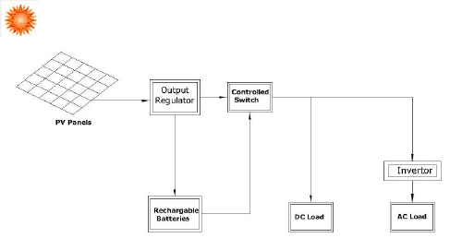
Figure 2.1: Basic Configuration of a Solar PV System
Solar energy systems are designed to capture sunlight and convert it into usable electrical energy. The basic components include:
- PVPanels: Convert sunlight into direct current (DC).
- Inverter: Converts DC to alternating current (AC).
- Charge Controller: Regulates voltage and current to the batteries.
- Battery Bank: Stores excess energy for use during low sunlight or grid failure.
- Balance of System: Includes mounting, wiring, and protective devices.
Solar energy is abundant in Nigeria, with average daily solar radiation ranging between 3.5 to 7.0 kWh/m²/day (Ikejemba et al., 2016). This makes it highly suitable for off-grid and hybrid systems.

2.4 Hybrid Power Systems
A hybrid power system combines two or more energy sources to deliver electricity more reliably and efficiently. Commonly used hybrids include solar-diesel, solar-grid, solar-wind, and solar-battery systems. Hybrid inverters lie at the heart of such systems, managing input from multiple sources and optimizing output.
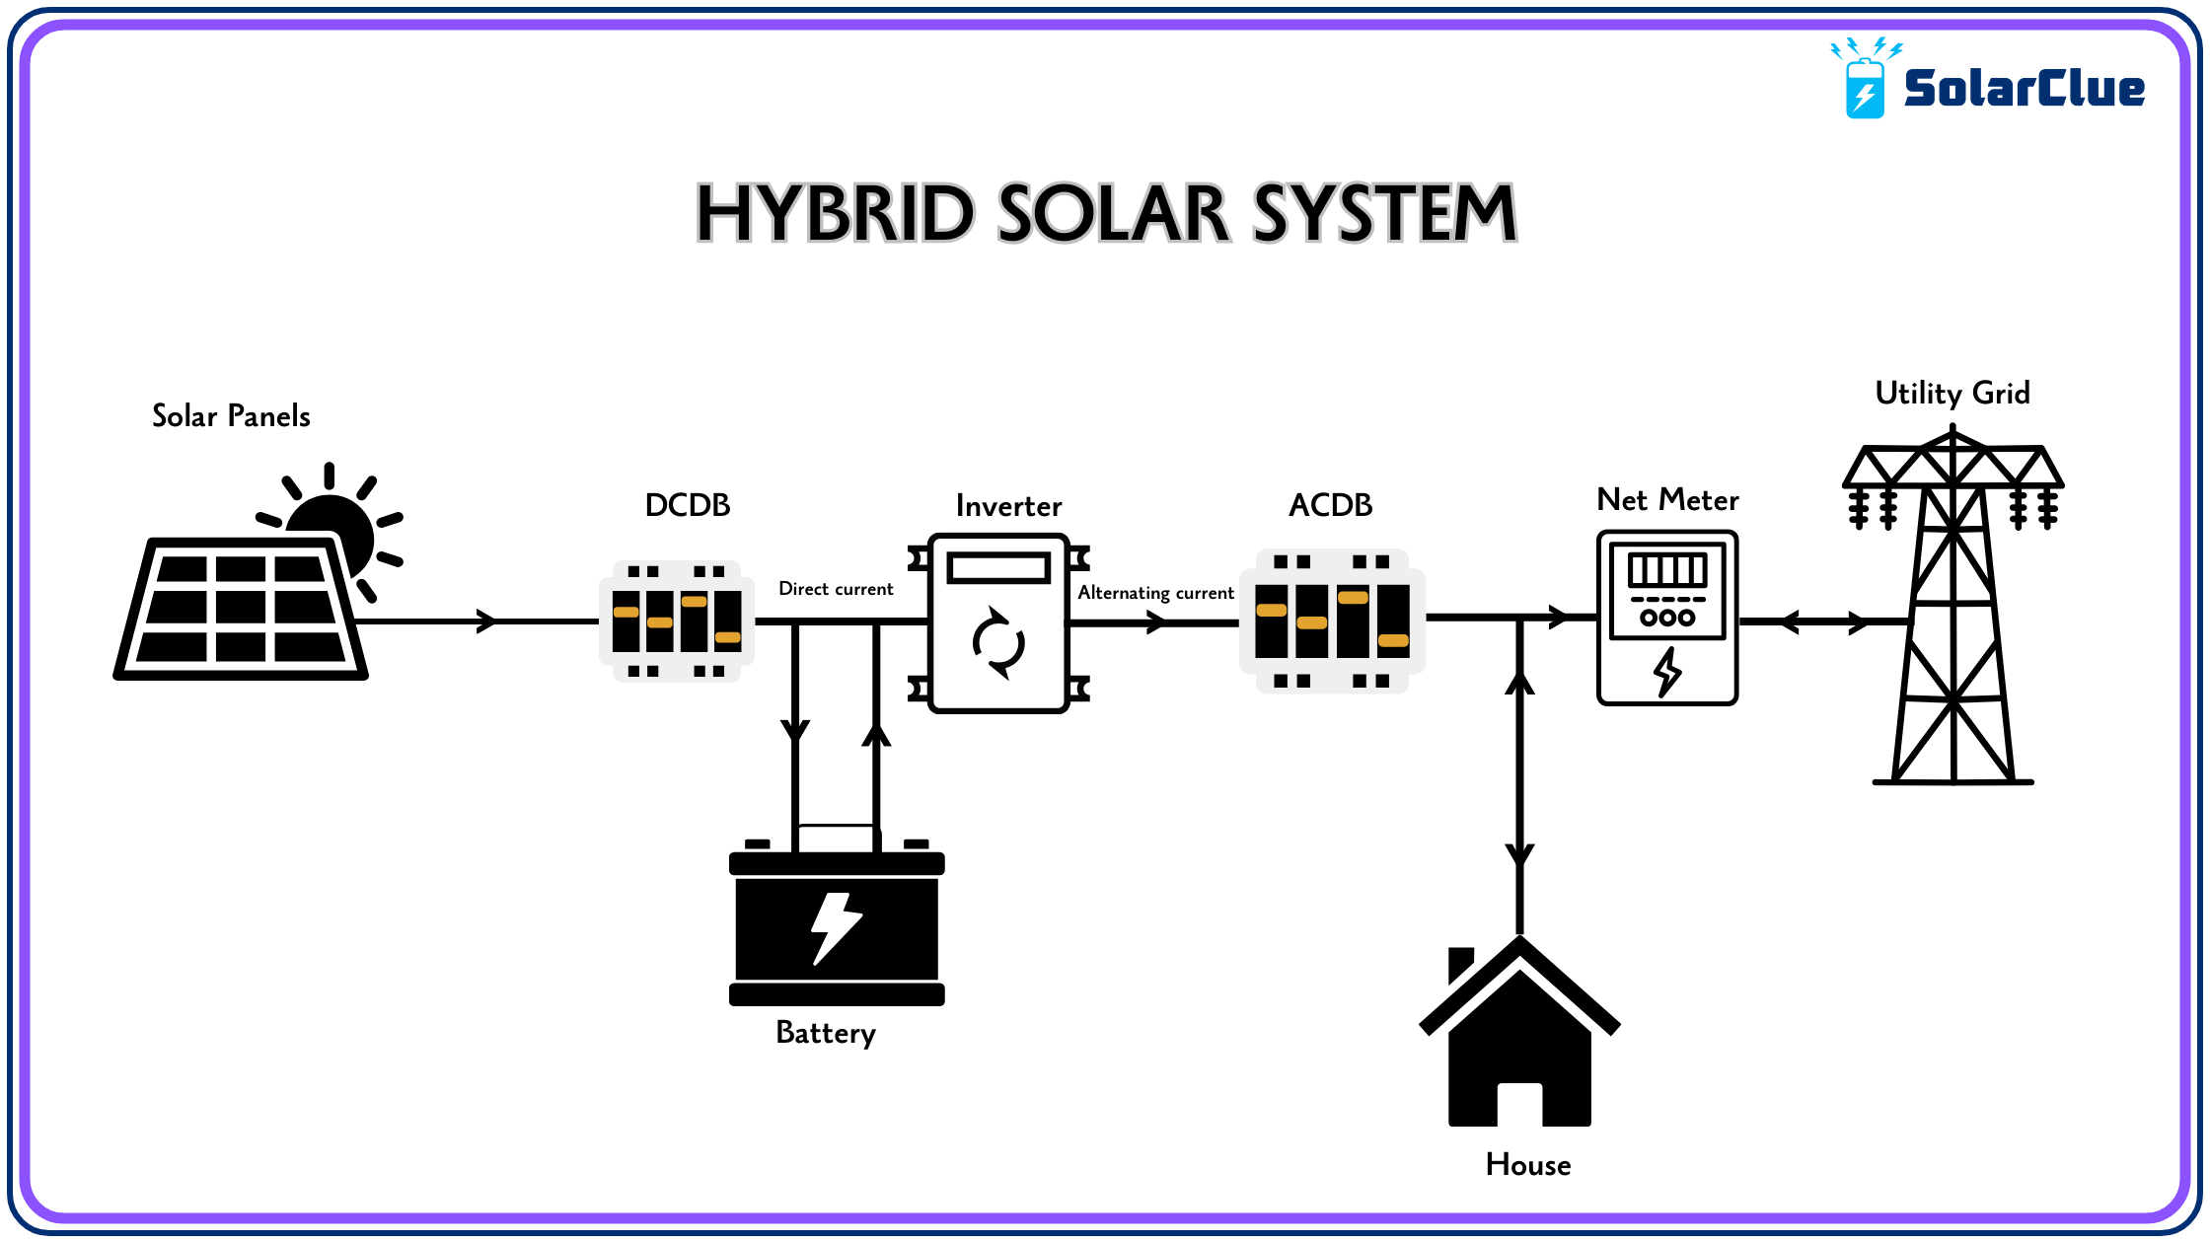
Figure 2.2: Schematic Layout of a Solar Hybrid System
Source: blog.solarclue.com, accessed May, 2025
Hybrid systems offer several advantages over single-source systems:
- Uninterrupted Power Supply through intelligent source switching.
- Improved Energy Efficiency via maximum power point tracking (MPPT).
- Cost Optimization by reducing generator or grid reliance.
- Environmental Benefits by integrating renewable sources (Hossain et al., 2019).

2.5 Inverter Technology
An inverter is a power electronic device that converts DC into AC. In solar applications, the inverter enables the use of DC energy stored in batteries or generated by PV panels to power AC appliances.

Types of Inverters
- Off-Grid Inverters: Operate independently of the national grid.
- Grid-Tied Inverters: Sync with the grid and may export excess power.
- Hybrid Inverters: Combine the capabilities of off-grid and grid-tied systems. They manage power from solar, battery, and grid sources and often support load prioritization, battery optimization, and net metering.
However, there are different types of inverters based on how they operate with other power sources. These include off-grid inverters, on-grid inverters and hybrid inverters. Each has its own mode of operation, application and advantages.
Figure 2.3 illustrates the basic configuration based on functionality
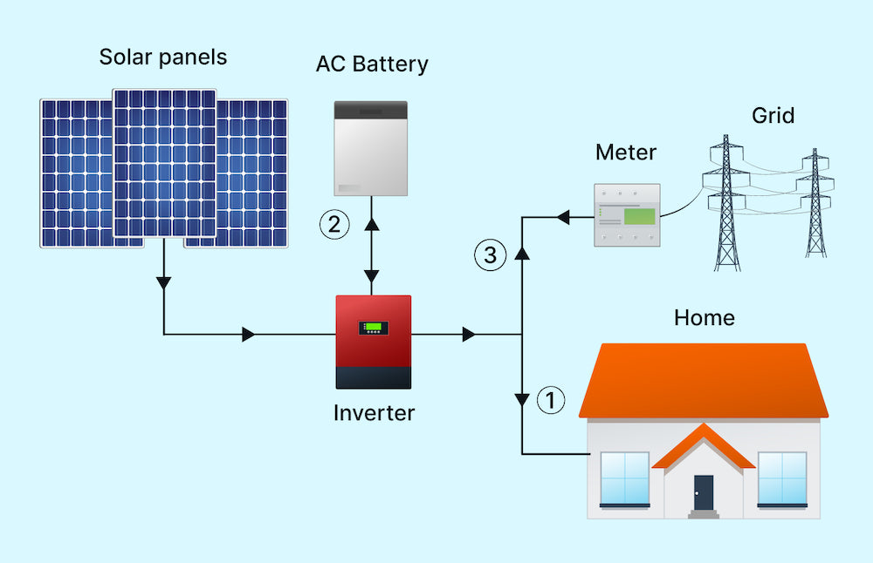
Figure 2.3: Types of Inverters Based on Functionality
Source: solarpowerworldonline.com (2023)

Key Features of Hybrid Inverters
- MPPT tracking:Every solar panel has a Maximum Power Point (MPP) a specific combination of voltage and current at which the panel produces themostpower. However, this point changesthroughouttheday due to fluctuations in sunlight intensity, temperature, and shading. It is the real-time processof continuously adjustingthe electrical operating point of the solar panel to stay at or near that maximum power point, thereby maximizing the energy that is harvested and delivered to the battery or load.
- Battery management: Refers to the set of practices, technologies, and systems used to monitor, control, protect, and optimize battery performance in energy systems especially in hybrid inverter setups.
- Source prioritization (solar → battery → grid): refers to the intelligent sequence in which a hybrid inverter decides which power source to use first, in order to maximize efficiency, reduce costs, and extend system life.
- Load scheduling:is the process of planning when specificelectrical appliances should turn on or offto optimize energy usage in a solar or hybrid inverter system.
- Wi-Fi/IoT monitoring interfaces:are digital platforms that allow users to remotely monitor and control their hybrid inverter systemsusing internet-connected devices like smartphones, tablets, or computers.

2.6 Battery Storage Technologies
Energy storage is critical in hybrid systems, allowing energy generated during the day to be used at night or during grid failure.

Battery Types
- Lead-Acid Batteries: Affordable, widely used, but limited cycle life.
- Lithium-Ion Batteries: Longer lifespan, higher energy density, more expensive.
- Gel/AGM Batteries: Sealed lead-acid types with lower maintenance needs.
Battery selection depends on depth of discharge, efficiency, maintenance, cost, and lifecycle (Larcher & Tarascon, 2015).

2.6.2 Battery Sizing and Management
Correct battery sizing ensures the system can store sufficient energy to meet load demands. Oversized batteries increase cost, while undersized batteries lead to short backup times and accelerated degradation.

2.7 Energy Management Systems (EMS)
Modern hybrid systems rely on EMS to automate energy source prioritization, load shedding, charge-discharge cycles, and fault detection. A well-designed EMS:
- Enhances system lifespan
- Reduces energy losses
- Provides data for performance tracking
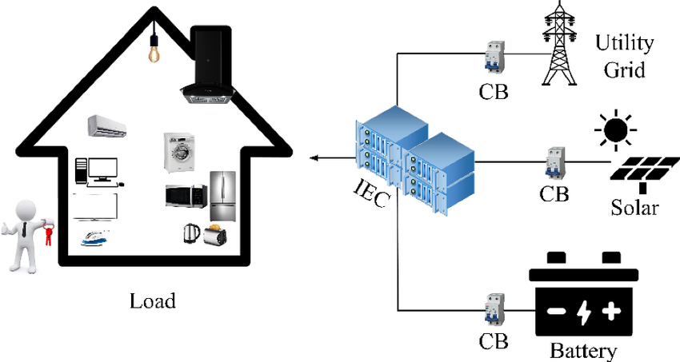
Figure 2.4: Architecture of an Energy Management System
Source: Reseachgate.net, 2025.
Many hybrid inverters come with built-in EMS features and user-friendly mobile interfaces. They are designed to optimize, control and optimize the generation, storage, and distribution of electrical energy in hybrid power setup.
Figure 2.4 above illustrates the basic architecture of an energy management system, showing how various components such as the inverters, solar input, batteries, loads and communication modules interact through a centralized control unit to maintain energy flow and system performance.

2.8 Component Sizing Techniques
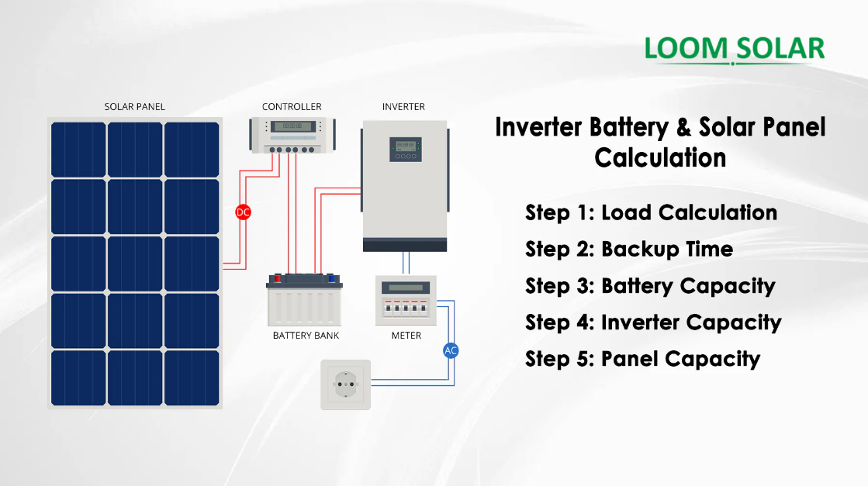
Figure 2.5: Manual Component Sizing Workflow for Hybrid Systems
Sizing is fundamental to system efficiency and includes the following steps:
- Load Analysis: Determining total daily energy demand (in Wh or kWh).
- Inverter Sizing: Must exceed peak load with a safety margin.
- Battery Sizing: Based on load, autonomy days, depth of discharge.
- PV Sizing: Depends on daily energy requirement and peak sun hours.
- Charge Controller Sizing: Based on array current and system voltage.
Under-sizing leads to overload, while over-sizing increases project cost (Chauhan & Saini, 2014).

2.9 Review of Related Works
Numerous studies have examined hybrid inverter system design and deployment in different contexts:
- Adekanmi et al. (2024)review hybrid energy storage system covering design, control strategies, and grid integration in Sustainable Energy Research.
- Bughneda et al. (2021)present a comprehensive survey of multilevel inverter topologies and performance in energies.
- Ishola & Ajayi (2021) implemented a 3kVA hybrid inverter for rural homes and found that system uptime improved from 52% (grid only) to 96% (hybrid).
- Leon Gomez et al. (2023)discuss various hybrid system configurations, battery integrations and optimization strategies.
These works support the technical and economic feasibility of hybrid inverter systems and validate their adoption as a solution for energy-insecure regions.

2.10 Nigerian Context for Renewable Energy Deployment
Despite abundant solar resources, Nigeria’s renewable energy penetration remains low. Regulatory frameworks like the Renewable Energy Master Plan (REMP), the National Energy Policy (NEP), and the Electrification Roadmap (with Siemens) aim to promote off-grid solutions, but implementation is slow.
Barriers include:
- High initial cost
- Lack of skilled technicians
- Inconsistent government incentives
- Limited awareness
However, initiatives such as the Rural Electrification Agency (REA) and donor-funded mini-grid pilots have started driving awareness and adoption of hybrid systems, especially in rural areas (Ohunakin et al., 2014).

2.11 Environmental and Economic Benefits
Adopting hybrid inverters has both environmental and economic impacts:
- Reduces CO₂ emissionscompared to generators
- Lowers operational costsdue to zero fuel requirements
- Minimizes noise pollution
- Improves energy independence
These benefits contribute to SDG 7 (Affordable and Clean Energy) and SDG 13 (Climate Action).
Table 2.1: Critical Review of Related Works
Author(s) & Year |  | Work Description |  | Identified Gap(s) |  | How This Work Fills the Gap
Adekanmi et al. (2024) – Sustainable Energy Research |  | Reviewed hybrid energy storage for grid integration, focusing on energy flow strategies and battery life. |  | No real-case implementation in Nigerian academic institutions; lacked inverter-specific sizing models. |  | Implements a working 4.2kVA hybrid inverter at Kwara State Polytechnic with full design metrics.
Bughneda et al. (2021) – Energies |  | Analyzed multilevel inverter topologies for PV systems, comparing their efficiency and output quality. |  | The study focused on high-power industrial systems, not small-scale educational or residential systems. |  | Applies similar concepts to a small, real-world educational setting with cost-effective components.
Gómez et al. (2023) – Eng (MDPI) |  | Surveyed architectures and control methods in hybrid PV systems, including IoT-based optimization. |  | Lacked focus on system protection, practical cabling/wiring, and deployment in low-income environments. |  | Includes installation wiring, local protection strategies, and inverter monitoring integration.
Renewable Energy Focus (2023) |  | Reviewed standalone vs. grid-tied hybrid systems, emphasizing energy balancing methods. |  | No discussion on application in polytechnic labs or load scheduling in small-scale academic systems. |  | Demonstrates load prioritization and switching logic tailored to departmental power needs.
Yusuf et al. (2022) – Nigerian Journal of Solar Energy |  | Case study of solar system installation in a rural secondary school in Nigeria. |  | Did not integrate hybrid switching or monitoring; focused only on solar and battery. |  | Incorporates grid interaction, mobile app monitoring, and changeover switch for a hybrid setup.

2.12 Summary of Critical Review
From the reviewed literature, it is evident that significant progress has been made in the development of hybrid renewable energy systems globally. However, most studies either focus on large-scale or rural off-grid applications, with limited attention to academic environments in developing countries like Nigeria. Furthermore, the practical integration of solar, battery, and grid sources with user-friendly features like Wi-Fi monitoring, load scheduling, and inverter protection is often not addressed in full.
This current project bridges those gaps by implementing a real-world 4.2kVA hybrid inverter system within the Electrical Engineering Department of Kwara State Polytechnic, incorporating all essential featuressystem sizing, smart load management,safety mechanisms, and energy monitoring. The work not only demonstrates practical feasibility but also serves as a functional learning model for students and staff alike.

