KWARA STATE POLYTECHNIC ILORIN,
KWARA STATE.

PROJECT DEFENCE
TOPIC:
DESIGN AND CONSTRUCTION OF ENERGY METER MONITORING OVER IOT WITH
ANDROID APPLICATION .

PRESENTEDED BY:
HND/23/EEE/FT/0212

SUPERVISEDBY:
ENGER. K. LATEEF

INTRODUCTION

Theglobalriseinelectricitydemand—fueled by population growth,industrialization,and heavyrelianceon electronic devices—calls for more efficientenergy managementsolutions.Traditionalmeteringsystems, which require manual readings,are oftenslow, error-prone, and lack theabilitytoprovidereal-timedata.Theseshortcomingsleadtodelayedbilling,inaccurateconsumptiontracking, and significant energy losses.
TheemergenceoftheInternetofThings(IoT)presentsamoreintelligentapproachtopowermanagement. By integrating sensorsand communicationmodulesintoenergysystems,IoTenablesreal-timemonitoring,automatedbilling,anomalydetection,andremoteaccessthroughmobileapplications.
Thisprojectfocusesonthedesignandconstructionof anIoT-basedenergymeter,connectedtoanAndroidapp,tohelpusersmonitortheirelectricityusageinrealtime.Thissmartsystemimprovesaccuracy, promotes transparency, and encourages more responsible energyconsumption, contributing to a sustainable and efficient power infrastructure.

PROBLEMSTATEMENT

Traditional methods ofenergy monitoring and billing are plagued with several inefficiencies. Manual readingsarenotonlytime-consumingbutalsopronetohumanerror, oftenresultingininaccuratebilling.Theabsenceofreal-
time monitoring makes it difficult for consumersto tracktheirenergyconsumptionandadjusttheir usage
accordingly. Inefficiencies within billing systems frequently lead to estimated charges,delayedinvoices,or
overbilling, which can frustrate usersand reduce trust in utility providers.Additionally, the inability to detect
power theft or system faults promptly contributes tosignificant revenuelossesandfrequentservicedisruptions.Most critically, these conventional systems do not promote proactive user engagement, as consumers typicallyreceive feedback only after billing—by which time opportunities for energy conservation may already be lost.This project seeks to resolve these challenges by introducing a smart, accurate, and user-friendlyenergy
monitoring solution that enables timely feedback, remote accessibility,and improvedefficiencyfor bothend-usersand service providers.

AIM & OBJECTIVES
Aim:

TodesignandconstructanIoT-enabledenergymeterintegratedwithanAndroidapplicationthatenablesreal-timemonitoring, usagealerts, anddataanalytics.

Objectives:

1. Design and build a reliable energy metering circuit using appropriatesensors.

2. Integrate a microcontroller (e.g., ESP32) with IoT communication modules.

3. Interface the system with cloud servicesfordatastorage and retrieval.

4.DevelopanintuitiveAndroidapplicationforuserstotrackenergy usageinrealtime.

5. Implement alert systems to notify users about abnormal usageor thresholds.

SCOPE OFSTUDY
This project focuses on:

• Real-time measurement ofelectrical energy usingcurrentand voltagesensors.

• Transmission ofdata to a cloud platformusing Wi-Fior GSM.

• Development ofan Android mobile application to display live consumption dataand usagehistory.

• Alert generation based on user-defined thresholds.

• The project does not cover prepaid billing integration, advanced tariffstructures,orindustrial-grade load analysis.

LITERATURE REVIEW
Severalstudies have explored the integration ofsmart technologies in energy management:

• Abhisheket al. (2017) designed an IoT-based energymeter thatsendsreal-timeconsumptiondataviaGSM. While effective, thesystem lacked a user-friendly interface and mobileappsupport.

• Kumar andSingh (2019) proposed asmart energy meter with prepaid billingand loadcontrolfeatures.Theirapproachenhancedutilitymanagementbutfocusedlessonconsumer-sidemonitoring.

• Akinyele et al. (2020) emphasizedsmart metering’s roleinreducingenergylossesandimprovinggridreliability in developing countries. However, cost and connectivity challenges remain.

• Chandran et al. (2021)developedan Android-based smartmeter prototypeusingIoTandcloudservices, improving transparency and user awareness, though scalability was not addressed.

METHODOLOGY (CIRCUIT

DIAGRAM)
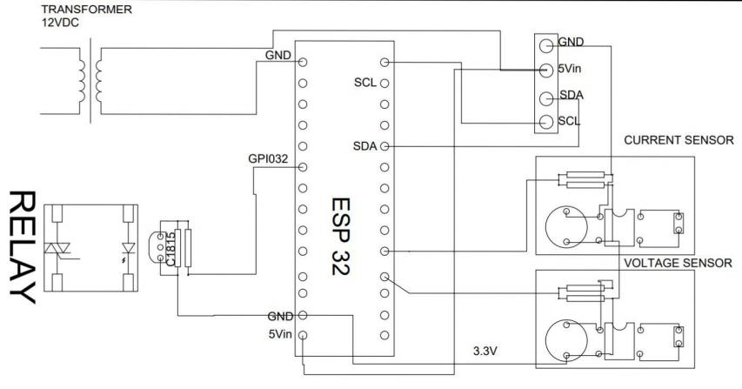

DESIGN CALCULATION

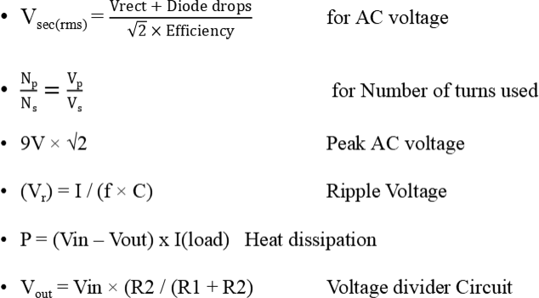

CONCLUSION

Conclusion

The design and implementation ofan IoT-based energy meter with Android integration
successfully addressed key issues in traditional energy monitoring systems. By offering real-timetracking, automated billing, and remote access, the system enhances transparency,efficiency,and user control. This solution not only benefits consumers but also aids utility providersinreducingenergy losses and improving servicedelivery.

RECOMMENDATION

Recommendations

• Adopt IoT-basedSmart energy meters: utilitiescompaniesshouldtransitionfromtraditionalmetering to IoT-enabled smart meters to enhance accuracy, enable real-timemonitoring,andreduceoperationalefficiencies.
• Promote user awareness and mobile integration: encourageenergysaving habitsby providingusers with intuitive mobile applications that offer real-timefeedback, usageanalytics and
alerts on abnormal consumptionorfaults.

REFERENCES

References

•Abhishek,S., Kumar, V., &Singh, R. (2017). IoT-based energy meter reading and billingsystem. InternationalJournalofEngineeringResearch, 6(8),123-129.
•Kumar, P., &Singh,A. (2019). Design of smart energy meter withprepaid billing and loadcontrol. Journal ofElectricalSystems,15(3), 210-218.
•Akinyele, D. O., Jimoh, A. A., & Ogunjuyigbe, A.S. O. (2020). Smart meteringfor developingcountries:Challenges and opportunities. Renewable Energy Journal,145, 2673-2682.
•Chandran, R., Nair, M., &Thomas, S. (2021).Android-basedIoTenergymeterprototypefor real-timemonitoring. InternationalJournalofSmartGrid, 7(1), 45-53.

