CHAPTER THREE
3.0 METHODOLOGY
Methodology is the systematic theoretical analysis of the methods applied to a field of study, it comprises the theoretical analysis of the body of methods and principles associated with a branch of knowledge. Typically, it encompasses concepts such as paradigm, theoretical model, phases and quantitative or qualitative techniques.
3.1 Reconnaissance
This has to do with framework of survey operation whereby all survey operations are going to base on.
Reconnaissance is also known as (Recce). Reconnaissance is examination of all part of an area accomplished insufficient detail to make generalization about the type and distribution of historical properties that may be present with a given project area. Also, is the process of having the general overview of the area to be surveyed with the view of determining the arrangement of the work such as method to employed, personnel to be involved, instrument to be used, scale at which plan/map is to be drawn. There are two stages of reconnaissance namely: Office and Field reconnaissance.
    - Field Reconnaissance
The first stage in this project was search for existing information in connection with the area in which the project was undertaken. Rough sketch diagram(recce) of the project area was drawn selecting and marking the approximate position of each point. To sum up, the reconnaissance facilitated the planning and execution of the actual survey as its takes into consideration, the possible problems that are likely to be encountered, and how such problems can be overcome or reduced to minimum.
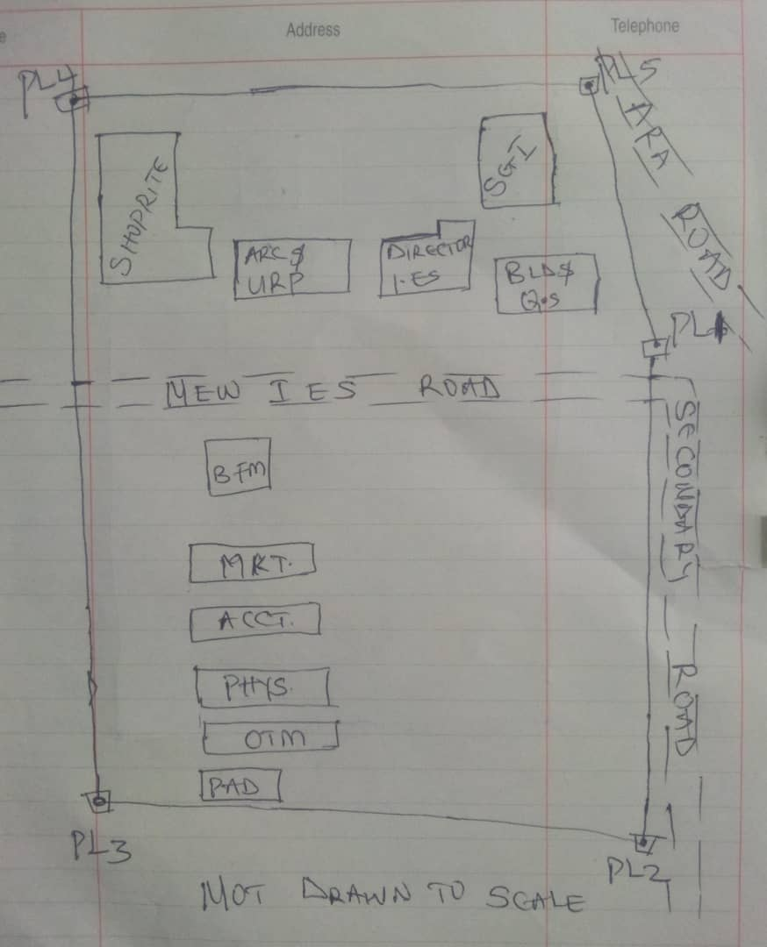

Recce diagram
3.1.2 Office Reconnaissance
Office reconnaissance/data gathering as the name implies is the exploratory survey, scouting or examination, to collect information necessary for the successful execution of the project. It can be simply define as making a preliminary survey before the actual mobilization for the project site. For the purpose of this project, the data search involved retrieving of the coordinate of three (3) existing control.
Pillar No. | Easting(m) | Northing(m) | Height | Location
KWPT 49 | 674341.289 | 937679.115 | 353.682 | Kwara Polytechnic
KWPT 50 | 674555.841 | 937618.402 | 354.903 | Kwara Polytechnic
Table 1: Show coordinates of existing and used control point.
3.1.3 Selection of Station
The boundaries as shown in the recce diagram were laid down by marking points on the ground (station).
The factors considered in selecting these stations include:
- Inter visibility between two points.
- Firmness of the ground at the selected point.
- Working convenience over the station.
- Points located where not disturbed.
3.2 Survey Rod
A survey rod is a physical marker, typically made of metal, used to mark the boundaries of a parcel of land. These markers are used to define the limits of a property and can be used as reference points for future surveys. Rods are durable and can be used in a variety of environments.
3.2.1 Survey rules guiding rod uses:
1. Placement: Rods should be placed at boundary corners or points of change in the boundary.
2. Visibility: Rods should be visible and easily identifiable
3. Durability: Rods should be durable and resistant to weathering.
4. Accuracy: Rods should be placed accurately, following the surveyed boundary.
5. Documentation: the location and description of rods or pegs should be documented in the survey records.

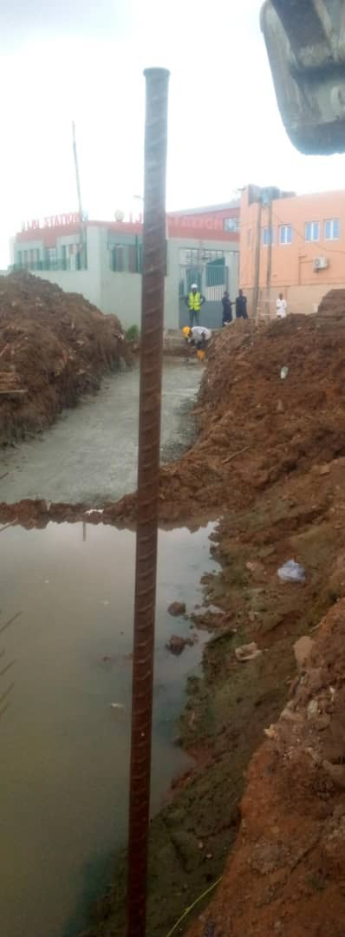

Figure 3.1: Graphical View of Cadastral Survey Rod
3.3 Instrumentation
It refers to the equipment and accessories employed for the successful execution of this project and they are as follows:
Hardware Used
- Stonex R2 Plus Total Station and its accessories
- Leica Digital Level instrument and its accessories
- Handheld GPS
- Hp Core i5 vPro 8th Gen Laptop
- Cutlasses
- Head-pan
- Nail and bottle cover
- 1 Hammer
- 1 Spade
- 1 Hand-trowel
Software Used
- AutoCAD 2007
- Golden Software Surfer 20.0
- Microsoft Office Excel 2013
- Microsoft Office Word 2013
Material Used
- Water
- Cement
Total Station:- It is an electronic or optical instrument used in modern surveying and building construction that used Electronic Distance Measurement (EDM). It is also known as electronic data collection and storage system of which all the data acquired on site is been stored and secured for office reconnaissance.
Digital Leveling:- It is considered one of the most precise methods for height determination. It employs an electronic level instrument and a bar-coded staff to measure vertical distances, reducing human errors common in conventional leveling.
Table 3.2: Equipment Description
S/N | Equipment | Uses
1 | Stonex R2 Plus Total Station | X, Y and Z coordinates of boundaries
2 | Leica Automatic Level | Determination of the reduced level
3 | Handheld GPS | X & Y coordinates of details
4 | Autodesk AutoCAD 2007 | Presentation of the boundaries
5 | Golden Software Surfer 20.0 | Contour and Generation of 3D model
6 | Microsoft Office Excel 2013 | X, Y and Y coordinates editing&program
7 | Microsoft Office Word 2013 | Report writing
3.4 Test of Instrument
For any survey job, testing of the instrument must be done before execution of the job, the instruments used for data acquisition were tested to ascertain whether they are in good working condition.
The following test were carried out,

3.4.1 Total Station
The total station instrument used (Stonex R2 Plus Total Station) underwent a two-phase check. Firstly, the vertical and horizontal angles were verified using pre-established control points within the school campus. Secondly, the electronic distance measurement (EDM) capability was tested for horizontal distances. The instrument passed all tests and was deemed suitable for use.
Below is the procedure for carryout the tests
3.4.1 Total Station
Instrument used in data acquisition was checked for integrity before moving them to site. Apart from check carried-out on Total Station, the following instruments were also checked: Tripod stand legs and their screw were confirmed okay, foot screws, focusing knob, vertical and horizontal knob for slow motion and clamp were all confirmed okay.
3.4.1.1 Horizontal Collimation Test
This error exists when the optical axis of the total station is not exactly perpendicular to the telescope axis. To test for horizontal collimation error, station A was selected and the instrument was set on it and leveled using three foot screws. Then, the telescope was rotated through 360°, but the bubble did not run out of the level tube centre which shows that the line of sight is parallel to the axis of the level tube.
Furthermore, the telescope was pointed to a target on station B in face left, then, pointed back to same target in face right; the difference in horizontal circle readings after averaging the result from both faces of the instrument was 180° except small variation is seconds which is permissible based on the allowable accuracy limit (least Count). The following results were displayed below.
Fairly Level Ground
STATION A
100m
REFLECTOR
(TARGET)
STATION B
Total Station

Fig 3.4.1.1: Horizontal Collimation and Vertical Index error test.
Table 3.4.1.1: Horizontal Collimation Data
Station | Target | Face | Hz Reading | Difference | Error
A | B | L | 38˚42’32”
 |  | R | 218˚42’35” | 180˚00’03” | 03”

3.4.1.2 Vertical Index Error Test
This test was performed to ensure that the vertical reading is exactly ninety degrees (90˚) when the line of sight is horizontal. Any deviation from this figure is known as vertical index error.
The Total Station was set over a point and necessary temporary adjustments were performed. A target set about 100m away from the Total station was sighted and bisected with the instrument on the face left and the reading was recorded. The target was also sighted and bisected on face right and the reading was also recorded. These readings are shown below
Table 3.4.1.2: Vertical Index Data
Instrument Station | Target Station | Face | Vertical | Sum | Error
A | B | L | 90˚00’00”
 |  | R | 270˚00’02” | 360˚00’02” | 02”

3.4.1.3 Analysis of Collimation and Vertical Index Data
The reading obtain during calibration were reduced to obtain new collimation and vertical errors.
Horizontal collimation = {(FR – FL) – 180}/2 = {(00˚00’03”}/2 = 1.5”
Vertical collimation = {(FL + FR) – 360} = (90˚00’00” + 270˚00’02”) - 360} = 02”
The result shows that the instrument is still in good working condition.
3.4.2 Digital Level Instrument
The level instrument employed for the research was Leica Digital level. Two pegs test was carried out on the digital level to check the collimation error of the instrument. The level instrument was set on a specific point A, with initial adjustments made for proper alignment, levelling, and focusing to eliminate parallax, it was now backsight on peg 1 and foresight on peg 2, the instrument was then now moved to another point B, and all the necessary adjustments were made, the peg 2 was bisected as backsight, and the peg 1 as foresight.

Level instrument STAFF (TARGET)

Fairly Level Ground
STATION A PEG 1
Fig3.4.1.1.: Horizontal Collimation error test
Table3.4.2.Horizontal Collimation Data
STATION | Remarks | BS | IS | FS | Diff.
A | Peg 1 | 1.734
A | Peg 2 |  |  | 2.042
 |  |  |  |  | 0.308
B | Peg 2 | 1.578
B | Peg 1 |  |  | 1.262
 |  |  |  |  | 0.316
 | Collimation Error |  |  |  | 0.008
The difference of the two-pegs test from 2 stations (0.008), shows the instrument is in good condition and can be used for the project.
3.5 Control Check
The control points were found along the road in Kwara State Polytechnic. In order to determine their correctness and their true position, one was used as station point KWPT 49 while the point KWPT 50 was used as the back sight. The coordinates obtained were compared with the received data from Department Field Data Records, the difference falls within the allowable accuracy of 3rd order survey job as can be seen in Table 3.3 below:
Table 3.3: Analysis of control check
PILLAR | COORDINATE | EASTING(m) | NORTHING(m) | HEIGHT(m)
KWPT 49 | RECEIVED | 674341.289 | 937679.115 | 353.682
KWPT 49 | OBSERVED | 674341.289 | 937679.115 | 353.682
KWPT 49 | DIFFERENCE | 0.000 | 0.000 | 0.000
PILLAR | COORDINATE | EASTING(m) | NORTHING(m) | HEIGHT(m)
KWPT 50 | RECEIVED | 674555.841 | 937679.115 | 353.682
KWPT 50 | OBSERVED | 674555.853 | 937679.097 | 353.691
KWPT 50 | DIFFERENCE | 0.012 | 0.018 | 0.009
Allowable accuracy |  | 0.600 | 0.600 | 0.600
3.6 Data Acquisition
Data acquisition in land surveying refers to the process of collecting and recording data about the land, its features, and boundaries. This can include:
- Geometric data acquisition
- Attribute data acquisition
3.6.1 Geometric Data Acquisition
Geometric data acquisition involves collecting data that defines the spatial relationships and positions of features on the land. This can include:
- Coordinates: Collecting X, Y, and Z coordinates of points on the land using instruments like total stations, GPS, and levels.
- Distances and angles: Measuring distances and angles between points on the land using instruments like total stations and tape measures.
- Elevations: Determining the height of points on the land above a reference datum using instruments like levels and GPS.
The geometric data of this project was obtained using the total station i.e. combination of electronic theodolite and the Electronic Distance Measurement (for X, Y, Z determination), and Level instrument (for height measurement) Geometric data are positional data, (i.e. they have the X, Y, Z) coordinates which make it easy to locate their actual position of features on the earth surface.
Here is a step-by-step procedure used for Total Station for geometric data acquisition:
Preparation
1. Setup: The Total Station was set over a known control point (KWPT 49).
2. Leveling: Level the instrument to ensure accurate measurements.
3. Orientation: It was done using two know control points KWPT 49(as occupy station) and KWPT 50(as backsight)
Data Collection
1. Target sighting: Sight the target (reflector) at the point to be measured.
2. Measurement: Determination of X, Y, Z of the target.
3. Recording: Record the measured data (coordinates).
4. Repeat: Repeat the process for each point to be measured.
Here's a step-by-step procedure used for Level instrument for data acquisition:
Preparation
1. Setup: The Level instrument was set on a stable surface, ensuring it's level and secure.
2. Leveling: Level the instrument using the built-in leveling mechanism.
3. Focus: The telescope was focused on the target (staff or rod).
Data Collection
1. Backsight: Took a backsight reading on a benchmark (KWPT 49).
2. Foresight: Take foresight readings on points to be measured, ensuring the staff is held plumb.
3. Reading: Record the readings, including the staff readings and points description.
4. Repeat: Repeat the process for each point to be measured.
3.6.2 Attributes Data Acquisition
Attribute data refers to information that describes the characteristics and properties of spatial features. It provides details such as names, classifications, and functions of geographic objects. In this study, the attribute data collected Include the names of buildings (e.g., lecture room of office), as well as information on roads. Handheld GPS was used to acquire attribute data for this project.
Handheld GPS units we used to gather attribute data by:
Collecting positional data: the GPS determines the location (LATITUTDE, Longtitude, and sometimes elevation) of the point where we standing.
Attaching attribute: you can then link attribute information to that location. This could be done by entering the information manually, (e.g. using the keypad on the GPS unit) or by uploading the data to a computer.
Saving the data: the GPS saves the location data along with the attributes, creating a dataset of points with associated information.
3.7 Perimeter, Detailing and Spot Heighting
Perimeter is the total distance covered along the boundary line and an area of land, the total distance covered is 1.214km. It is very important in order to get the exact location of a property. Traversing is a subordinate to perimeter and it may be defined as the process of connecting the series of lines with known bearing and distances (or XYZ).
The Total Station was carefully set up over control point KWPT49, with a back sight taken to point KWPT 50 after performing the necessary station adjustments, including cantering, levelling, and focusing, the KWPT50 (backsight) was measured and the observed coordinates was compared with given one, the difference is not significant and allowable. Then peg1 was established and measured in other to transfer the control to the site. The same procedure was repeated to determine the coordinates of the next point (peg2), and continued progressively until the site was reached. The radiation method was used for data acquisition, where two or more points were coordinated from a single instrument station.
The following steps outline the procedure:
- After completing temporary adjustments, the instrument was powered on, and a new job titled PRJT1 was created in the internal memory under the job menu.
- In the coordinate menu, orientation was established by inputting the coordinates of the instrument station and back sight.
- The height of the instrument and the reflector height were measured and entered into the instrument.
- The reflector at the back sight was accurately bisected before confirming the orientation.
- Once oriented, the reflector was aimed at the next target (nail), and the "OBS" (observe) function was selected. The three-dimensional coordinates (Easting, Northing, and Height) were displayed and saved by pressing "REC" (record). For subsequent observations, the "ALL" option was used to streamline the process.
- It was ensured that the centre of the prism on the reflector was properly aligned and securely mounted on the tripod to minimize height determination errors.
- Once all visible details, including boundary points, spot heights and building, had been observed from the current station, the instrument was relocated to the next control nail, and the temporary adjustments were repeated.
This process was systematically carried out until all boundary points and elevation data were captured. In this project, spot heights were not recorded at regular grid intervals but were instead collected randomly after it has been pegged. For each building, three corner points were surveyed. Upon completing the data acquisition phase, all relevant features were accurately recorded and positioned accordingly on the final site plan.
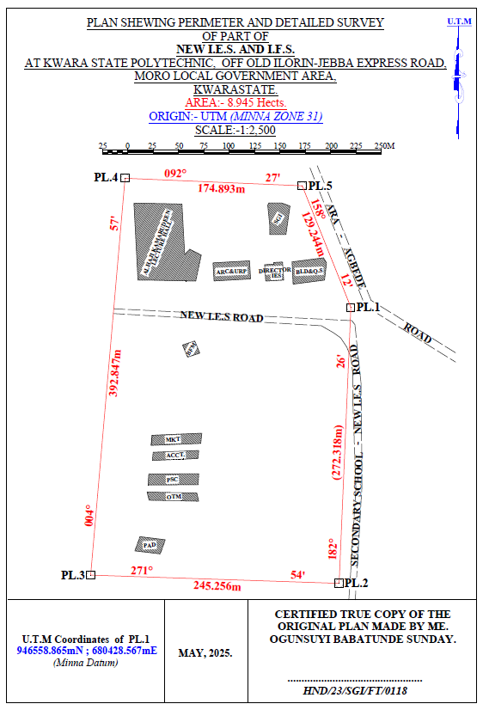
…………………………
HND/23/SGI/FT/0079

KAZEEM KABIRAT DAMILOLA
Figure 3.7: Plan showing Perimeter and Detailed Survey.
Area Computation using Cross Multiply Coordinates
E1 N1
E2 N2
E3 N3
E4 N4
E5 N5
E1 N6
680428.567 946558.865
680417.004 946286.792
680171.885 946294.956
680205.833 946686.334
680380.567 946678.865
680428.567 946558.865

∑ - ∑
2
460,787,138,011.03 – 460,786,959,116.36
2
178,894.67
2
Area = 89,447.335 sqft
Area = 8.945 hect.

