CHAPTER THREE
3.0 METHODOLGY
The methodology for designing the 5KVA inverter refers to the structured and creating a power electronic device that converts DC (Direct Current) power to AC (Alternating current) with an output capacity of 5KVA (5000 volt-amperes). This apparent power rating determines the inverter's ability to handle both resistive and reactive loads.
3.1 DESIGN SPECIFICATIONS
The design specifications of the inverter are:
- Output power 5KVA
- Output waveform is Modified sine wave
- Output frequency is 50Hz
- Output voltage 220 volts AC
- Charging type constant voltage.
The capacity of the inverter is a function of:
- The type and number of power MOSFETs used
- The size and capacity of the power transformer used

3.2 INVERTER STAGES
The inverter consist of different stages coupled to perform purpose of DC/AC conversion. The stages involved include:
3.2.1 Battery stage
3.2.2 Solar panel stage
3.2.3 Oscillator stage
3.2.4 Mosfet drive stage
3.2.5 Transformer stage
3.2.6 Output stage
3.2.1 Battery Stage
This stage consists mainly of Direct Current (DC) battery and in this case photovoltaic cells (PVC) was included as the mains to power the battery. The battery provides 24V direct current (DC) supply to the inverter system. Two 12V-220Ah batteries were connected in series to produce 24V-220Ah.
The batteries used at full load for 5hrs was calculated using:
Energy required (W)= 5000W × 5hrs =25,000Wh
Each 12V-220Ah batteries has a total energy capacity of:
Capacity (Wh) = voltage (v) × capacity (Ah)
= 12V × 220Ah = 2640Wh of each 12V
The number of batteries required to provide 5000Wh at full load was calculated using:
Number of batteries required to provide 5000Wh, divide the total energy required by the capacity of one battery.
Number of batteries at full load = $\frac{total energy required (Wh)}{ Capacity of one battery (Wh)}$
= $\frac{25,000}{2640}$
= 9.47 ~ 10 batteries
Therefore, the batteries needed to power the 5KVA inverter for 5 hours is 10 batteries of 12V 220Ah rating (i.e, the battery requirement depends on the hours which the inverter wants to run). Since 24V is needed, the batteries was arranged in series.
3.2.2 Solar Panel Stage
To determine the amount of solar panel needed for a 5KVA inverter, the wattage of the panel are to be considered at it common ranges between 250W to 400W.
To calculate the solar panel needed for a 5KVA inverter using 300W solar panels
The capacity of the inverter will be divided by the wattage of the solar panel
For a 5KVA system using 300W solar panels
Number of panels =$\frac{Number of the capacity}{Wattage of panel }$
= $\frac{5000}{300}$=16.67~ 17 solar panels
Therefore, the 300W panels need to fully utilize the capacity of a 5KVA inverter is 17 solar panels.
3.2.3 Oscillator Stage
The oscillator in the inverter generate a stable clock or timing signal that controls the switching frequency of the MOSFETS, power semiconductor devices. This switching frequency determines the inverter output waveform characteristics, including voltage, frequency and harmonic content.
IC EGS002 oscillator circuits used in the 5KVA inverter include integrated PWM controller ICs such as the SG3524 which integrate an internal oscillator, error amplifier and PWM comparator. These ICs allow frequency adjustment via external resistor-capacitor (RC) networks.
The major functional unit of the IC (SG2524) is the oscillator circuitry. The oscillating frequency is varied through the resistor and capacitor connected to pin 6 and pin 7.
The inverter system needs to generate signals at a frequency of 50Hz, a driver, an oscillator circuit, i.e Electronic Grid Solution (EGS002) was used to produce. There is a specific driver the 5V, 50Hz needed.
EGS002 is specify and part of a sine wave inverter module to generate voltage of 5V, 50Hz is contain various section. Such as feedback, shutdown, +5V regulator. It has 17 pins and also function as current, temperature protection, LED warning indicator and fan control.

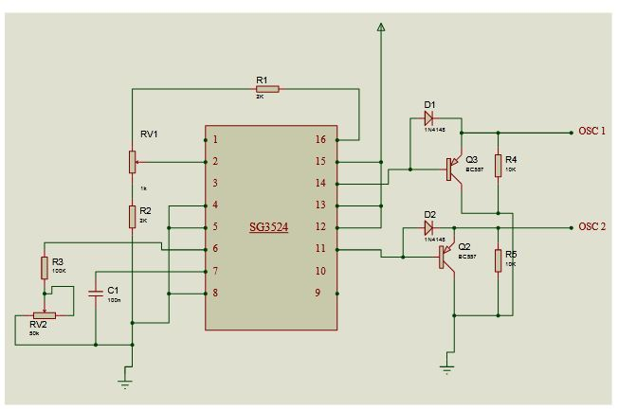
Figure 2: Circuit Diagram of the Oscillator [51]
3.2.4 MOSFET Drive Stage
For the design of a 5KVA inverter, selecting appropriate MOSFETs is crucial to ensure reliable and efficient operation, The MOSFETs have a voltage rating significantly higher than the inverter's, DC input voltage, typically around 150V to 200V, to provide a safe margin against voltage spikes. Additionally, the current rating exceed the expected load current, generally above 30A, to handle the power demands without overheating or failure. To manage the high current load of the 5KVA, the MOSFETs were arranged in a full-bridge (H-bridge) configuration, with multiple MOSFETs connected in parallel per switch leg to share current evenly and reduce conduction losses. This arrangement improves the inverter's efficiency and thermal performance, which is essential for stable long-term operation.
The gate driver circuit plays a vital role in controlling the MOSFETs by delivering the required gate voltage and current for fast and efficient switching. Dedicated gate driver ICs IRF3205 are used, provide isolated high and low-side drive signals, ensuring proper timing and preventing short circuits between the MOSFETs. This drivers incorporate features like dead-time insertion to avoid simultaneous conduction of MOSFET pairs (shoot-through), gate resistors to limit inrush current, and under-voltage lockout to protect the devices during startup. Together, the careful selection and arrangement of the MOSFETs combined with a robust gate driver design enable the inverter to deliver stable 5KVA output power with high efficiency and reliability.
Total power of the inverter is 5KVA
power in watts= KVA × pf
At power factor of 1
$$5KVA=\frac{WATTS}{pf}=5KVA×1=WATTS$$
Power rating of IRF3205 MOSFET
Maximum voltage = 55V
I = 110A
P = IV
P = 5000W
V = 24V
$I=\frac{P}{V}$ = $\frac{500}{24}$ = 208.3A
But one MOSFET is rated 110A
Therefore total number of MOSFET = $\frac{Currant Required}{Current rating of one MOSFET }$
Our MOSFET is rated to handle half of it's maximum rating because all conditions stated in for specification sheet (IRFF3205) cannot be satisfy.
Half of the 110A MOSFET rated power is 55A
= $\frac{Current Required by inverter (5KVA)}{Current rating of one MOSFET }$
$=\frac{208.3A}{55A}$ = 3.78 ̴ 4 MOSFETs
The H-bridge circuit has four arms, one arm of the H-bridge requires 4 MOSFETs (IRF3205). Total number of MOSFETs required is 16 MOSFETs.
3.2.5 Transformer
The transformer in 5KVA inverter plays a crucial role of stepping up the low-voltage 24V 50Hz AC output generated by the MOSFET switching stage to the standard mains voltage of 220V AC. This voltage transformation is essential for powering typical household and commercial appliances, ensuring compatibility with the electrical grid and efficient energy delivery. Without the transformer, the inverter output would remain at a low voltage unsuitable for most practical applications.
When designing the transformer, several key specifications were considered. The choice of core type significantly affects the transformer's size, weight, and performance. Ferrite cores, often preferred in modern inverter designs due to their compact size and excellent high-frequency characteristics, Allows for smaller and lighter transformers. The winding turns ratio calculated based on the input voltage from the MOSFET stage and the desired output voltage. For example, a turns ratio of approximately 1:3 is needed to achieve 220V AC output. The primary winding has fewer turns than the secondary to step up the voltage accordingly.
The transformer was rated to handle the full 5KVA power output of the inverter to prevent overheating and saturation, ensuring reliable and efficient operation. Proper insulation between the primary and secondary windings is vital for safety and preventing electrical breakdowns. Additionally, the wire gauge used for winding are sufficient to carry the expected current on both sides, minimizing losses and heat generation. High efficiency in the transformer design contributes directly to the overall efficiency of the inverter system.
Number of primary turns = $\frac{number of turns in primary}{number of turns in secondary}$ = $\frac{primary voltage}{secondary voltage}$
Secondary voltage $=220V$
Primary voltage $=24V$
Number of turns in the secondary $=350 turns$
$\frac{Np}{Ns}$ $=\frac{Vp}{Vs}$
Np$=$ $\frac{Vp ×Ns}{Vs}$
Np $=$ $\frac{24 ×350}{220}$ $=38$
Np $=38 turn$

The turns ratio of the transformer
$\frac{Vs}{Vp}$ $= \frac{220}{24}$ $=1∶9$
3.2.6 Output Stage
The output stage of the 5KVA inverter is the final section of the inverter circuit, it main function is to deliver clean and stable AC power to electrical appliances. After the DC voltage from the battery has been converted and stepped up using the oscillator, MOSFETs, and transformer stages, the output stage prepares this high-voltage signal for actual use.
This stage also ensures that the output voltage remains within the standard range of about 220V at 50Hz, which is normal supply for most electrical devices in Nigeria. The output stage often has safety features, like fuse to protect against overload, short circuits, and voltage spikes that can damage connected appliances.
Output power $=$5KVA $×$p.f
Assuming power factor $=$ 0.8
5000$×$ 0.8 pf $=$ 4000 WATTS
Output voltage $=$ 220V
P $=$ IV
4000 $=$ I $×220$V
I $= \frac{4000w}{220V}$ $=$ 18.1A
We took into consideration tolerance of 10$\%$ due to heat, load changes and maximum load.
Max load at p.f of 0.8 $=$ 4000W
10$\% =$ $\frac{4000}{100}$ $×$ 10 $=$ 400W
Total load $=$ 4400W
Socket rating $=$ $\frac{4400W}{220v}$ $=$ 20A
A socket of 20A is not available at the market, we decided to make used of two 15A socket.

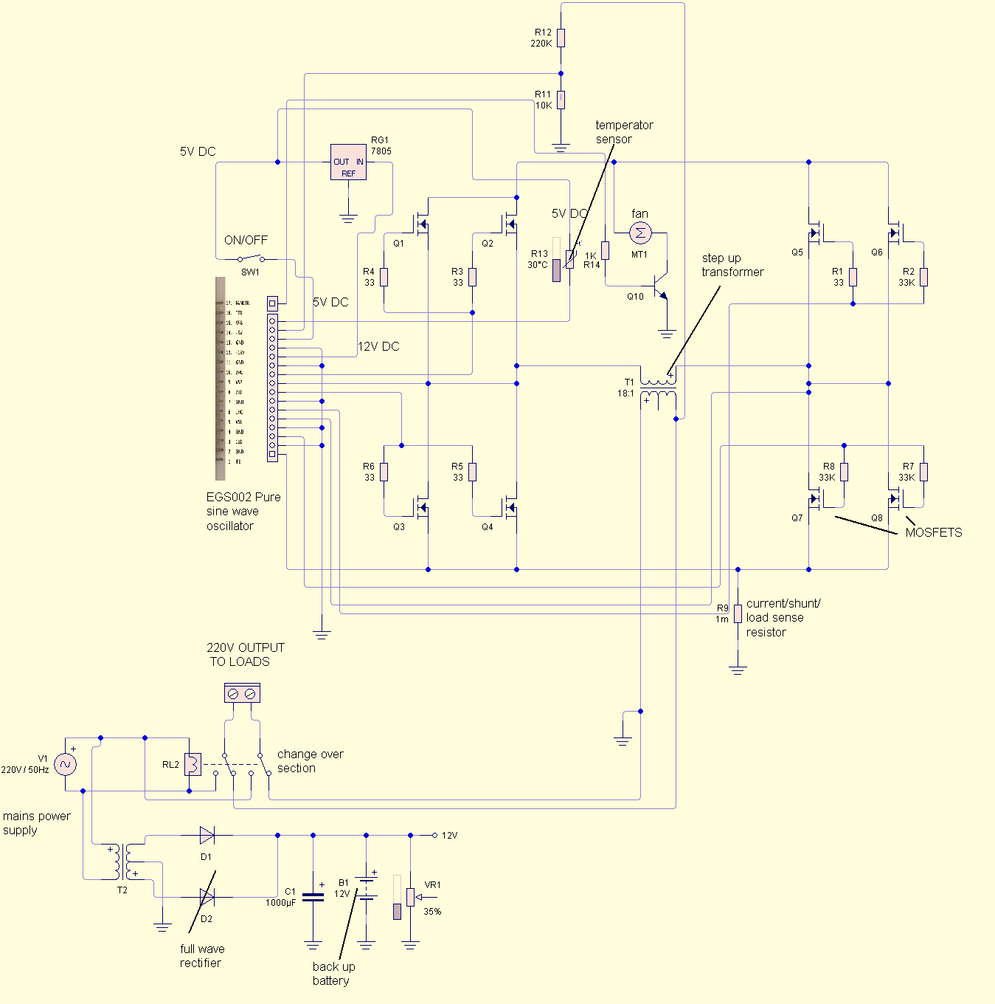
Figure 3: Circuit Diagram for 5KVA Inverter

