CHAPTER THREE
3.0 Methodology
3.1 Material Sourcing
3.1.1 Sampling of sawn timber lengths
The African Copal wood logs from the forests were processed to solid sawn wood boards of 100 mm x 150 mm x 1200 mm (4” x 6” x 4ft) in a sawmill at Igbaja Area of Kwara State. The sample specimens were taken from the top position close to the bark of a tree.
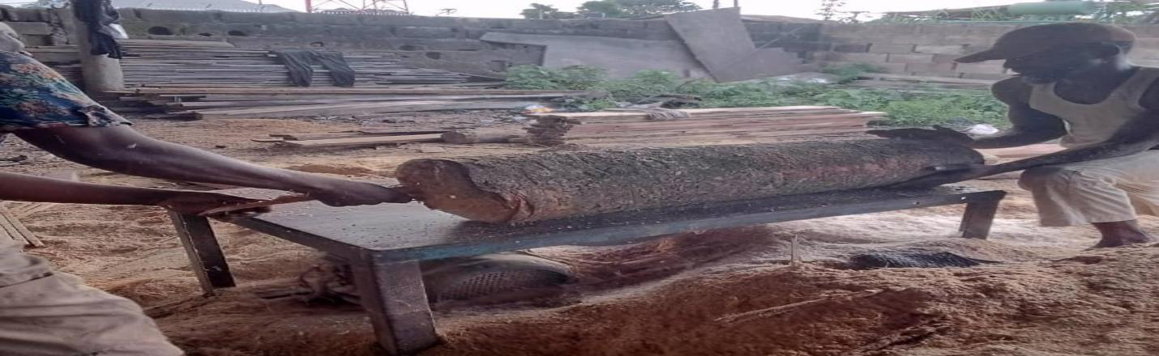
Plate I: Sawing of timber from the log at the sawmill
3.1.2 Conditioning of sawn timber lengths
The sawn timber prepared was therefore transported to the Civil Engineering Department of the University of Ilorin where they were conditioned at a standard environment temperature of (20 ± 2) °C and (65 ± 5) °C relative humidity according to the code of practice BS EN 373:1957.
3.1.3 Preparation of test specimens
After conditioning, the solid-sawn woods were cut by the required specimen dimensions given by the Code of Practice BS EN 373:1957. The preparation of test specimens took place in the wood workshop of the Faculty of Engineering, University of Ilorin.
3.1.4 Coarse Aggregate
The coarse aggregate used for this experiment is granite. Granite size ranging from 5mm to 10mm from quarry along roval valley road Gariki, Ilorin, Kwara State. The coarse aggregate use conformed to the requirement of BS EN 12620:2013
3.1.5 Fine Aggregate
The fine aggregate used for this experiment is sand. Sand was gotten from a river along oko-olowo area, Ilorin, Kwara State. The fine aggregate use conformed to the requirement of BS EN 12620:2013
3.1.6 Portland Cement
Dangote (3X) cement with strength of 42.5R is obtained from a local seller along old Kwara polytechnic campus, Ilorin, Kwara State. The cement is used as a binder and conformed to requirement of BS EN 197-1-2000.
3.1.7 Water
The water use for this study conforms to the requirement of BS EN 1008:2002 (Mixing water for concrete).
3.2 Flexural Strength Test of Timber Reinforced Concrete Slab
This section covers the flexural test on the teak reinforced concrete slab to determine the variation of the slab's flexural strength with an increase in the percentage of longitudinal timber reinforcement. The flexural test was carried out by BS EN 12390-5:2009 (Testing hardened concrete: Flexural strength of test specimens) using a universal testometric machine (UTM) at Material Science, Mechanical Department, University of Ilorin, Ilorin, Kwara State.
3.2.1 Reinforcement Preparation
Design parameters were formulated based on BS 8110-1:1997 to give average initial values for laboratory tests. Longitudinal reinforcements were varied by section of the slab (area) in 1% and 2% concrete slab samples. In this case, the longitudinal squares of two different local timber each 360 mm long, and square transverse timber each 160 mm long were nailed together at a right angle. The longitudinal timber bars were placed below while the transverse bars were placed above. Also, Steel reinforcement for control slabs was prepared similarly. Information on reinforcement sizes and arrangement using timber are shown in Table 3 below. Table 4 also shows the arrangement of steel reinforcement for slab test as control.
Table 3: Description of Timber Rebar Arrangement for Slab Test.
Label | h mm | d mm | Longitudinal Bar |  |  |  |  | Transverse Bar
Label | h mm | d mm | As  mm² | 100As/bh  (%) | 𝜙  mm | No | S  mm | As  mm² | 100As/Lh  (%) | 𝜙  mm | No | S  mm
1CT | 75 | 54 | 150 | 1 | 12 | 2 | 160 | 900 | 3 | 16 | 5 | 72
2CT | 75 | 53 | 300 | 2 | 12 | 3 | 80 | 900 | 3 | 16 | 5 | 72

h denotes the thickness of the slab (mm)
TT denotes treated top
d denotes the effective depth (mm)
TB denotes the treated bottom
As denoted the area of reinforcement (mm²)
■ denotes the bar size in square (mm).
S denotes the spacing (mm).

Table 4: Description of Steel Reinforcement Arrangement for Slab Test.
Label | h  mm | d  mm | Longitudinal Steel bar |  |  |  |  | Transverse Steel Bar
Label | h  mm | d  mm | As  mm² | 100As/bh  (%) | 𝜙  mm | No | S  mm | As  mm² | 100As/Lh  (%) | 𝜙  mm | No | S  mm
SS1 | 75 | 54 | 120 | 0.8 | 10 | 2 | 160 | 360 | 1.2 | 10 | 5 | 72

Note:
The minimum reinforcement for high-yield steel in Slab is 0.12% bh while the maximum range is from 1 to 2% bh (BS 8110:Part1:1997). The percentage to be used for this research is chosen as 0.80% for the longitudinal bar and 1.2% for the transverse bar.
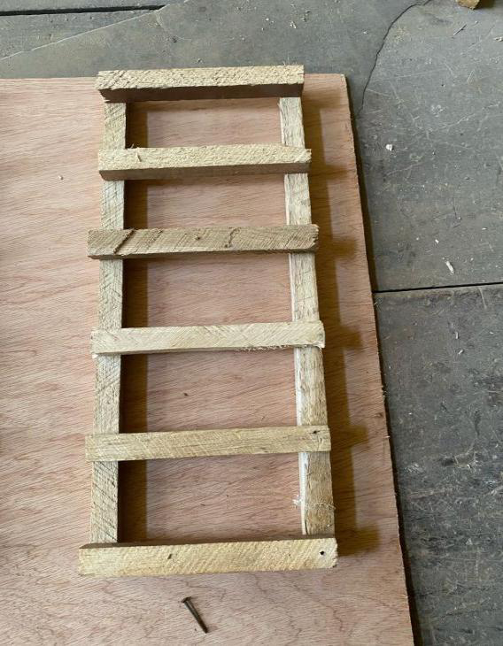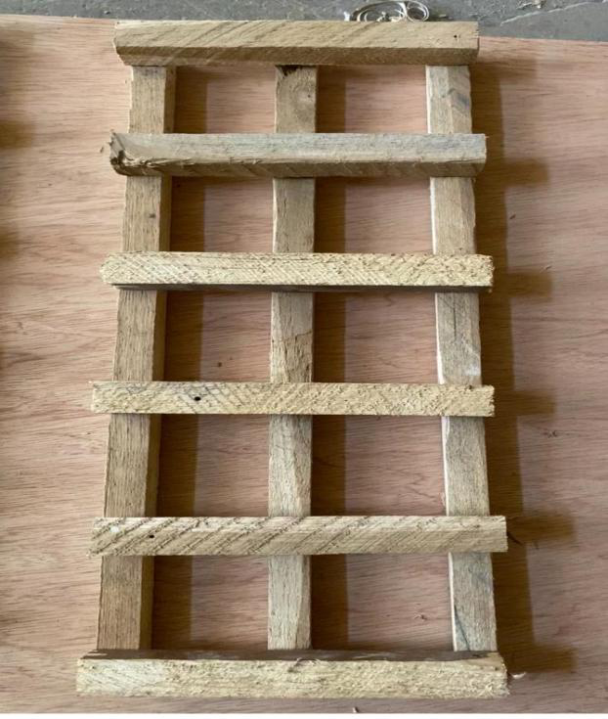
Plate II: 1% Timber Rebar Plate III: 2% Timber Rebar
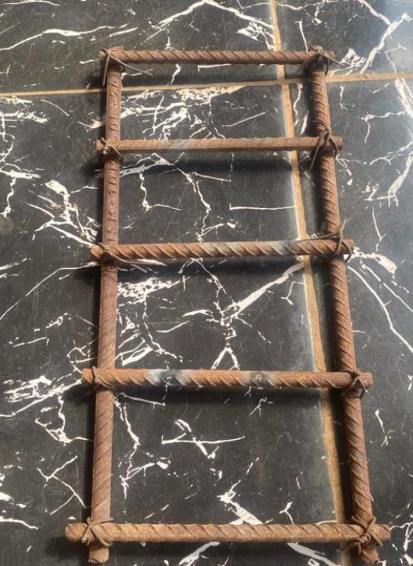
Plate IV: Steel Rebar
Concrete Slab Preparation
The preparation of concrete samples was carried out after the arrangement of timber reinforcement. The concrete samples used were cement, fine aggregate (sand), and coarse aggregate (granite). Hand mixing techniques were employed to mix the ingredients of the concrete with a designed trial mix ratio of 1:2:4 with a water/cement ratio of 0.50 on a clean concrete slab. Sample slabs of 75 mm deep by 200 mm wide by 400 mm long (Figure 3.1) were cased inside a prepared wooden formwork. Casting started by first placing the wooden formwork on the floor. The internal surface of the formwork was oiled to prevent the adhesion of concrete onto the surface of the formwork. A concrete layer of 20 mm was initially poured into the formwork which served as a cover for the reinforcement. The slab reinforcement was then placed in the formwork on the concrete cover and more concrete was poured until the formwork was filled up. The wet concrete in the formwork was then tamped round with a 25 mm square steel tamping rod. After 60 minutes of setting the concrete, identification inscriptions were made on the slabs for easy identification. The wooden formwork was then taken off after 24 hours of casting and the concrete slabs were cured for 7,14, and 28 days by wetting the slabs daily and covering the slabs with polythene sheeting to prevent loss of moisture. A total of eighteen (18) slabs consisting of 12 No. of timber reinforced slabs and 6 No. of steel-reinforced slabs were cast on different days.
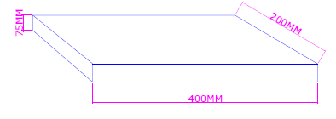
Figure 3.1: Concrete Slab Section.
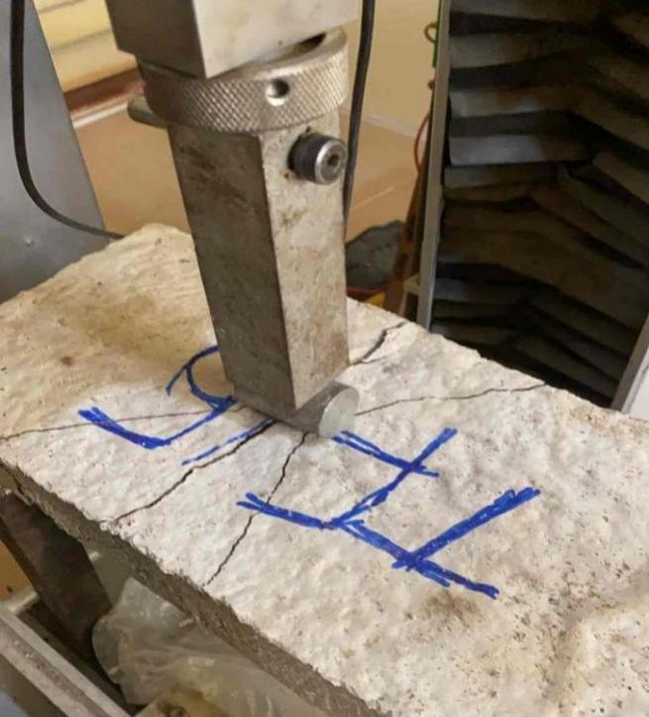
Plate V: Arrangement and Failure Mode of Timber Reinforced Slab

