Chapter three
3.1 Research Methodology

Preparation of Rice Flour
Rice flour is a finely milled powder made from raw or parboiled rice and is commonly used as a gluten-free alternative to wheat flour in baking and snack production. The quality of rice flour significantly affects the texture, flavor, and structural integrity of the final food product. Therefore, proper preparation is crucial for both domestic and industrial use.

Types of Rice Used
Rice flour can be prepared from:
- White rice – most commonly used due to its mild flavor and light color.
- Brown rice – retains the bran and germ, resulting in higher fiber and nutrient content but a coarser texture and slightly nutty flavor.
- Glutinous (sticky) rice – used for soft, chewy textures in snacks and desserts.

Basic Steps in Rice Flour Preparation

Step 1: Cleaning
- Raw rice is sorted to remove impurities such as stones, husks, and dirt.
- It is washed thoroughly with clean water to remove surface dust and debris.

Step 2: Soaking (Optional)
- Soaking rice in water for 4–6 hours helps to soften the grains and reduce the time required for grinding.
- Soaking also enhances the smoothness of the flour and may improve its digestibility.

Step 3: Drying
- After soaking, the rice is drained and dried.
- Drying can be done under the sun or in a mechanical dryer at 40–50°C until the rice is completely dry to prevent microbial growth and ensure easy grinding.

Step 4: Grinding or Milling
- The dried rice is ground into a fine powder using:
  - A hammer mill or plate mill (for large-scale production)
  - A blender or grain grinder (for small-scale or home production)

Step 5: Sieving
- The ground flour is passed through a fine sieve (e.g., 100–150 microns) to ensure uniform particle size.
- Coarse particles can be reground for consistency.

Step 6: Packaging and Storage
- The rice flour is packed in airtight, moisture-proof containers.
- It should be stored in a cool, dry place to prevent clumping, mold growth, or insect infestation.
- For long shelf life, especially in hot climates, refrigeration is recommended.

Quality Considerations
- The texture, color, and aroma of rice flour vary depending on the rice variety and processing method.
- Parboiled rice flour often has a stronger aroma and yellowish color.
- Properly prepared rice flour should be dry, fine, free-flowing, and have a mild, fresh odor.

Industrial Processing (Optional Expansion)
For industrial-scale production, rice flour is often prepared using automated systems that incorporate:
- Precision washing and drying systems
- Roller or jet mills for ultra-fine grinding
- Quality control measures such as microbial testing and moisture content analysis

Recipe Formulation for Bread and Snacks: Control vs. Rice-Based
In order to evaluate rice as an alternative ingredient in bread and snack production, it is important to formulate two sets of recipes:
- A control recipe using conventional wheat flour.
- A test recipe using rice flour (either 100% or partially substituted).
This comparison allows assessment of functional, sensory, and nutritional differences.

A. Bread Formulation

Control Bread (100% Wheat Flour)
Ingredients:
- Wheat flour – 500 g
- Warm water – 300 ml
- Instant yeast – 7 g
- Sugar – 25 g
- Salt – 7 g
- Vegetable oil – 30 ml
Method:
- Mix dry ingredients in a bowl.
- Add water and oil; knead for 10–12 minutes until smooth and elastic.
- Let the dough rise (1 hour).
- Punch down and shape into a loaf.
- Allow to rise again (30–45 minutes).
- Bake at 180°C for 30–35 minutes.

Rice-Based Bread (100% or 70% Rice Flour)
Ingredients (100% rice flour):
- Rice flour – 500 g
- Warm water – 320 ml
- Instant yeast – 7 g
- Sugar – 25 g
- Salt – 7 g
- Vegetable oil – 30 ml
- Xanthan gum – 1.5 tsp (or psyllium husk – 2 tsp)
- Optional: egg (1) for better binding
Method:
- Mix dry ingredients (rice flour, gum, sugar, salt, yeast).
- Add water, oil, and egg if used.
- Mix well (no kneading needed as rice dough lacks gluten).
- Pour into greased loaf pan.
- Let rise for 45–60 minutes.
- Bake at 180°C for 35–40 minutes.
Note: For better results, consider partial substitution:
- 70% rice flour + 30% wheat flour or other starches (e.g., tapioca or potato starch).

B. Snack Formulation (e.g., Crackers or Chin Chin)

Control Snack (Wheat-Based Crackers)
Ingredients:
- Wheat flour – 250 g
- Baking powder – 1 tsp
- Salt – ½ tsp
- Sugar – 20 g
- Butter – 50 g
- Water – ~80 ml
Method:
- Combine dry ingredients.
- Rub in butter until crumbly.
- Add water gradually to form a stiff dough.
- Roll out, cut into shapes.
- Bake at 180°C for 15–20 minutes.

Rice-Based Snack (Rice Flour Crackers)
Ingredients:
- Rice flour – 250 g
- Baking powder – 1 tsp
- Salt – ½ tsp
- Sugar – 20 g
- Butter – 50 g
- Water – ~90 ml
- Optional: 1 tsp psyllium husk or xanthan gum for binding
Method:
- Mix dry ingredients.
- Rub in butter to form crumbs.
- Add water gradually until dough forms.
- Roll out between parchment sheets (dough may be delicate).
- Cut into shapes and bake at 180°C for 20 minutes.
Optional Variations:
- Add grated cheese, herbs, or spices for flavor.
- Replace part of the rice flour with corn, millet, or legume flour for texture and nutrition.
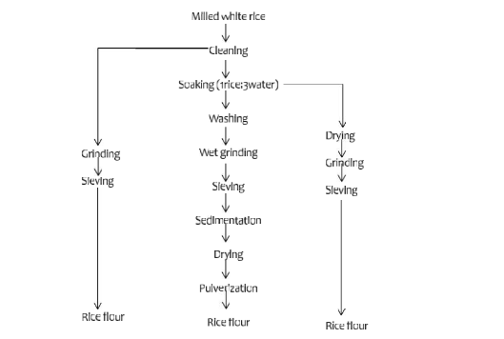
FIG 1

