CHAPTER THREE
3.0 METHODOLOGY
3.1 Study Area
Kwara state is located between located between latitude 8⁰-32⁰ North and longitude 4° - 35⁰ East. Its bordered to the east by Kogi state, to the north by Niger state, and to the south by Ekiti, Osun, and Oyo states, while its western border makes up part of the international border with the Benin Republic. Its capital is the city of Ilorin and the state has 16 local government areas. (https://en.wikipedia.org/wiki/Moro)
Moro Local Government area (LGA) in Kwara state, North Central Nigeria. The population of the local government area was projected at 108,792 as of the 2006 census, and the area is 3,272 km^{2.} There is approximately 1302 mm of rain every year in Moro, LGA and the average annual temperature is 34º, With an average humidity of 70% and 88 dry days per year. (www.besttimetovisit.com.pk. Retrieved 2023-09-30). The current population is projected in 2022 is 163,200. (National Population Commission of Nigeria (web), National Bureau of Statistics (web) 2022).
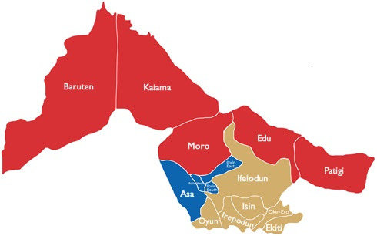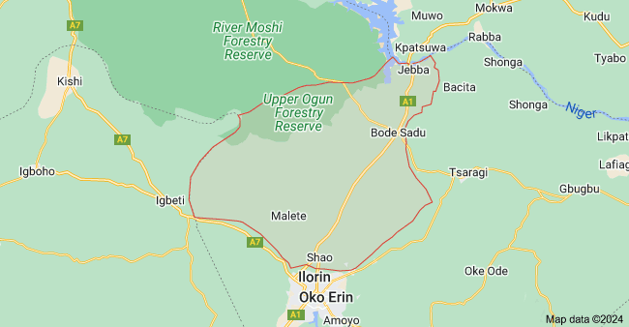
Figure 1. Map of Kwara State showing Moro Local Government Area

3.2 Population of the Study
The population of this study will consist of farmers who have access to either traditional or digital extension services. These smallholder farmers that are involved in activities such as maize, yam, cassava, and guinea corn production.
3.3 Sampling Procedure and Sample Size
A three staged random sampling procedure was employed in carrying out this study. The first stage involved the selection of purposive selection of Ilorin East Local Government Area of kwara State. Second stage involved selection ten (10) communities from the LGA, While, the third stage involved the selection of fifteen (15) farmers from each communities. This gave a total number of one hundred and fifty (150) respondents.
3.4 Instruments for Data Collection
Structured Questionnaires was used to collect quantitative data on socio-economic characteristics, extension method preferences, costs, and challenges which Comprises of open and closed-ended questions and likert-scale questions.
3.5 Data Analysis Techniques
Data analysis for this study involved both quantitative and qualitative techniques; descriptive statistics will be used to describe socio-economic characteristics of the farmers, inferential statistics (logistic regression) to examine relationships between variables.
3.6 Measurement of Variables
Dependent Variable: Adoption of extension methods (1 = digital, 0 = traditional).
Independent Variables: Socio-economic factors (age, education, income, etc.).
Farm-related factors (crop types, access to tools, etc.).
Accessibility factors (distance, frequency of contact, etc.).

