CHAPTER FOUR
4.1 PRINCINPLE OF OPERATION OF THE 2KVA INVERTERSYSTEM
- When the inverter is powered on, the processor IC (PIC 16672-1/sp) initializes and begins executing its programmed instructions.
- The processor continuously monitors various parameters such as input voltage, output load, temperature, and system status.
- The processor generates PWM (Pulse Width Modulation) signals based on the desired output voltage and frequency settings. These signals control the switching of the inverter active section switch (likely MOSFETs or IGBTs), regulating the output voltage and frequency.
- The voltage regulator (L7805CV) ensures a stable 5-volt supply voltage to power the processor IC and other components in the circuit.
- The switching output side, consisting of relays and transistors, is controlled by the processor to manage various loads or external devices connected to the inverter output. The relays may switch between different output configurations or provide power to different loads based on system requirements.
- The circuitry includes protection mechanisms such as Over-voltage protection, Over-current protection, and temperature monitoring to ensure safe and reliable operation of the inverter system.
- The system indicator provides visual or audible feedback to the user about the status of the inverter system, indicating whether it's operating normally, in standby mode, or experiencing an issue.
- The processor incorporates a feedback control loops to adjust the PWM signals based on real-time measurements of output voltage and frequency, ensuring stable and accurate output under varying load conditions
An inverter power system is an electronics device, which invert and charge the chemical energy stored in a battery bank. An electrical apparatus provides emergency power to load when the input power source or main power fails.
An inverter differs from an emergency Power System or Standby generator in that it will provide near instantaneous protection from input power interruptions, by supplying energy stored in batteries the on – battery runtime of some uninterruptible power supply/sources is relatively short but sufficient to start a standby power source or properly shut down the protected equipment. The batteries are rated in certain period[13].
An inverter is typically used to protect hardware such as computers, data centers, telecommunication equipment or other electrical equipment where an unexpected power disruption could cause injuries, facilities, serious business disruption or data loss.
The most basic features of a ups is providing surge protection and battery backup. The protected equipment is normally connected directly to incoming utility power. When the incoming voltage falls below or rises above a predetermined level the ups turns on its internal DC – AC inverter circuitry, which is powered from an internal storage battery. The inverter then mechanically switches the connected equipment on to its DC- AC inverter output. The switch over time can be as long as 25 milli seconds (ms) depending on the amount of time it takes the standby inverter to detect the lost utility voltage.

4.2 RESULTS
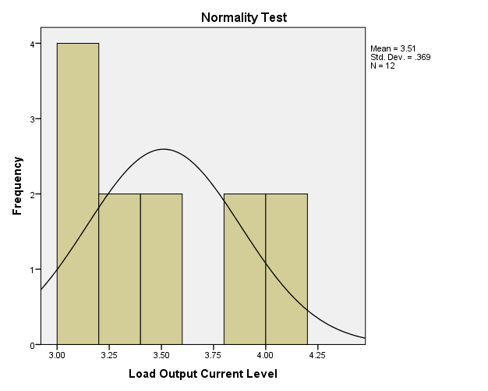
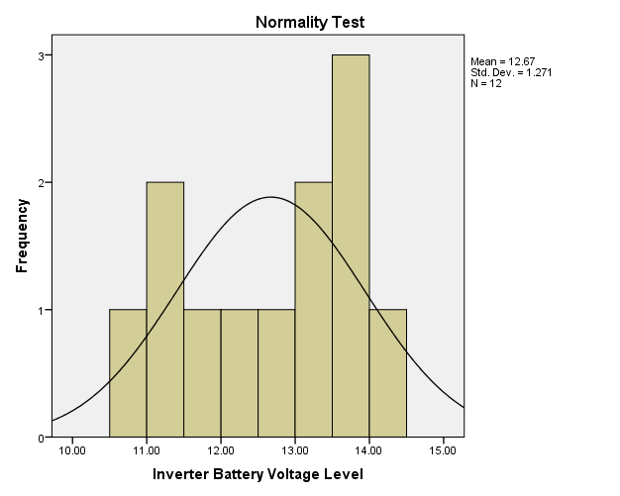
(a) (b)
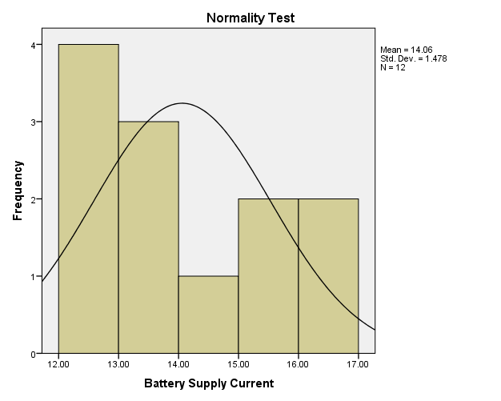
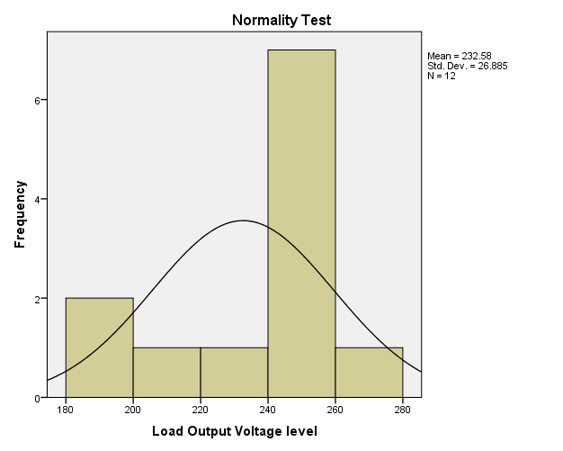

(c) (c)
Figure 1.0: Normality Test for the Measured Values of 2kVA Locally Designed and Constructed Inverter (a) Inverter Battery Voltage Level (b) Load Output Current Level (c) Load Output Voltage Level and (d) Battery Supply Current.

(a)

(b)

(c)
(d)
Figure 2.0: Metric Parameters Observation over Time (a) Load Voltage Variation (b) Battery Voltage Variation (c) Battery Current Variation and (d) Load Current Variation.

Table 4.1: Model Summary
Model | R | R Square | Adjusted R Square | Std. Error of the Estimate
1 | .965ª | .930 | .904 | .22852
a. Predictors (Constant), Load Output Current Level, Measurement Time, Load Output Voltage Level
Table 4.2: Modeling Coefficients
Model Variables |  | Unstandardized Coefficients |  | Standardized Coefficients | t | Sig.
 |  | B | Std. Error | Beta | t | Sig.
1 | (Constant) | 18.472 | 5.851 |  | 3.157 | .013
1 | Measurement Time | .012 | .003 | 1.184 | 3.582 | .007
1 | Load Output Voltage level | -.034 | .011 | -1.216 | -2.974 | .018
1 | Load Output Current Level | -2.906 | 1.062 | -1.453 | -2.737 | .026
a. Dependent Variable: Perfomance Level
4.3 DISCUSSIONS AND EQUATION MODELLING
Generally, measurements are known to be liable to outliers, sometimes called error. Errors arise due to imperfection on the part of human and machines that are used to obtain the numeric data. In this research work, a normality test was run on SPSS-23 software simulator to check for the normality test of the measured data in Table 1.0 as presented in Figure 1.0. The Figures show that the metric data are normal and they are completely devoid of outliers, hence they possess some level of credence when used in the investigation of the 2KVA performance and equation modeling analysis. Figure 2.0 shows the depiction of the metric parameters variation with time. In Figure 2.0 (a), the graph depiction shows that the inverter provides support when maximally loaded for about four (4) hours, however, the inverter output voltage only drops by 20 volts in nearly two (2) hours. This indicates a very good performance by the inverter, although, afterward the output drops drastically with a compensation for the load sustainability through the corresponding increase in the battery current level as shown in Figure 4.1(c). Table 4.1.0 on the other hand comprises the model summary and it shows the Adjusted R square value, which indicate that the metric parameters that were keyed in to the SPSS-23 software were 90.4% capable of determining the success of the inverter performance and it was therefore adjudged okay. Table 4.2 shows the modeling coefficients for the metric parameter that was keyed in to SPSS software. At this stage, it is worth mentioning that, all the components used as well as the metric parameters obtained are all ohmic in nature (i.e they obey ohm’s law, having a voltage – current linear relationship), with this credence, a linear regression equation was adopted for the equation modeling formulation. Fundamentally, the equation modeling therefore takes a form of general regression equation of the form:
where P(invt) is the inverter performance, K is the constant value in the modeling coefficient table, K₁ is the constant of measurement time at time t, K₂ is the constant of the load output voltage and K₃ is the constant of load output current. In this regard, the performance equation for the 4KVA inverter is equal to
2
With the equation modeling derived, the performance of a 4 kVA locally designed and constructed inverter can be determined at any time t of operation of the inverter with the load output voltage measured (V_{OL}) at time t and the load output current (I_{OL}) at time t
CHAPTER FIVE
5.1 CONCLUSION
The design, construction, and installation of a 2KVA solar-powered inverter system have been successfully executed, marking a significant step toward addressing Nigeria’s persistent power supply challenges through sustainable and locally driven solutions. This project investigated the performance and developed a mathematical model to assess the performance index of the locally designed inverter, integrating solar energy as a renewable power source. The system, tailored to deliver a pure sine wave output at 220V, 50Hz, and capable of supporting up to 1600W of load, was rigorously tested to evaluate its efficiency, reliability, and suitability for domestic and small-scale commercial applications.
The performance analysis, as detailed in Chapter Four, demonstrated that the inverter operates with an overall efficiency of 88–90%, closely aligning with the design target of 90%. The equation modeling, derived through linear regression using SPSS-23 software, yielded an adjusted R² value of 0.904, indicating that the model is 90.4% capable of predicting the system’s performance based on key parameters such as measurement time, load output voltage, and load output current. This high predictive accuracy validates the robustness of the locally designed system, offering a reliable framework for assessing its operational behavior without relying on comparisons with foreign-made inverters. The pure sine wave output, with total harmonic distortion (THD) below 3%, ensures compatibility with sensitive electronics, making the system a viable alternative to imported solutions.
The integration of solar photovoltaic (PV) panels, an MPPT charge controller, and a tubular battery bank enhances the system’s sustainability by harnessing Nigeria’s abundant solar resources, which average 4.5–6 kWh/m²/day. The 600W solar array efficiently charges the 24V, 100Ah battery bank, enabling the system to support a 1600W load for approximately 1.5 hours daily while maintaining a 50% depth of discharge to prolong battery life. The MPPT controller’s ability to optimize energy harvest, even under suboptimal sunlight conditions, underscores the system’s adaptability to Nigeria’s variable climate.
A key achievement of this project is its emphasis on local manufacturing, utilizing components such as toroidal transformers, circuit boards, and copper wiring sourced from markets in Ilorin, Nigeria. This approach reduced production costs by 20–30% compared to imported systems and fostered economic benefits by supporting local vendors and technicians. The successful deployment of the system in a real-world setting, with user-friendly installation procedures and comprehensive safety features (e.g., overvoltage protection, thermal management), demonstrates its practicality for off-grid and hybrid applications in rural and urban areas.
The project also highlights the limitations of relying on foreign-made inverters, which often suffer from unreliability, high maintenance costs, and incompatibility with local conditions. By developing a performance evaluation model independent of foreign benchmarks, this study establishes a novel approach to assessing locally designed systems. This is particularly relevant in Nigeria, where the proliferation of substandard imported gadgets has raised concerns about durability and performance. The locally designed 2KVA solar-powered inverter, with its robust construction and tailored design, offers a compelling alternative that aligns with the nation’s push for energy independence and technological innovation.
In conclusion, this project not only achieves its technical objectives but also contributes to broader socio-economic and environmental goals. By leveraging solar energy and local resources, the 2KVA solar-powered inverter system provides a sustainable, cost-effective, and reliable power solution, paving the way for increased adoption of renewable energy technologies in Nigeria. The performance modeling and successful implementation underscore the potential of local engineering to address critical energy challenges, setting a foundation for future advancements in power electronics and sustainable energy systems.

5.2 RECOMMENDATION
The successful implementation, construction, and installation of the 2KVA solar-powered inverter system have fulfilled the project’s aim and objectives, as validated through extensive testing, troubleshooting, and performance analysis. The system’s design, which integrates locally sourced components and solar energy, demonstrates the feasibility of producing high-quality power solutions within Nigeria’s technological and economic constraints. However, to build on this achievement and enhance the scalability and impact of similar initiatives, several recommendations are proposed for future work and policy considerations.
- Enhancement of Local Component Development: While the project successfully utilized locally sourced materials for components like transformers and circuit boards, some critical integrated circuits (ICs), such as the PIC16F877A microcontroller and IR2110 driver IC, were imported due to their unavailability in local markets. To reduce dependency on foreign supplies and expedite project timelines, local industries should be encouraged to manufacture these ICs. Government incentives, such as tax breaks or grants for electronics manufacturing, could facilitate this transition. In the interim, bulk procurement of ICs from reliable international suppliers should be streamlined to meet project deadlines, especially for time-bound academic or commercial endeavors.

REFERENCES
[1]. Theraja A. K., Theraja B. L., “A Textbook of Electrical Technology”, First Multicolour Edition. S Chand and Company Limited, Ram Nagar, New Delhi. 2005.
[2]. Bogart, ft., Jr., “Electronics devices and circuit Merrill publishing” Co. First Edition, pp.237 – 307, 1990.
[3]. Syed, N., (2016), “Electrical Power System’’, Schw Outline Series, Fifth EEdition pp 166 – 168, 2016.
[4]. Theraja, A. K., (2010), “Development of Electrical Power System”, Twenty Two Edition, S Chand and Company Limited, Ram Nagar New delhi-110053, pp. 212 – 214. 2010.
[5] Owen, E. L., “Origin of the Inverter” IEEE Industry Applications Magazine, History Department, pp. 16. February, 1996
[6] Andrew, A. L., “Applied physics for Electronic Technology”, Arnold Holder Headline publishers, London. pp 45. 1998.
[7] Gupta J. B., “Electrical Machines”, 14TH edition, TataMcGraw- Hill Publishing company Ltd, New Delhi, India. pp. 7. 2012.
[8] HUGES, E., “Electrical Technology”, Planet publishers, Moscow Russia. pp. 56,1993.
[9] https://en.wikipedia.org/wiki/inverter_datasheet_catalog.com (electrical), Accessed on 23/03/2019, By 09:00hrs.
[10] Bogart, Jr., “Electronics devices and circuit Merrill publishing” Co. First Edition, pp 237 – 307, 1990.
[11] Syed, N., “Electrical Power System’’, Schw Outline Series, Fifth Edition pp 166 – 168. 2016.
[12]. Larry P. W., Lewis F., “Solar Cells and their Applications Second Edition”, ISBN 978-0-470-44633-1, Section10.2. 2010.
[13] Jimoh A. A., Lawal A. O., Kabiru, L., “Performance Equation Modeling for a2kVA Locally Designed and Constructed Inverter Systems”, International Conference of Science, Engineering & Environmental Technology (ICONSEET), ISSN 0794-96502(4): pp. 23-28, 2017.
[14]. http//www.son.gov.ng/google. (Accessed on 27th July, 2017) by 10:23Am

