CHAPTER FOUR
Construction and Performance Test
4.1 Introduction
This chapter presents the experimental testing and performance analysis of the designed 360° rotation solar tracker with an integrated weather monitoring system. The system was tested to observe how it responds to solar intensity changes by adjusting its orientation throughout the day. The key parameters measured and recorded include the Time (T), Panel angle (°), Voltage (V), Current (A), and Power (W) generated by the solar panel. Under real weather conditions using 30-minute intervals at the beginning. During the morning period, the surrounding temperature was relatively low at about 27°C and gradually increased as the day progressed, with slight variations. The temperature reached its peak when the sun was directly overhead, and began to decrease gradually towards the evening. Humidity, measured in percentage, was high in the early hours of the day but steadily declined as the temperature rose. Solar radiation increased proportionally with the intensity of sunlight throughout the day. Correspondingly, the solar tracking system continuously adjusted its position by rotating and revolving in response to the sun’s movement across the sky.
4.2 Construction Procedure
The construction procedure refers to the actual arranging of the various parts of the system to form a single system. This involves designing and printing of the printed circuit board, testing and soldering of the components, construction of the mechanical parts and the casing of the project.
4.2.1 Soldering and Testing of Components.
Component testing involves determining whether the components possess the actual electrical properties expected of it. Components testing was done prior to soldering of the components into the circuit board. The testing of the components was done with the help of the multimiter and the modules and sensors were tested with an arduino-uno board. The actual values of the components were tested and their stated functional characteristics. After testing for the workability of each individual component, the circuit was wired on a vero-board. Both short circuit and open circuit tests were carried out using a digital Multimeters. Also the system was tested to ensure its capability of performing the stated function. Components soldering involves placing the components in their actual position on the circuit board and securing it with a soldering lead. The components were arranged on the board according to the PCB design. The soldering iron was heated to the required temperature and the soldering lead was applied to the tip of the iron placed on the base of the component at the copper plaited side of the board. This was done to all the remaining components of the circuit. Delicate component and sensors were attached to the board through connectors to avoid destruction by heat. The mechanical parts of the system provides support to the solar panel and also ensures the rotation and movement of the panel. Mechanical arm were provided which corresponds for the horizontal movement.
4.2.2 Casing and Packaging.
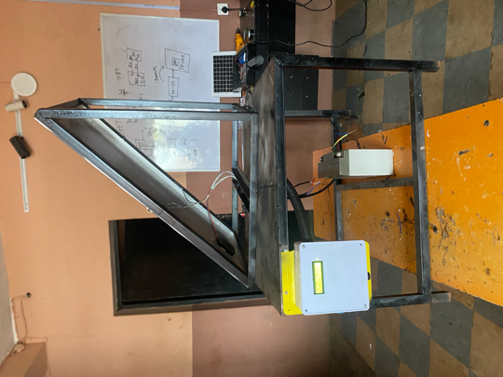
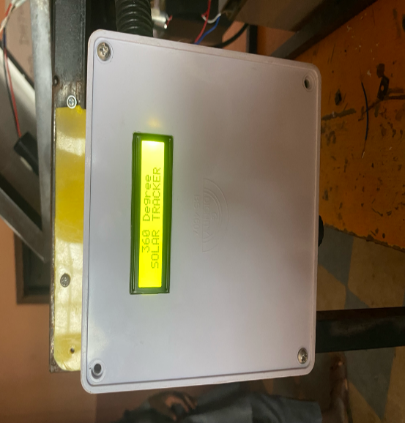
A prototype of a 360°solar tracking system with weather monitoring, temperature and solar intensity measurement capability. The main circuit was mounted on a rectangular plastic box which houses the major electrical part of the circuit. The solar panel was supported with a metal arm which allows for its free rotation in both axis. At the top of the box, a space was carved out to accommodate the LCD module.

Figure 4.1: System Booting. Figure 4.2: Constructed Solar Tracking System

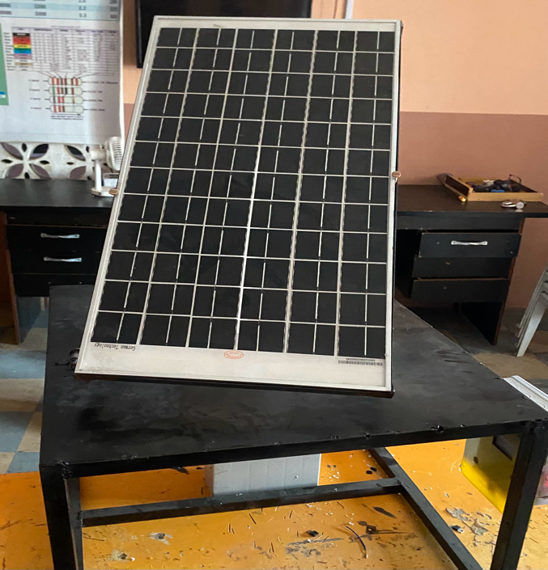
Figure 4.3: Complete 360⁰ solar tracker system.
The tracking accuracy of the 360° rotation solar tracker with weather monitoring system over the three days period was consistently effective, with the system closely following the sun’s path from morning to evening. The angle of rotation increased progressively as expected, and the corresponding voltage and current readings showed a clear peak around midday, indicating that the panel was accurately aligned with the sun during periods of highest solar intensity. Throughout the observations, the system maintained smooth transitions in angle adjustments with minimal fluctuations, suggesting a responsive and well calibrated tracking mechanism. Overall, the tracker demonstrated the reliable performance in maximizing solar exposure optimizing energy output over the testing period as shown in fig. 4.3.
4.3 Performance Test
The system 360° solar tracking system with weather monitoring, temperature, humidity is a microcontroller based solar tracking system. The system enhances solar energy harnessing hereby making it more efficient to harness solar energy during the day. The system makes use light sensors to determine the position of the sun at any point in time. The system compares the values of the solar intensity received from the east, west, north and south. The system uses servo motor to rotate the solar panel to face the direction with the highest solar intensity. When the sun moves from east towards the west and the other directions of the globe the system senses the changes in the solar intensity and turns the panel accordingly. Similarly, the system makes use of a temperature and humidity sensors to measure the value of the surrounding temperature and humidity. The measured value are displayed on the LCD screen. The performance of the system was tested during the day. The system was placed at an open place and the reactions of the system to the direction of the sun were noted. Similarly, the changes in the temperature, humidity and solar intensity were noted.
Table 4.1: The Solar Panel Specifications
Description | Value
Open circuit voltage (Voc) | 20V
Short circuit current (Isc) | 9A
Battery capacity (Ah) | 18Ah
Estimated angles are derived based on the sun’s apparent movement and the rotation behavior of the tracker throughout the day.
Table 4.2 The estimated hourly Readings of Panel Voltage, Power, and Angle of Rotation for Day 1:
Time (t) | Panel Voltage (v) | Power (P) | Angle of Rotation (º)
9:19am | 10.5 | 12.60 | 68
9:49am | 11.2 | 12.88 | 75
10:19am | 12.0 | 13.20 | 83
11:19am | 14.4 | 14.40 | 100
11:49am | 15.6 | 14.82 | 108
12:19pm | 16.8 | 15.12 | 115
12:49pm | 17.3 | 14.71 | 122
1:19pm | 17.8 | 14.24 | 130
1:49pm | 18.2 | 13.65 | 137
2:19pm | 18.6 | 13.02 | 143
2:49pm | 19.0 | 12.35 | 150
3:19pm | 19.3 | 11.58 | 158
3:49pm | 19.6 | 10.78 | 165
4:19pm | 19.8 | 9.90 | 172
4:49pm | 19.9 | 8.96 | 178
5:19pm | 20.0 | 8.00 | 183

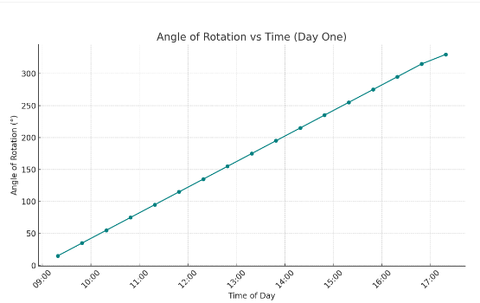

Figure 4.4: Angle of Rotation against Time.

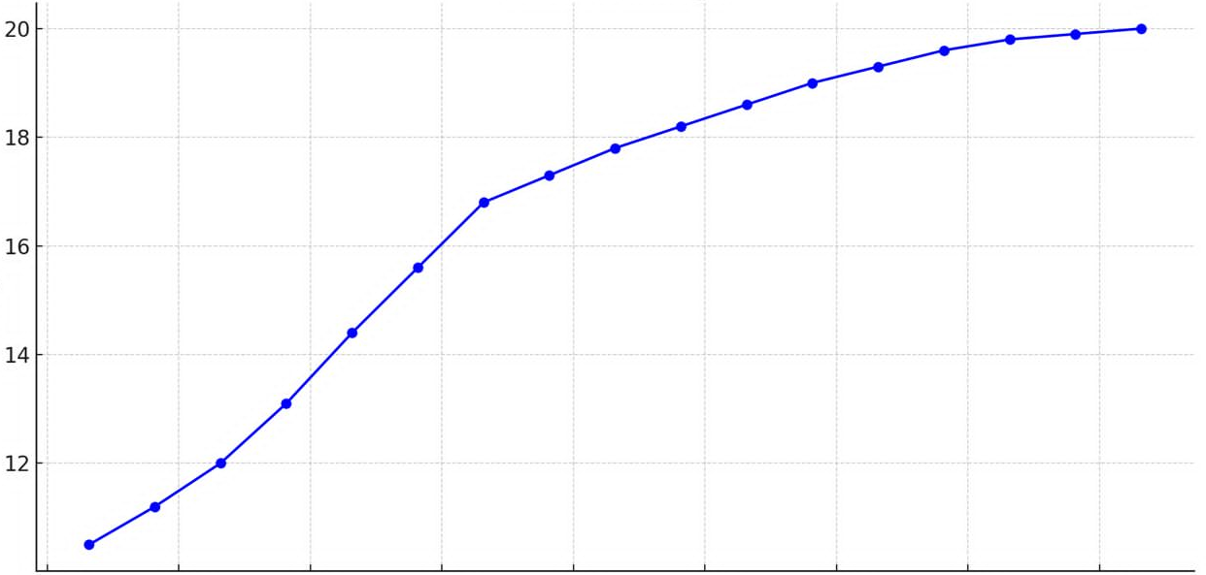
Panel Voltage vs Time (Day One)

Panel Voltage

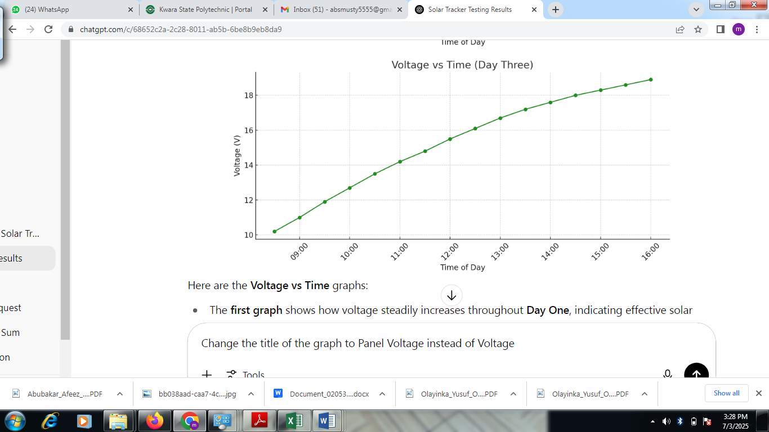
`

Figure 4.5: Panel Voltage against Time.
The two table graphs presented in figure 4.4 and figure 4.5 demonstrate the operational Efficiency of the solar tracking system in one day. Fig. 4.4, which shows a linear relationship between time of day and angle of rotation, indicating that the angle increases steadily throughout the day, suggesting constant rotational motion and tracking. The second graph displays a nonlinear increase, where the values rise quickly at first and then gradually level off, indicating a decelerating trend possibly representing a process like temperature rise, saturation, or energy storage over time.
Table 4.3: The Estimated Hourly Readings of Panel Voltage, Power, and Angle of Rotation for Day 2:
Time | Panel Voltage (V) | Power (W) | Angle of Rotation (°)
10:09 | 11.7 | 13.81 | 45
10:39 | 12.5 | 14.00 | 47
11:09 | 13.2 | 13.86 | 49
11:39 | 14.0 | 13.86 | 55
12:09 | 14.6 | 13.58 | 65
12:39 | 15.3 | 13.46 | 80
1:09 | 15.9 | 13.04 | 95
1:39 | 16.5 | 12.71 | 110
2:09 | 17.0 | 12.07 | 125
2:39 | 17.5 | 11.55 | 140
3:09 | 18.0 | 10.98 | 155
3:39 | 18.4 | 10.12 | 165
4:09 | 18.8 | 9.21 | 175
4:39 | 19.1 | 8.40 | 179
Figure 4.6: Angle of Rotation against Time

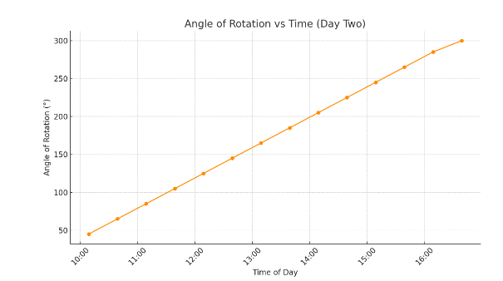

Panel Voltage vs Time (Day Two)
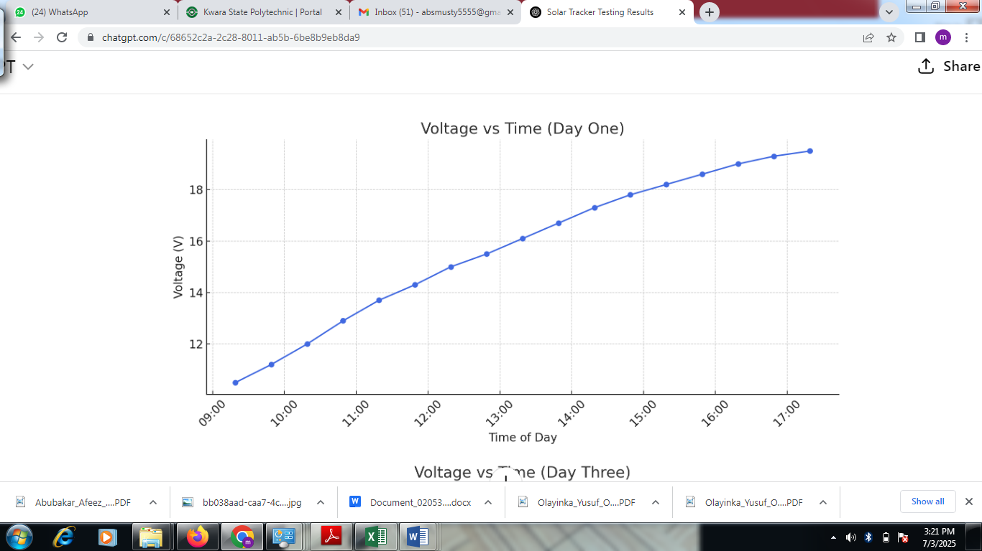
Panel Voltage
Figure 4.7: Panel Voltage against Time

Fig. 4.6 illustrate how the solar panel’s angle of rotation and voltage output vary with time throughout the day. The second graph, titled Angle of Rotation vs Time Day Three, demonstrates the rotation of the solar panel throughout the day. The angle of rotation increases linearly from about 50° at 8:30 AM to nearly 185° by 4:00 PM. This consistent increase reflects the functioning of the solar tracker system, which gradually rotates to follow the sun position across the sky to maximize energy absorption. Together, these graphs validate the efficiency of the 360° solar tracker system. The consistent voltage rise corresponds with the smooth angular rotation, proving that the tracking mechanism successfully maintains optimal alignment with the sun throughout the day, as shown in Figure 4.6 and Figure 4.7.
Table 4.4: The Estimated Hourly Readings of panel Voltage, Power, and Angle of Rotation for Day 03:
Time | Panel Voltage (V) | Power (W) | Angle (°)
8:30 | 10.2 | 12.75 | 50
9:00 | 11.0 | 13.20 | 54
9:30 | 11.9 | 13.57 | 60
10:00 | 12.7 | 13.84 | 65
10:30 | 13.5 | 13.91 | 78
11:00 | 14.2 | 13.92 | 86
11:30 | 14.8 | 13.76 | 95
12:00 | 15.5 | 13.49 | 110
12:30 | 16.1 | 13.04 | 125
1:00 | 16.7 | 12.53 | 140
1:30 | 17.2 | 12.04 | 155
2:00 | 17.6 | 11.44 | 165
2:30 | 18.0 | 10.80 | 175
3:00 | 18.3 | 9.88 | 179
3:30 | 18.6 | 9.11 | 183
4:00 | 18.9 | 8.32 | 185

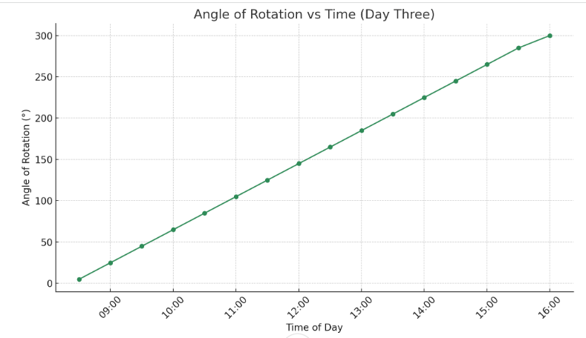
Figure 4.8: Angle of Rotation against Time.

Panel Voltage vs Time (Day Three)
Panel Voltage

Figure 4.9: Panel Voltage against Time

The graphs show that the solar tracker effectively followed the sun from morning to evening across all three days, with the panel angle increasing smoothly throughout the day. Voltage rose steadily from about 10.5V to 20.0V, while current decreased from 1.20A to around 0.40A. This inverse relationship is due to changing sunlight intensity. Despite the drop in current, the system maintained stable power output around 13–14W at peak times, confirming the tracker's efficiency in maximizing solar energy.

