CHAPTER TWO

LITERATURE REVIEW
  - INTRODUCTION
This chapter is a description of some of major components that are used in the design and construction of a single-phase transformer trainer. It highlights the principle of operation employed by these components.

Transformer
It is a static electrical device which transforms the electrical energy from one electrical circuit to another without any change of frequency through the process of electromagnetic induction. It is interesting to note that the transfer of energy from one circuit to another takes place with the help of mutual induction that is flux induced in the primary winding gets linked with the secondary winding (Engineering World, 2019).
2.1.2 Single Phase Transformer
A single-phase transformer is a power transformer that operates on single phase alternating current. It consists of a primary winding connected to the source of supply and a secondary winding to provide electric power to the load. The two windings are wound around a common magnetic core made of laminated silicon steel sheets which provides a low reluctance path for the magnetic flux. Single phase transformers convert the alternating voltage from one circuit to another without any direct electrical connection between the two circuits. A typical single-phase transformer uses single-phase AC, meaning it operates with a voltage cycle that moves in sync over time. This type of transformer works based on Faraday's law of electromagnetic induction, which states that a change in magnetic flux through a coil induces a voltage in the coil.

2.1.3 Faraday's Law of Electromagnetic Induction
Faraday's law states that an electromotive force (EMF) is induced in any closed circuit when there is a change in the magnetic flux through the circuit. This electromagnetic induction effect is the basis for the working of single-phase transformers. When an alternating current flow through the primary winding, it produces an alternating magnetic flux around the core. According to Faraday's law, this changing flux induces an EMF in the secondary winding.

2.1.4 Single-Phase Transformer Construction and Working Principle
A single-phase transformer is a high-efficiency piece of electrical equipment, and its losses are very low because there isn’t any mechanical friction involved in its operation. Transformers are used in almost all electrical systems, from low voltage up to the highest voltage level. It operates only with alternating current (AC) because direct current (DC) does not create any electromagnetic induction.
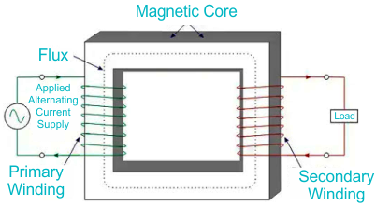
Figure 2.1: Single Phase Transformer Core
The primary coil of the transformer receives the voltage which is alternating in nature. The alternating current flowing in the coil produces a continuously changing and alternating flux which is produced around the primary winding. Then we have the other coil or the secondary coil which is near to the primary coil which get linked to the primary because some alternating flux gets linked. As the flux is changing continuously it induces an EMF in the secondary coil according to Faraday’s law of electromagnetic induction. If the secondary side circuit is closed a current will flow and this is the most basic working of a transformer, (Marshall Brain & Charles W. Bryant. 2007)
The three main part of any transformer are:

  - The primary winding ii. Secondary winding iii. The magnetic core.

2.1.5 Primary Winding
This is the main winding where the incoming alternating current is expected. Depending on the fact that the transformer is either a step up or step-down transformer the winding construction changes accordingly.
2.1.6 Secondary Winding
This is the winding in which the flux produced by the primary winding get linked. In this case also depending on the fact that the transformer is either a step up or step-down transformer the winding construction changes accordingly.
    - Classification of Transformer Based on Voltage Levels
- Step-Up Transformer
As the name suggest, step up transformer are used to increase the voltage at the secondary side of the transformer. This is achieved by having a greater number of turns in the secondary side of the transformer as compared to the primary side of the transformer.
- Step- Down Transformer
As the name suggest, step down transformer are used to decrease the voltage at the secondary side of the transformer. This is achieved by having a smaller number of turns in the secondary side of the transformer as compared to the primary side of the transformer.

2.2 ARDUINO LCD DISPLAY
The Arduino LCD (Liquid Crystal Display) module is a widely used output device that allows microcontrollers like Arduino to display text, numbers, and simple graphics. The most common type is the 16x2 LCD, which shows 16 characters per line across 2 lines, though other sizes (e.g., 20x4) are also available. These displays are popular due to their low power consumption, ease of interfacing, and clear visibility.

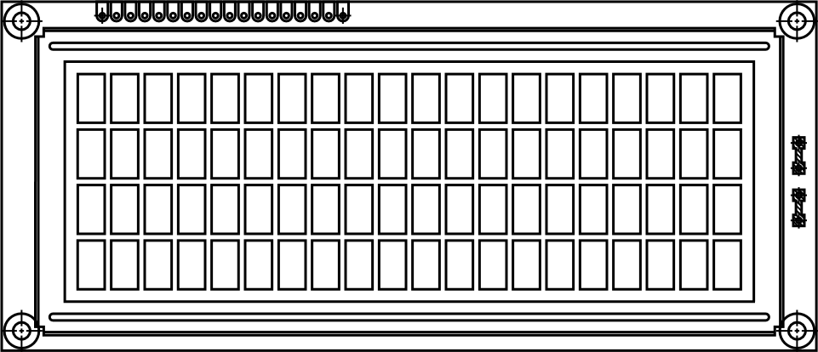

Figure 2.2: Arduino LED

Source: Raj, 2015

