CHAPTER ONE
1.0 INTRODUCTION
1.1 BACKGROUND OF THE STUDY
Perimeter and detail surveying is the main aspect of survey that would be considered in this work.
Perimeter survey is a specific type of survey that measures the distance along the boundary line of a given land or area.
Perimeter survey is important to find out the correct position of land property and probably determine the extent of which such parcel of land can be evaluated in case of the land being mapped in dispute.
Perimeter and detail survey is a survey that involves transferring all the details on the land such as heights and all what is to be located on the land, which consists of both natural and artificial features. It also refers to as Cadastral Survey because it contains coordinates of all beacons, part of the boundaries and determination of relative positions of natural and artificial features on the earth surface and depicting them by means of conventional symbols on the map.
A detail survey is used to determine and locate features and improvement on a parcel of land, hence perimeter and detail survey is the type of survey that involve delineation of boundary point on the boundary line of a property, measurement and location of features in their relative positions so as to come out with a survey plan showing the details and boundary points property demarcated.
With this kind of survey, one can obtain quite a party which consists of the interior of all property line together with a list of the related corners and the types are used for building system.
Below are the reasons why this type of survey is needed
- It is a survey required from time to time so as to update the pre-existing plan and to affect change where necessary.
- If there is encroachment on a landed property, it shows the discrepancy between adjoining boundaries.
- If the property boundary is carried out, it prevents conflict between land claimers.
- The end product is useful for property identification. Perimeter and detail survey is when the subject of the survey goes in line with boundary demarcation and facilitation and limitation.
Perimeter and detail survey is a type of land survey that defines the boundaries of a particular parcel of land or real estate property. This involves surveying the entire perimeter or boundary lines of a property to determine the exact shape and geometry of the property and identify any easement that may be present within the land.
Also, perimeter survey is used to identify and to location of old boundaries, documentation and survey plans are used to set up memories. A perimeter survey does not identify the features and improvements that are situated on a property such as garages, sheds, dwelling, surface utilities, roadway, pool and visible bodies of water, only features that fall within the 15-foot width around the boundary perimeter will be located.
Also, perimeter survey resolves conflicts on maps and deeds description and shows structures such as fences, hedges, yards and walls.
Perimeter surveys are Cadastral. The measurements were taken and plotted in order to create a registerable Cadastral instrument. Detail Survey is the survey of the positions of permanent natural features within the area.
Perimeter/boundary surveys are carried out for the purpose of delineating the boundary of a parcel of land, determining its area and preparation of survey plan. The survey plan is usually the end product of a land arc survey; the survey plan shows ownership and describes the land.
A perimeter survey is usually carried out for other purposes such as:
i. Settling a land dispute
ii. Determining encroachment
iii. Subdivision of land
iv. Re-establishing missing beacons

1.2 Statement of the Problem
The reason for carrying out this project operation is due to the irregular or changing boundary line between the project area and its environment( due to encroachment), in order to help school authority outline a plan for future expansion and development of the project area, the need for a more current and valid perimeter and detailing is suggested.

1.3 Aim of the Project
The aim of this project is to carry out and produce current and comprehensive perimeter and detail survey plan of Federal Staff School, Adewole, Ilorin, Kwara State.

1.4 Objective of the Project
The following objectives are perused to achieve the aim of the project:
a. Reconnaissance which include office planning and field reconnaissance
b. Identification of existing features
c. Pegging out some selected point along the boundary line
d. Terrestrial theodolite traverse to determine X and Y coordinate of the selected point
e. Fixation of detail around the school using total station method
f. Production of plan showing the boundary lines and all details of the school
g. Project report writing

1.5 Scope of the Project
This study focuses on perimeter and detail survey of Federal Staff School, Adewole. However, there are stages that will be involved to achieve our aim:
i. Project planning
ii. Reconnaissance
iii. Data acquisition
iv. Data processing
v. Data analysis
vi. Data preparation
vii. Technical report writing and plan production

1.6 Personnels Involved
The personnels involved in the project are Group 13 members of the Department of Surveying and Geoinformatics students 2022/2023 academic session, Kwara State Polytechnic, Ilorin.

S/N | NAME | MATRIC NUMBER | ROLE PLAYED
1 | DADA ELIZABETH OLUWAPELUMI | HND23/SGI/FT/0043 | AUTHOR
2 | OJO ADEBISI MOTUNRAYO | HND23/SGI/FT/0041 | MEMBER
3 | ADEBAYO BLESSING MARY | HND23/SGI/FT/0042 | MEMBER
4 | OLADIMEJI RAPHAEL OLUSEGUN | HND23/SGI/FT/0045 | MEMBER
5 | IBITOYE JOSHUA AYOKUNLE | HND23/SGI/FT/0047 | MEMBER
6 | AKINYEJO EZEKIEL DAMILOLA | HND23/SGI/FT/0051 | MEMBER
7 | OSUNLEKE HABEEB OLAIDE | HND22/SGI/FT/0052 | MEMBER

1.7 Significance of the Study
The outcome of this project will provide vital foundational data that enables the school facility to be safe, functional, compliant, and well managed for both present operations and future development. They are invaluable tools for making informed decisions regarding the physical environment of the school. Other importance of this study is listed below:
i. Informed decision making
ii. Risk management
iii. Improved safety and security
iv. Optimized resource allocation
v. Enhanced facility management

1.8 Study Area
The study focuses on Federal Staff School, Adewole located in Ilorin, Kwara State, Nigeria. The school is situated in the Adewole area, a well-known residential and educational neighborhood within Ilorin West local government area. The geographic location of the study lies between latitude 8.477702, 4°30'47"N and longitude 4.510178, 8°28'40"E.
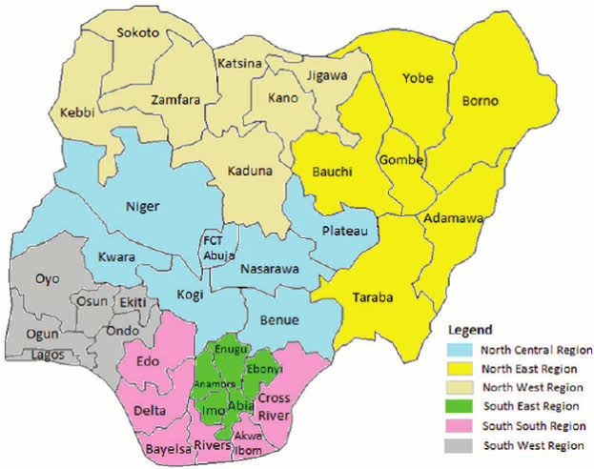 | 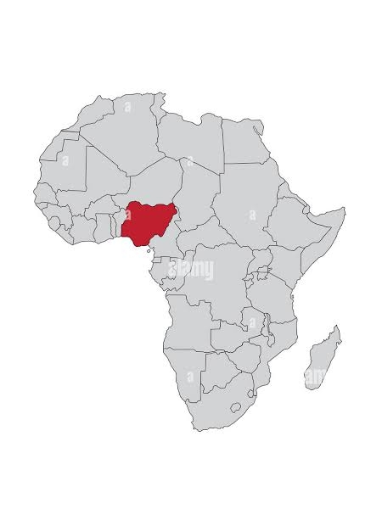
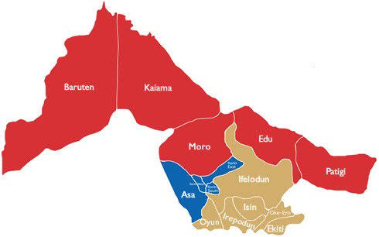 | 