CHAPTER THREE
3.1 DESIGN AND METHODOLOGY
This chapter deals with the entire procedures and designs involved in the design of all the electrical/electronic component of Single-phase transformer trainer.
3.2 SINGLE PHASE TRANSFORMER TRAINER

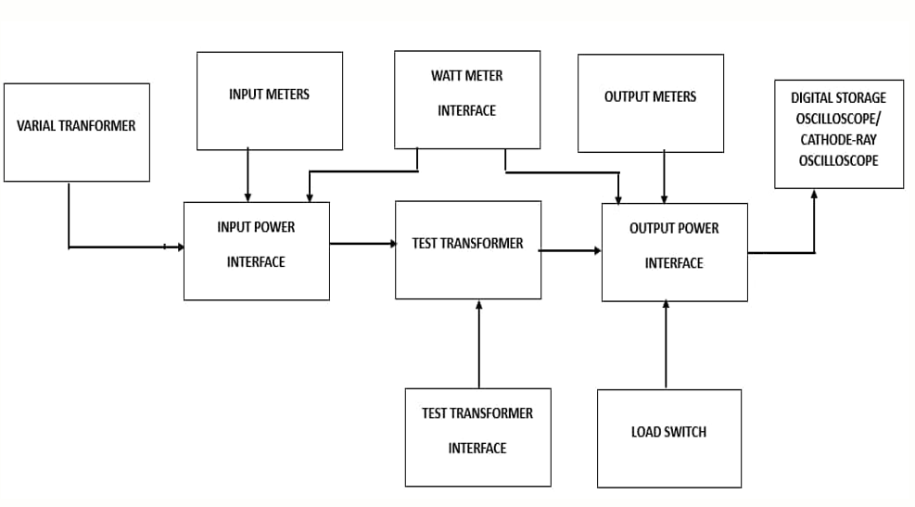

Figure 3.1: Block diagram of a single-phase transformer trainer
Source: Engineering World (2019).

3.2.1 Power Supply
The power supply in the mother board is to supply a voltage of 5V DC to the LCD display on the transformer trainer. This task is accomplished by rectifying AC to DC and then smoothening the rectified voltage to remove AC ripples before it is regulated to 5V using IC voltage regulator.

The power supply supplies 12v and 2A by using two voltage regulators connected in parallel. It also supplies 5v for powering the LCD and the current sensor. In achieving this, the power from the authorities has to be stepped down, filtered and regulated. The power supply unit consist of the following components:
- Transformer

- The rectifier circuits

- Smoothing capacitor

- The regulators

3.2.2 Output

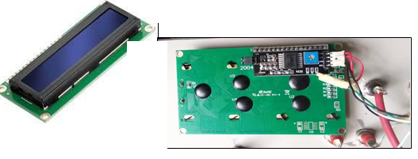The output from the trainer is connected to LCD to display the result of various experiment performed on the trainer. The trainer and the LCD are linked via the digital pin on the Arduino board.

Figure 3.2: Output Digital Display

Source: Raj, Aswinth (2015)

3.2.3 Wire Selection
The selection of SWG (Standard Wire Gauge) wire in a transformer is a critical aspect of transformer design, particularly for the winding of coils. The wire gauge chosen impacts various transformer characteristics such as resistance, current-carrying capacity, and space utilization The SWG of the wire should be chosen to handle the expected current in the winding without excessive heating. Higher SWG values indicate thinner wire, which may have lower current-carrying capacity.
Primary current 𝐼𝑝 = 4𝐴
Secondary current = 2A
Using table; Primary Winding = 17 SWG
Secondary Winding =19 SWG
3.2.4 Insulation
Insulation materials are crucial in transformers to prevent electrical breakdown and ensure the safe and reliable operation of the device. The insulation between primary and secondary windings is essential to avoid short circuits and maintain the electrical integrity of the transformer. We have used paper binding tape for the purpose as shown in the figure below.

Figure 3.3: Paper Binding Tape

3.2.5 Core sheets

Inserting core E sheets is the next step in the construction of the core of a transformer. The core E sheets, typically made of laminated silicon steel, form the magnetic circuit that allows the efficient transfer of magnetic flux. These lamination stampings when connected together form the required core shape. For example, two “E” stampings plus two end closing “I” stampings to give an E-I core forming one element of a standard shell-type transformer core. These individual laminations are tightly butted together during it’s construction to reduce the reluctance of the air gap at the joints producing a highly saturated magnetic flux density.


Figure 3.4: The Core E and I Sheet

3.3 ASSEMBLING OF A SINGLE-PHASE TRANSFORMER
3.3.1 Frame Construction

The trainer is enclosed in a square shape cast wooden frame with a vertical position slightly bent backwards. The meters are mounted on a vertical section while the mimic diagram data is covered with vanished ½ plywood board screwed into the meter frame. The front panel where the meters are mounted is covered with velvet cloth to enhance its ecstatic. The trainer frame rests on four legs, the material for the Trainer construction was chosen with the utmost regard to their reliability, durability, maintainability and readability attributes.

3.3.2 Procedures for the construction of the single-phase transformer trainer
The procedures for the construction of the transformer trainer are as follow;
- The wooden frame is first cut into require size of 60cm by 43cm by 58cm to form a skeletal frame of how the trainer will look like.
- The pointed board of the transformer shows the parameters of the transformer circuit to required shape and length.
- The placing of the sockets at the relevant areas to show the current, voltage and power is done by the drilling to give the reading for the connection to the ammeter, voltmeter and wattmeter of the board.
- Wiring of the socket after drilling is done so that the readings can be shown at the ammeter and voltmeter.
- Placing the ammeter, voltmeter, circuit breaker and toggle switch was done at their respective position.
- The wiring was done in such a way that a return path was made so that a complete circuit was established.
- After the connection of the equipment it is then wrapped with suitable leather to give it ecstatic
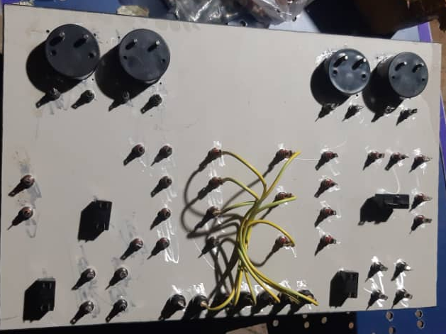

Figure 3.5: Transformer circuit board internal connection
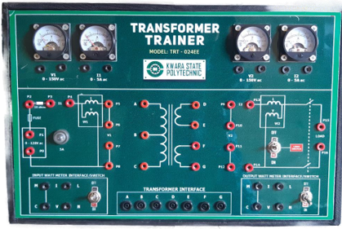Figure3.6:Front view of a Single Phase Trainer

TESTING

The following tests were carried out during and after the construction

Continuity test:

The continuity test was carried out to check for disconnection and open circuit in the work using a multimeter.

Power consumption:

The voltage across each component and the entire circuit was measured when the system was powered.

System Testing and Integration

After the design and implementation stage, the system was tested for durability and effectiveness and also to ascertain if there is need to modify the design. The system was first assembled using breadboard. All the component where properly soldered to the ferro board and test were carried out at various stages. To ensure proper functioning of the components, they were tested using a digital multimeter to ensure that they were within the tolerance value. Faulty components were discarded.
3.5 SOME OF THE EXPERIMENTS THAT CAN BE CARRIED OUT ON THE CONSTRUCTED TRAINER
3.5.1 Experiment 1: Voltage and Turn Ratio Test for Step down and Step up Transformer
Objective: To measure the primary and secondary voltages and currents of a transformer

Equipment Required
- Transformer trainer (TRT – 024EE)
- AC power supply (0-120V adjustable)
- Voltmeters (1 and V2 on the panel)
- Connecting wires (patch chords)
Diagram;
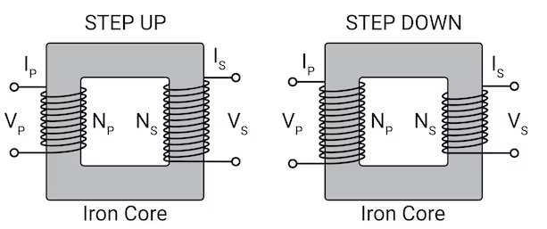

Figure 3.7: Circuit Diagram of Voltage Turn Ratio
Apparatus:
- Single-phase transformer trainer
- Multimeter (for cross-checking)
- Load (resistor or lamp)
- Connecting wires
Theory:
The performance of a transformer largely depends on the accuracy of its turn or voltage ratio. Therefore, the transformer ratio test is essential. To ensure safety, voltage should only be applied to the high voltage (HV) winding. It helps to understand how a step up or step- down transformer works.
Procedures:
- Step-Down Transformer (2:1):
    - Primary Connection: Connect the primary winding (220 V) to the AC supply.
    - Secondary Connection: Leave the secondary winding (110 V) open.
    - Measurements:
    - Primary voltage (Vp​), current (Ip), and input power (Pin​).
    - Secondary voltage (Vs).
    - Record: Vp​=220 V, Ip​=0.1 A, Pin​=22 W, Vs​=110 V.
- Step-Up Transformer (1:2):
  - Primary Connection: Connect the primary winding (110 V) to the AC supply.
  - Secondary Connection: Leave the secondary winding (220 V) open.
  - Measurements:
    - Primary voltage (Vp), current (Ip​), and input power (Pin​).
    - Secondary voltage (Vs).
- Record your observations in a table.
3.5.2 Experiment 2: Open Circuit (Core loss Test)
Objective: To measure the no-load current and core loss in a transformer.
Equipment Required
- Transformer trainer
- AC power supply (0-120V adjustable)
- Wattmeter (W₁)
- Voltmeter (V₁)
- Ammeter (I₁)
- Connecting wires

Theory:
The open circuit test, also known as the no-load test, determines the core losses of a transformer, which include hysteresis losses and eddy current losses in the transformer core. Hysteresis losses arise due to the repetitive magnetization and demagnetization of the core material during each AC cycle, while eddy current losses occur due to circulating currents induced within the conductive core material.
This test also helps calculate the magnetizing reactance (Xm) and the excitation current (Im), both of which characterize the magnetization behavior of the transformer core under no-load conditions. By applying a rated voltage to the primary winding with the secondary winding open, the no-load current drawn by the transformer is measured, providing critical insights into the efficiency and performance of the transformer.
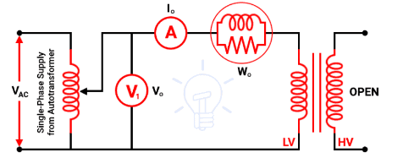 Diagram:

Figure 3.8: Open Circuit (No load test)
As shown in the above figure, the primary winding (low voltage winding) is supplied by rated voltage and frequency and the secondary winding is kept open. A voltmeter V₀, an ammeter I₀, and a wattmeter W₀ are connected in the primary winding. The secondary winding is kept open and the current that passes through the secondary winding is zero. And the load is not connected. Hence, the current that passes through the primary winding is no-load current I₀. The current that passes through the primary winding is measured by an ammeter that gives the value of no-load current.
No-load power W₀ = V₁ I₀ Cos ϕ₀ = Iron loss (3.1)
I_{W} = I₀ Cos ϕ₀ (3.2)
I_{M} = I₀ Sin ϕ₀ (3.3)

Procedure

- Connect the variac transformer input winding to the mains power supply
- Connect the variac transformer output winding to point P0 and P1 on the transformer trainer unit. Keep the knob of the variac transformer at zero position.
- Connect ammeter I1 to points P2 and P4 to measure the input current
- Interface the test transformer to its labeled input points
- Use points P5 and P8 throughout the experiment as your input voltage source to supply power to the transformer at specific inputs
- Connect the primary winding terminal A to P5 and B to P8
- Leave the secondary winding terminals (D, E, F, and G) open.
- Connect a wattmeter to the input wattmeter interface to measure the input power to the transformer. Keep the wattmeter switch at the ON position
- Connect a voltmeter V1 across points P6 and P7 to measure the primary voltage
- Turn on the power supply and gradually increase the voltage to the rated value.
- Record the primary voltage, no-load current, and input power.
- Calculate the core losses using the wattmeter reading.
- Repeat the test for different voltage levels below the rated voltage to observe the variation in core losses and magnetizing current.

3.5.3 Experiment 3: Short Circuit Test (Copper Loss Test)

Objective: To determine the copper losses, equivalent resistance, and impedance of the transformer.
Equipment Required
- Transformer trainer (TRT – 024EE)
- AC power supply (0-30V adjustable)
- Ammeter
- Wattmeter
- Voltmeter
- 10-ohm resistance
- Connecting wires (patch chords)

Theory:
The short circuit test, also known as the copper loss test, is conducted to determine the copper losses in a transformer. Copper losses occur due to the resistance of the primary and secondary windings and depend on the load current. This test also helps calculate the equivalent impedance and resistance of the transformer windings.

Circuit Diagram:

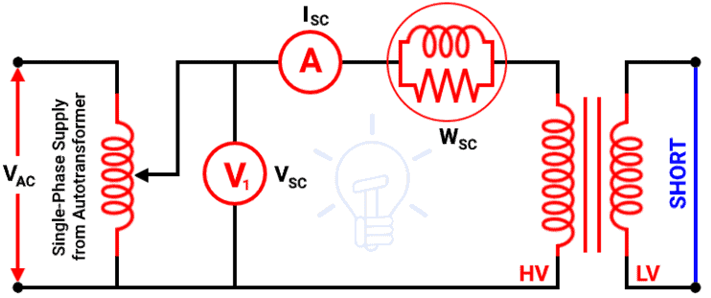
Figure 3.9: Short Circuit Test (Copper Loss Test)
A low voltage winding is short-circuited using a thick wire. An ammeter is connected to measure the rated load current. An ammeter, a voltmeter, and a wattmeter are connected in the high voltage side as shown in the above figure Primary winding is the high voltage winding and secondary winding is the low voltage winding.
The high voltage winding is supplied by the reduced input voltage from a variable supply source. The supply voltage gradually increases until full-load primary current flows through the primary winding. The current that passes through the windings is a full-load current. So, a copper loss that occurs during a test is a normal full-load copper loss. And the wattmeter indicates the full-load copper loss. The secondary winding is short-circuited. So, the secondary voltage (output voltage) is zero.
Procedure
- Connect the variac transformer input winding to the mains power supply
- Connect the variac transformer output winding to point P0 and P1 on the transformer trainer unit. Keep the knob of the variac transformer at zero position.
- Connect ammeter I1 to points P3 and P4 to measure the input current A 10-ohm resistance is connected in series with the primary winding to limit the current.
- Interface the test transformer to its labeled input points
- Use points P5 and P8 throughout the experiment as your input voltage source to supply power to the transformer at specific input voltage
- Connect the primary winding terminal A to P5 and B to P8
- Connect a wattmeter to the input watt meter interface to measure the input power to the transformer. Keep the input watt meter switch at the ON position
- Connect a voltmeter (V1) across points P6 and P7 to measure the primary voltage
- Short the secondary winding terminals (D and E).
- Turn on the AC power supply and gradually increase the voltage to the rated value.
- Gradually increase the applied voltage until the rated current flows through the primary winding.
- Record the following readings:
- Primary current (Isc)
- Applied voltage (Vsc)
- Input power (Psc)
- Calculate the copper losses using the wattmeter reading.
- Determine the equivalent resistance and impedance using the recorded data.
3.5.4 Experiment 4: Transformer Efficiency Test (Load Test)

Objectives:
- To determine the efficiency of a single-phase transformer under different loading conditions.
- To analyze the variation of efficiency with load and power factor.
- To plot efficiency curves for different power factors.

Apparatus Required

- Single-phase transformer
- Voltmeter (AC), Ammeter (AC), and Wattmeter.
- Resistive load bank or rheostat.
- AC supply (regulated).
- Connecting wires.
- Multimeter (optional, for verification of readings).
Theory:
Transformer efficiency test experiment typically involves setting up a circuit, applying a known voltage and current, measuring the output power, and calculating the efficiency. The efficiency is the ratio of output power to input power, expressed as a percentage. The test involves both open-circuit and short-circuit tests, as well as a load test, to determine the transformer's performance characteristics

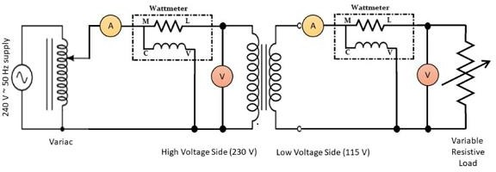
Circuit Diagram
Figure 3.10: Circuit Diagram for Transformer Efficiency
Precautions:
  - All connections should be neat and tight.
  - Connecting leads should be perfectly insulated.
  - There should be no error in ammeter and voltmeter.
  - The range of instruments should be carefully chosen.
Procedure:
- Set up the transformer with an appropriate input voltage.
- Measure the input voltage (primary side) and current using the respective meters.
- Measure the output voltage and current on the secondary side.
- Calculate the input power as Pin =Vprimary × Iprimary. (3.4)
- Calculate the output power as Pout=Vsecondary × Isecondary. (3.5)
- Compute the efficiency using the formula:
η = (Pout / Pin) ×100 (3.6)
- Record the results and observe how efficiency changes with different loads.
Expected Results: The efficiency should be close to 100%, with slight losses due to the transformer's internal resistance.
3.5.5: Experiment 5: Voltage Regulation of a Transformer
Objective: To study the voltage regulation of a single-phase transformer by varying the load.
Apparatus:
- Single-phase transformer trainer
- Voltmeter and ammeter (built into the trainer)
- Variable resistor (load)
- Connecting wires
Procedure:
- Set the primary voltage to a fixed value (e.g., 100V).
- Measure the no-load secondary voltage (open-circuit).
- Apply a load to the secondary side and measure the secondary voltage under load.
- Record the no-load and full-load voltages.
- Calculate the percentage voltage regulation using the formula:
Voltage Regulation= ((Vno_load – Vfull_load) / Vfull_load) × 100 (3.7)
- Repeat the experiment for different load values and plot the voltage regulation curve.
Expected Results: Voltage regulation will increase as the load increases.
- Circuit Diagram:

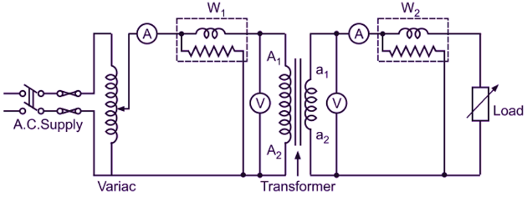

Figure 3.11: Circuit Diagram for Voltage Regulation

