

A TECHNICALREPORT
STUDENT INDUSTRIAL WORKING EXPERIENCE SCHEME (SIWES)

Held at

OLORIEGBE NIGERIAL IMITED

Prepared by:

ABDULLAHI ABDULWARIS ENIOLA ND/23/PSM/FT/0049

SUBMITTEDTO

DEPARTMENT OF PROCUREMENT AND SUPPLY CHAIN MANAGEMENT INSTITUTE OF FINANCE AND MANAGEMENT STUDIES
KWARASTATEPOLYTECHNIC,ILORIN

IN PARTIAL FULFILLMENT OF THE AWARD OF THE REQUIREMENT OF THE AWARD OF NATIONAL DIPLOMA IN PROCUREMENT AND SUPPLY CHAIN MANAGEMENT

Aug.,–Dec.,2024

DEDICATION

IdedicatethistechnicalreporttotheAlmightyGod,thegiverofknowledge, wisdom and who is rich in mercy.

ACKNOWLEDGEMENT

Itakethisopportunitytoexpressmyprofoundgratitudeanddeepregardsto thecreatorofheavenandearth,theonewhoknowsthebeginningandtheend, the alpha and the omega, the Almighty God and also to my guides (MR & MRS ABDULLAHI,andtoallthosewhohashelpedmeduringmySIWESprogramme. Theblessings,helpandguidancegivenbythem,timetotimehascarrymesothis farandshallcarryonthejourneyoflifeonwhichIamabouttoembark.Ialsotakethisopportunitytoexpressadeepsenseofgratitudetocomplimentmymentor for his cordial support valuable information and guidance which helped me incompletingmySIWESthroughvariousstages. Lastlymydeepregardtothebest andmostinspiringbrother and sister.

Abigthanks goes to my friends, May AlmightyGOD bless,protect,keep, nourishandguideyouthroughallyourlife’sentirejourney.Andalsomyregard totheschoolboardoftrusteesandthestaffaverybigthankyoutoallandsundry.

TABLEOFCONTENT

Titlepage i
Dedication ii
Acknowledgements iii
Tableofcontent iv

CHAPTERONE:INTRODUCTION
Backgroundof SIWES
HistoryofSIWES
Objectivesof SIWES
ObjectivesofOloriegbenigerialimited

CHAPTERTWO:EXPERIENCEANDOBSERVATIONS
BenefitsDerivedfromtheSIWESProgramme
PrecautionaryMeasuresintheEnterprise
IntroductiontoEnterpriseOperationsandKeyTools

CHAPTERTHREE:PROCUREMENT ANDSUPPLYMANAGEMENT IN OLORIEGBE NIGERIA LIMITED
OverviewofProcurementProcesses
SupplyChainManagementintheEnterprise
ChallengesinProcurementandSupplyManagement
SolutionsandRecommendations

CHAPTERFOUR:LESSONSLEARNEDANDPERSONALREFLECTIONS
KeyLessonsLearned
PersonalReflections

CHAPTERFIVE:CONCLUSIONANDRECOMMENDATIONS
Summaryof Experience
Conclusion
Recommendations

APPENDICES
AppendixA:OrganizationalChartofOloriegbenigerialimited Appendix B: Supply Chain Diagram
Appendix C: Sample Inventory Report AppendixD:ImagesofEnterpriseOperations

REFERENCES

CHAPTERONE
BACKGROUNDOFSIWES
The Student Industrial Work Experience Scheme (SIWES) is a skill development program designed to prepare students of universities, polytechnics, and colleges of education for the industrial work situation they are likely to encounter after graduation. EstablishedbytheIndustrialTrainingFund(ITF)in1973,SIWESbridgesthegapbetween theoryandpracticebyprovidingstudentswiththeopportunitytogainhands-onexperience in their chosen fields. The program is mandatory for students in engineering, technology, science, and other related disciplines, as it equips them with practical skills and exposure to real-world work environments.

StudentsIndustrialWorkExperienceScheme(SIWES)isaSkillsTrainingProgram designed to prepare and expose Students of Universities, Polytechnics, Colleges of Technology, Colleges of Agriculture and Colleges of Education for the Industrial Work situation they are likely to meet after graduation. The Scheme affords Students the opportunityof familiarizing and exposing themselves handling equipment and machinery that are usually not available in their institutions.

The Student Industrial Work Experience Scheme (SIWES) is a program designed to provide students with practical exposure to their chosen fields of study. It bridges the gap between theoretical knowledge acquired in academic institutions and the practical skills required in the workplace. This report documents myexperience during the SIWES programatOloriegbenigerialimited,focusingonprocurementandsupplymanagementin the foodstuff sector.

HISTORYOFSIWES
The Students’ Industrial Work Experience Scheme (SIWES) was initiated in 1973 by the Federal Government of Nigeria under the Industrial Training Fund (ITF) to bridge the gap between theory and practice among products of our tertiary Institutions. It was designedtoprovidepracticaltrainingthatwillexposeandpreparestudentsofUniversities, Polytechnics, and Colleges of Education for work situation they are likely to meet after graduation.Theprogramwascreatedtoaddressthelackofpracticalskillsamonggraduates and to ensure that students are adequately prepared for the demands of the labor market. Over the years, SIWES has become a mandatory part of the curriculum for students in professional disciplines.

Before the establishment of the scheme, there was a growing concern among the industrialists that graduates of institutions of higher learning lacked adequate practical backgroundstudiespreparatoryforemploymentinindustries.Thustheemployerswereof theopinionthatthetheoreticaleducationgoingoninhigherinstitutionswasnotresponsive to the needs of the employers of labour.

Asaresultoftheincreasingnumberofstudents’enrolmentinhigherinstitutionsof learning, the administration of this function of funding the scheme became enormous, hence ITF withdrew from the scheme in 1978 and was taken over by the Federal Government and handed to National Universities commission (NUC), National Board for Technical Education (NBTE) and National Commission for Colleges of Education (NCCE). In 1984, the Federal Government reverted back to ITF which took over the scheme officially in 1985 with funding provided by the Federal Government

OBJECTIVESOFSIWES
TheprimaryobjectivesofSIWESinclude:
    - Toexposestudentstoreal-worldworkenvironments.
    - Toequipstudentswithpracticalskillsrelevanttotheirfieldsofstudy.
    - Tofosterasmoothtransitionfromacademiclifetoprofessionalcareers.
    - Toenhancestudents'understandingofworkplaceethicsandresponsibilities.

OBJECTIVESOFOLORIEGBENIGERIALIMITED
Oloriegbe nigeria limited is a reputable business specializing in the sale of foodstuffs and general merchandise. The objectives of the enterprise include:
    - Providinghigh-qualityfoodstuffsandmerchandisetocustomers.
    - Ensuringefficientprocurementandmanagementofinventory.
    - Maintainingacustomer-centricapproachtobusinessoperations.
    - ContributingtothegrowthofthefoodandretailindustryinNigeria.

CHAPTERTWO
BENEFITDERIVEDFROMSIWESPROGRAMME
The experience, knowledge, skills and exposure acquired during the period of attachment in the industrial exercise cannot be over emphasized. I was exposed to certain areas in my course of study, such as:
    - Skill Development: Students acquire practical skills and competencies that are essential for their professional growth.

    - Industry Exposure: The program provides students with firsthand experience of industrial operations, processes, and technologies.

    - Networking Opportunities: Students interact with professionals in their field, building valuable connections for future career prospects.

    - EnhancedEmployability:Employersprefer candidates withpracticalexperience, making SIWES participants more competitive in the job market.

    - Improved Academic Performance: The application of theoretical knowledge in real-world scenarios enhances students' understanding of their coursework.

    - Contribution to National Development: By producing a skilled workforce, SIWES contributes to the economic and technological advancement of the nation.

PRECAUTIONARYMEASURESINTHEENTERPRISE
Toensuresmoothoperations,theenterpriseimplementedthefollowingprecautions:
    - SafetyMeasures:Regularsafetybriefingsandtheuseofpersonalprotective equipment (PPE) were enforced to prevent accidents.

    - SecurityProtocols:Strictaccesscontrolmeasureswereimplementedtosafeguard the mall's assets and ensure the safety of customers and staff.

    - HealthGuidelines:Compliancewithhealthregulations,suchasmaintainingcleanliness and adhering to COVID-19 protocols, was prioritized.

    - Operational Standards: Standard operating procedures (SOPs) were followed to ensure smooth and efficient operations.

    - Customer Service Training: Staff were trained to handle customer inquiries and complaints professionally, ensuring a positive shopping experience.
    - Regularmaintenanceofequipmenttopreventbreakdownsandensurecustomer satisfaction.

    - Implementationofstrictinventorycontrolmeasurestoavoidstockoutsoroverstocking.

    - Ensuringcompliancewithsafetyregulationstoprotectbothemployeesand customers.

    - Useofsurveillancesystemstopreventtheftandensuresecuritywithinthestore.

    - Adherencetohealthandsafetyprotocols,especiallyinhigh-trafficareas.

INTRODUCTIONTOENTERPRISEOPERATIONSANDKEYTOOLS
Theenterpriseisequippedwithstate-of-the-arttoolsandsystemstoenhancecustomer experience and streamline operations. Some of the key tools include:
- PointofSale(POS)Systems:Usedforprocessingtransactionsandmanagingsalesdata.
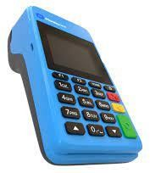
- InventoryManagementSoftware:Tracksstocklevels,orders,anddeliveriesinreal- time.
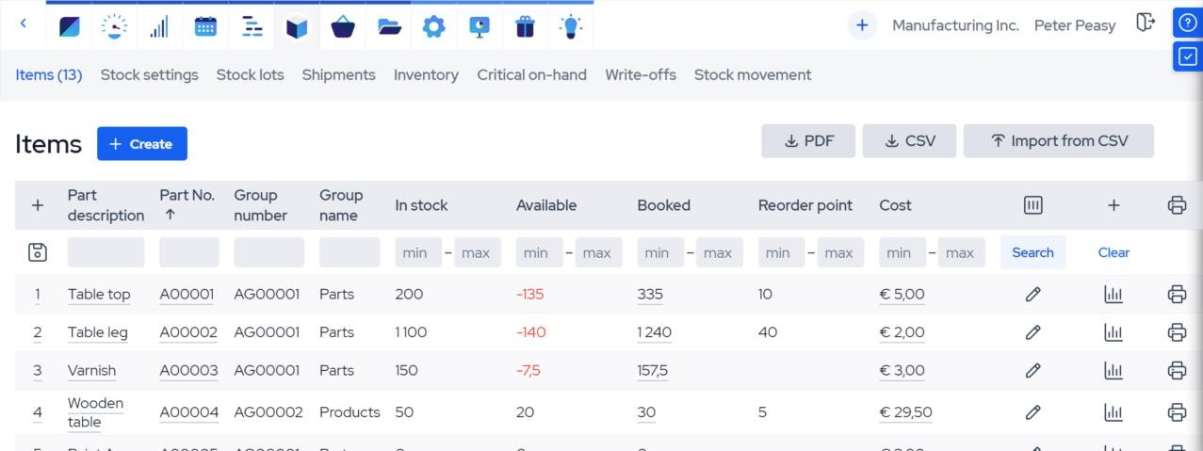

- SecuritySystems:IncludesCCTVcamerasandalarmsystemstoensuresafety.
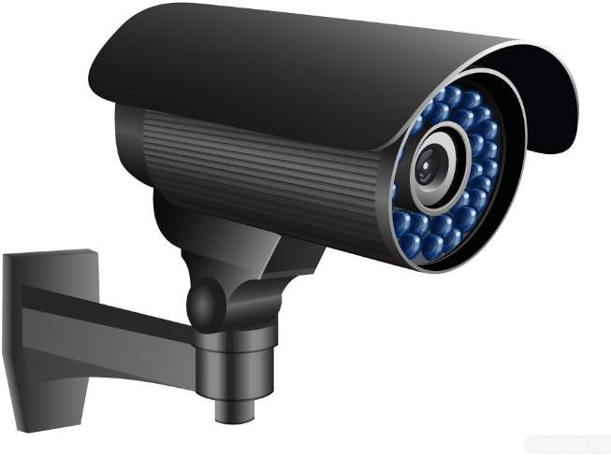
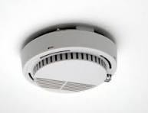
- DisplayUnits:Strategicallyplacedtoshowcasefoodstuffsandmerchandise.




Mouse:usedtoclickandselectonthemonitor.

Mouse

QR-Codescanner:usedtoscangoodsbarcodetogetthepriceofthegoods.
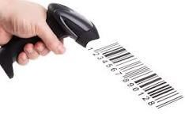

QR-Codescanner

Keyboard:usedtoinputdigitandwordsonmonitor,andtoinputgoodsnameandprice.
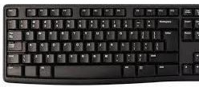

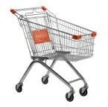
Keyboard Trolley:usedtocarrygoodsaroundinthesupermarket.

Trolley
- CustomerRelationshipManagement(CRM)Software:Usedtomanagecustomerinteractions and feedback.

CHAPTERTHREE
OVERVIEWOFPROCUREMENTPROCESSES
Procurement in the enterprise involves sourcing high-quality foodstuffs and merchandise from reliable suppliers. The process includes:
    - Identifyingsuppliersandnegotiatingcontracts.
    - Placingordersandensuringtimelydelivery.
    - Inspectinggoodsforqualityandcompliancewithspecifications.
    - Managingvendorrelationshipstoensurelong-termpartnerships.

SUPPLYCHAINMANAGEMENTINTHEENTERPRISE
The supply chain management process ensures that products are delivered to customersefficiently. Key activities include:
    - Inventorymanagementtomaintainoptimalstocklevels.
    - Logisticsanddistributiontoensuretimelydeliveryofgoods.
    - Monitoringandanalyzingsupplychainperformancetoidentifyareasforimprovement.

CHALLENGESINPROCUREMENTANDSUPPLYMANAGEMENT
SomeofthechallengesobservedduringmySIWESprograminclude:
    - Delaysindeliveryfromsuppliers.
    - Fluctuationsinproductpricesduetomarketconditions.
    - Difficultyinmaintainingconsistentqualityacrosssuppliers.
    - Highcompetitionintheretailandfoodindustry.

SOLUTIONSANDRECOMMENDATIONS
Toaddressthesechallenges,thefollowingsolutionsarerecommended:
    - Establishinglong-termpartnershipswithreliablesuppliers.
    - Implementingadvanced inventorymanagementsystems to trackstock levelsin real-time.
    - Diversifyingthesupplierbasetoreducedependencyonasinglesource.
    - Conductingregulartrainingforstaffonprocurementandsupplychainbestpractices.

CHAPTERFOUR
KEYLESSONSLEARNED
    - Theimportanceofeffectivecommunicationinprocurementandsupplychain management.
    - Theroleoftechnologyinstreamlininginventoryandsupplychainprocesses.
    - Theneedforadaptabilityinaddressingsupplychainchallenges.
    - Thevalueofteamworkandcollaborationinachievingorganizationalgoals.

PERSONALREFLECTIONS
MySIWESexperiencehasbeenbothchallengingandrewarding.Ilearnedtheimportance of attention to detail in procurement and the critical role of supply chain management in ensuring customer satisfaction. This experience has deepened my understanding of the retail and food industry and prepared me for future career challenges.

CHAPTERFIVE
SUMMARYOFEXPERIENCE
MySIWESattachmentatOloriegbeNigeriaLimitedprovidedmewithacomprehensive understanding of procurement and supply management in a retail environment. I gained practical skills in inventory management, vendor negotiation, and supply chain optimization, which will be invaluable in my future career.

CONCLUSION
The SIWES program has been a transformative experience, equipping me with the knowledgeandskillsrequiredtoexcelinthefieldofprocurementandsupplymanagement. The exposure to real-world challenges and solutions has prepared me for the demands of the professional world. The SIWES program provided me with a unique opportunity to gain practical experience in procurement and supply chain management. Through my attachment at Esteem-G mall, I was able to applythe theoretical knowledge gained in the classroom to real-world scenarios.

The program enhanced my understanding of procurement processes, inventory management, supplier relationship management, logistics, and compliance. It also equippedmewithessentialskillssuchasproblem-solving,communication,andteamwork, which are critical for success in the procurement and supply chain industry.

RECOMMENDATIONS
To enhance the effectiveness of the SIWES program, the following recommendations are proposed:
    - Increasethedurationoftheprogramtoallowfordeeperimmersioninthework environment.
    - Providestudentswithmoreopportunitiestoparticipateindecision-makingprocesses.
    - Encourageorganizationstoassignmentorstoguidestudentsthroughouttheprogram.
    - Incorporateregularfeedbacksessionstoassessstudents'progressandaddresschallenges.

APPENDICES

AppendixA:OrganizationalChartofOloriegbeNigeriaLimited
CEO(ChiefExecutiveOfficer)

|

| | | |

OperationsManager MarketingManagerFinanceManagerProcurementManager

| | | |

| | | | | | | |

SalesTeam CustomerService AccountingTeam ProcurementTeam

| | | |

| | | | | | | |

SalesAssociates SupportStaff Accountants ProcurementOfficers

EXPLANATIONOFTHEORGANIZATIONALCHART
- CEO(ChiefExecutiveOfficer):Overseestheentireorganizationandmakes strategic decisions.

- OperationsManager:Managesdailyoperations,includingsalesandcustomer service.

- MarketingManager:Handlesbranding,advertising,andcustomerengagement.

- FinanceManager:Managesbudgets,financialreporting,andaccounting.

- Procurement Manager: Oversees the procurement process, including sourcing and vendor management.

- ProcurementTeam:Includesprocurementofficersresponsibleforpurchasinggoods and managing supplier relationships.

- SalesTeam:Handlesthesaleoffoodstuffsandmerchandisetocustomers.

- CustomerService:Providessupporttocustomersandhandlesinquiriesand complaints.

- AccountingTeam:Managesthefirm'sfinancialrecords,payroll,andtax compliance.

- SupportStaff:Handlesofficeadministrationandothersupportfunctions.

AppendixB:SupplyChainDiagram

Product | QuantityinStock | ReorderLevel | Supplier | LastOrderDate
Rice(50kg) | 100 | 50 | Supplier X | 2023-09-15
Beans(50kg) | 80 | 40 | Supplier Y | 2023-09-10
VegetableOil(20L) | 150 | 75 | Supplier Z | 2023-09-05
Noodles(5cartons) | 120 | 60 | SupplierW | 2023-09-12
Semo(50kg) | 90 | 45 | Supplier V | 2023-09-08

REFERENCES
- Chopra, S., & Meindl, P. (2016). Supply Chain Management: Strategy, Planning, and Operation. Pearson Education.

- Lysons,K.,&Farrington,B.(2016).ProcurementandSupplyChainManagement. Pearson Education.

- Monczka, R. M., et al. (2015). Purchasing and Supply Chain Management. CengageLearning.

- Chartered Institute of Procurement & Supply (CIPS). What is Procurement? Available at: https://www.cips.org](https://www.cips.org

- SupplyChainManagementReview(SCMR).ArticlesandCaseStudies.Availableat:
https://www.scmr.com](https://www.scmr.com

