CHAPTER FOUR

TESTING AND RESULT
4.1 TEST AND ANALYSIS
A solar-enabled rechargeable fan (SERF) requires proper construction and assembly. The assembling must be in accordance with the design analysis. After the assembly has been completed, the must be properly tested to ensure that the panels and other vital components of the solar -enabled rechargeable fan (SERF) are working optimally. After testing all the components and units of the solar -enabled rechargeable fan and one is assured that they are all working perfectly, the performance of the of the solar is then analyze. The output voltage, the charging hours, the running hours, and other qualities of a good solar -enabled rechargeable fan must be analyze to ensure that it is fit for use.
4.2 ​Assembly Of The Solar-Enabled Rechargeable Fan (Serf) Components
The components rating, types are prime factor in solar-enabled rechargeable fan (SERF) assembly. The main feature that a (SERF) must possess is the ability to provide electrical energy that will run for the expected amount of time. The following materials are therefore employed in the assembly of the solar -enabled rechargeable fan;
4.2.1 The Solar Panel (Photovoltaic Cells)
The basic unit of a solar PV generator is the solar cell. It is made from a semiconductor material, mostly silicon (Si). The mono-crystalline solar panel has two cables running from its circuit the first one is connected with a diode to the designated terminal on the charge controller. The function of this diode is to disallowed current from flowing back to the solar panel and the second cable is connected directly to the terminal without any semiconductor devices attached to it as shown in fig. 4.1.
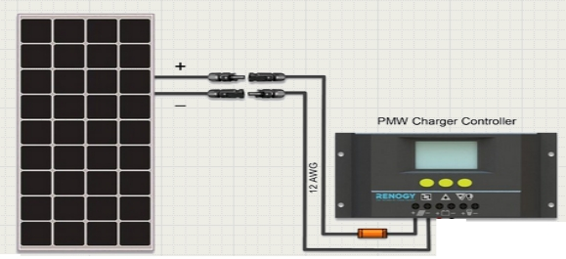
Fig.4.1: Diagram of solar and charge controller connections. (www.windofkeltia.com)
4.2.2 The lion Battery
The deep cycle battery is to store the power supplied by the solar panel for a later use and is connected to the battery icon on the charge controller. The terminals designated positive and negative in the deep cycle battery was connected to the positive and negative terminals of the charge controller respectively.
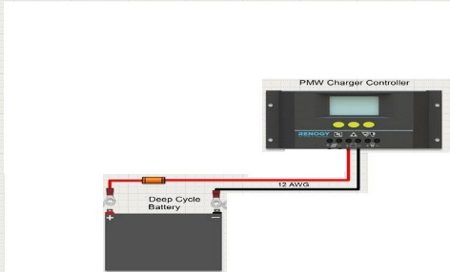
Fig. 4.2: Diagram of lion and charge controller connections. (www.windofkeltia.com)

4.3 SUMMARY OF THE SYSTEM ASSEMBLY
The following steps were taken in the assembling of the solar battery charger
  - Connect the battery according to the polarity shown on the battery and on the charge controller.
  - Connect the photovoltaic (or solar) panels with regards to the polarity. At this point, the solar panel ready for the action of providing power to the battery.
  - Connect the DC loads, probably inverter or dc loads.
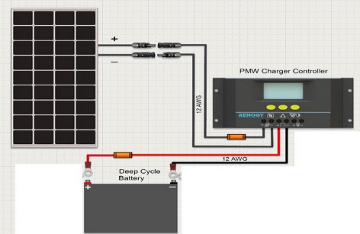
Fig: 4.3 diagram of solar panel, charge controller and battery (www.windofkeltia.com)

4.4 CIRCUIT DIAGRAM
The complete circuit diagram illustrates the interconnection between the major components of the system, including the solar panel, battery charge controller, lithium-ion battery, voltage regulators, DC fan motor, LED lighting, USB output, battery status indicator, and control switches.
4.4.0 Explanation of Major Sections
4.4.1 Solar Input and Charging Stage:
- The solar panel (18V, 20W) supplies DC power to the system.
- A diode (IN4148) is used to prevent reverse current flow.
- The battery charge controller regulates voltage and current going into the battery.
4.4.2 Battery Storage:
- A 7.4V lithium-ion battery (3700mAh) stores energy for use when solar input is unavailable.
- Battery terminals are protected and connected to both the output load and battery status indicator.
4.4.3 Fan Voltage Control and Speed Regulation:
- A rotary switch selects one of three fixed output voltages: 9V (7809), 12V (7812), or 18V (7818) — which controls fan speed.
- A 10kΩ potentiometer is connected to regulate the fan speed more precisely.
4.4.4 Peripheral Outputs:
- The USB module (5V, 1A) provides charging for external devices.
- A DC LED light is connected directly to the battery with its own control switch.
- A voltmeter or LED bar display is used to monitor battery level.
4.4.5 Protection and Switching
• Diodes (IN4148) are used at key nodes to prevent backflow current.
• Major output (fan, LED, USB) is controlled by a power switch.

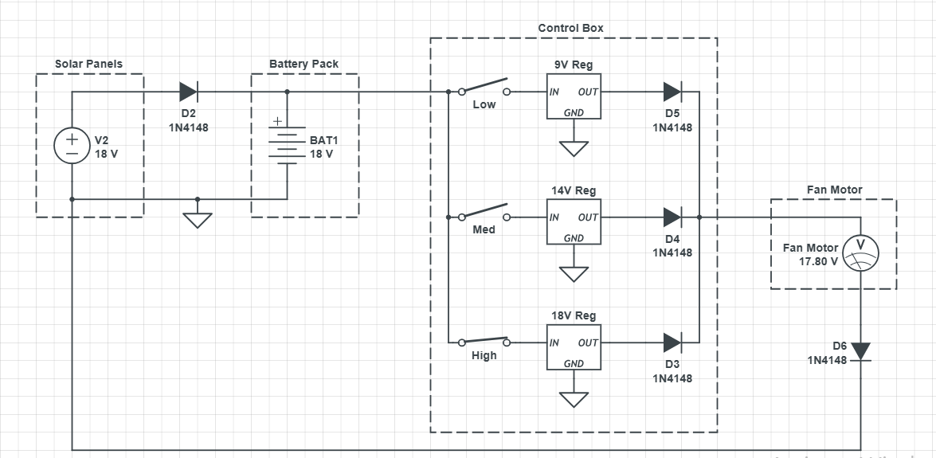
Fig: 4.4 Circuit diagram of solar powered DC fan

4.5 CONSTRUCTION PROCEDURE
The construction of the solar-enabled rechargeable fan system was carried out through organized phases to ensure proper alignment with the design schematic. Each stage from layout design to final casing was approached with testing and verification in mind.
4.5.1 Simulation and Layout Design
Before physical assembly, the circuit was simulated using Livewire software. This helped verify the circuit logic, test voltage regulation, switching behavior, and battery charging flow. After a successful simulation, the PCB layout was developed using PCB Wizard to guide component positioning.
4.5.2 Veroboard Implementation
A vero-board (stripboard) was used instead of a custom printed PCB due to its accessibility and ease of modification. The design from PCB Wizard was carefully mapped onto the vero-board.
4.5.3 Component Placement and Soldering
All components — including:
- the voltage regulators (7809, 7812, 7818),
- diodes
- potentiometer,
- fan motor
- USB port
- LED
- battery voltage monitor
were placed according to their positions on the schematic. Soldering was done carefully, ensuring no loose joints or short circuits.
4.5.4 System Integration
After basic component connections were completed, the modules were integrated:
- The solar panel was connected to the charge controller.
- The battery was linked with a protective diode and connected to power the system.
- The voltage selector switch was wired to the regulators, with the speed control potentiometer in series with the fan.
- The USB output, LED lighting, and battery indicator were connected to the battery via switches.

4.5.5 Enclosure Setup
A plastic casing was used to house the entire assembly. Openings were created for:
- the rotary switch (for voltage selection),
- power switch (for LED, fan, and USB),
- display modules (USB port, LED, voltmeter).
The solar panel was placed externally and connected via a detachable DC cable.

4.6 EVALUATION OF FAN PERFORMANCE
4.6.1 Airflow Measurement (CFM)
The airflow performance of the fan was evaluated using the Cubic Feet per Minute (CFM) formula:
CFM = Air Velocity (ft/min) × Cross-sectional Area (ft²)
Air velocity was measured using an anemometer, and the fan’s cross-sectional area was calculated based on the blade diameter. This provided an estimate of the volume of air moved per minute at different speed settings.
4.6.2 Efficiency Calculation
The overall system efficiency was evaluated using the ratio of output power to input power as shown below:
Efficiency (%) = (Output Power / Input Power) × 100
Input power was obtained from the battery or solar output, while output power was based on the electrical power consumed by the fan motor and its mechanical output performance

