KWARA STATE POLYTECHNIC ILORIN,
KWARA STATE.

PROJECT DEFENCE TOPIC:
DESIGN AND CONSTRUCTION OF ENERGY METER MONITORING
OVER IOT WITH ANDROID APPLICATION .

PRESENTEDED BY:
HND/23/EEE/FT/0021

SUPERVISED BY:
ENGR. K. LATEEF

INTRODUCTION
The global rise in electricity demand fueled by population growth, industrialization, and heavy reliance on electronic devices calls for more efficient energy management solutions. Traditional metering systems, which require manual readings,are often slow, error-prone, and lack the ability to provide real-time data. These short comings lead to delayed billing, inaccurate consumption tracking, and significant energy losses.
The emergence of the Internet of Things (IoT) presents a more intelligent approach to power management. By integrating sensorsand communication modules into energy systems, IoT enables real-time monitoring, automated billing, anomaly detection, and remote access through mobile applications.
This project focuses on the design and construction of an IoT-based energy meter, connected to an Android app, to help users monitor their electricity usage in real time.This smart system improves accuracy, promotes transparency, and encourages more responsible energy consumption, contributing to a sustainable and efficient power infrastructure.

PROBLEM STATEMENT
Traditional methods of energy monitoring and billing are plagued with several inefficiencies. Manual readings are not only time-consuming but also prone to human error, often resulting in inaccurate billing. The absence of real-time monitoring makes it difficult for consumers to track their energy consumption and adjust their usage accordingly. Inefficiencies within billing systems frequently lead to estimated charges, delayed invoices, or overbilling, which can frustrate users and reduce trust in utility providers. Additionally, the inability to detect power theft or system faults promptly contributes to significant revenue losses and frequent service disruptions. Most critically, these conventional systems do not promote proactive user engagement, as consumers typically receive feedback only after billing by which time opportunities for energy conservation may already be lost. This project seeks to resolve these challenges by introducing a smart, accurate, and user-friendly energy monitoring solution that enables timely feedback, remote accessibility,and improved efficiency for both end-users and service providers

AIM & OBJECTIVES
Aim:
To design and construct an IoT-enabled energy meter integrated with an Android application that enables real-time monitoring, usage alerts, and data analytics.
Objectives:
1. Design and build a reliable energy metering circuit using appropriate sensors.
2. Integrate a microcontroller (e.g., ESP32) with IoT communication modules.
3. Interface the system with cloud servicesfordatastorage and retrieval.
4.Develop an intuitive Android application for users to track energy usage in real-time.
5. Implement alert systems to notify users about abnormal usageor thresholds.

SCOPE OFSTUDY
This project focuses on:
• Real-time measurement of electrical energy using current and voltage sensors.
• Transmission of data to a cloud platform using Wi-Fior GSM.
• Development of an Android mobile application to display live consumption data and usage history.
• Alert generation based on user-defined thresholds.
• The project does not cover prepaid billing integration, advanced tariff structures, or industrial-grade load analysis.

LITERATURE REVIEW
Several studies have explored the integration of smart technologies in energy management:
• Abhisheket al. (2017) designed an IoT-based energy meter that sends real-time consumption data via GSM. While effective, the system lacked a user-friendly interface and mobile app support.
• Kumar andSingh (2019) proposed a smart energy meter with prepaid billing and load control features. Their approach enhanced utility management but focused lesson consumer-side monitoring.
• Akinyele et al. (2020) emphasized smart metering’s role in reducing energy losses and improving grid reliability in developing countries. However, cost and connectivity challenges remain.
• Chandran et al. (2021)developed an Android-based smart meter prototype using IoT and cloud services, improving transparency and user awareness, though scalability was not addressed.

METHODOLOGY (CIRCUIT DIAGRAM)

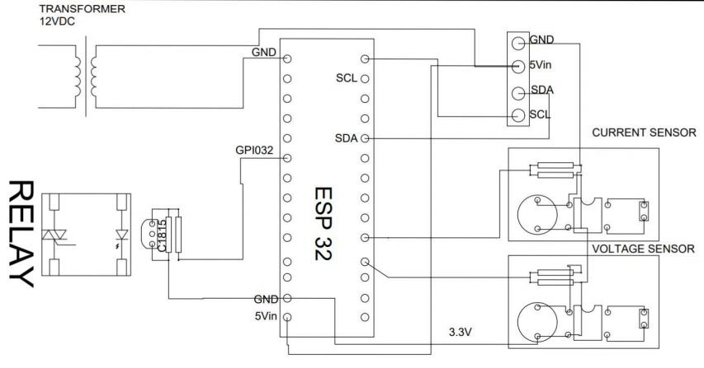

DESIGNCALCULATION

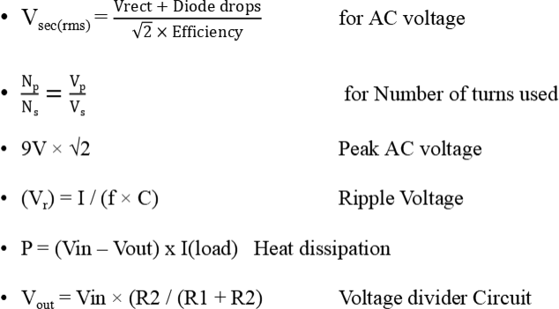

CONCLUSION
The design and implementation ofan IoT-based energy meter with Android integration successfully addressed key issues in traditional energy monitoring systems. By offering real-timetracking, automated billing, and remote access, the system enhances transparency,efficiency,and user control. This solution not only benefits consumers but also aids utility providersinreducingenergy losses and improving servicedelivery.

RECOMMENDATION

• Adopt IoT-based Smart energy meters: utilities companies should transition from traditional metering to IoT-enabled smart meters to enhance accuracy, enable real-time monitoring, and reduce operational efficiencies.
• Promote user awareness and mobile integration: encourage energy saving habits by providing users with intuitive mobile applications that offer real-time feedback, usage analytics and alerts on abnormal consumption or faults.

REFERENCES
•Abhishek,S., Kumar, V., & Singh, R. (2017). IoT-based energy meter reading and billing system. International Journal of Engineering Research, 6(8),123-129.
•Kumar, P., & Singh,A. (2019). Design of smart energy meter with prepaid billing and load control. Journal of Electrical Systems,15(3), 210-218.
•Akinyele, D. O., Jimoh, A. A., & Ogunjuyigbe, A.S. O. (2020). Smart metering for developing countries:Challenges and opportunities. Renewable Energy Journal,145, 2673-2682.
•Chandran, R., Nair, M., & Thomas, S. (2021).Android-based IoT energy meter prototype for real-time monitoring. International Journal of SmartGrid, 7(1), 45-53.

