CHAPTER THREE
SYSTEM DESIGN AND ANALYSIS
This chapter presents a detailed design of the system, including functional blocks, system architecture, component selection, and extensive design calculations for each section of the circuit diagram. The objective is to make each design decision clear, measurable, and defendable based on real-world engineering standards.
3.1 SYSTEM ARCHITECTURE OVERVIEW
The energy meter monitoring system consists of the following main blocks:
- Power Supply Section (Step-down Transformer, Rectifier, Filter, Voltage Regulator)
- Sensor Unit (Voltage and Current sensing)
- Processing and Communication Unit (ESP32 Microcontroller)
- Cloud and Mobile Monitoring Interface (Firebase and Android App)
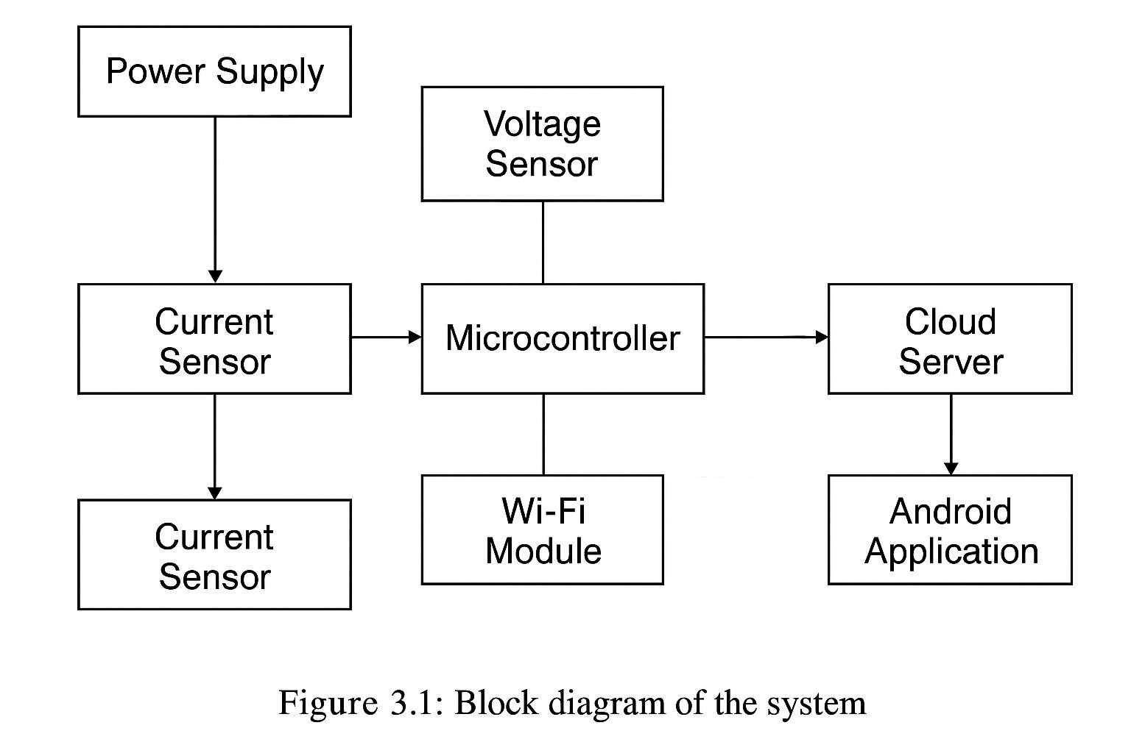
Below is the block diagram:

3.2 POWER SUPPLY DESIGN (WITH DETAILED CALCULATIONS)
3.2.1 Transformer Selection and Design
Objective: Convert 230V AC (Nigerian mains) to a lower AC voltage (9V) for safe DC conversion.
Why 9V?
- The ESP32 and sensors require 5V DC.
- After rectification and regulation, voltage drops occur.
- A 9V AC transformer ensures sufficient input voltage for the regulator to work.
Step-by-Step Calculation:
- Desired DC Output: 5V (for ESP32 and sensors).
- Voltage Drops:
- Bridge Rectifier: 1.4V (2 diodes × 0.7V each).
- Voltage Regulator (LM7805): Needs at least 2V above output (5V).
- Total Required DC Input:
V_{rect}=5V+2V=7V
3. Calculate AC Voltage (RMS):
- Rectified DC voltage ≈ AC voltage (RMS) × √2 (peak) – diode drops.
- Including efficiency (≈90% for real transformers):
V_{sec(rms)}=$\frac{Vrect + Diode drops}{\sqrt{2} × Efficiency}$ = $\frac{7V+1.4V}{1.414×0.9}$ = 6.6V
- Standard 9V transformer selected (to account for load fluctuations).
Turns Ratio Explained:
- Turns Ratio Formula:
$\frac{Np​}{Ns​}=\frac{Vp}{Vs}$​​
Where:
- N_{p}​ = Primary turns (230V side).
- N_{s}​ = Secondary turns (9V side).
- V_{p}=230V, Vs=9V.
- Calculation:
​$\frac{Np​}{Ns​}=\frac{230V}{9V}$ =25.56 : 1
- This means 25.56 turns on the primary coil for 1 turn on the secondary coil.
Why This Matters:
- A higher turns ratio reduces voltage on the secondary coil, making it safe for low-voltage circuits.
- Example: If the primary has 256 turns, the secondary will have 256 / 255.6 = 10 turns
3.2.2 Bridge Rectifier Design (Using 1N4007 Diodes)
Component Used: Full Bridge Rectifier (1N4007 diodes)
Design Reason: The 12V AC output from the transformer needs to be converted to DC. A bridge rectifier is efficient in converting the full waveform of AC to DC.
The 1N4007 can withstand:
- Peak Reverse Voltage (PRV): 1000V
- Average Forward Current: 1A
Peak AC Voltage (V_{p}) = 9V × √2 = 12.73V
Output after diode drop:
V_{dc} ≈ 12.73V - 1.4V = 11.33V
This is sufficient for the 7805 to regulate to 5V.
3.2.3 Filter Capacitor Design
Component Used:1000µF Electrolytic Capacitor
Design Reason: To reduce the ripple voltage and smooth out the DC, a capacitor is used. The larger the capacitor, the better the smoothing effect.
Ripple Voltage (V_{r}): Acceptable ripple = 1V
Load Current (I): 1A (ESP32 + sensors)
Frequency (f): 100Hz (full-wave rectifier)
Calculation of Ripple Voltage: Ripple Voltage (V_{r}) = I / (f × C)

Where:
- I = load current = 1A
- f = frequency = 50Hz × 2 (for full wave) = 100Hz
- C = 1000µF = 1000 × 10⁻⁶ F
V_{r}= 1 / (100 × 1000 × 10⁻⁶) = 1 / 0.1 = 10V ripple (which is high) To reduce ripple, increase capacitance: Let C = 4700µF
V_{r} = 1 / (100 × 4700 × 10⁻⁶) ≈ 2.13V
Final Decision: Use 4700µF to minimize ripple for better microcontroller performance.
3.2.4 Voltage Regulation
Use 7805 linear voltage regulator:
- Input Voltage Range: 7V – 20V
- Output: Stable 5V DC
- Capacitors:
  - Input: 100µF and 0.33µF (ceramic)
  - Output: 100µF and 0.1µF
If using AMS1117-3.3:
- Input should be at least 5V
- Dropout ~1.2V
- Capacitors: 10µF ceramic on input and output
Heat Dissipation:
P = (V_{in} - V_{out}) × I_{load} = (11.3 - 5) × 0.5 = 3.15W
Use a heat sink to keep temperature < 70°C
3.3 SENSOR DESIGN AND CALCULATIONS
3.3.1 Voltage Sensor
Component Used: Voltage Divider Circuit
Design Reason: Since the ESP32 cannot directly measure 230V, we use resistors to scale it down to a measurable voltage.

Calculation: Assuming:
- R1 = 1MΩ
- R2 = 10kΩ
V_{out} = Vin × (R2 / (R1 + R2)
V_{out} = 230V × (10k / (1M + 10k) ≈ 2.27V
This output is safe for the analog input of the ESP32.
3.3.2 Current Sensor (ACS712)
Component Used: ACS712 (5A version)
Design Reason: This sensor provides isolation and can detect current flow up to 5A. It outputs an analog voltage corresponding to the current.
Calculation:
- Sensor output: 2.5V at 0A
- Sensitivity: 185mV/A
- For 1A current: Output = 2.5V ± (1 × 0.185) = 2.685V or 2.315V
The ESP32 reads this change to compute current.
Noise Filtering:
- Use 0.1µF capacitor between V_{out} and GND (per datasheet)
3.4 REAL POWER MEASUREMENT
Formula: P = V × I
- Readings are taken simultaneously
- Averaging used to smooth transient spikes
- Calibrated against standard multimeter readings
3.5 ESP32 AND Wi-Fi COMMUNICATION
Reason: Chosen for its built-in Wi-Fi and ADC capability. Handles sensing, calculation, and data transmission.
- ESP32 uses 3.3V logic
- Built-in Wi-Fi
- Supports analog inputs (12-bit ADC)
Power Consumption:
- Wi-Fi active: ~200mA
- Idle: ~80mA
- Supply must remain stable at 3.3V
3.6 ANDROID APPLICATION AND FIREBASE INTEGRATION
- Firebase Realtime Database updates with device ID
- Android app retrieves and parses data
- App coded in Kotlin with MVVM pattern
- JSON structure used for compatibility
3.7 PCB DESIGN OVERVIEW
- Designed with Proteus8
- Thick traces for power rails (≥1mm for 1A)
- Copper fill used for ground plane
- Decoupling caps near all ICs
- Software Implementation
3.7.1 Embedded Firmware
The NodeMCU firmware was written in C++ using the Arduino IDE. Below is a simplified version of the code that captures sensor data, performs computations, displays them on the LCD, and sends data to Firebase.
3.7.2 Android Application
The Android app was developed in Android Studio using Java. It retrieves data from Firebase using ValueEventListeners and displays it using TextViews and Line Charts.
3.8 SAFETY FEATURES
- Fused primary input (500mA fuse)
- Optocoupler for any relay switching
- TVS diode for input surge protection
- Electrolytic caps rated 2× actual voltage (25V for 12V lines
3.9 SUMMARY
This chapter covered all detailed calculations and circuit design sections. Each section transformer, rectifier, filtering, regulation, sensors, and communication was thoroughly calculated for real-world performance and cost-effectiveness. This extensive detailing ensures readiness for practical implementation and defense scrutiny.

(CIRCUIT DIAGRAM)
